Assignment 3 Part2
a. When the program runs, how many processes are created (including the program itself)? How many “Hello ....” are printed? Capture the output of pstree.
Code:
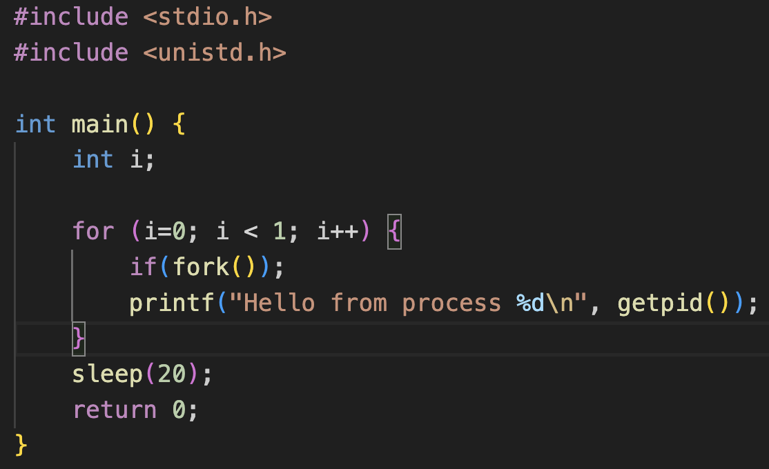
Processes Created:
: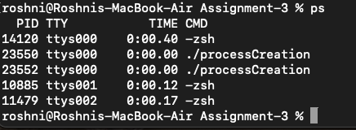
Hello, Printed on Output window:
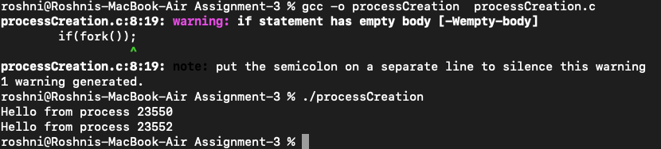
Capture the output of pstree:
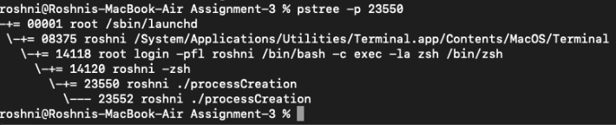

- Change the value of “i” to 2. How many processes are created? And how many “Hello ....” are printed? Capture the output of pstree.
Code:
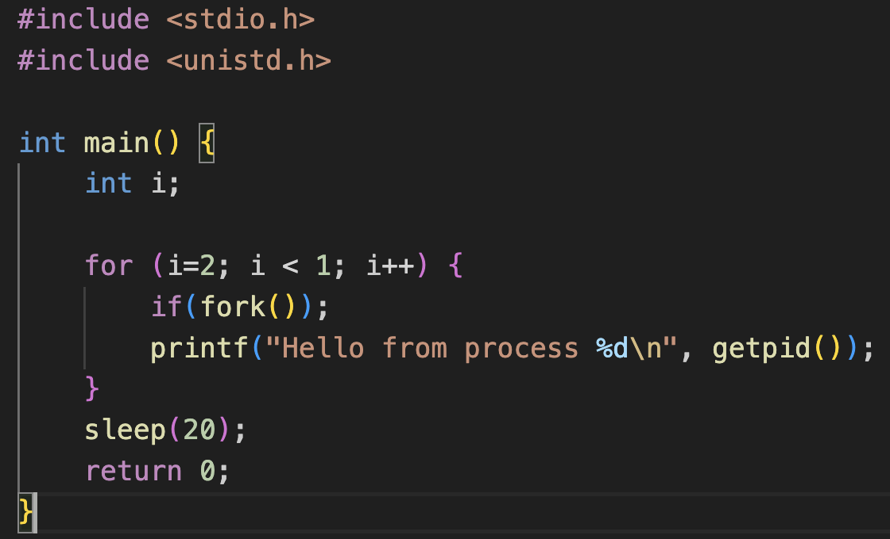
Processes Created:
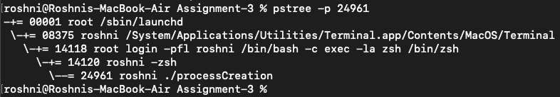
Hello, Printed on Output window:
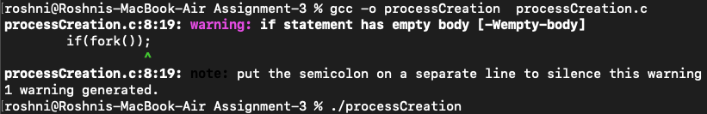
Capture the output of pstree:
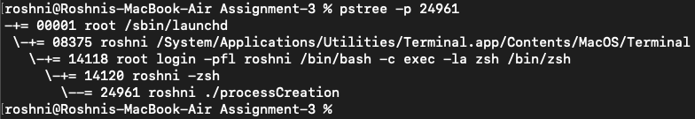

- What is the relation between the number of consecutive fork calls and the total number of processes created? Capture the output of pstree.
The relation between the number of consecutive fork() calls and the total number of processes created follows an exponential growth pattern:
- For each fork() call, the number of processes doubles.
- If there are n consecutive fork() calls, the total number of processes created (including the original) is 2^n.
Observation:
When i=0, i<1, i++ (2 fork() calls):
Total processes created: 2 processes (including the parent).
Total "Hello" printed: 2 times.
When i=2, i<1, i++ (1 fork() call):
Total processes created: 1 process.
Total "Hello" printed: None.
The observation captured are in above answer.

- Delete the “;” after the fork() statement and rerun parts a through c. Document the results. Why are the results different with and without the semicolon?
Observation:
With the semicolon, the if condition had no effect, and both the parent and child processes executed the printf() statement. Whereas, Without the semicolon, the printf() was correctly linked to the result of the fork() call, leading to only one of the processes (either parent or child) printing "Hello."
Output window:

Processes created:
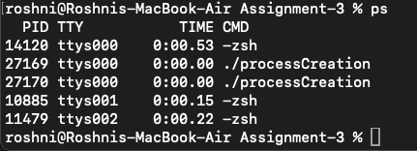
Capture the output of pstree:

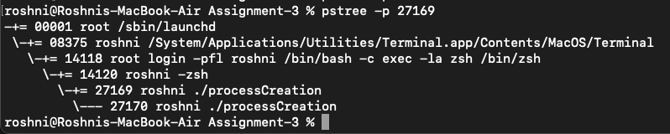

Part 2-2
A. Test argv : Part2-2-a-tempfile.txt
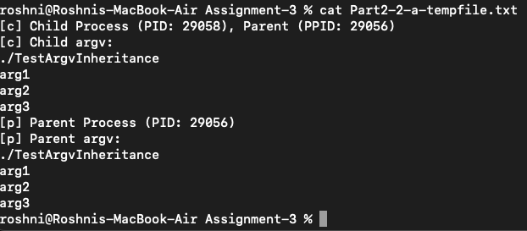

B. Test envp: Part2-2-tempfile_envp.txt

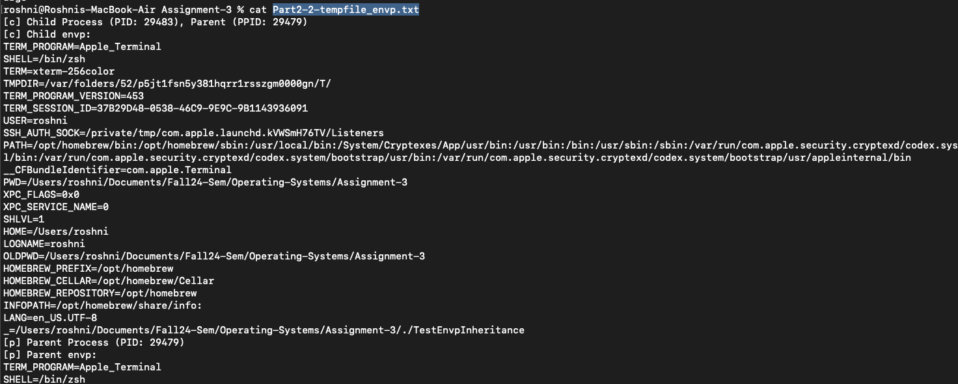

C. Test open file descriptors: outputfile.txt

