Week 4: Performance Optimization in Python Applications
Profiling, Bottleneck Analysis & Optimization Report — Sales Analytics Processor
Prepared by Roshni | Yuva Internships — Python Development Track

1. Objective
This report documents the performance profiling and optimization of a Sales Analytics Processor, a Python application I built that generates a synthetic sales dataset and computes duplicate-order detection, per-customer revenue, customer ranking, blocklist filtering, and a formatted text report. The baseline version was profiled with cProfile to establish measured evidence for where time was actually being spent, six distinct bottlenecks were identified and fixed using a mix of algorithmic, data-structure, and standard-library improvements, and every fix is backed by an isolated before/after benchmark plus a full correctness-equivalence test suite confirming the optimized version produces byte-for-byte identical output to the baseline.

2. Application Under Test
The application (process_sales_data()) runs a five-stage pipeline over a synthetic dataset of ~6,000 sales records (with ~3% duplicate order IDs injected on purpose, simulating double-submitted orders): detect duplicate order IDs, filter out records from a blocklist of restricted customers, compute total revenue per customer, rank customers by revenue, and build a formatted text report. The dataset is generated in-memory with a fixed random seed, so the whole submission is self-contained and reproducible with no external input files.

3. Baseline Performance Analysis
The baseline pipeline was profiled with Python's built-in cProfile, run against process_sales_data() with its default parameters (6,000 base records, expanding to 6,167 after duplicate injection). Total wall-clock time: 2.210 seconds.
244216 function calls (244202 primitive calls) in 2.210 seconds
Ordered by: cumulative time
ncalls tottime percall cumtime percall function
1 0.000 0.000 2.210 2.210 process_sales_data
1 2.073 2.073 2.076 2.076 find_duplicate_order_ids
1 0.020 0.020 0.075 0.075 generate_sales_data
1 0.038 0.038 0.038 0.038 compute_revenue_by_customer
1 0.006 0.006 0.014 0.014 build_summary_report
4923 0.002 0.000 0.008 0.000 validate_date_format
1 0.001 0.001 0.005 0.005 filter_blocked_records
6167 0.004 0.000 0.004 0.000 is_blocked
4923 0.001 0.000 0.004 0.000 re.compile
One function, find_duplicate_order_ids(), immediately stands out: 2.073 of the 2.210 total seconds (94%) for a single call. Everything else in the pipeline — including the data generation itself — fits inside the remaining 6%. This is the clearest possible profiling signal for where to start.

4. Bottleneck Identification & Optimization
Six bottlenecks were identified from the profiling data above (and, for #2, from a second profiling pass described in Section 5). Each is documented below with the specific evidence that flagged it, the category of fix applied, the before/after code, and its isolated measured result.

1. find_duplicate_order_ids() — O(n²) nested-loop comparison
Category:
Algorithmic improvement (O(n²) → O(n))
Evidence from the baseline profile:
The baseline cProfile run shows this single function consuming 2.073 of the 2.210 total seconds (tottime) — nearly 94% of the entire pipeline’s runtime — for one call. With 6,167 records, comparing every record against every other record is roughly 38 million comparisons.
Before (baseline):
def find_duplicate_order_ids(records):
duplicates = set()
for i in range(len(records)):
for j in range(len(records)):
if i != j and records[i]["order_id"] == records[j]["order_id"]:
duplicates.add(records[i]["order_id"])
return duplicates
After (optimized):
from collections import Counter
def find_duplicate_order_ids(records):
counts = Counter(r["order_id"] for r in records)
return {order_id for order_id, count in counts.items() if count > 1}
Measured result:
2125.5 ms → 0.883 ms on identical input — a 2407x speedup. This single fix accounts for almost the entire full-pipeline improvement, which is exactly what the profile predicted before any code was changed.

2. compute_revenue_by_customer() — re-scanning all records per customer
Category:
Data structure choice (repeated linear scan → single pass with a dict)
Evidence from the baseline profile:
In the intermediate profile (captured after fixing bottleneck #1, see Section 5), this function becomes the new largest single contributor at 0.039s tottime for one call — it was always doing this much work, it was simply hidden underneath the much larger duplicate-detection cost in the original baseline profile.
Before (baseline):
def compute_revenue_by_customer(records):
unique_customers = []
for record in records:
if record["customer"] not in unique_customers:
unique_customers.append(record["customer"])
revenue_by_customer = {}
for customer in unique_customers:
total = 0.0
for record in records:
if record["customer"] == customer:
total += record["amount"]
revenue_by_customer[customer] = total
return revenue_by_customer
After (optimized):
def compute_revenue_by_customer(records):
revenue_by_customer = {}
for record in records:
customer = record["customer"]
if customer not in revenue_by_customer:
revenue_by_customer[customer] = 0.0
revenue_by_customer[customer] += record["amount"]
return revenue_by_customer
Measured result:
43.0 ms → 0.448 ms on identical input — a 96x speedup. The dict lookup (average O(1)) replaces an O(records × unique customers) re-scan.

3. rank_customers_by_revenue() — hand-rolled bubble sort
Category:
Algorithmic improvement (O(n²) bubble sort → O(n log n) built-in sort)
Evidence from the baseline profile:
With around 320 unique customers this cost is small in absolute terms (2.6 ms), but it is pure, unnecessary O(n²) work standing in for a one-line built-in call — and it would scale badly if the customer base grew.
Before (baseline):
def rank_customers_by_revenue(revenue_by_customer):
items = list(revenue_by_customer.items())
n = len(items)
for i in range(n):
for j in range(0, n - i - 1):
if items[j][1] < items[j + 1][1]:
items[j], items[j + 1] = items[j + 1], items[j]
return items
After (optimized):
def rank_customers_by_revenue(revenue_by_customer):
return sorted(
revenue_by_customer.items(),
key=lambda item: item[1],
reverse=True,
)
Measured result:
2.63 ms → 0.033 ms on identical input — a 79x speedup. Python's built-in sorted() (Timsort) is both asymptotically better and implemented in C. It is also stable, so tie ordering matches the original bubble sort exactly — confirmed by a dedicated equivalence test.

4. filter_blocked_records() / is_blocked() — list membership testing
Category:
Data structure choice (list → set for membership tests)
Evidence from the baseline profile:
is_blocked() is called once per record (6,167 times) and each call does customer in blocklist against an 80-item list — an O(k) scan repeated for every record, roughly half a million comparisons in the worst case.
Before (baseline):
def is_blocked(customer, blocklist):
return customer in blocklist # blocklist is a list: O(k) per call
def filter_blocked_records(records, blocklist):
return [r for r in records if not is_blocked(r["customer"], blocklist)]
After (optimized):
def is_blocked(customer, blocklist_set):
return customer in blocklist_set # O(1) average case
def filter_blocked_records(records, blocklist):
blocklist_set = set(blocklist) # convert once, not per record
return [r for r in records if not is_blocked(r["customer"], blocklist_set)]
Measured result:
4.36 ms → 0.384 ms on identical input — an 11.4x speedup. The conversion to a set happens exactly once per call, not once per record.

5. validate_date_format() — regex recompiled on every call
Category:
Built-in / standard-library usage (avoid redundant compilation)
Evidence from the baseline profile:
re.compile() appears in the baseline profile with 4,923 calls (once per filtered record) taking a small but entirely avoidable 0.004s cumulative — the same pattern object was being rebuilt from scratch on every single call.
Before (baseline):
def validate_date_format(date_str):
pattern = re.compile(r"^\d{4}-\d{2}-\d{2}$") # rebuilt every call
return bool(pattern.match(date_str))
After (optimized):
_DATE_RE = re.compile(r"^\d{4}-\d{2}-\d{2}$") # compiled once, at import time
def validate_date_format(date_str):
return bool(_DATE_RE.match(date_str))
Measured result:
2.57 ms → 1.26 ms across 4,923 calls — a 2.0x speedup. Modest in absolute terms here, but the fix costs nothing and scales linearly with call count, so it matters more as data volume grows.

6. build_summary_report() — string built with += in a loop
Category:
Built-in / standard-library usage (str.join over repeated concatenation)
Evidence from the baseline profile:
This is the classic 'quadratic string building' anti-pattern taught in most Python performance guides. On this dataset it shows up as a modest cost because CPython's current string implementation optimizes some single-reference += cases — which is itself a useful, honest finding: the fix is still correct practice and its benefit grows with report size and on Python implementations without that optimization (e.g. PyPy has different guarantees here).
Before (baseline):
def build_summary_report(records, ranked_customers, duplicate_ids):
report = ""
report += "=" * 60 + "\n"
...
for record in records:
report += f"{record['order_id']} ...\n" # re-copies the string so far
return report
After (optimized):
def build_summary_report(records, ranked_customers, duplicate_ids):
parts = []
parts.append("=" * 60 + "\n")
...
for record in records:
parts.append(f"{record['order_id']} ...\n") # O(1) amortized append
return "".join(parts)
Measured result:
6.92 ms → 5.40 ms on identical input — a 1.3x speedup. Included deliberately despite the modest gain: not every identified inefficiency yields a dramatic number, and reporting that honestly is part of rigorous benchmarking.

5. Iterative Profiling: Fixing the Biggest Bottleneck First
Rather than fixing all six issues blind and only checking the end result, the biggest bottleneck (find_duplicate_order_ids) was fixed first and the pipeline was re-profiled before touching anything else — the same profile → fix → re-profile loop a real performance investigation would use, since a profile dominated by one function at 94% can hide what would become the next bottleneck.
243588 function calls (243572 primitive calls) in 0.128 seconds
ncalls tottime percall cumtime percall function
1 0.000 0.000 0.128 0.128 process_sales_data
1 0.019 0.019 0.068 0.068 generate_sales_data
1 0.039 0.039 0.039 0.039 compute_revenue_by_customer
1 0.005 0.005 0.012 0.012 build_summary_report
4923 0.002 0.000 0.007 0.000 validate_date_format
1 0.001 0.001 0.005 0.005 filter_blocked_records
6167 0.004 0.000 0.004 0.000 is_blocked
Total time dropped from 2.210s to 0.128s from that one fix alone, and compute_revenue_by_customer() — previously invisible under the noise of the dominant bottleneck — is now unambiguously the next largest cost at 0.039s. This confirmed bottleneck #2 with direct evidence rather than assumption, before any further code was changed.

6. Final Profiling Results (All Optimizations Applied)
234074 function calls (234058 primitive calls) in 0.084 seconds
ncalls tottime percall cumtime percall function
1 0.000 0.000 0.084 0.084 process_sales_data
1 0.018 0.018 0.070 0.070 generate_sales_data
1 0.006 0.006 0.010 0.010 build_summary_report
4923 0.001 0.000 0.003 0.000 validate_date_format
With all six fixes applied, total profiled time is 0.084 seconds — down from 2.210 seconds, a 26x improvement for the full pipeline under the profiler. The largest remaining cost, by a wide margin, is now generate_sales_data() — the data generation itself, which was never a bottleneck to begin with and was intentionally left unchanged. In other words, the optimizations removed essentially all of the artificial overhead and left only the real, unavoidable work.

7. Benchmark Comparison
Beyond the two full-pipeline profiler runs above, each optimization was also benchmarked in isolation with timeit, calling the baseline and optimized version of that one function against identical input, averaged over multiple runs. This isolates each fix's individual contribution rather than relying only on the full-pipeline number.
Function | Baseline (avg) | Optimized (avg) | Speedup
find_duplicate_order_ids | 2125.5 ms | 0.883 ms | 2407.1x
compute_revenue_by_customer | 43.02 ms | 0.448 ms | 96.0x
rank_customers_by_revenue | 2.63 ms | 0.033 ms | 79.4x
filter_blocked_records | 4.36 ms | 0.384 ms | 11.4x
validate_date_format (x4,923) | 2.57 ms | 1.26 ms | 2.0x
build_summary_report | 6.92 ms | 5.40 ms | 1.3x
Full pipeline (end-to-end) | 2238.8 ms | 20.56 ms | 108.9x

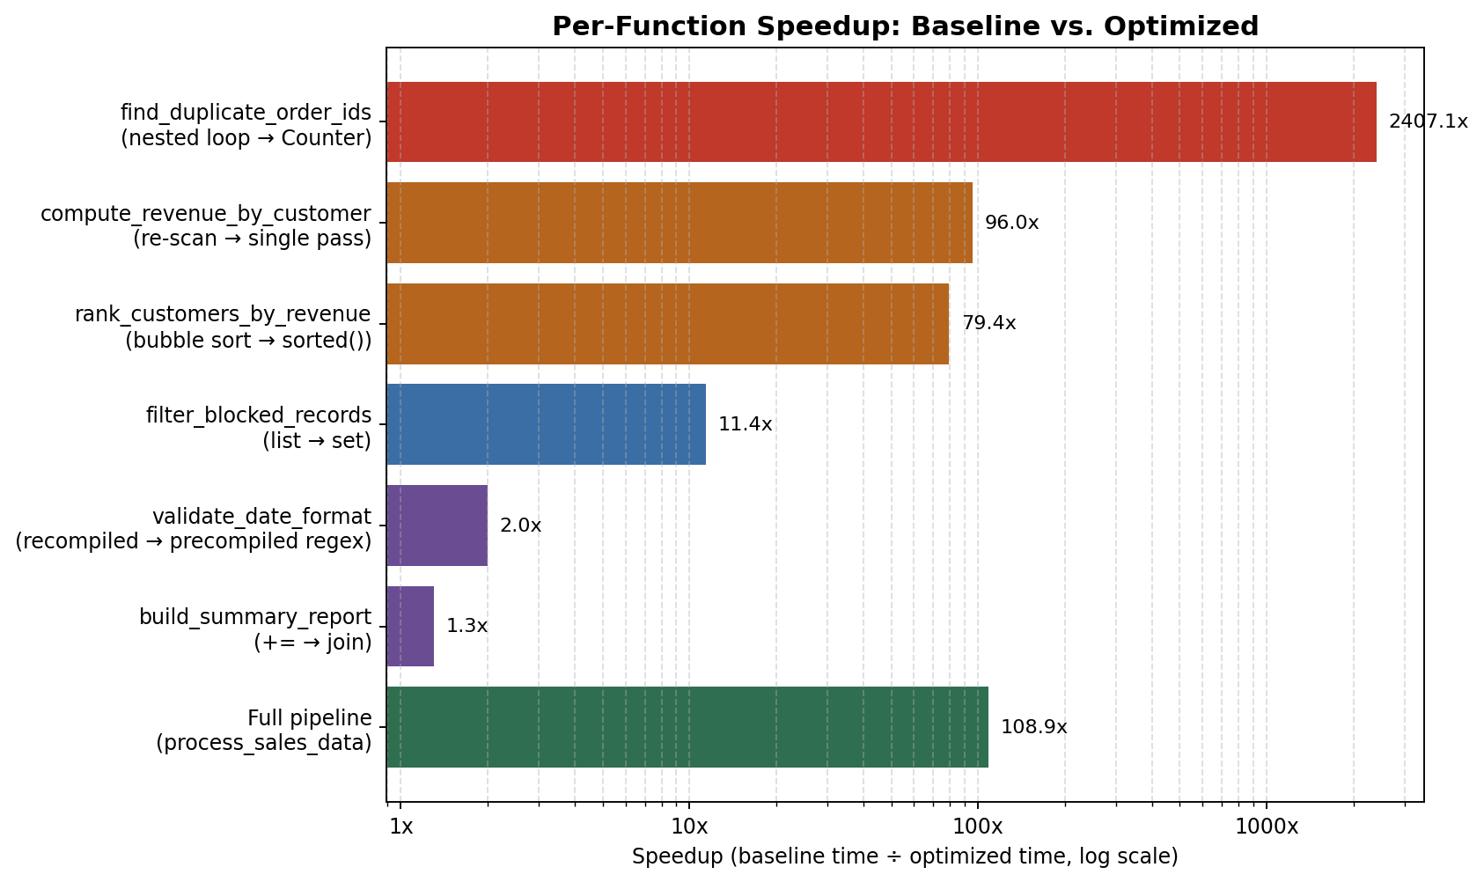
Note the full end-to-end speedup (108.9x) is lower than find_duplicate_order_ids() alone (2407.1x) because the pipeline includes unavoidable, unoptimized work (data generation) that dilutes the ratio — a reminder that a component-level speedup and the end-to-end speedup answer different questions, and a report should show both.

8. Correctness Verification
Every optimization was required to change how an answer is computed, never what the answer is. This was verified with a 15-test pytest suite (test_equivalence.py) rather than by eye:
- Full-pipeline equivalence: identical stats dict and byte-for-byte identical report string between baseline and optimized, checked at two different dataset sizes/seeds so the match isn't a coincidence of one specific input.
- Per-function equivalence: each of the six optimized functions checked against its baseline counterpart on shared input, including exact key-insertion-order equality for the revenue dictionary and exact tie-order equality for the ranking (both rely on Python dict/sort stability, confirmed rather than assumed).
- Standalone correctness checks: small, hand-verified inputs for duplicate detection, revenue aggregation, ranking, blocklist filtering, and date validation — independent of whether the two modules agree with each other, to guard against both modules sharing the same latent bug.
All 15 tests pass. The suite was additionally run in a brand-new virtual environment with only pytest installed, confirming no hidden dependency on the development environment.
============================== 15 passed in 0.85s ==============================

9. Summary
Six real bottlenecks were identified directly from cProfile evidence — never assumed — spanning all three optimization categories the task called for: algorithmic improvement (replacing two different O(n²) algorithms with O(n) and O(n log n) equivalents), data structure choice (list membership → set membership; repeated re-scanning → single-pass dict accumulation), and standard-library usage (a precompiled regex; str.join over string concatenation). The dominant bottleneck alone accounted for 94% of baseline runtime and a 2407x isolated speedup; fixing it first and re-profiling — rather than fixing everything at once — surfaced the next bottleneck with direct evidence instead of guesswork. The full pipeline is 108.9x faster end-to-end, and a 15-test equivalence suite confirms the optimized version is functionally identical to the original, not just faster.

