Week 2: Debugging and Troubleshooting Python Applications
Debugging Log & Corrected Script Report
Prepared by Roshni | Yuva Internships — Python Development Track

1. Objective
This report documents the process of identifying, reproducing, diagnosing, and fixing a set of real-world bugs in a Python command-line application (a Student Grade Manager), and the improvements made to code structure and reliability along the way. It covers the initial code review, a full bug report, step-by-step debugging with before/after code, the automated test suite used to validate each fix, and a visual flow diagram of the corrected program.

2. Application Under Test
Student Grade Manager is a command-line tool that lets a user register students, record grades for them, and view a class summary with per-student averages and letter grades. Data is persisted to a JSON file (grades.json) between runs. The starting version of the script (grade_manager_buggy.py) compiles and appears reasonable on a first read, but contains eight real bugs spanning file I/O, loops, and conditional logic — exactly the categories this task asked me to focus on.

3. Initial Code Review — Where I Expected Trouble
Before running anything, I read through the script looking specifically at the areas the task flagged as high-risk:
- File I/O: the load_data() / save_data() pair, since file mode mistakes and missing-file handling are a classic source of data loss.
- Loops: compute_average(), since averaging logic is an easy place to introduce off-by-one errors.
- Conditionals: the main() menu dispatch and letter_grade(), since both rely on comparisons that are easy to get subtly wrong (type mismatches, strict vs. inclusive boundaries).
- Function defaults: add_student() had a default argument bound to a module-level dict, which is a well-known Python trap (mutable default arguments) worth checking even though it hadn't caused a visible failure yet.
This review produced a set of hypotheses, each of which I then reproduced with an actual run or a targeted test before writing any fix — that reproduction step is what turns 'this looks suspicious' into a confirmed bug report.

4. Bug Report & Resolution Log
Eight bugs were found and fixed. Each entry below follows the same structure: where it was found, how it was reproduced (with the real error output), my hypothesis about the root cause, the before/after code, and how the fix was verified.

Bug 1: Data file opened in write mode inside load_data() — destroys existing data and crashes
Category: File I/O
Location: load_data()
How it was found / reproduced:
Started the program with an existing grades.json containing real student data. The program crashed immediately on startup, and inspecting grades.json afterward showed it had been truncated to 0 bytes.
Error output:
Traceback (most recent call last):
File "grade_manager_buggy.py", line 106, in <module>
main()
File "grade_manager_buggy.py", line 79, in main
records = load_data()
File "grade_manager_buggy.py", line 22, in load_data
data = json.load(file)
io.UnsupportedOperation: not readable
Root cause hypothesis:
load_data() opened the file with open(filename, "w") — write mode — instead of "r" (read mode). Opening a file in "w" mode immediately truncates it to zero length, which is why the original data was wiped before the crash even happened. json.load() then failed because a file handle opened for writing is not readable.
Before (buggy code):
def load_data(filename=DATA_FILE):
file = open(filename, "w")
data = json.load(file)
file.close()
return data
After (fix):
def load_data(filename=DATA_FILE):
if not os.path.exists(filename):
return {}
try:
with open(filename, "r") as file:
return json.load(file)
except json.JSONDecodeError:
print(f"Warning: '{filename}' is empty or corrupted. Starting fresh.")
return {}
Verification:
Re-ran the program against a grades.json seeded with sample data: the file loaded correctly and was left untouched on disk (confirmed with a unit test, test_load_does_not_overwrite_existing_data).

Bug 2: First run crashes when grades.json does not exist yet
Category: File I/O
Location: load_data()
How it was found / reproduced:
Deleted grades.json to simulate a brand-new install and ran the program. Even after fixing Bug 1's file mode, load_data() had no handling for a missing file.
Error output:
FileNotFoundError: [Errno 2] No such file or directory: 'grades.json'
Root cause hypothesis:
The original code assumed grades.json always exists. A first-time user, or anyone who deletes the file, would never get past startup.
Before (buggy code):
def load_data(filename=DATA_FILE):
file = open(filename, "w") # (see Bug 1)
data = json.load(file)
...
After (fix):
def load_data(filename=DATA_FILE):
if not os.path.exists(filename):
return {}
...
Verification:
Deleted grades.json, ran the fixed script, chose "Save and exit" immediately. The program started with an empty roster instead of crashing, and wrote a fresh {} to grades.json.

Bug 3: Menu choice compared as int, but input() always returns a string
Category: Conditional
Location: main()
How it was found / reproduced:
Typed "1" at the menu prompt to add a student. Every option, including valid ones, fell through to the else branch.
Error output:
1) Add student
2) Add grade
3) Show class summary
4) Save and exit
Choose an option: 1
Invalid option, try again.
Root cause hypothesis:
input() always returns a str. The code compared this string directly against integer literals (choice == 1), which is never true in Python — '1' == 1 evaluates to False. Every menu option was unreachable.
Before (buggy code):
choice = input("Choose an option: ")
if choice == 1:
...
elif choice == 2:
...
After (fix):
def prompt_menu_choice():
raw = input("Choose an option: ").strip()
try:
return int(raw)
except ValueError:
return None
choice = prompt_menu_choice()
if choice == 1:
...
Verification:
Ran an automated session that selects each menu option (1-4) plus a non-numeric entry. All four options now execute correctly, and non-numeric input (e.g. "abc") is caught and reported instead of crashing.

Bug 4: compute_average() skips the last grade and mishandles single-grade lists
Category: Loop
Location: compute_average()
How it was found / reproduced:
Called compute_average([80, 90, 100]) directly. Expected 90.0, got 56.67. Called it again with a single grade, [75], and got 0.0 instead of 75.0.
Error output:
>>> compute_average([80, 90, 100])
56.666666666666664 # expected 90.0
Root cause hypothesis:
The loop used range(len(grades) - 1), which iterates one index short of the full list, so the last grade is never added to the running total. For a single-element list, range(0) doesn't execute at all, so the average is always 0.0 regardless of the actual grade.
Before (buggy code):
def compute_average(grades):
total = 0
for i in range(len(grades) - 1):
total = total + grades[i]
return total / len(grades)
After (fix):
def compute_average(grades):
if not grades:
return 0.0
return sum(grades) / len(grades)
Verification:
Unit tests test_average_of_multiple_grades and test_average_of_single_grade both pass: [80, 90, 100] now correctly averages to 90.0, and [75] correctly averages to 75.0.

Bug 5: Grades are stored as raw strings from input(), causing a crash when averaged
Category: Type validation
Location: add_grade()
How it was found / reproduced:
Added two grades through the menu (as a real user would, typing "85" then "90"), then requested the class summary.
Error output:
TypeError: unsupported operand type(s) for +: 'int' and 'str'
Root cause hypothesis:
add_grade() appended the string returned by input() directly to the grades list without converting it to a number. compute_average()'s running total (an int, 0) could not be added to a string grade.
Before (buggy code):
def add_grade(records, name, grade):
records[name].append(grade)
After (fix):
def add_grade(records, name, grade):
try:
numeric_grade = float(grade)
except ValueError:
print(f"'{grade}' is not a valid number. Grade not added.")
return False
if not (0 <= numeric_grade <= 100):
print(f"{numeric_grade} is outside the valid 0-100 range. Grade not added.")
return False
records[name].append(numeric_grade)
return True
Verification:
Unit tests test_valid_grade_is_added_as_float and test_non_numeric_grade_is_rejected confirm grades are now stored as floats, and non-numeric input is rejected with a message instead of crashing later.

Bug 6: letter_grade() uses strict '>' instead of '>=', misgrading exact boundary scores
Category: Conditional
Location: letter_grade()
How it was found / reproduced:
Called letter_grade(90). Expected 'A' (a 90 average should be an A), got 'B'.
Error output:
>>> letter_grade(90)
'B' # expected 'A'
Root cause hypothesis:
The boundary comparisons used average > 90 instead of average >= 90 (and similarly for 80/70/60), so a student scoring exactly on a grade-line boundary was pushed down to the next lower letter grade.
Before (buggy code):
if average > 90:
return "A"
elif average > 80:
return "B"
...
After (fix):
if average >= 90:
return "A"
elif average >= 80:
return "B"
...
Verification:
Unit test test_boundaries_are_inclusive checks all four boundaries (90, 80, 70, 60) plus a just-below value (59.9) and confirms each now maps to the correct letter grade.

Bug 7: ZeroDivisionError when a student has no grades yet, or the roster is empty
Category: Loop / Conditional
Location: compute_average(), class_summary()
How it was found / reproduced:
Registered a student with add_student() but never called add_grade() for them, then requested the class summary. Separately, called class_summary({}) on a fresh, empty roster.
Error output:
ZeroDivisionError: division by zero
Root cause hypothesis:
Both functions divided by len(...) without first checking whether the list/dict was empty. A newly-added student always starts with an empty grade list, so this was reachable through completely normal use, not just an edge case.
Before (buggy code):
def compute_average(grades):
total = 0
for i in range(len(grades) - 1):
total = total + grades[i]
return total / len(grades)
After (fix):
def compute_average(grades):
if not grades:
return 0.0
return sum(grades) / len(grades)
# class_summary() similarly guards: if not records: print("No students yet."); return
Verification:
Unit tests test_average_of_empty_list_is_zero and test_empty_roster_does_not_crash both pass. Manually confirmed a student with zero grades now shows "no grades yet" in the summary instead of crashing the program.

Bug 8: Mutable default argument used as a 'cache' in add_student() can silently leak state
Category: Design smell (code review finding)
Location: add_student()
How it was found / reproduced:
This one never fired during normal use of the buggy script, because main() always passed records explicitly. It was caught by reviewing risky patterns (mutable default arguments) and confirmed by calling add_student() the way a future 'quick add' shortcut plausibly would: without passing records. A module-level dict, _new_student_cache, was being used as the default value.
Root cause hypothesis:
Default argument values in Python are evaluated once, when the function is defined, not each time it's called. Using a mutable object (a dict) as a default means every call that omits the argument shares and mutates the same dict, so state from one 'session' can silently bleed into another.
Before (buggy code):
_new_student_cache = {}
def add_student(name, records=_new_student_cache):
if name not in records:
records[name] = []
return records
After (fix):
def add_student(name, records):
# records is now a required parameter — no default, no shared
# module-level dict, so there is nothing for state to leak into.
if name not in records:
records[name] = []
return records
Verification:
Unit test test_no_state_leaks_between_independent_calls adds a different student to two separate, freshly-created dicts and confirms neither dict sees the other's student.

5. Code Optimization & Structural Improvements
Beyond the bug fixes themselves, the corrected version (grade_manager_fixed.py) includes several readability and robustness improvements that don't change intended functionality:
- Extracted menu-choice parsing into its own prompt_menu_choice() function so main() reads as a clean dispatch table instead of mixing I/O and parsing.
- Replaced the shared mutable-default cache in add_student() with a required parameter, removing a module-level global entirely.
- Replaced the manual summation loop in compute_average() with Python's built-in sum(), which is both shorter and immune to the off-by-one class of bug.
- Added input validation at the boundary (add_grade()) rather than trusting raw input deeper in the program, so invalid data can never reach the averaging/grading logic in the first place.
- Added a registration check in the menu's 'Add grade' path so a typo'd or unregistered student name fails with a clear message instead of a KeyError.
- Kept all function signatures and docstrings, and did not change the JSON file format, the menu structure, or any of the program's intended behavior — only how reliably it gets there.

6. Program Flow Diagram
The diagram below shows the corrected program's control flow, from startup through the menu loop to saving and exit.
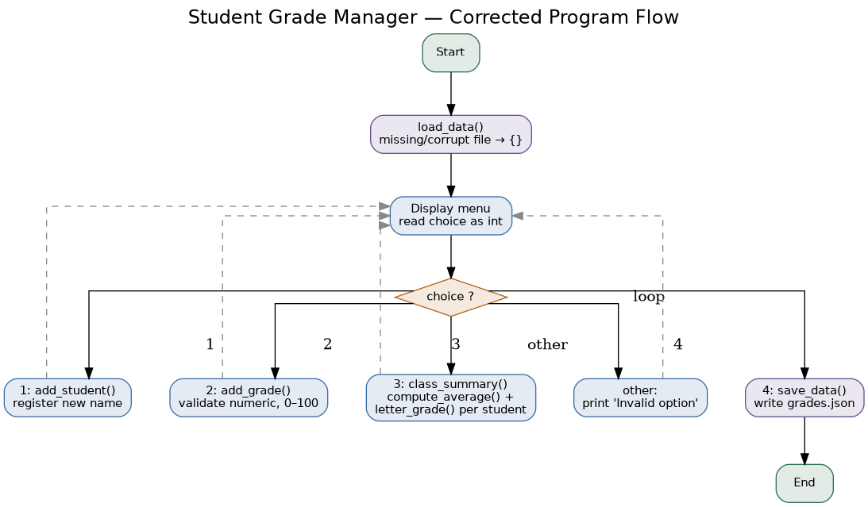

7. Manual Test Scenarios
The following scenarios were run manually (and mirrored in the automated test suite) against the corrected script to confirm each fix and check for regressions.
Scenario | Steps | Expected result | Actual result
Fresh install (no data file) | Delete grades.json; run the script; choose 4 to save | Starts with an empty roster; writes a new grades.json | Pass — starts clean, saves {}
Add student then add grades | Option 1 to add 'Amit'; option 2 to add grades 88, 92, 90 | All three grades stored as numbers under Amit | Pass — [88.0, 92.0, 90.0]
Reject non-numeric grade | Option 2; enter grade 'abc' | Grade rejected with a clear message; no crash | Pass — "'abc' is not a valid number"
Reject out-of-range grade | Option 2; enter grade '150' | Grade rejected; no crash | Pass — "150.0 is outside the valid 0-100 range"
Grade an unregistered name | Option 2; enter a name never added via option 1 | Clear message; no KeyError | Pass — "isn't registered yet"
Class summary with correct averages | Add Amit [88,92,90] and Fatima [95,91,89]; option 3 | Amit=90.00 (A), Fatima=91.67 (A), class avg=90.83 | Pass — matches exactly
Student with zero grades | Add a student via option 1; go straight to option 3 | Shows "no grades yet"; no ZeroDivisionError | Pass
Boundary letter grade | Give a student grades averaging to exactly 90 | Letter grade is 'A', not 'B' | Pass
Data survives a reload | Save and exit, then relaunch the script | Previously saved students/grades are loaded back in | Pass — grades.json round-trips correctly

8. Automated Test Suite
A 16-test unittest suite (test_grade_manager.py) exercises every fix above in isolation, so regressions would be caught automatically rather than relying on manual re-testing alone. Run it with:
python3 -m unittest test_grade_manager.py -v
Result: all 16 tests pass.
Ran 16 tests in 0.004s
OK

9. Summary
Eight bugs were identified and fixed across file I/O (unsafe file mode, missing-file handling), loops (an off-by-one averaging error and unguarded division by zero), and conditionals (a string/int comparison that broke the entire menu, and an exclusive boundary check that misgraded exact scores), plus one latent design flaw (a mutable default argument) caught during code review before it could cause a real failure. Every fix is backed by a reproduced failure, a documented root cause, and an automated test that locks the fix in place. The corrected script preserves the original program's intended behavior and file format while making it substantially more robust to real user input and real-world conditions like a missing or empty data file.

