Name: Roshan Sundar

GitHub Username: rmsundar

Purdue Username: 0032402630

Instructor: Ghasemi

**Problem1_writeup.**

**(1) Estimated Functions:**

y1(x) = 29.0587x+ 92.7676

y2(x) = -2.1111x2 + 28.5066x + 112.3148

y3(x) = 1.7574x3 - 1.4324x2 - 0.3307x + 101.8661

y4(x) = -0.0152x4 + 1.7541x3 - 1.0821x2 - 0.2558x + 100.9145

y5(x) = -0.0004x5 - 0.0154x4 + 1.7668x3 - 1.0743x2 - 0.3227x + 100.8874

**(2) Data Visualization:**

**(3) What degree polynomial does the relationship seem to follow? Please explain your answer.**

Sample answer:

The data seems to match d = 3, 4, 5. In following Occam’s Razor, the simplest model that matches should be chosen. d=3, or y3(x), is the model that matches this criterion.

**(4) If we measured a new data point, $x=3,$ what would be the predicted value of $y$, based on the polynomial identified as the best fit in Question (3)?**

y3(x) = 135.4328

**Problem2_writeup.**

**(1) Plot the mean squared error as a function of lambda in Ridge Regression:**

*(Insert plot obtained by completing the* ***main*** *function)*

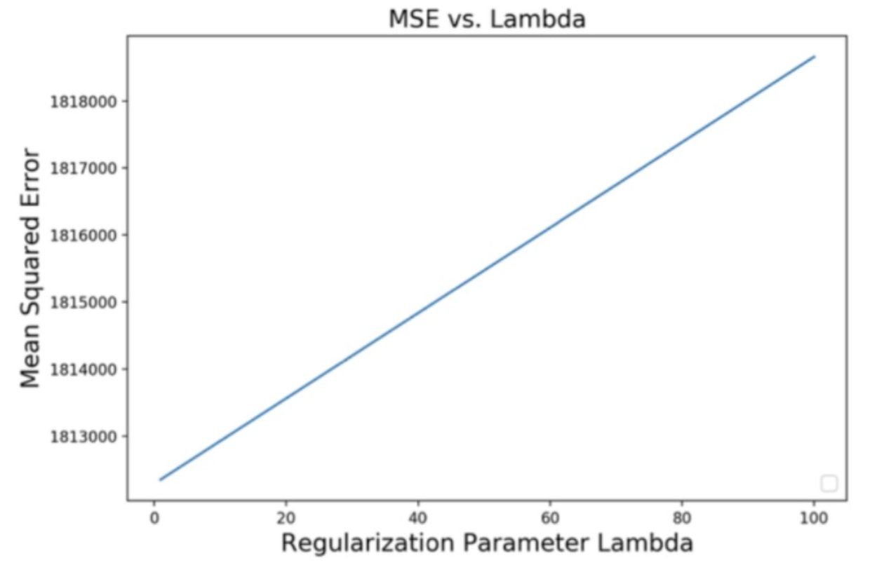

**(2) Find best lambda:**

Sample answer:

Based on the range of Lambda values tested, the best lambda value is $c$, which yields an MSE of $d$ as shown on the plot above.

**(3) Find equation of the best fitted model:**

(*Insert numerical values for ’s and )*

**(4) Draw a prediction plot using Google data**

*(Note that the plot below is not the solution)*

