S.No. | Description | Page No.
1. | Title of the project | 6-7
1.1 | Introduction
2. | Objective | 7
3. | Hardware and software requirement specification | 8
4. | System analysis | 8
4.1 | Identification of need | 9-10
4.2 | Feasibility study | 10
4.3 | Project Planning | 10-
4.3.1 | Gantt chart/Pert chart | 10
4.4 | SE model used(web e model) | 12-15
4.5 | DFD / Use case diag | 15-22
5 | System Design | 23
5.1 | Modules detail | 24
5.2 | Process logic of each module | 27
5.3 | Database design | 28-32
5.3.1 | Data integrity and constraints
5.3.2 | ERD
5.3.3 | Data Tables
6 | Coding
6.1 | Comments and description
6.2 | Error handling
7. | Testing
7.1 | Testing technique used
7.2 | Test cases design
8. | Security measures
9. | Cost estimation of the project
10. | Reports (Sample screen)
11. | Future scope and further enhancement
12. | Conclusion
13. | Bibliography
14. | Appendices (if any) | 33

1. TITLE OF THE PROJECT:

Project Management System

1

2. INTRODUCTION AND OBJECTIVES OF THE PROJECT
INTRODUCTION
2.1About the Project:

Project management System has a capacity to help plan, organize, and manage resource pools and develop resource estimates. Depending the sophistication of the software, resource including estimation and planning, scheduling, cost control and budget management, resource allocation, collaboration software, communication, decision-making, quality management and documentation or administration systems. Today, numerous PC-based project management software packages exist, and they are finding their way into almost every type of business. In the early days, however, project management software ran on big mainframe computers and was used only in the large projects. These early system were limited in their capabilities and, by today's standards, were hard to use.

2.2. Objectives:
In a company where the hierarchy of employees spans over thousand managing the work with them is a difficult job. And in an environment where number of jobs is done simultaneously picking the right person for the job is also difficult task, as you are not aware of their availability. This application is designed for such an environment where the work is divided into group of employees and during the course of division the employees are selected to be part of the work in hand.
This software being a web based is easily accessible from any corner of the company as every machine is part of a LAN network. The reason why it is made as a web application rather than a window based application if for the same reason. The complete task is divided into two types of users. Administrator (Highest authority), Manager (working group Community). The activities underlying these sections are as per the company policies.
This application provides most of the features required to manage the tasks developed in a firm.

2.3. Understanding of existing system:
- The current system is a manual one where in the company maintains all the information in the form of records. There by collecting necessary information with require a manual search in the record(s).
- Transfer of information between different sections of the enterprise is in the form of documents or letters. Drafting letters will take time.
- Selection of a person for a task is done by manually approaching the person and confirming the availability of the person.
- Unavailability of proper information to different levels of employees with in the firm.

3

3. PROJECT CATEGORY:-
Internet with RDBMS
RDBMS (Relational Database Management System) is a type of database management system that stores data in the form of related tables. Relational Databases are powerful because they require few assumptions about how data is related or how it will be extracted from the database. As a result, the same database can be viewed in many different ways.

4
4. TOOLS/PLATFORM USED:-
HARWARE AND SOFTWARE REQUIRMENT SPECIFICATION
Hardware and the software plays a major role in the development cycle of any system, right from the planning phase to the end of the development process and then in the implementation of the system. The Hardware and the software requirements are the key factors during the feasibility of the candidate system.
4.1. Software requirements:

Sno. | Name | Description
1 | OS | Windows XP, Windows 7
2 | Web Server | Apache Tomcat 6.0.35
3 | Front End | JSP, Servlet
4 | Front End Editor | MyEclipse8.5
5 | Back End | MySQL 5.5
6 | For Documentation | MS Office 2007

4.2. Hardware requirements:

Sno. | Name | Version
1 | Processor | Dual Core
2 | RAM | 512MB
3 | HDD | 15GB

5
5. REQUIREMENT ANALYSIS:
5.1. FEASIBILITY STUDY
This part or aspect of systems analysis that concentrates on finding out whether an intended course of action violates any constraints is referred to as FEASIBILITY analysis .All the projects are feasible – given unlimited resources and infinite time! Unfortunately, the development of a computer –based system or product is more likely beleaguered by scarcity of evaluate the feasibility of a project at the earliest possible time of project inception.
Technical Feasibility-
Internet is available all through the world these days. The hardware required is not a costly affair. Every student who wants to study on the website may use his/her personal computers or tablets etc. to access the website.
Economical Feasibility-
The project is not a costly product for the customer, as the database used in the product is MySQL which is open source.only one or two technical personnels are required to host the website. The administrator himself can upload the files(study material) which does not requires extra training.
The JSP is used to design the front end of the product which does not requires any license.
Operational Feasibility-
The website would have a good GUI so no training would be required to access the product. The student registering for study and certification should only know English language, basic knowledge of computer and knowledge of internet browsing and surfing.

6
5.2 PROJECT PLANNING AND SCHEDULING:
GANTT CHART
Task No. | Task | Jul-Aug | Aug-Oct | Oct-Jan | Jan-Feb | Feb-Mar | Mar-Apr | Apr-May
1 | Requirement Analysis
2 | Design
3 | Coding
4 | Testing
5 | Documentation
6 | Implementation
7 | Final Review

7

5.2.1 DATA FLOW DIAGRAM (DFD)

Level 0 Diagram:
0.0

Techno Task Manager
Employee
Managed Task

First Level DFD FOR ADMIN:

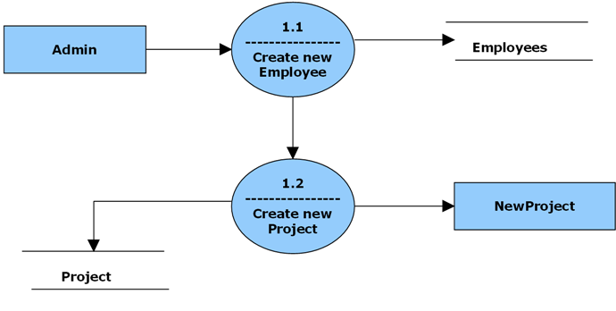

First Level DFD FOR EMPLOYEE:

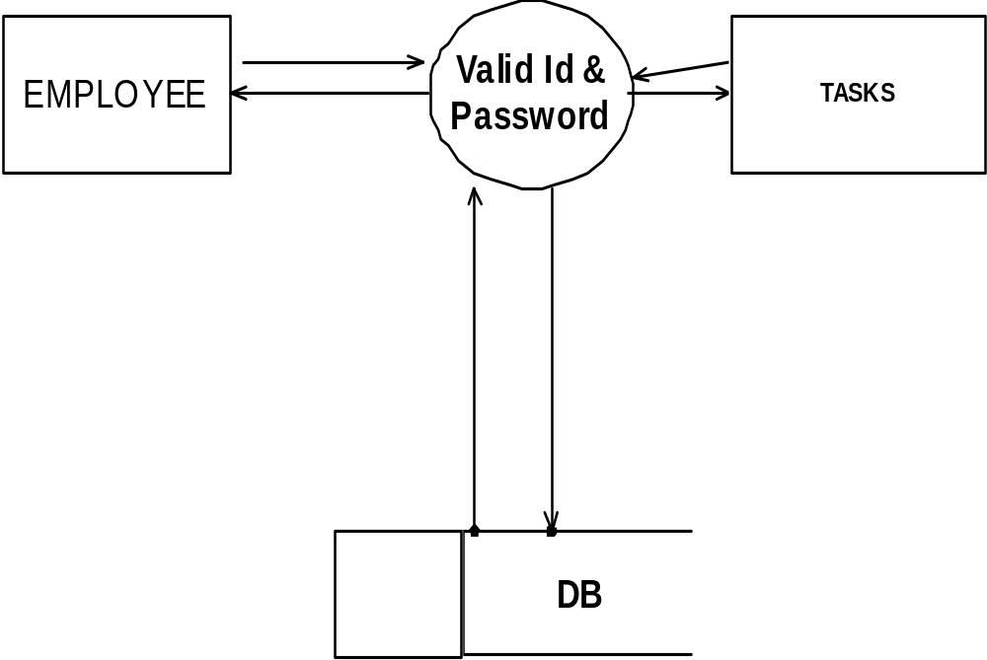

level 2 Diagram for Admim:
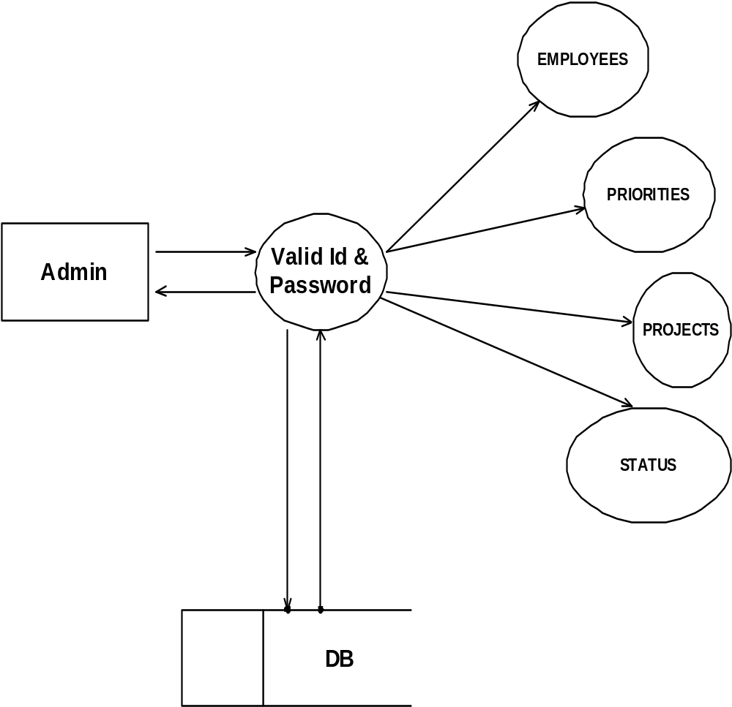

Level 2 Diagram for Employee:

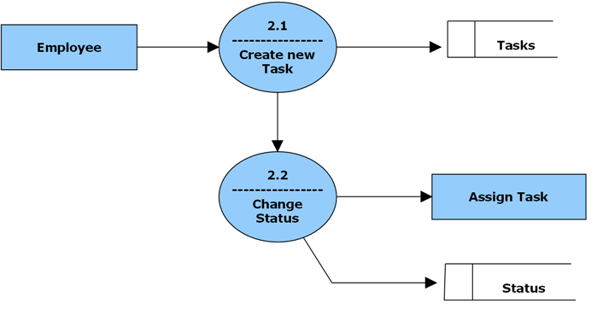
8

5.2.3. ERD

ER DIAGRAM
Employee
DETAILS

HAS
ADMIN

employee_id (PK)
employee_name
login
pass
email
security_level
Admin ID (FK)

Admin ID (PK)
User Name
Password

PROJECTS
HAS
ADMIN

Admin ID (PK)
User Name
Password

project_id (PK)
project_name
Admin ID (FK)

PRIORITIES
HAS
ADMIN

Admin ID (PK)
User Name
Password

priority_id (PK)
priority_desc
Admin ID (FK)

STATUS
HAS
ADMIN

Admin ID (PK)
User Name
Password

status_id (PK)

Status

Admin ID (FK)

HAS
EMPLOYEE

TASKS
task_id (PK)

task_name

task_desc

resolution

date_assigned

date_resolved

employee_id (PK)

employee_id (PK)
employee_name
login
pass
email
security_level

TASKS
HAS
PROJECTS
task_id (PK)

task_name

task_desc

resolution

date_assigned

date_resolved

project_id (FK)

project_id (PK)
project_name

HAS
PRIORITIES
TASKS
task_id (PK)

task_name

task_desc

resolution

date_assigned

date_resolved

priority_id (FK)

priority_id (PK)
priority_desc

TASKS
HAS
STATUS
task_id (PK)

task_name

task_desc

resolution

date_assigned

date_resolved

status_id (PK)

status_id (PK)

Status

6. SCOPE OF THE SOLUTION:

PMS can be helpful in using it as a proper way to leverage quality of education as it breaks the barriers in terms of geography, time, quality and competent.
It gives the users a great bit of independence and freedom to follow a routine that is of convenience and in accord with his time available. There are no strict routines to be followed, no commuting problems, learning time at your discretion and the best part is that you have the access to courses irrespective of the location and to unlimited related content.

Helps in developing knowledge of Internet: PMS helps in developing knowledge of the Internet. The concept of E-learning also encourages students to take personal responsibility for their own learning. When the learners succeed, it builds self-confidence and self-knowledge.

Flexibility: Another benefit of PMS is flexibility. The greatest advantage of PMS is that it has the advantage of taking class anytime anywhere.

Cost-effective: E-learning is most cost-effective than traditional learning as less time and money is spent travelling. This type of learning is less costly than doing learning at a traditional institute.

11
7. COMPLETE STRUCTURE

7.1. Module Description
ADMINSTRATOR:
In these Administrator means the person who is managing the entire website.
FUNCTIONALITIES:
- Association between Admin and Employees
- Association between Admin and Projects
- Association between Admin and Priorities
- Association between Admin and Status

EMPLOYEE MODULE:
Description: Provides different tasks as well as the employees associated with the work. Provides instant status of the involvements of a person in the task Security to the confidential information
FUNCTIONALITIES:
- Association between Employees and Tasks
- Association between Employees and Status
APPLICATION MODULE
FUNCTIONALITIES:
- Association between Employees and Projects
- Association between Admin and Projects

TASKS MODULE:
Each Employee will be assigned different tasks like Designing, coding, testing and database etc. At the end of the Week or month the administrator will see the status of the respective employees and there completed work.
FUNCTIONALITIES:
- Association between Employees and tasks
- Association between Admin tasks
12
7.2. Data Structure

EMPLOYEES:
SNO | ColumnName | DataType(Size) | Constraints(Key) | ReferenceS  FROM
1 | employee_id | int | Primary key
2 | employee_name | varchar(50) | Null
3 | login | varchar(15) | Null
4 | pass | varchar(15) | Null
5 | email | varchar(50) | Null
6 | security_level | int | Null

PRIORITIES:
SNO | ColumnName | DataType(Size) | Constraints(Key) | ReferenceS  FROM
1 | priority_id | int | Primary key
2 | priority_desc | varchar(15) | Null

PROJECTS:
SNO | ColumnName | DataType(Size) | Constraints(Key) | ReferenceS  FROM
1 | project_id | int | Primary key
2 | project_name | varchar(50) | Null
3 | employee_id | int | Null

STATUSES:
SNO | ColumnName | DataType(Size) | Constraints(Key) | ReferenceS  FROM
1 | status_id | int | Primary key
2 | Status | varchar(15) | Null

TASK:
SNO | ColumnName | DataType(Size) | Constraints(Key) | ReferenceS  FROM
1 | task_id | int | Primary key
2 | project_id | varchar(15) | ForiegnKey | Projects
3 | priority_id | int | ForiegnKey | Priorities
4 | status_id | int | ForiegnKey | Status
5 | task_name | varchar(15) | Null
6 | task_desc | text | Null
7 | resolution | text | Null
8 | assigned_by | int | ForiegnKey | Employees
9 | assigned_to | int | ForiegnKey | Employees
10 | date_assigned | datetime | Null
11 | date_resolved | datetime | Null

EMP:
SNO | ColumnName | DataType(Size) | Constraints(Key) | ReferenceS  FROM
1 | name | varchar(50) | Null

14
7.3 PROCESS LOGIC OF EACH MODULE:
REGISTER:
INPUT: student detail, test date, verification of student by administrator.
process:
- take the input information from student.
- store the information of student in temp table.
- verify the student.
- store the verified student information in student database.
OUTPUT: information of student is stored in database.
study:
input: student information, content information, course information.
process:
- Student selects course and content for study.
OUTPUT:study course information and student information to test process and
Test date information, student information, course information and content information to student.
ADMIN:
INPUT:test detail, couse detail & content detail from administrator.
PROCESS:
- Stores test information in database.

OUTPUT:test detail to test, course information and content information to study process.
TEST:
INPUT:study course information & student information from study process, test date information from registration process and test information from admin process.
PROCESS:
- Conducts test process and process result. 15
OUTPUT:test information, student information course information content information and result information to administrator and result information to student.

7.4 LIST REPORT THAT ARE LIKLELY TO BE GENERATED:
- STUDENT INFORMATION TABLE:
This table consists of the information of the registered student at the website.
- RESULT:
This table consists of the information of the student status of pass or fail in exam.

16
8. IMPLEMENTATION OF SECURITY MEASURES AT
VARIOUS LEVELS
The three components of information security are as follows:
- Confidentiality: Preventing unauthorized disclosure and use of information.
- Integrity: Preventing unauthorized creation, modification or deletion of information
- Availability: Preventing unauthorized delay or denial of information.
Security is very much required to prevent unauthorized access and malicious practices. In the software, there are two levels of security. The 1st level of security, which is provided by the FRONT END and 2nd level of security provided by the BACK END(database).
FRONT END SECURITY:
Primary goal of authentication is to allow access to legitimate system users and to delay to authorized parties. User name and password is a simple form of user authentication.
BACK END SECURITY:
In the particular software our back end used is MySQL. So all the inbuilt security aspects provided by the MySQL database is used as it is. It will provide the strong feature of security so that it will be difficult to change, modify any personal data.

17
9.FUTURE SCOPE AND FURTHER ENHANCEMENT OF THE PROJECT:
- Further enhancements to this project will be to create a module for video upload and download.

- Another enhancement would be allow video conferencing.

- We will use payment gateway for online transaction.

- Other enhancement would be to allow multiple choice questions and subjective questions. This would allow many varieties of questions to be added. The tutorials can be made available in flash format and other animated formats.

18
10. CONCLUSION:
We have successfully designed a project on PMS. This project is designed for “PMS”. This project is designed in JSP (Java Server Pages) which runs on Apache Tomcat Web Server.
Keeping in view these facts we will develop successfully. Developing the project will help us some experience on website development. 19

