RETIAL SALES DATA PROCESSING AND
BUSINESS INSIGHTS GENERATIONS

1.Project Overview
Retail Data Engineering Pipeline using Azure Data Factory, Azure Data Lake Storage, Azure Databricks, Azure SQL Database, and Power BI for ABC Retail Solutions
Objective :
ABC Retail Solutions, a multinational retail company, operates across multiple cities through both online and offline sales channels.
To improve reporting accuracy and operational efficiency, ABC Retail Solutions aims to build an end-to-end data engineering pipeline that ingests, cleans, transforms, and visualizes retail transaction data for business intelligence and reporting purposes.

2.Architecure Diagram

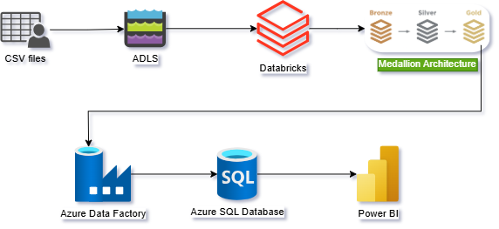

3.Data Flow Diagram

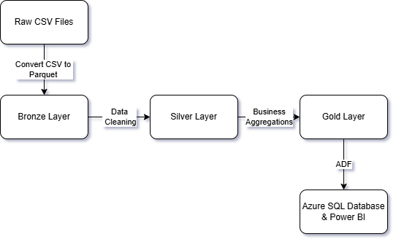

4.Data Model
4.1 Overview
The Gold layer consists of curated analytical tables derived from cleaned Silver data. These tables were designed to support reporting and dashboard creation in Power BI.
The model contains:
- Transaction-level fact data
- Customer analytics tables
- Product performance tables
- Revenue analysis tables
- Time-based sales metrics
The table gold_transactions_sql acts as the central fact table and is connected to multiple aggregated analytical tables

4.2 ER Diagram

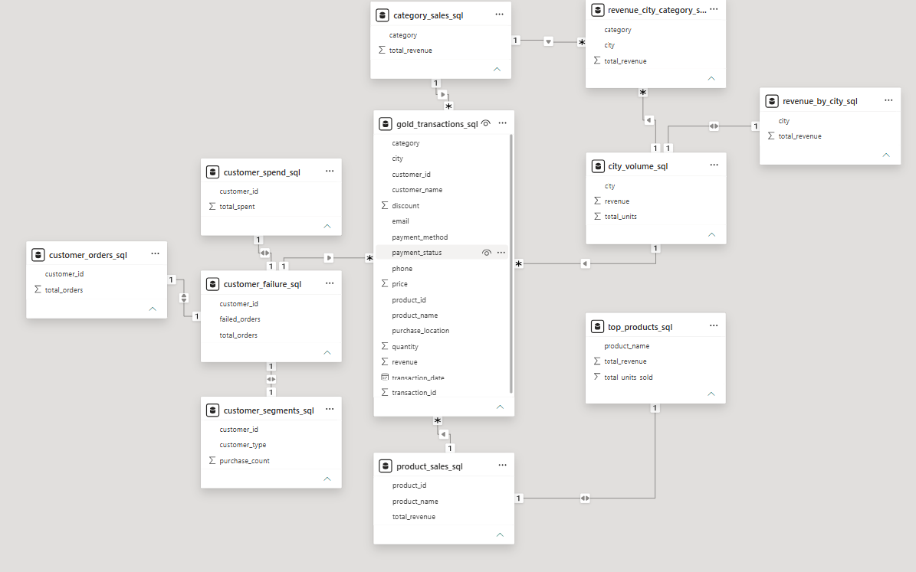

4.3 Core Fact Table
gold_transactions_sql
This table contains cleaned transactional records and serves as the primary source for analytical reporting.
Column
customer_id
customer_name
city
category
payment_method
payment_status
discount
email
Phone
Price
Product_id
Purpose:
- Transaction-level analysis
- Customer behavior analysis
- Product category analysis
- Revenue analysis

4.3 Customer Analytics Tables
customer_orders_sql
Contains total orders placed by each customer.
Metric
total_orders
Business Use:
- Identify frequent customers
- Customer activity analysis

customer_spend_sql
Contains total spending by each customer.
Metric
total_spent
Business Use:
- Customer value analysis
- High-value customer identification

customer_failure_sql
Contains failed order statistics.
Metric
failed_orders
total_orders
Business Use:
- Order failure monitoring
- Customer experience analysis

customer_segments_sql
Contains customer segmentation information.
Metric
customer_type
purchase_count
Business Use:
- Customer classification
- Loyalty analysis

4.4 Product Analytics Tables
product_sales_sql
Contains revenue generated by products.
Metric
total_revenue
Business Use:
- Product performance analysis
- Revenue contribution tracking

top_products_sql
Contains top-performing products.
Metric
total_revenue
total_units_sold
Business Use:
- Best-selling product analysis
- Inventory planning support

4.5 Revenue Analytics Tables
category_sales_sql
Contains revenue aggregated by product category.
Metric
total_revenue
Business Use:
- Category performance analysis

revenue_by_city_sql
Contains revenue generated by city.
Metric
total_revenue
Business Use:
- Geographic revenue analysis

revenue_city_category_sql
Contains revenue aggregated by both city and category.
Metric
total_revenue
Business Use:
- Regional category performance analysis

city_volume_sql
Contains sales volume and revenue metrics by city.
Metric
revenue
total_units
Business Use:
- Regional demand analysis
- Market performance evaluation

4.6 Time-Based Metrics
daily_sales_sql
Contains daily revenue information.
Metric
daily_revenue
transaction_date
Business Use:
- Daily sales trend analysis
- Time-series reporting

average_order_value_sql
Contains average order value KPI.
Metric
avg_order_value
Business Use:
- Customer spending behavior analysis
- Revenue efficiency monitoring

4.7 Star Schema
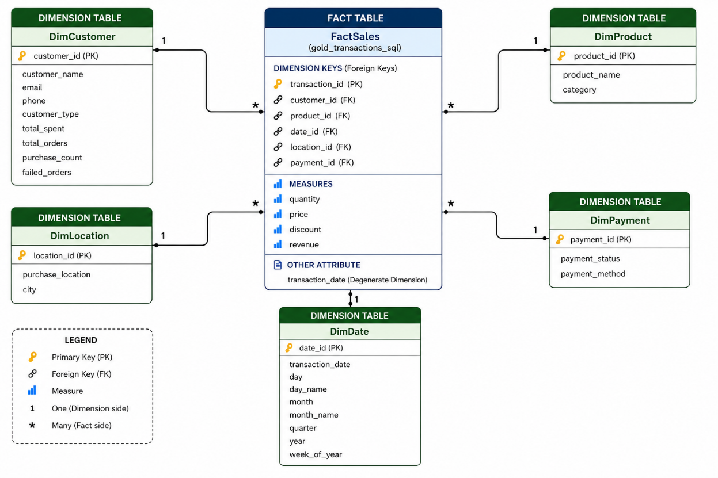
5. Assumptions Made
The following assumptions were made during the design and implementation of the data engineering solution:
- The retail transaction datasets represents sales data collected from multiple operational systems and is assumed to be the primary source of truth for business reporting.
- Transaction records with duplicate transaction identifiers were mostly for transactions which where failed at first, so those duplicate records where not removed.
- Records containing critical missing values required for business analysis where obtained from the product_details dataset.
- Product names and categorical fields were standardized to ensure consistency across all analytical datasets with the help of the product_datasets table.
- Transaction quantities and sales amounts were assumed to be valid only when greater than zero. Records containing invalid values were removed from the transaction dataset considering transactions with such quantities or the sales amounts is not going to happen.
- Date fields contained mixed date formats. The DD-MM-YYYY format was assumed as the standard business date format throughout the project.
- For date values where the format could be clearly identified as MM-DD-YYYY (for example, when the second component exceeded 12), the date was converted to the standard DD-MM-YYYY format before processing.
- Ambiguous date values where both day and month components were less than or equal to 12 were assumed to follow the DD-MM-YYYY format.
- Here a medallion architecture which include bronze, silver and gold layers for data transformations is used.
- The Bronze layer stores raw ingested data with minimal modifications which include converting the csv file to parquet format which is way easier to be processed compared to csv file.
- The Silver layer contains cleansed and standardized data.
- Gold layer tables were designed as reporting-oriented analytical datasets optimized for Power BI dashboard consumption.
- Azure SQL Database was used as the storage layer for analytical reporting purposes, while Azure Data Lake Storage remained the primary storage layer for processed data.
- Customer, product, category, and city identifiers were assumed to be unique and suitable for establishing analytical relationships within the reporting model.
- All monetary values are assumed to be represented in a single currency and no currency conversion logic was required.
- The generated business metrics, including revenue, customer spending, average order value, product performance, and sales trends, are assumed to accurately represent the underlying transactional data after cleansing and transformation.

6. Data Cleaning Strategy
The retail transaction dataset contained several data quality issues that could impact reporting accuracy and business decision-making. A structured data cleansing process was implemented in the Silver layer to improve data consistency, reliability, and usability.
6.1 Duplicate Record Handling
Duplicate transaction records with same transaction_id were identified and kept based on the understanding that they were duplicated because those transactions were failed at first.
Action Taken:
- Removed duplicate records from the dataset apart from considering duplicates occurred due to transaction failure
6.2 Missing Value Treatment
The dataset contained missing values in several columns.
Action Taken:
- Critical records with missing values where recovered from the product_details dataset.
6.3 Standardization of Text Fields
Categorical attributes such as product names, categories, payment methods, and customer-related fields contained inconsistencies in formatting.
Action Taken:
- Standardized text values to ensure consistency.
- Removed leading and trailing spaces.
- Applied uniform naming conventions across analytical datasets.
6.4 Date Format Standardization
The source data contained multiple date formats, including both DD-MM-YYYY and MM-DD-YYYY representations.
Action Taken:
- Established DD-MM-YYYY as the standard date format.
- Identified records that clearly followed MM-DD-YYYY format and converted them to the standard format.
- Converted the standardized date field to Date data type for accurate time-based analysis.
- Invalid dates were excluded from downstream processing.
6.5 Validation of Numeric Fields
Business-critical numerical columns were checked for invalid values.
Action Taken:
- Removed or filtered records containing invalid quantities or revenue values.
- Ensured quantity and revenue measures were suitable for aggregation and reporting.
6.7 Data Quality Verification
After cleansing operations were completed, validation checks were performed to verify data integrity.
Validation Checks Included:
- Duplicate record count verification.
- Null value assessment.
- Date conversion validation.
- Data type verification.
- Aggregate metric reconciliation.
6.8 Cleansing Outcome
The data cleaning process produced a standardized and reliable Silver layer dataset suitable for business transformation and analytical processing. The cleansed data was subsequently used to generate Gold layer datasets, which served as the foundation for Azure SQL reporting tables and Power BI dashboards.

7. Transformation Logic
Following data cleansing and standardization in the Silver layer, business transformations were performed to generate analytical datasets in the Gold layer. These transformations were designed to support reporting, business intelligence, and decision-making through Power BI dashboards.
7.1 Customer Order Analysis
Output Table: customer_orders
The dataset was grouped by customer identifier to calculate the total number of orders placed by each customer.
Transformation Logic:
- Group transactions by customer.
- Count the number of transactions per customer.
- Generate customer order metrics.
Business Purpose:
- Identify active customers.
- Measure customer engagement.

7.2 Customer Spending Analysis
Output Table: customer_spend
Customer-level spending metrics were calculated by aggregating revenue across all transactions.
Transformation Logic:
- Group transactions by customer.
- Sum transaction revenue.
- Calculate total spending per customer.
Business Purpose:
- Identify high-value customers.
- Support customer segmentation analysis.

7.3 Customer Failure Analysis
Output Table: customer_failure
Failed transaction records were analyzed to determine customer-level failure rates.
Transformation Logic:
- Filter failed transactions.
- Count failed orders by customer.
- Calculate total orders and failed orders.
Business Purpose:
- Monitor transaction reliability.
- Identify customers affected by order failures.

7.4 Customer Segmentation
Output Table: customer_segments
Customers were categorized based on purchasing behavior.
Transformation Logic:
- Calculate purchase frequency for each customer.
- Apply segmentation rules based on purchase count.
- Assign customer categories.
Business Purpose:
- Customer profiling.
- Loyalty and retention analysis.

7.5 Product Revenue Analysis
Output Table: product_sales
Product-level revenue metrics were generated.
Transformation Logic:
- Group transactions by product.
- Sum total revenue generated by each product.
Business Purpose:
- Evaluate product performance.
- Identify revenue-generating products.

7.6 Top Product Identification
Output Table: top_products
Best-performing products were identified using sales and quantity metrics.
Transformation Logic:
- Aggregate revenue and units sold by product.
- Rank products by performance.
- Select top-performing products.
Business Purpose:
- Product performance monitoring.
- Inventory and marketing decisions.

7.7 Category Revenue Analysis
Output Table: category_sales
Revenue was aggregated at the product category level.
Transformation Logic:
- Group transactions by category.
- Calculate total revenue for each category.
Business Purpose:
- Category performance evaluation.
- Product portfolio analysis.

7.8 Revenue by City Analysis
Output Table: revenue_by_city
Geographic revenue metrics were generated.
Transformation Logic:
- Group transactions by city.
- Aggregate total revenue.
Business Purpose:
- Regional sales analysis.
- Market performance evaluation.

7.9 City Volume Analysis
Output Table: city_volume
Sales volume and revenue metrics were generated for each city.
Transformation Logic:
- Group transactions by city.
- Calculate total revenue.
- Calculate total units sold.
Business Purpose:
- Demand analysis.
- Regional market assessment.

7.10 Revenue by City and Category
Output Table: revenue_city_category
Revenue was analyzed using both geographic and product dimensions.
Transformation Logic:
- Group transactions by city and category.
- Calculate total revenue for each combination.
Business Purpose:
- Regional category performance analysis.
- Localized business insights.

7.11 Daily Sales Trend Analysis
Output Table: daily_sales
Time-series sales metrics were generated.
Transformation Logic:
- Group transactions by transaction date.
- Aggregate daily revenue.
Business Purpose:
- Trend analysis.
- Sales pattern monitoring.

7.12 Average Order Value Calculation
Output Table: average_order_value
Average revenue generated per order was calculated.
Transformation Logic:
- Calculate total revenue.
- Divide total revenue by total number of orders.
Business Purpose:
- Measure customer spending behavior.
- Evaluate revenue efficiency.

7.13 Gold Layer Outcome
The transformation process produced business-ready analytical datasets optimized for reporting and visualization. These Gold layer datasets were subsequently loaded into Azure SQL Database through Azure Data Factory pipelines and consumed by Power BI dashboards for business analysis and insight generation.

8.Visual Insights
8.1 Dashboard
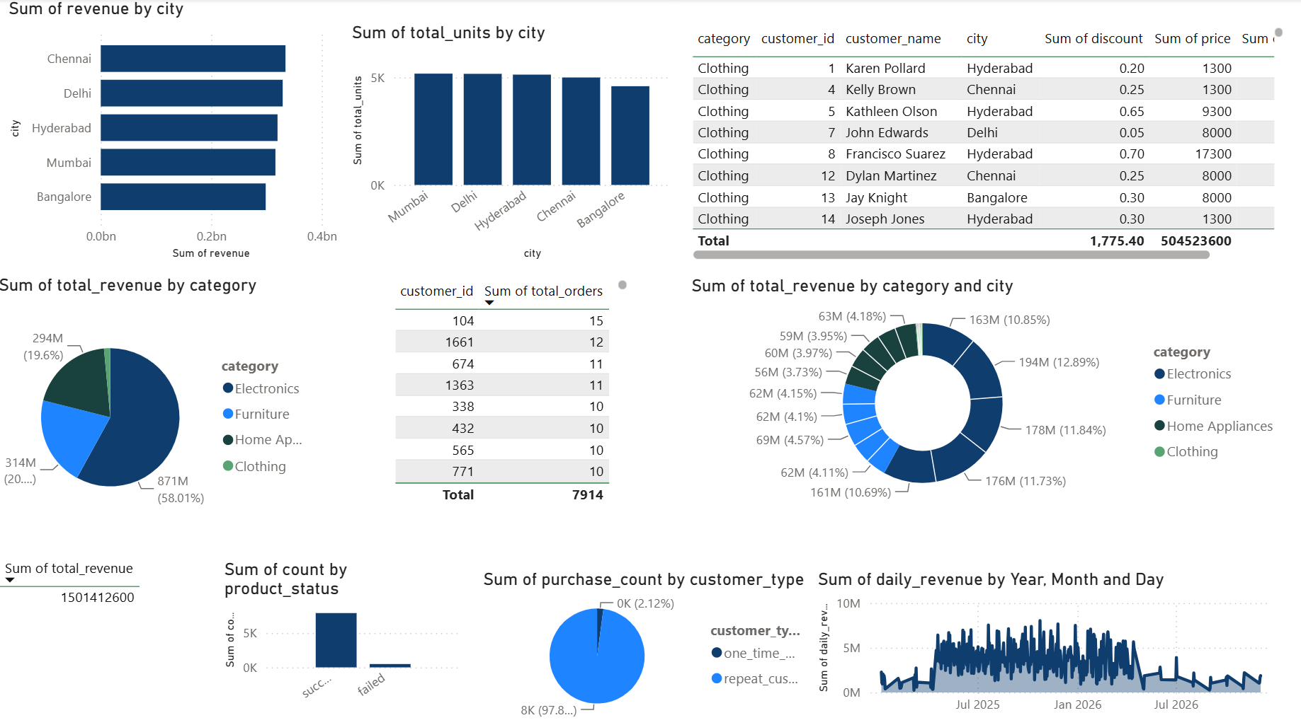

The Power BI dashboard was developed to provide insights into sales performance, customer behaviour, product performance, and geographic revenue distribution. The visualizations generated from the Gold layer datasets support business decision-making through interactive reporting.
8.2 Revenue Distribution by City
Visualization: Sum of Revenue by City
Observation:
- Revenue generation is relatively balanced across all cities.
- Chennai generated the highest revenue, followed closely by Delhi and Hyderabad.
- Bangalore recorded the lowest revenue among the analyzed cities.
Business Insight:
- The business has achieved a broad geographic sales distribution.
- High-performing cities can be prioritized for future expansion and targeted marketing initiatives.

8.3 Sales Volume by City
Visualization: Sum of Total Units by City
Observation:
- Mumbai, Delhi, Hyderabad, and Chennai recorded similar sales volumes.
- Bangalore showed slightly lower unit sales compared to other cities.
Business Insight:
- Product demand is relatively consistent across regions.
- Additional promotional efforts may help improve sales performance in Bangalore.

8.4 Revenue Contribution by Product Category
Visualization: Total Revenue by Category
Observation:
- Electronics generated approximately 58% of total revenue.
- Furniture and Home Appliances contributed roughly 20% each.
- Clothing contributed only a small percentage of overall revenue.
Business Insight:
- Electronics is the primary revenue driver for the business.
- Clothing may require pricing, inventory, or marketing optimization to improve performance.

8.5 Revenue by Category and City
Visualization: Revenue by Category and City
Observation:
- Electronics consistently contributes the largest share of revenue across all cities.
- Revenue distribution across cities remains relatively balanced.
- No single city dominates overall category performance.
Business Insight:
- Electronics demonstrates strong demand regardless of geographic location.
- Product category performance appears stable across markets.

8.6 Customer Order Analysis
Visualization: Customer Orders Summary
Observation:
- The most active customer placed 15 orders.
- Several customers recorded between 10 and 15 purchases.
- Customer activity is distributed across a broad customer base.
Business Insight:
- The business benefits from repeat purchasing behavior.
- Customer retention programs could further increase order frequency.

8.7 Customer Segmentation Analysis
Visualization: Purchase Count by Customer Type
Observation:
- Repeat customers account for approximately 98% of total purchases.
- One-time customers represent only a small proportion of total transactions.
Business Insight:
- The business demonstrates strong customer loyalty.
- Existing customer retention strategies appear effective.

8.8 Order Success and Failure Analysis
Visualization: Order Status Distribution
Observation:
- Successful transactions significantly outnumber failed transactions.
- Failed orders represent only a small percentage of total orders.
Business Insight:
- The order processing system is operating effectively.
- Continuous monitoring of failed orders can help improve customer experience.

8.9 Daily Revenue Trend Analysis
Visualization: Daily Revenue Trend
Observation:
- Daily revenue fluctuates throughout the analysis period.
- Multiple revenue peaks are visible, indicating periods of increased sales activity.
- Revenue remained relatively stable over the majority of the reporting period.
Business Insight:
- Seasonal or promotional events may influence sales performance.
- Trend monitoring can support forecasting and inventory planning activities.

8.10 Overall Business Performance
Observation:
- Total revenue exceeded 1.5 billion monetary units.
- Electronics is the highest-performing category.
- Customer retention levels are strong.
- Geographic sales distribution is balanced across major cities.
- Order success rates remain consistently high.
Business Insight:
- The business demonstrates healthy sales performance, strong customer loyalty, and diversified revenue generation across product categories and locations.

9.Conclusion
This project successfully developed an end-to-end Azure Data Engineering pipeline using Azure Data Lake Storage Gen2, Azure Databricks, Azure Data Factory, Azure SQL Database, and Power BI. Raw retail data was ingested, cleansed, transformed, and organized using a Medallion Architecture (Bronze, Silver, and Gold layers).
The processed data was used to generate business-ready analytical datasets and interactive dashboards, providing insights into customer behaviour, product performance, sales trends, and revenue distribution. The project demonstrates the practical application of modern data engineering concepts and Azure services to support data-driven decision-making.

