User Requirements Specification (URS)
Web Application: Todo List
Company: WebBobBrain
Document ID: TODO-002
Baseline: Derived from TODO-001 (enriched)
Version: 0.2 (Sample document)
Date: 21 Apr 2026
Status: Draft

0. Executive Summary
WebBobBrain intends to deliver a lightweight Todo List web application focused on individual productivity. The initial release targets core task operations (create, read, update, delete) along with completion and priority management. This document describes the business context, user experience assumptions, functional and non-functional requirements, and traceability to test cases.

0.1 Document Structure and Reading Guide
Sections 1–4 establish ownership, purpose, scope, and shared terminology. Section 5 provides indicative UI mockups. Section 6 contains the functional requirements in a tabular, testable format, supported by narrative notes to clarify intent. Section 7 captures baseline non-functional expectations. Section 8 maps requirements to example test cases.

1. Document Control
This section records document ownership, stakeholders, and classification to support governance and change control. Any change to requirements should be reflected in the revision history and re-reviewed by relevant stakeholders.
Field | Value | Field | Value
Document Owner | Product Owner (simulated) | Author | Roberto Sidoti (sample)
Stakeholders | Business + IT | Reviewer | BA/QA (simulated)
Channel | Web | Domain | Task Management
Confidentiality | Internal | Document Type | Functional Requirement (simulated)

2. Purpose
This document simulates a functional requirement specification for a simple web-based task management application (Todo List) for WebBobBrain. The goal is to provide a complete and usable example of a specification: clear, traceable, and testable, including acceptance criteria, tables, and UI mockups.

2.1 Business Context
The application supports users who need a minimal, fast interface to capture tasks, review priorities, and track completion. The system is designed to reduce cognitive load by keeping the interaction model simple and predictable. The primary business outcome is improved individual task throughput and better visibility of what is pending versus completed.

2.2 Objectives and Success Criteria
- Enable a user to capture a task in less than 10 seconds from page load.
- Provide reliable status tracking (Open vs Done) and quick filtering.
- Ensure baseline security with authenticated access and per-user data isolation.

3. Scope
The scope defines the boundaries of the initial release. Items listed as 'in scope' must be delivered to consider the release complete. Items listed as 'out of scope' may be revisited in later iterations but are not required for the current acceptance.
In scope:
- Create, view, edit, complete, and delete tasks.
- Priority flagging and filters (e.g., Important, Completed).
- Backend persistence via API and UI synchronization.
- Baseline non-functional requirements (performance and basic security).
Out of scope:
- Real-time multi-user collaboration.
- Integrations with external systems (e.g., Jira, Outlook) in this version.
- Mobile-native push notifications.

3.1 Assumptions and Dependencies
Assumptions describe conditions expected to hold true for the requirements to remain valid. Dependencies indicate external prerequisites.
- Users access the application through a modern evergreen browser.
- User authentication is provided by an existing identity provider supporting OIDC.
- A backend API is available to persist tasks and enforce per-user access.

4. Definitions
The following definitions establish consistent terminology. Any term used in the requirements should align with these definitions to avoid ambiguity.
Term | Definition
Task | A todo list item with title, status, optional due date and priority.
Done | Status indicating a task is completed.
Important | High priority marker; highlighted in the UI and filterable.
CRUD | Create, Read, Update, Delete (basic operations on a resource).

4.1 User Roles and Permissions
The initial release assumes a single interactive role: a standard authenticated user. All tasks are private to the owner by default. Administrative reporting and shared lists are out of scope.
- Authenticated User: can perform CRUD on their own tasks only.
- System: enforces authorization checks on every request and prevents cross-user access.

5. UI Mockups (Indicative)
The UI mockups below illustrate intended user flows and layout. They are non-binding and may evolve, provided that the functional behavior defined in Section 6 is preserved.
5.1 Home / Task list
The home screen emphasizes rapid task entry and a clear view of the current list. Important tasks are visually distinguished. Completion is designed as a single-click action via a checkbox.
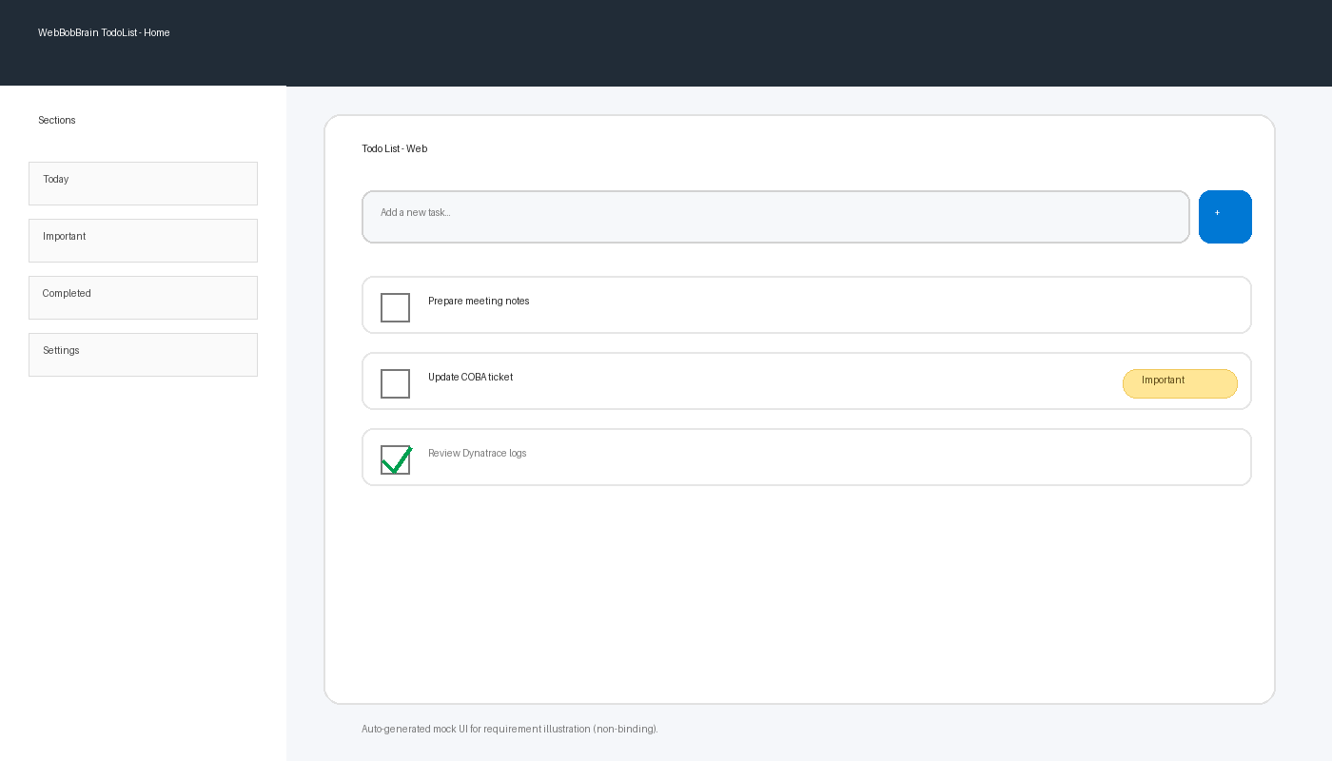
5.2 Filters and priority
Filters provide focused views (e.g., Important, Completed). The intent is to keep navigation shallow: users should reach any view in one click.
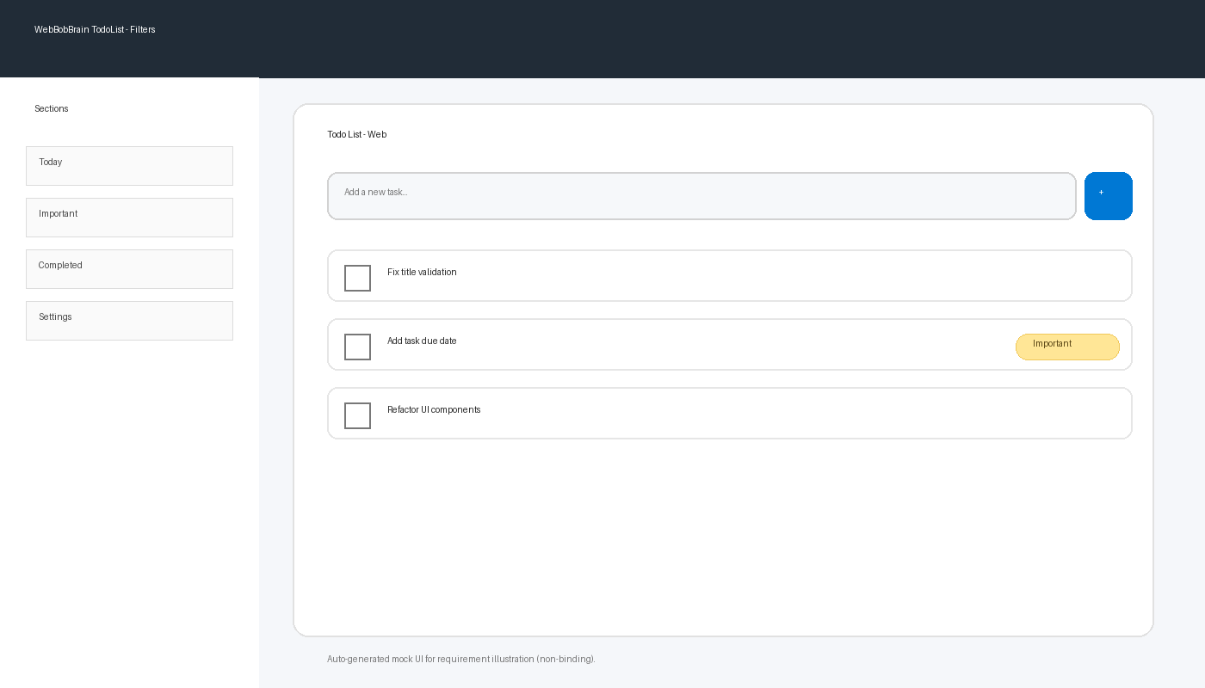

6. Functional Requirements
Functional requirements are expressed using 'shall' statements where mandatory, and are accompanied by acceptance criteria written in Given/When/Then style. Requirements are prioritized using MoSCoW to support incremental delivery.

6.1 Functional Overview
The application manages a single primary entity (Task). A task lifecycle begins as 'Open' and may transition to 'Done'. Users can optionally apply an 'Important' flag to aid prioritization. Filtering and basic ordering support quick triage.
ID | Title | Description | Acceptance Criteria (AC) | Priority
FR-001 | Create a task | The user shall be able to create a new task by providing at least a non-empty title. | - Given a non-empty title, when the user saves, then the task appears in the list with status 'Open'.  - If the title is empty or whitespace-only, then the system blocks saving and displays a validation message.  - After creation, the total task counter is updated. | Must
FR-002 | Complete a task | The user shall be able to mark/unmark a task as completed. | - When the user selects the checkbox, then the status changes to 'Done' and the UI shows it as completed.  - When the user unselects the checkbox, then the status returns to 'Open'.  - The 'Completed' filter shows only tasks with status 'Done'. | Must
FR-003 | Important priority flag | The user should be able to flag a task as 'Important'. | - When 'Important' is enabled, the task is highlighted with a badge/pill and listed above non-important tasks (all else equal).  - The 'Important' filter shows only tasks flagged as 'Important'. | Should
FR-004 | Edit and delete a task | The user shall be able to edit the task title and delete a task. | - Edit: the updated title is visible in the list after saving.  - Delete: the task is removed from the list after user confirmation.  - Deletion does not leave stale references in the UI (list refreshes). | Must

6.2 Data Model Notes
A Task includes at minimum: unique identifier, title, status (Open/Done), and timestamps for creation/update. Optional attributes may include due date and priority flags. The exact storage schema is implementation-defined, but the behavior must satisfy the requirements above.

6.3 Error Handling and Validation
Validation errors should be handled at the UI layer and confirmed at the API layer. Errors returned by the API should be mapped to user-friendly messages without exposing internal technical details.

7. Non-Functional Requirements (Baseline)
Non-functional requirements define quality attributes. They are baseline expectations for the first release and may be refined with measurable SLAs in later phases.
ID | Area | Requirement | Measure/Note
NFR-001 | Performance | Task list loads within 2 seconds with 200 tasks | Measured on standard corporate network
NFR-002 | Reliability | CRUD operations are idempotent at API level where applicable | e.g., retry-safe create with client-generated id
NFR-003 | Security | Authentication required (OIDC) and authorization per user | No anonymous access
NFR-004 | Usability | UI error messages are clear and non-technical | Optional IT/EN localization

7.1 Security Considerations (Narrative)
The application must prevent unauthorized access to tasks by enforcing authorization checks on every API call. Session management and token validation are assumed to be handled by the chosen OIDC integration. Audit logging and advanced security monitoring are not part of this baseline unless mandated by the hosting platform.

7.2 Performance Considerations (Narrative)
Performance expectations focus on perceived responsiveness. UI interactions (such as toggling Done) should provide immediate feedback, even if the final persistence is confirmed asynchronously. Any background retries should be transparent to the user.

8. Traceability Matrix (Example)
The traceability matrix provides an example mapping between requirements and test cases to support verification and validation planning.
Requirement | Test Case | Notes
FR-001 | TC-001 | Title validation and create
FR-002 | TC-002 | Done toggle + completed filter
FR-003 | TC-003 | Important badge + ordering
FR-004 | TC-004 | Edit + delete with confirmation

9. Revision History
All changes to requirements should be logged below. For a real project, each revision would include references to change requests or approvals.
Version | Date | Author | Description
0.2 | 21 Apr 2026 | Roby73 | TODO-002: Enriched version of TODO-001 with additional narrative sections and context.

