TEC PARTNERSHIP



**“How do IoT wearables influence health behaviour and lifestyle changes among users?”**

**Being a Dissertation submitted in fulfilment of the requirements for the Degree of Bachelor of Science in Digital & Technology**

**Solutions**

Rose Barker

629703

Feb 2025

Word Count: 7659

Ethical/Own Work Declarations

I declare that I have read and adhered to the TEC Partnership ethical policy.

I declare that this dissertation is my own work and that all sources have been properly acknowledged

# Abstract

This study investigates the influence of IoT wearables, such as smartwatches and fitness trackers, on health behaviour and lifestyle changes. Through a survey of 62 participants, 51 current users and 11 former users, the research explores user engagement, behavioural changes, and the psychological effects of wearable devices. The findings indicate that wearables primarily encourage physical activity, with 66.7% of current users and 63.6% of former users reporting increased activity levels. However, the influence on other health behaviours, such as sleep and diet, is less influential. A significant barrier identified was the limited battery life, which possibly effected engagement with other features. Additionally, while most participants found wearables to be motivating, their impact on long-term behaviour change is mixed. Current users showed sustained engagement, with 70.6% rating their device as effective in promoting long-term lifestyle changes, whereas former users were less consistent in maintaining behaviour changes. The study also highlights the psychological effects of wearables, noting that while most users did not feel pressured by their devices, a small percentage do experience self-consciousness or stress.

The results suggest that wearables can be powerful tools for encouraging short-term health behaviour changes, but their long-term impact may depend on continued engagement and positive reinforcement. The study also identifies opportunities for improvement in data sharing with healthcare professionals and the accuracy of wearable devices.

For future studies investigating the role of IoT wearables in health behaviour change, it is recommended that a longitudinal approach be adopted to explore the long-term effects of these devices over extended periods of use. Additionally, future research should aim for a more diverse demographic to better understand if factors such as age, gender, and ethnicity influence the effectiveness of wearables. A deeper dive into why individuals discontinue using fitness trackers could also provide valuable insights. Understanding the barriers to sustained engagement and investigating the reasons behind device abandonment could help improve the design and usability of wearables, enhancing their potential for adopting long-term health behaviour changes.

# Acknowledgements

I would like to express my gratitude to the following people for their amazing support over the past three years. To my tutors, Ashley Darley and Yasmin Tuck, thank you for your advice and knowledge throughout this degree. Also, to my classmates who helped me with assignments and offered me valuable advice. I couldn’t have completed my bachelor’s degree to the level I have without all of you.

Additionally, I am grateful to everyone who encouraged and supported me along the way, especially in times where I have been stressed with assignments. And a huge thank you to those who took the time to complete and submit the survey for this research. Your contribution has been essential to the completion of this project.

Contents

Abstract 1

Acknowledgements 2

Introduction 4

Research aims and objectives 5

Definition of terms 6

Literature Review 6

Introduction 6

Theoretical Frameworks 8

User engagement 9

Physical Activity 10

Diet and Sleep 12

Methodology 14

Research Design 14

Research Philosophy 14

Data Collection Methods 14

Ethical Considerations 16

Limitations of the methodology 16

Results 18

Conclusion 30

Bibliography 31

# Introduction

The Internet of Things (IoT) refers to technology that connects physical devices to the internet, allowing them to communicate and exchange data (Lesconnec, 2024). IoT wearables, such as fitness trackers, smartwatches, and other health monitors, are designed to be worn on the body. They have gained huge popularity over the past couple of years particularly in the health and fitness sectors, due to their ability to track health metrics like heart rate, sleep patterns, physical activity, and more. They function by using sensors to gather data, which is then processed and analysed through algorithms to provide users with actionable insights. For example, a wearable can monitor steps taken throughout the day and suggest personalised activity goals or it might alert a user to irregular heartbeats.

According to Oliynyk (2024), global spending on IoT wearable technology in 2021 reached $81.5 billion, an 18% increase from 2020. This surge in sales highlights the growing relevance of these devices in modern society. Despite their popularity, studies investigating the impact and influence of IoT wearables remain relatively limited. This research aims to close that gap by exploring how IoT wearables influence health behaviours and lifestyle changes amongst current and former users. Understanding this relationship is crucial, as it could reveal how technology can be used to promote healthier lifestyles and shape the future of preventative healthcare.

This study will use a mixed methods approach, combining both primary and secondary data collection. The use of qualitative methods will provide detailed insights into user experiences and perceptions, while quantitative methods will offer generalisable data about behavioural trends and lifestyle changes. This approach ensures an understanding of this subject. A pragmatist research philosophy will be used, allowing flexibility in integrating both qualitative and quantitative data. As Kelly (2020) explains, a pragmatist approach facilitates the exploration of how individual experiences, knowledge, and actions are shaped through social interactions, making it especially suitable for examining the impact of IoT wearables.

The focus of this research will be on how wearables impact health and lifestyle, aiming to generate actionable recommendations for stakeholders, including users, developers, healthcare professionals, and businesses. By identifying ways to maximise the benefits of IoT wearables, this study aspires to be meaningful to both academic and non-academic people. The findings could help developers design more effective and user-friendly devices, possibly assist healthcare professionals in leveraging wearables for patient care and encourage users to make informed decisions about their health.

This research is particularly relevant to the field of IT, as it delves into technology, data analytics, and user behaviour. By examining the features of IoT wearables and their implications, this study aligns with current trends in tech innovation and highlights the potential of technology making positive changes within society.

# Research aims and objectives

* Evaluate the role of data feedback in behaviour changes
  + Assess how data feedback (real-time notifications, progress tracking etc) contributes to positive behaviour changes (increased daily steps, dietary changes)
* Explore if demographic factors influence the effectiveness of IoT wearables on behaviour
  + This report will investigate if age, gender or occupation affect how users engage with wearables
* Assess the impact of IoT Wearables on Health Behaviour
  + Examine if the use of wearables influences users’ behaviour

# Definition of terms

IoT - “The Internet of Things (IoT) is a network of physical devices that can transfer data to one another without human intervention. The term was first coined by computer scientist Kevin Ashton in 1999” (Schulze, 2023)

SDT – “Self-determination theory (SDT) seeks to explain how being self-determined impacts motivation—that people feel more motivated to take action when they think that what they do will have an effect on the outcome.” (Cherry, 2024)

HBM - The [Health Belief Model](https://sphweb.bumc.bu.edu/otlt/MPH-Modules/SB/BehavioralChangeTheories/BehavioralChangeTheories2.html) (HBM) is a theoretical model that can be used to guide health promotion and disease prevention programs. It is used to explain and predict individual changes in health behaviours. It is one of the most widely used models for understanding health behaviours. (Glanz & Rimer, 2005)

SCT – Social Comparison Theory (SCT) suggests that people value their personal and social worth by assessing how they compare to others (Cherry, 2024)

# Literature Review

### Introduction

Siliezar (2021) reports that when it comes to physical activity, our ancestors from two centuries ago beat us by roughly 30 minutes a day according to a new Harvard study. Modern society has access to gyms and high-end equipment; however, technology advancements and social changes have reduced the need for physical activity. People were used to walking and cycling long distances to and from work and daily work tasks required much more muscle power and physical effort as stated by Engström, (2004).

When smartwatches launched, they were first marketed as a fashion statement rather than fitness trackers. As reported by Dayaram (2023), Apple presented their Series 0 in September 2014 as a fashion accessory with different swappable bands and even a gold edition. It appeared at events such as Paris fashion week and graced the cover of Vogue. However, when it was officially released in April 2015, its focus shifted to fitness-orientated features. Since then, 180 million units are predicted to sell in 2024, this primarily being a result of integrating advanced health and fitness tracking features (Kumar, 2024). Friend et al. (2023) in agreement with this stated that 92% of smartwatch users reported that they used the devices to maintain and manage their health. This Literature review will examine current research on if IoT wearables have an impact on health behaviour and lifestyle changes amongst users. This report will use similar studies and their findings to help answer this question.

|  |  |  |  |  |
| --- | --- | --- | --- | --- |
| Authors | Year | Title | Sample | Findings |
| [Dr. Gulhan Bizel,](https://iksadyayinevi.com/wp-content/uploads/2022/03/BUSINESS-WORLD-STUDIES-IN-THE-SCOPE-OF-MANAGEMENT-TRADE-AND-MARKETING.pdf)  [Soundarya Srinivasan &](https://iksadyayinevi.com/wp-content/uploads/2022/03/BUSINESS-WORLD-STUDIES-IN-THE-SCOPE-OF-MANAGEMENT-TRADE-AND-MARKETING.pdf)  [Majd Zeitouny](https://iksadyayinevi.com/wp-content/uploads/2022/03/BUSINESS-WORLD-STUDIES-IN-THE-SCOPE-OF-MANAGEMENT-TRADE-AND-MARKETING.pdf) | 2022 | Understanding how fitness trackers and smartwatches motivate people to a healthy lifestyle | * 256 participants * 144 Female - 107 Male * Aged between 15-60+ * Caucasian 91 35.5% * Bachelor's Degree (116) 45.3% * (81) 31.6% Earn less than $25,000 * (89) 34.8% from USA | * Apple 42% (108) & Fitbit 22% (57) most common devices * 47% (122) used their fitness trackers less than 12 months * 21.8% (29) said trackers were no longer motivating them * 44.9% (115) somewhat agreed that they incorporate more activity in their day * 27% (69) somewhat agreed to eating healthier * 16% (41) strongly agreed to sleeping more since they started using fitness trackers whereas 27.7% (71) somewhat agreed * 46.5% feel motivated using their trackers * 73.4% (188) Don’t share their data * 35.5% felt accountable when using their trackers * 45.3% somewhat agree to having a positive experience |
| [Carol Maher, Jillian Ryan, Christina Ambrosi and Sarah Edney](https://ro.ecu.edu.au/cgi/viewcontent.cgi?article=12836&context=ecuworkspost2013#:~:text=Users%E2%80%99%20experiences%20of%20wearable%20activity%20trackers%3A%20A%20cross-sectional,promise%20for%20helping%20users%20to%20adopt%20healthier%20lifestyles.) | 2017 | Users’ experiences of wearable activity trackers: a cross-sectional study | * 237 participants * 69 male - 168 Female * Aged between 18-65 * 154 (65.0%) In a relationship * 95 (40.1%) have Undergraduate degree | * Fitbit (67.5%) and Garmin devices (16.5%) most common * Participants typically used their trackers for 5–7 months * 89% value the real time feedback * Most users (70%) reported they had experienced functionality issues * 65% (130) do not share their data * 29.7% (11) stopped wearing their tracker because they “Learnt everything they could” * 94% of current users and 65% of former users agreed that they had had a positive overall experience using their tracker |

### Theoretical Frameworks

The Self-Determination Theory provides a great foundation in understanding how IoT wearables are able to motivate users. According to Wang et al. (2019), SDT says that motivation is enhanced when three psychological needs of autonomy, competence, and relatedness are satisfied. IoT wearables address these needs in different ways:

**Competence**: Wearables offer real-time feedback, such as tracking step counts or monitoring heart rate improvements, enabling users to visualise their progress and feel a sense of achievement. This aligns with the findings of Bizel et al. (2022), where 44.9% of respondents reported to incorporating more physical activity into their daily routines due to their wearable devices.

**Autonomy**: Users can personalise their goals, such as choosing specific fitness activities or setting tailored health targets, giving them a sense of control over their health and fitness journey.

**Relatedness**: Sharing progress with friends on social media or participating in community challenges creates a sense of connection, which could further enhance an individual’s motivation.

SDT relates closely to the concept of intrinsic motivation. This is where individuals are driven by personal satisfaction or the joy of accomplishing a goal. For example, users might feel intrinsically motivated to complete a daily step goal because they have a long-term goal to lose weight.

In contrast to this, extrinsic motivation is driven by external rewards or pressures, which can also be explained within the SDT. Gamification elements, such as badges, leaderboards, and streaks, act as extrinsic motivators by rewarding users for completing tasks or challenges. These features often provide users an initial push for engagement, but long-term obedience to their goals may require them to become intrinsically motivated. This could mean that extrinsic rewards can spark an initial action, but intrinsic motivation will sustain it.

The HBM emphasises the role of cues to action. Nortje (2024) highlights how this component of the HBM prompts individuals to take action regarding their health. IoT wearables use cues to action through features like sedentary reminders, which encourage movement after periods of inactivity. These reminders act as extrinsic motivators, delivering real-time calls to action. Maher et al. (2017) found that 89% of users reported real-time monitoring features as useful, showing the effectiveness of these cues in developing behavioural changes.

The Social Comparison Theory (SCT) explains how competitiveness and comparison can also influence motivation. When users compare their fitness levels with others, whether it’s friends or social media acquaintances, this can positively or negatively impact their self-esteem and mood. For instance, outperforming peers may boost self-esteem and serve as an extrinsic motivator. However, when users feel they are underperforming, it may decrease their confidence and self-esteem, which could lead to disengagement. SCT aligns with Bizel et al. (2022), where 42.2% of respondents admitted feeling self-conscious due to their fitness tracker.

Gamification is a recurring theme across these frameworks, integrating both intrinsic and extrinsic motivational elements. As stated in a study from Bitrián et al., (2021), gamification enhances engagement by satisfying SDT need for competence, autonomy, and relatedness. Features like progress tracking (intrinsic) and competitive leaderboards (extrinsic) ensure diverse motivational elements for all users.

By examining these frameworks, it becomes clear that both intrinsic and extrinsic motivation is important to understanding how IoT wearables influence user behaviour and health. While extrinsic motivators such as gamification and cues to action often initiate initial engagement, the development of intrinsic motivation through personal achievement and satisfaction is vital for sustained behavioural change.

### User engagement

The studies by Bizel et al. (2022) and Maher et al. (2017), both show that IoT wearables do influence user’s lifestyles in one way or another, but the duration of usage varies. Maher et al., (2017) found that former users wore their IoT wearables for around 5 months and current users reported to wearing their wearables for a median duration of 7 months. Similarly, Bizel et al. (2022) reported that most respondents (24%) have their devices for less than 6 months, while 23% reported 6-12 months. Unlike Maher et al. (2017), this study didn’t distinguish between former and current users, making it more challenging to interpret the findings in terms of sustained engagement. However, these results do highlight the challenge of maintaining long-term engagement with IoT wearables. The limited duration in usage could be influenced by many different factors such as device functionality, user motivation or demographic differences.

Maher et al. (2017) asked former user’s reasons as to why they no longer use their wearables with 29% responding that they had learnt everything the device could offer. However, there may be limitations to these findings such as sampling biases and limited geographical representation. Many respondents were likely already active individuals as they were recruited through health and fitness community groups on Facebook as well as the University of South Australia’s social media feeds. In conjunction with this, most respondents (33.8%) were aged between 18-24. These factors may mean that many users may have primarily used IoT wearables to achieve short terms goals or to get an idea of where their fitness levels are, which could explain the limited engagement duration. Similarly to this, 53% of respondents to Bizel et al. (2022) were aged between 20-29 years old. When asked why they no longer use the smartwatch 21.8% of respondents answered that trackers were no longer motivating them. Device functionality could also play a part in users lack motivation over a sustained amount of time. Most users (70%) reported by Maher et al. (2017) said they had experienced functionality issues with their devices, most related to battery life and technical difficulties. This could be frustrating for users if they are constantly having to charge their devices or not being able to get full use out of it due to technical difficulties, making it more likely for them to stop using their wearables.

Usage duration is significant in determining the effectiveness of IoT wearables. Longer wear time could correlate with sustained health benefits, while shorter durations could show challenges with user engagement. IoT wearables rely on advanced sensors and machine learning algorithms to collect and analyse the user’s data. Longer usage durations enable the device to analyse patterns in health data, offering personalised recommendations for diet, exercise, and overall well-being. This can be especially vital for those with illnesses such as diabetes or heart disease, where continuous monitoring of metrics such as heart rate or glucose levels can lead to better health outcomes. Goodings et al., (2024) reported that a Canadian study carried out in 2016 found that 85% of participants would share their data if their doctor requested it. Wearables could help healthcare professionals improve the effectiveness of chronic illness management as well as help alleviate anxiety for users by providing reassurance about their health. Maher et al. (2017) and Bizel et al. (2022) results show that there is initial motivation but there are limited insights on maintaining engagement over a long period of time. Understanding the reasons behind limited usage duration could help companies like Apple and Fitbit for future development. Designers might consider improvements to gamification, visualised goals and integration with social networks. These features can enhance user motivation by providing real-time feedback and fostering a sense of achievement. Future advancements in IoT wearables could also include enhanced battery life, better integration with other devices, and improved algorithms that evolve with user behaviour. By addressing these technical challenges, developers can ensure that there will be better user engagement and possibly more sales.

### Physical Activity

As previously briefly stated within this report, the general impact of IoT wearables is that they often encourage increased physical activity for users. This is achieved through various features such as setting daily step goals, providing real-time feedback, and sending reminders. Wearables continuously monitor metrics like steps taken, calories burned, and heart rate, offering real-time feedback that enables users to adjust their activity levels. For example, a wearable might notify a user that they are halfway to their daily step goal, prompting them to complete their target. Or that a user has been sedentary for too long. This immediate feedback reinforces positive behaviour changes which then gives the user a sense of accomplishment.

Goal setting is another crucial factor. IoT wearables allow users to set personalised activity goals tailored to their fitness levels, such as a setting a specific step count, a target for calories burnt, or workout duration. Personalisation enhances motivation by giving users a sense of control over their health journey. Meeting these customised goals can build confidence and encourage sustained engagement with physical activity.

There are studies that support these impacts. Neither Bizel et al. and Maher et al. explored the impact of gamification or goal setting specifically, however, Hydari et al. (2022) explored the relationship between health wearables, gamification, and healthful activity. They found that sedentary users who participated in a Fitbit leaderboard for at least 237 days took more than 300,000 additional steps (1,300 additional daily steps). As stated by Davidov, (2024) leaderboards inspire users to push themselves, improve their performance, and feel a sense of accomplishment. While this highlights the power of gamification for motivation people, the role of real-time feedback and goal achievement is also just as influential, as they help users visualise their progress and can then adjust their behaviours accordingly.

As noted by Maher et al. (2017), 95% of current users strongly or somewhat agreed that the step-counting feature was useful, emphasising the importance of visualising their progress in reinforcing healthy habits. Similarly to this, Bizel et al. (2022) found that 71.5% of respondents somewhat or strongly agreed that fitness trackers influenced them to incorporate more activity into their day. These findings suggest that IoT wearables encourage consistent physical activity by offering real-time insights and personalised objectives, which resonate with users across various different demographics. However, Maher et al. (2017) also found that 68.3% of current users and 70.2% of former users reported an initial increase in their activity levels, but 9.5% of current users and 27.0% of former users noted that this increase was transient, with activity levels eventually returning to baseline. This once again highlights the challenge of sustaining engagement with IoT wearables over the long term, as previously stated in user engagement.

Individual differences in response to wearable features should also be considered. Ghaban & Hendley, (2019) stated within their report on how different personalities benefit from gamification, individuals favoured different game elements depending on their personalities. For example, extroverts preferred leaderboards whereas introverts preferred physical rewards such as gifts and keyrings or in smartwatch terms this could be badges. This aligns with intrinsic and extrinsic motivational elements as previously stated within this report. These findings once again highlight the importance of designing features that cater to different user preferences to ensure long-term engagement with their wearable. By combining real-time monitoring, personalised goal setting, and gamification, IoT wearables create a varied approach to promoting physical activity. While gamified elements play a significant role, the ability of wearables to adapt to the individual needs of the user and provide feedback straight away is equally just as important for sustained behavioural changes.

### Diet and Sleep

IoT wearables expand their impact to sleep and diet through features such as calorie and sleep tracking. Maher et al. (2017) briefly touches on this when asking about various features included in their wearable. 66% of respondents reported finding the sleep feature useful, while 36% found the food intake feature helpful. They also reported that 40.2% of current users and 13.5% of former users improved their eating patterns due to using their tracker, while only 24.1% of current users and 10.8% of former users reported improving their sleeping patterns. Similarly, Bizel et al. (2022) observed modest influence, with 16% of respondents strongly agreeing that their wearable influenced them to sleep more, and 19% strongly agreeing it encouraged healthier eating habits. These findings suggest that using wearables for improving sleep and diet is less popular than using them for enhancing fitness levels. However, they are able to influence a small number of users.

A possible explanation for the lower engagement with diet and sleep tracking features compared to physical activity tracking could be the complexity involved in monitoring these behaviours. For example, calorie tracking often requires users to manually log their meals into third-party apps, such as MyFitnessPal or CaloPal, which can be time-consuming and tedious, and users may often forget. Similarly, sleep tracking algorithms may lack the accuracy needed to provide actionable insights, making the data less useful for users. Additionally, users may prioritise fitness goals over diet and sleep because physical activity delivers more immediate feedback and visible results, such as progress toward step goals or calories burned. Furthermore, research by Alnawwar et al. (2023) suggests that regular physical activity can naturally improve sleep quality, reducing the need for separate sleep focused features.

As previously noted, Maher et al. (2017) identified low battery life as a major complaint among users, with 29.7%. This could further discourage users from utilising sleep tracking features, as they may need to charge their devices overnight. Addressing these issues through technological developments, such as improved battery life and more accurate algorithms, could improve user engagement with these features.

Despite these barriers, diet and sleep tracking are important for people’s health and fitness. Effective tracking of these behaviours can help prevent conditions such as obesity and cardiovascular disease. Future research could explore ways to enhance engagement with these features, such as automating calorie tracking using AI or improving the accuracy of sleep tracking. Additionally, developers might consider integrating sleep and diet insights with other health metrics, such as stress levels or recovery, to make these features more actionable and appealing to users.

#### Conclusion

This literature review highlights both the advantages and limitations of IoT wearables in influencing health behaviours and lifestyle changes amongst current and former users. The findings across these studies show that wearables do have a significant impact on promoting physical activity through features like real-time feedback, goal setting, and gamification. Users benefit from personalised insights and give them a sense of accomplishment, which are key aspects to implementing positive behavioural changes. Theoretical frameworks such as SDT, HBM, and SCT provides different perspectives on the motivational mechanisms behind these impacts.

However, there are several gaps within the research that need further exploration. While wearables are good in encouraging physical activity, their influence on diet and sleep is a lot less noticeable. Studies by Maher et al. (2017) and Bizel et al. (2022) touch on these features but lack in-depth analysis of why engagement with them is limited. Barriers, such as the complexity of calorie tracking, inaccuracies in sleep monitoring, and user priorities favouring fitness over holistic health, have not been explored. In addition to this, research on long-term user engagement remains limited as well, with both studies focusing on initial usage rather than prolonged usage. This raises questions about the long-term effect of wearables on whether they encourage lasting lifestyle changes.

However, despite these gaps, the advantages of IoT wearables are clear. They offer innovative solutions for health monitoring and behavioural change, using advanced technology like real-time tracking and gamification to enhance user engagement. Features such as personalised goal setting and data visualisation tools empower users to take control of their health. Additionally, the integration of wearable data with healthcare systems has the potential to improve chronic illness management and overall health outcomes.

Future research should address the limitations that are identified in these current studies. This includes exploring the reasons behind lower engagement with diet and sleep features, understanding the role of demographic and psychological factors in wearable usage, and investigating ways to improve long-term usage. Developers should also focus on improving technical problems, such as battery life and data accuracy, while enhancing the usability and appeal of features that target health. By addressing these gaps, IoT wearables can continue to evolve as effective tools for promoting health and well-being.

# Methodology

## Research Design

This study will use a mixed methods approach to explore how IoT wearables influence health behaviour and lifestyle changes amongst users. Mixed method research collects both quantitative and qualitative data, allowing for a better understanding by integrating numerical data with open ended questions into participants thoughts and experiences.

Google Forms will be used for data collection and the survey will be posted on various social media platforms and in group chats. By doing this it will gather diverse demographics from a broad background. This type of research is appropriate because there aren’t many existing studies on this topic, and the findings may be used for further investigation on this topic.

## Research Philosophy

Pragmatism is the most suitable research philosophy for this study because focuses on finding practical solutions and understanding real world problems. It doesn’t limit itself to objective (quantitative) data, or subjective (qualitative) data. Instead, it allows flexibility to combine both to get a deeper understanding of the influence of IoT wearables on health behaviour and lifestyle changes.

This philosophy is vital to understanding IoT’s influence as quantitative data can show patterns and trends such as the average usage time, or the type of brand they use. But it can’t explain why. Whereas qualitative data will give an insight to peoples thoughts and experiences and provides more context.

Pragmatism also emphasises the importance of practical outcomes. This aligns with the study’s aim to provide actionable insights into how IoT wearables impact health behaviours, which could potentially help improve the development of wearables and how they are used in the future.

## Data Collection Methods

The data collection method used for this study was an online survey distributed through Google Forms. This method was selected because it’s efficient, cost effective, and its ability to reach a diverse audience. Google Forms was specifically chosen over other platforms such as SmartSurvey because it’s user friendly, easy to use, and has built-in tools for organising and analysing data.

The survey was shared on various social media platforms, including Reddit, Instagram, and Facebook, as well as in group chats, to try and maximise reach and engage participants from a range of different demographics. By using this approach, it enabled a collection of a wide variety of current and former IoT wearable users, ensuring that the data reflects diverse perspectives. By doing this it improves the reliability of the results.

A convenience (or availability) sampling approach was used, where participants were recruited based on their accessibility and their willingness to complete the survey. The target audience for this survey included individuals aged 18 and over who were either current or former users of IoT wearables. While younger participants could have been used, the age criteria ensured that respondents were able to provide informed consent. Using teenagers would have been more challenging and time consuming and they also may not have had enough experience with IoT wearables to answer the survey questions meaningfully.

The survey was structured with a mix of close-ended questions (e.g. multiple choice, Likert scale, and checkboxes) to collect quantitative data, alongside a few open-ended questions to gather in-depth qualitative insights. Before beginning the survey, participants were presented with a disclaimer outlining the following:

* Responses were limited to individuals aged 18 and over.
* Only current or former IoT wearable users were eligible to participate.
* Participation was voluntary and completely confidential.
* Individual responses would not be shared with any third party.
* Participants had the right to withdraw at any time by exiting the survey.
* The survey would take approximately 2 minutes to complete.

To encourage participation and minimise withdrawal rates, the survey was designed to be short and straightforward, taking no more than 2 minutes to complete. The use of clear and simple language ensured that all participants were able to answer questions correctly and not be put off by words they don’t understand. This allowed for accessibility for participants of all backgrounds.

The survey began with demographic questions to gather information such as age, race, place of residence, and whether participants had sedentary or active jobs. This was followed by usage-related questions, including the brand of wearable used, the primary purpose of its use, and the duration of use. Participants were then asked about the impact of wearables on their health and lifestyle, measured through questions such as how often they achieved goals set by their device and which features most influenced their behaviour.

The following sections focused on user engagement, including challenges faced when using wearables, data-sharing habits, and reasons for discontinuing use (for former users). The final section explored the psychological impact of wearables, asking participants if the devices made them feel motivated, self-conscious, or encouraged healthier eating habits.

For easier analysis, the questions were divided into separate sections for former and current users, rather than combining them into a single group of questions. This ensures that the responses from current and former users can be examined separately, allowing for more precise comparisons and insights. By organising it this way the results can be analysed more effectively, highlighting any differences or similarities between the two groups.

## Ethical Considerations

This study complied with research guidelines to protect participants rights to confidentiality throughout the data collection process.

Informed consent was collected from all participants before they began the survey. On the first page there was a disclaimer presented to potential participants outlining the purpose of the study, eligibility criteria such as being over the age of 18 and only current or former smartwatch/fitness tracker users. It was also made clear that participants had the right to withdraw at any moment they could do so simply by exiting the survey and their answers won’t be submitted. By proceeding to the survey, they confirmed their consent to participate.

To ensure confidentiality and to protect participants privacy, all responses were collected anonymously. No personal information such as email addresses and names were collected. All data was stored securely on Google forms which is only accessible to me and will be deleted once the study is complete.

The survey complied with relevant data protection regulations, such as the GDPR. Participants were assured that their data would only be used for this research and would remain confidential throughout.

By following these procedures, the study ensures that participants rights and privacy are respected at all times throughout and the study complies with research guidelines.

## Limitations of the methodology

This study aimed to provide reliable and valuable insights into how IoT wearables influence health behaviour and lifestyle changes, however there are methodology limitations that need to be acknowledged.

Firstly, one potential limitation is sampling bias. Although consideration was taken to try and gather a range of different people, the majority of the participants were recruited though my social media accounts and group chats. This may have resulted in a sample that isn’t fully representative of a broad population of wearable users which could possibly influence the generalisation of the findings.

In addition to this, the sample size is fairly small for a study of this nature. This may limit the importance of the findings as a larger more diverse sample could provide more of an understanding of user’s behaviours and perceptions.

Time constraints was also a challenge, as the research was conducted within a small timeframe of approximately 3 months. A longer study could have allowed for a more participants from a wide range of backgrounds.

Despite these limitations, this study still offers valuable data on the impact of IoT wearables, and future research could build on these findings, using a bigger sample size.

# Results

This section presents the findings from the survey on “How do IoT wearables influence health behaviour and lifestyle changes among users?”. The results offer valuable insights into user engagement, behavioural changes, and the psychological effects of IoT wearables. These findings both support and challenge literature previously reviewed.

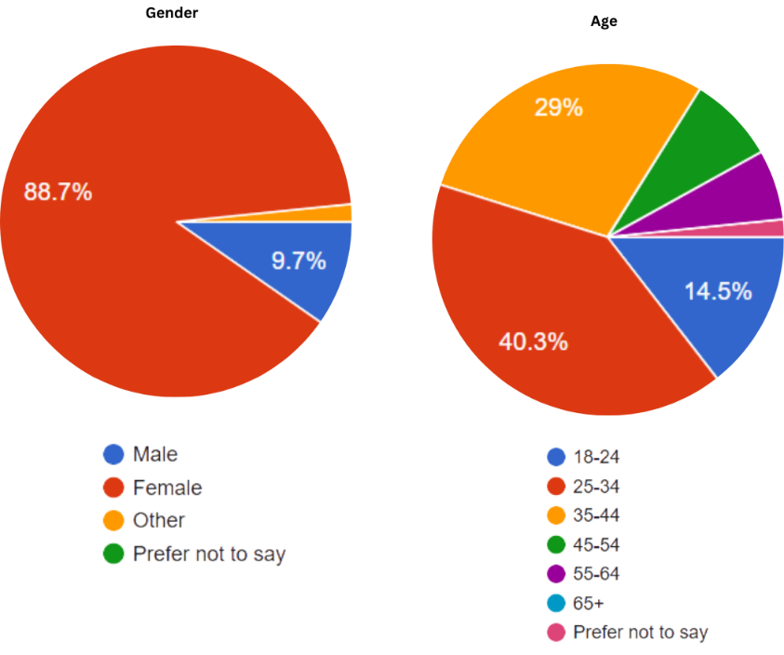

Figure 1 - Age & Gender current and former users

The survey gathered responses from a total of 62 participants, 51 were current users of smartwatches or fitness trackers, while 11 were former users. This allows for a comparison between active engagement with wearable technology and reasons for no longer using them. This may help anyone looking to investigate this for further research.

As seen in figures one and two, the vast majority of respondents identified as White (93.5%) and female (88.7%), with 93.5% living in Europe. This demographic is likely influenced by the way the survey was distributed, as it was shared through my social media accounts. Additionally, 69.3% of participants were 25-44 years old, indicating that smartwatches and fitness trackers are very popular among millennials.

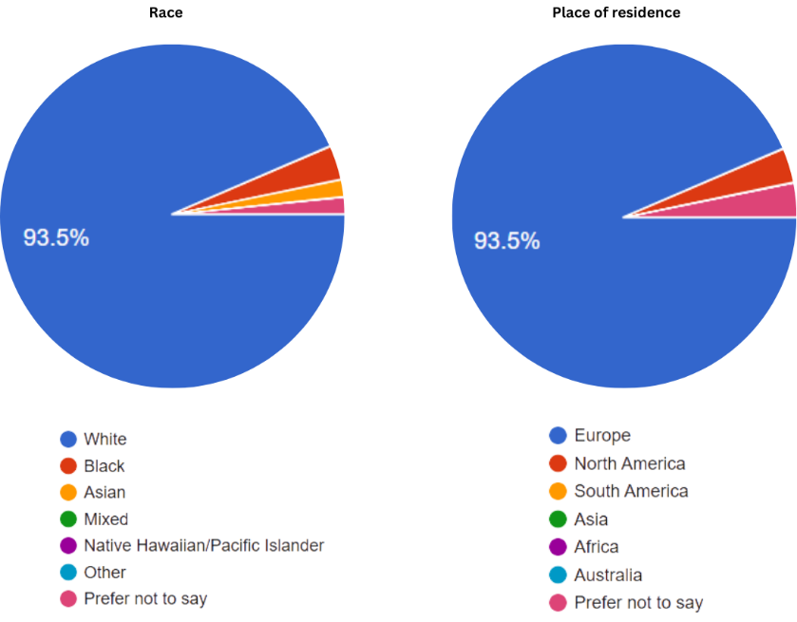

Figure 2 - Race & Residence current and former users

These findings align with the demographic trends seen in Bizel et al.’s (2022) study, which also reported a majority of white female participants aged 20–29. However, a key difference is the location. While my survey’s respondents were mostly European, Bizel et al.'s study were mostly from the USA. Despite the geographical difference both studies have a similar trend, IoT wearables are more commonly used by younger adults, particularly women, rather than by those aged 45 and over. Older adults may be less likely to use smartwatches and fitness trackers for several reasons. Some may find the technology hard to use, while others may not see any point in tracking their health through a wearable. This aligns with the results from when participants were asked “Do you have any pre-existing health conditions that influenced your use of wearables?”. 90.9% of former and 66.7% of current users responded “No”. Exploring these challenges more could help future research and development find ways to make wearable technology more accessible and appealing to older generations and those who have illnesses, ensuring they can also benefit from the health insights they provide.

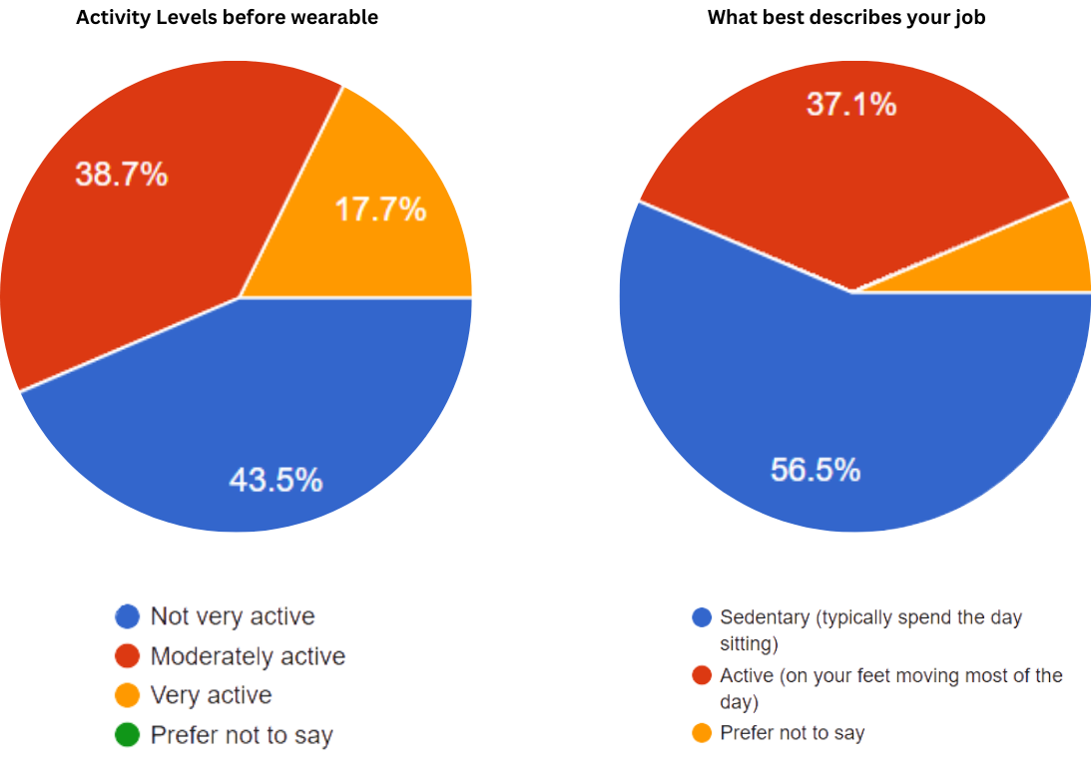

Figure 3 - Current and former users when asked their activity levels before wearable and what best describes their job

As shown in figure three, most participants reported that they weren’t very active before they started using their wearable devices. This could be linked to the fact that a large portion of respondents have sedentary jobs, where they spend most of their day sitting. When asked whether factors like age, gender, or occupation influenced their use of wearables, one current user said, "I sit down all day for my job, so the reminders to move have helped me hit my goals easier*."* This suggests that features like sedentary reminders play a key role in encouraging users, especially those with office jobs, to be more active throughout the day.

Brand preferences amongst participants also correlates with trends seen in previous research. When asked which wearable brand they use, Apple was by far the most popular choice. Among current users, 47.1% reported using an Apple Watch, while 36.4% of former users had used one in the past. This aligns with Bizel et al.’s (2022) findings, where 42% of participants also used Apple. However, this contrasts massively with Maher et al.’s (2017) study, where Fitbit was the most common choice, with 67.5%.

This could be due to Apple’s ease of integration, making it a convenient choice for people who already own other IOS products. Additionally, users may find Apple’s interface and third-party apps more engaging compared to Android products. This may indicate that wearables go beyond just fitness tracking, factors like ease of use, design, and other factors play a big role in influencing a customer’s choices.

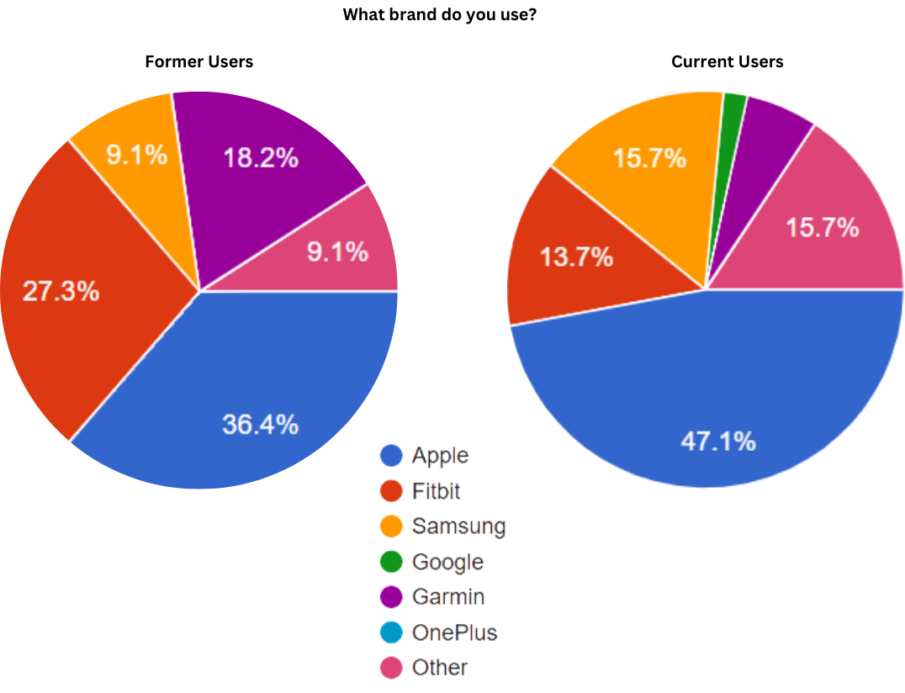

Figure 4 - Former & Current users responses to "What brand do you use"

Figure 6 - Current & Former users when asked what challenges they faced when using their wearable

When participants were asked whether using a wearable had led to any changes in their health behaviours, the majority reported an increase in physical activity. Specifically, 66.7% of current users and 63.6% of former users said they became more active after using a smartwatch or fitness tracker. This trend aligns with Maher et al.’s (2017) findings, where 81.4% of current users and 51.3% of former users said that they incorporated more activity into their daily routine.

It's important to note though, that although both this study and Maher et al.’s research highlight increased physical activity as the most common behaviour change, other health behaviours, such as better sleep and dietary habits, were less common. This suggests that while wearables are good at encouraging more activity, their influence on other lifestyle changes isn’t as influential. This claim can also be backed up in figure seven when participants were asked the feature that most influenced their health behaviour, with step counting being most influential between current (51%) and former users (54.5%). As previously stated within the literature review a possible explanation for this is that many users primarily engage with features like step counting, while sleep and nutrition tracking requires more manual input. Another factor that could be limiting engagement with these health metrics is battery life. Wearable devices need to be worn consistently to track sleep patterns and long-term health trends effectively. However, as shown in Figure 6, battery life was a significant challenge for many users. In my survey, 58% of current users and 36.4% of former users reported the battery life as a challenge when using their wearable. Similarly, Maher et al. (2017) found that 20% of their participants listed “low battery life” as a concern with wearables, the second highest after “none”.

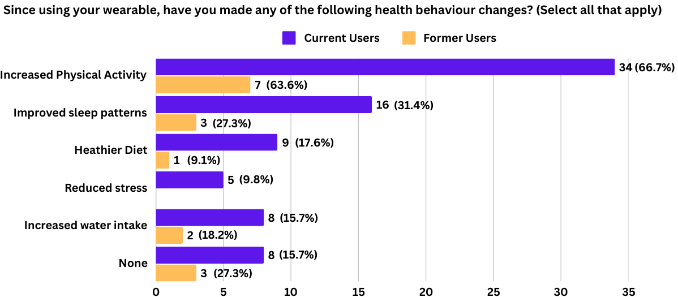

Figure 5 - Current and former users when asked if they have made any health behaviour changes

This comparison between studies implies that as wearable technology has evolved over the years, battery life remains an issue. While devices have improved in design and functionality, the need for frequent charging may still discourage users from taking full advantage of all the features. Addressing this barrier, either through longer battery life or faster charging, could be key to making wearables more effective in promoting health behaviour changes beyond physical activity.

Figure 7 - Current & Former users responses to which features of your wearable most influence your health behaviour

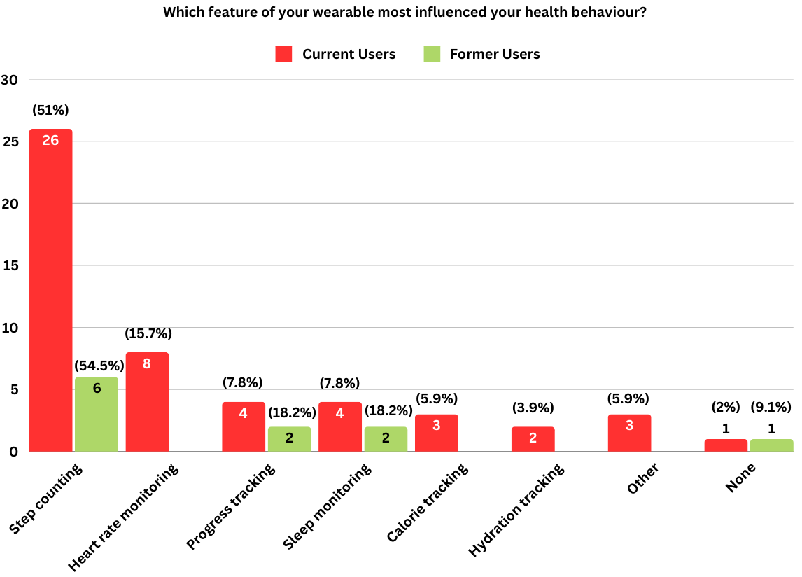

Analysing figures eight and nine, the results suggest that the majority of current users believe wearables are effective in promoting long-term lifestyle changes, with 70.6% rating their device as either “very effective” (35.3%) or “effective” (35.3%). This positive perception could be linked to the fact that the majority of current users in this study have had their wearable for a sustained time, with 64.7% using it for more than two years. This long-term engagement suggests that wearables become an integrated part of people’s daily routines, which reinforces positive health habits over time.

In contrast, studies by Maher et al. (2017) and Bizel et al. (2022) had participants who were relatively new to wearable technology, with most using their devices for less than a year. Their findings suggest that wearables can encourage short-term behavioural changes, but the long-term impact is less clear. Maher et al. (2017) found that while 68.3% of current users and 70.2% of former users initially increased their activity levels, 9.5% of current users and 27.0% of former users reported that this increase was only temporary, with their activity levels eventually “returning to baseline”.

This raises the possibility that once users stop using their wearable, they may also abandon the healthy habits they had while using it. The difference in engagement between current and former users in this study supports this idea. While many long-term users continue to find value in their devices, those who stop using them often do so within the first year, possibly before these habits become deeply ingrained into their daily routine. This highlights a key challenge for wearable technology, while it is a powerful tool for encouraging physical activity and lifestyle changes, its impact may not always be sustained once the device is no longer in use.

Understanding what helps users maintain their habits even after they stop using a wearable could be crucial for maximising their long-term effectiveness. Future research should explore ways to make behaviour change more permanent.

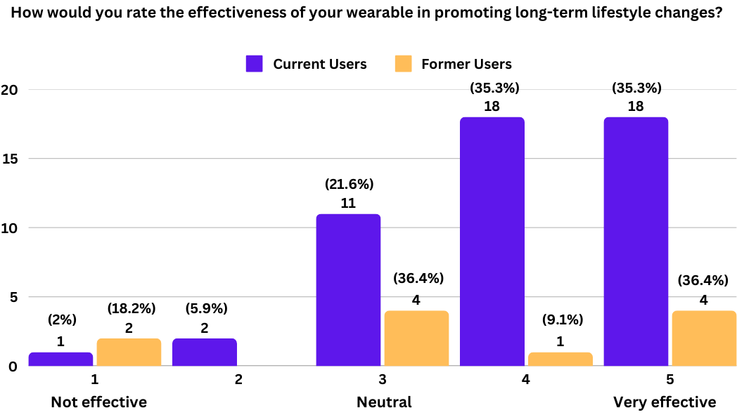

Figure 8 - Current & Former users when asked the effectiveness of wearables promoting long-term lifestyle changes

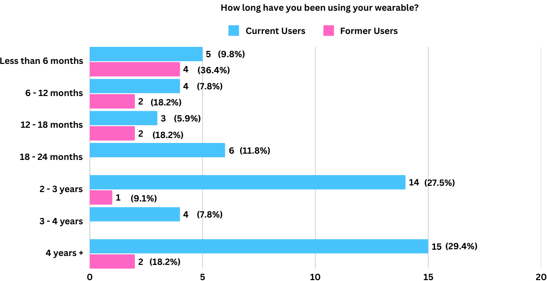

Figure 9 - Current & Former users when asked how long have you been using your wearable?

A common trend across all studies is that the majority of wearable users do not share their data. Bizel et al. reported that 73.4% of users chose not to share their wearable data, while Maher et al. found the same pattern, with 65% of participants keeping their data private. In this study, the amount of users who do not share their data is slightly lower, at 54.5%.

For those who did share their data, in-person conversations were the most common method. Among current users, 21.6% reported discussing their wearable data face-to-face, while only 9.1% of former users did the same. This indicates that while some users find value in sharing their insights with others, it remains a relatively uncommon, especially amongst those who have stopped using their devices.

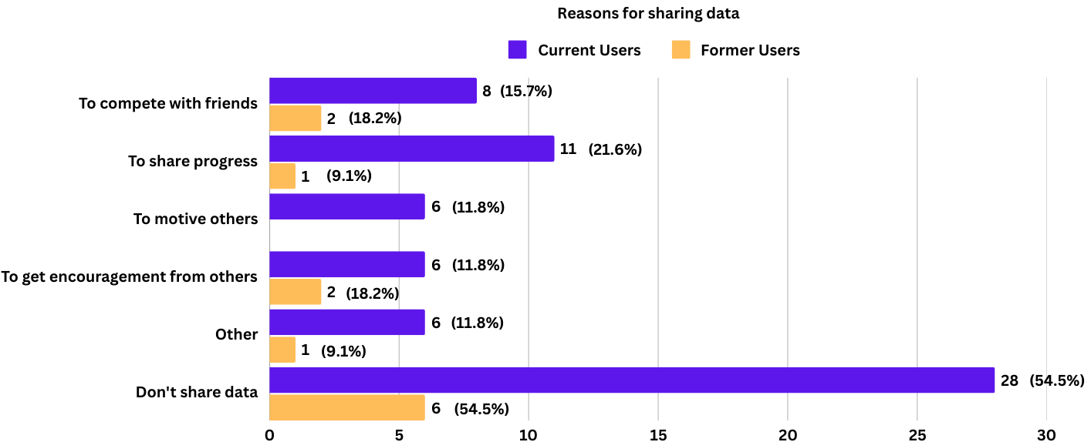

Figure 10 - Current & Former users reasons for sharing data

However, when current and former users were asked whether they would be willing to share their wearable data with a healthcare professional, responses were completely different. A significant number of current users (60.8%) said they would be open to sharing their data with a medical expert, compared to 45.5% of former users. This suggests that while users may not want to share their activity metrics online with friends, they see the value of sharing their data with a healthcare professional.

These findings highlight a key opportunity for the future of wearable technology. While most users may not feel comfortable sharing their data socially, there’s a clear interest in using wearables for personalised healthcare. However, one potential barrier is data accuracy. Figure six shows that 11.8% of current users have concerns about the reliability of their wearable’s data. This could explain why some users are reluctant to share their information with medical professionals.

This presents a possible gap in the market. If wearable devices were more accurate and had secure, user-friendly ways to share data with healthcare professionals, more people might see them as valuable health tools rather than just fitness trackers. Addressing accuracy concerns could be a crucial step in making wearables a reliable and widely accepted tool within the healthcare industry.

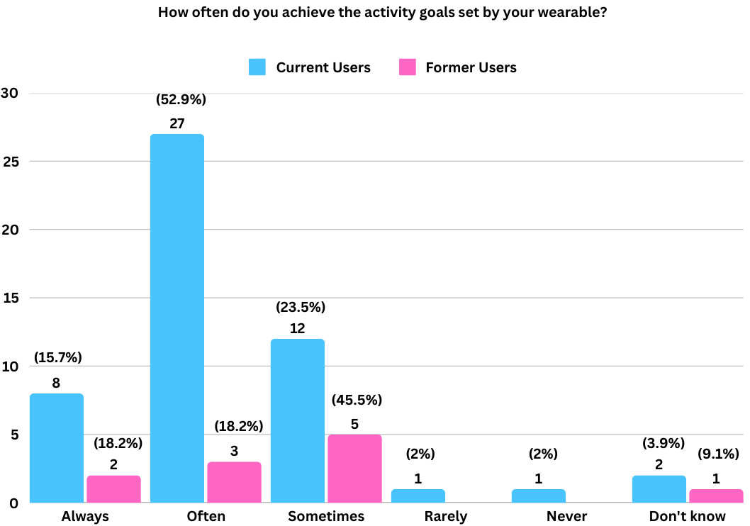

Figure 13 - Current & Former users when asked how often do you achieve to goals set by your wearable?



Figure 1 - Current & Former users when asked if your wearable made you feel motivated

The results of this study suggest that wearables have a significant psychological impact on users, influencing motivation, self-consciousness, and lifestyle behaviours such as physical activity and diet. While many users report feeling motivated by their devices, the extent to which this motivation translates into sustained behaviour change varies. Additionally, wearables appear to have a complex relationship with self-consciousness, with some users experiencing pressure or heightened awareness of their health behaviours.

One of the key psychological effects of wearables is their role in motivating users to be more active as seen in figure 12. A majority of current users (74.5%) reported that their wearable made them feel motivated, with 41.2% somewhat agreeing and 33.3% strongly agreeing. Even among former users, 72.8% reported feeling motivated at some point, suggesting that wearables do encourage behavioural change while they are in use. This aligns with the responses regarding goal achievement in figure 13, where 68.6% of current users reported meeting their activity goals either "always" or "often." However, former users were less consistent in meeting their goals, with only 36.4% achieving them "often" and 45.5% only meeting them "sometimes."

These findings suggest that wearables can act as effective motivators, especially for those who constantly use them. The goal-setting and progress tracking may encourage users to stay active, reinforcing positive health behaviours. However, the drop in goal achievement among former users may indicate that once individuals stop using their wearable, they also lose the motivation and accountability that the device provides. This suggests that wearables may be more effective as short-term motivational tools rather than long-term behaviour changes for some users.

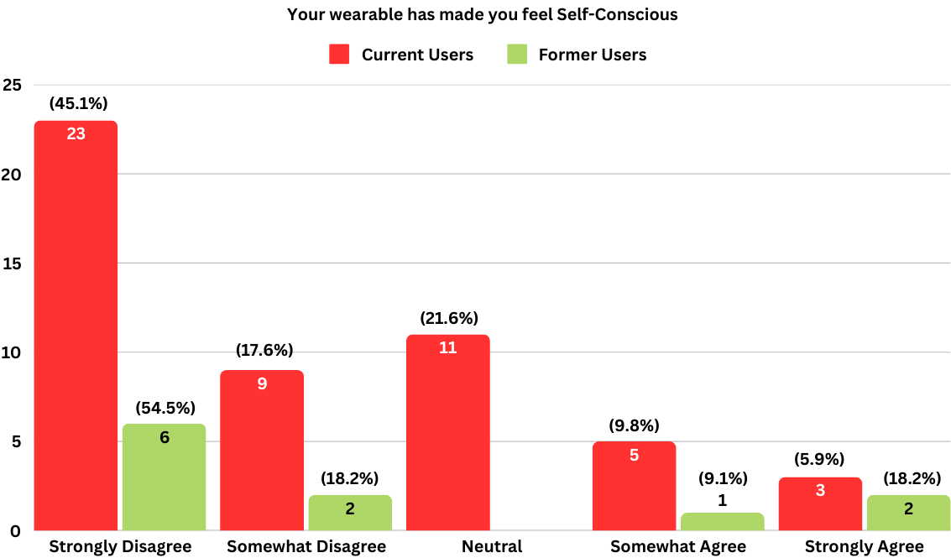

Figure 14 - Current & Former users when asked if your wearable made you feel self-conscious?

While wearables can be motivating, they can also contribute to feelings of self-consciousness. In this study as seen in figure 14, 45.1% of current users and 54.5% of former users strongly disagreed that their wearable made them feel self-conscious, suggesting that most users do not experience any pressure from their device. However, a small percentage (15.7% of current users and 27.3% of former users) reported feeling somewhat or strongly self-conscious.

This mixed response could indicate that while wearables do provide motivation, they may also create pressure to meet goals, potentially leading to negative experiences for some users. Those who struggle to achieve their targets may feel discouraged or guilty, especially if they perceive their progress as being monitored or compared to others. This psychological barrier could be one reason why some users eventually discontinue use, as the pressure to perform outweighs the benefits.

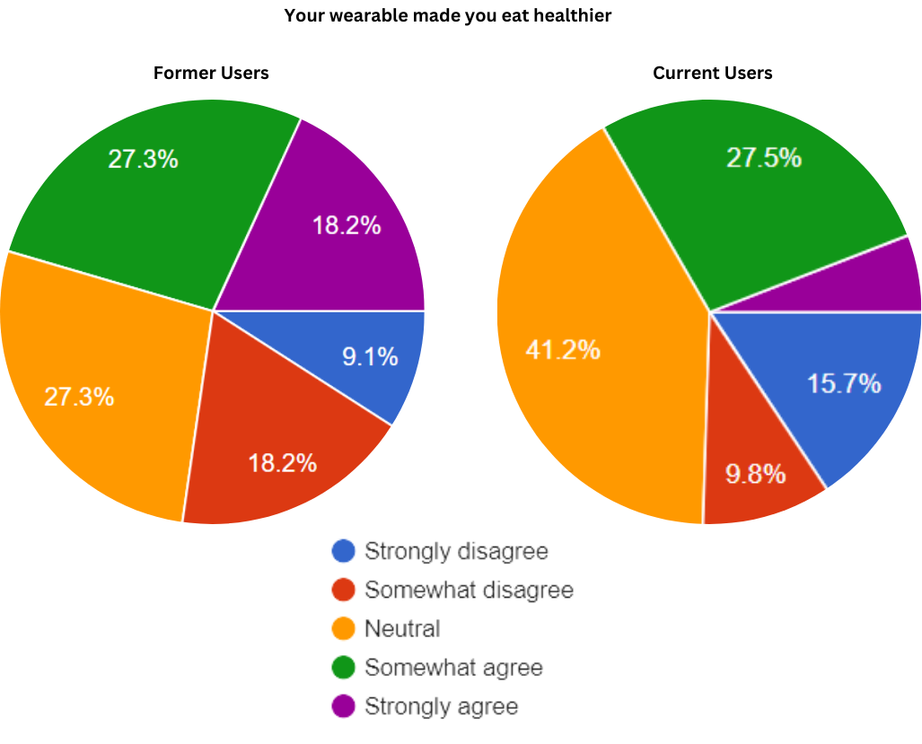

Figure 13 - Current & Former users when asked if your wearable made you eat healthier

Wearable devices don’t just impact physical activity—they also have the potential to influence other lifestyle habits, like diet. However, the results suggest that this impact is mixed. While 33.4% of current users felt their wearable encouraged them to eat healthier, a large portion (41.2%) remained neutral, and 25.5% disagreed. This shows that, for many, wearables are seen primarily as activity trackers rather than full blown health tools.

This finding is in line with Maher et al. (2017), who found that while wearables do a great job of motivating people to move more, their influence on other health behaviours like sleep and diet is much weaker. One possible reason for this is that most wearables are designed with step counts and workout tracking as the main focus, while features related to diet and nutrition often require manual input, making them less engaging. It’s also likely that many users prioritise exercise over diet, seeing physical activity as the main function of their device.

A key trend that stands out is that wearables seem to provide a strong initial boost in motivation, but this doesn’t always translate into long-term change, especially for those who stop using their device. Current users tend to stay motivated, while former users often slip back into old habits. This suggests that wearables keep users on track while they are engaged with them, but once the device is removed, so is the reinforcement.

Another consideration is the psychological impact of these devices. While most people don’t feel pressured by their wearable, a small percentage do experience negative emotions, such as guilt or stress, when they don’t meet their goals. If wearables could focus more on positive reinforcement rather than tracking, they might be more effective at keeping users engaged over the long run.

# Conclusion

The findings from this study highlight the significant impact IoT wearables do have on health behaviours, especially in increasing physical activity. While most users report feeling motivated by their devices, the long-term effectiveness varies, with former users often struggling to maintain positive habits once they stop using their wearable. Factors such as battery life, ease of use, and accuracy influence engagement, while step counting remains the most impactful feature. However, wearables have a weaker influence on other lifestyle behaviours like diet, possibly due to their primary focus on activity tracking. Psychological effects also play a role, with most users experiencing motivation but a small percentage feeling self-conscious or pressured. These results suggest that for wearables to drive lasting behaviour change, they may need to shift from short-term tracking tools to more holistic, user-friendly health management systems that can integrate well with healthcare and reinforce long-term habits for all users.

# Bibliography

Alnawwar, M.A., Alraddadi, M.I. and Algethmi, R.A. (2023) *The effect of physical activity on sleep quality and sleep disorder: A systematic review*, *Cureus*. Available at: https://www.cureus.com/articles/178269-the-effect-of-physical-activity-on-sleep-quality-and-sleep-disorder-a-systematic-review (Accessed: 20 January 2025).

Bitrián, P., Buil, I. and Catalán, S. (2021) *Enhancing user engagement: The role of gamification in mobile apps*, *Journal of Business Research*. Available at: https://www.sciencedirect.com/science/article/pii/S0148296321002666 (Accessed: 13 January 2025).

Cherry, K. (2024) *How social comparison theory influences our views on ourselves*, *Verywell Mind*. Available at: https://www.verywellmind.com/what-is-the-social-comparison-process-2795872 (Accessed: 06 January 2025).

Cherry, K. (2024) *How does self-determination theory explain motivation?*, *Verywell Mind*. Available at: https://www.verywellmind.com/what-is-self-determination-theory-2795387 (Accessed: 27 December 2024).

Dayaram, S. (2023) *What happened to the Apple Watch being about fashion?*, *CNET*. Available at: https://www.cnet.com/tech/mobile/what-happened-to-the-apple-watch-being-about-fashion/ (Accessed: 19 December 2024).

Davidov, S. (2024) *The psychology behind leaderboards: How friendly competition drives success*, *Free, Fully Customizable Apps, Widgets & Plugins*. Available at: https://www.commoninja.com/blog/the-psychology-behind-leaderboards (Accessed: 05 January 2025).

Engström, L.-M. (2004) ‘Social Change and physical activity’, *Scandinavian Journal of Nutrition*, 48(3), pp. 108–108. doi:10.1080/16513860410017674.

Friend, S.H., Ginsburg, G.S. and Picard, R.W. (2023) *Wearable Digital Health Technology*, *The New England Journal Of Medicine* . Available at: https://www.nejm.org/doi/full/10.1056/NEJMe2303219 (Accessed: 19 December 2024).

Ghaban, W. and Hendley, R. (2019) ‘How different personalities benefit from Gamification’, *Interacting with Computers*, 31(2), pp. 3–3. doi:10.1093/iwc/iwz009.

Goodings, A.J. *et al.* (2024) *Factors influencing smartwatch use and comfort with health data sharing: A sequential mixed-method study protocol*, *BMJ Open*. Available at: https://bmjopen.bmj.com/content/14/5/e081228#ref-14 (Accessed: 02 January 2025).

Glanz, K. and Rimer, B.K. (2005) *The health belief model*, *Rural Health Promotion and Disease Prevention Toolkit*. Available at: https://www.ruralhealthinfo.org/toolkits/health-promotion/2/theories-and-models/health-belief (Accessed: 27 December 2024).

Hydari, M.Z., Adjerid, I. and Striegel , A.D. (2022) *Health Wearables, Gamification, and Healthful Activity*, *pubsonline*. Available at: https://pubsonline.informs.org/doi/10.1287/mnsc.2022.00744 (Accessed: 02 January 2025).

Joshi, K. (2024) *Smartwatch statistics by vendors, revenue and number of users*, *Electro IQ*. Available at: https://electroiq.com/stats/smartwatch-statistics/ (Accessed: 19 December 2024).

Kelly, L.M. (2020) *Three principles of pragmatism for research on organizational ...*, *Three principles of pragmatism for research on organizational processes*. Available at: https://journals.sagepub.com/doi/10.1177/2059799120937242 (Accessed: 06 December 2024).

Kumar, N. (2024) *Smartwatch Statistics (2024): Market & Sales Data*, *DemandSage*. Available at: https://www.demandsage.com/smartwatch-statistics/#:~:text=180%20Million%20Smartwatches%20Are%20Predicted%20To%20Be%20Shipped%20In%202024&text=This%20is%2016%25%20up%20from,expected%20to%20come%20from%20India. (Accessed: 19 December 2024).

Lesconnec, N. (2024) *What is IOT (internet of things) and how does it work?*, *Soracom UK*. Available at: https://soracom.co.uk/guides/what-is-iot/ (Accessed: 15 January 2025).

Nortje, A. (2024) *What is the health belief model? an updated look*, *PositivePsychology.com*. Available at: https://positivepsychology.com/health-belief-model/ (Accessed: 29 December 2024).

Oliynyk, K. (2024). *IoT Trends in Wearable Devices: Personal and Business*. [online] webbylab.com. Available at: https://webbylab.com/blog/wearable-iot-trends-personal-and-business-use/ (Accessed: 30 October 2024).

Schulze, J. (2024a) *What is the internet of things (IOT)? with examples*, *Coursera*. Available at: https://www.coursera.org/articles/internet-of-things (Accessed: 06 December 2024).

Siliezar, J. (2021) *Progress doesn’t always mean movement, says Harvard study of Daily Exercise*, *Harvard Gazette*. Available at: https://news.harvard.edu/gazette/story/2021/10/progress-doesnt-always-mean-movement-says-harvard-study-of-daily-exercise/ (Accessed: 16 December 2024).

Wang, J. *et al.* (2019) *Competence, autonomy, and relatedness in the classroom: Understanding students’ motivational processes using the self-determination theory*, *Heliyon*. Available at: https://www.sciencedirect.com/science/article/pii/S240584401935604X (Accessed: 27 December 2024).