Group 39 Individual Report- Siân McManus-B01021399

Intro

This group project involved the collaborative design and development of a web-based application which we named ‘Stress Less’, that aims to help students manage and reduce stress. The website was developed using a mix of HTML, CSS, JavaScript and jQuery. With a strong focus on interactivity, usability and accessibility. As a group, we planned, designed and implemented the system collaboratively. Throughout the development process, we aimed to apply Shneiderman’s Eight Golden Rules of Interface Design particularly with regards to consistency and usability to ensure a clear and user-friendly experience.

Throughout the project, we organised several group meetings to plan the structure and overall functionality of our website. During these meetings we discussed who our target audience would be and identified key features that we wanted and considered how to create an effective and user-friendly experience for our website.

The use of Miro allowed the group to visually map out ideas and how the features would all work together, which improved our communication and reduced misunderstandings during the development. Similarly, Canva was used to produce initial wireframes and logo concepts, helping to form a clear visual direction before implementation began. This planning stage ensured that development was more structured and efficient.

(Initial wireframe)
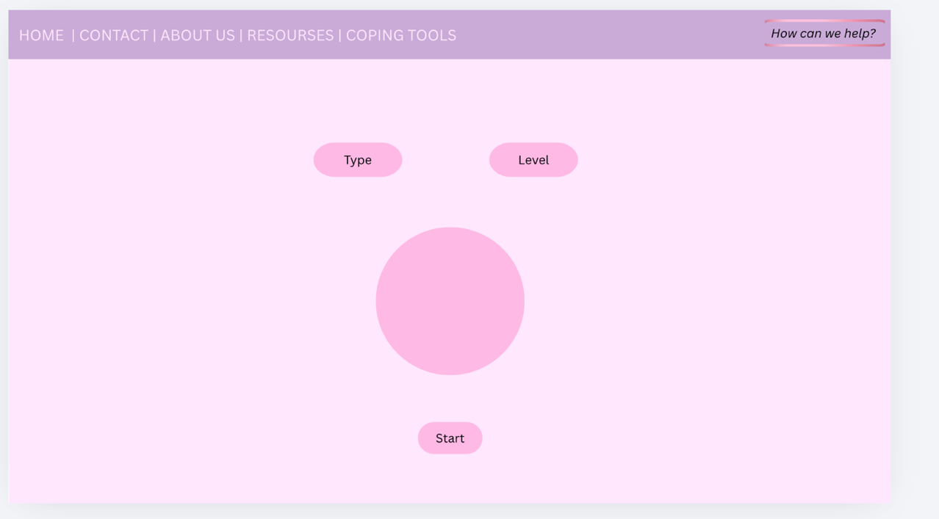

To manage the workload we divided the website into different sections rather than working on everything together. This allowed each team member to take responsibility for a specific part and develop it into more detail. The breathing exercise section acts as an interactive feature of the website. This section allows users to select a breathing method and difficulty level and then it guides them through a structured breathing exercise using animations and timed instructions. The main aim of this section was to create a functional, visually appealing and relaxing webpage that was easy to use for all.

Design and Implementation
The breathing exercise is the main focus of my assigned webpage(breathing tools) and it makes use of asynchronous JavaScript through setTimeout() and setInterval(). These functions allow for controlled time-based events such as transitioning between inhale, hold, and exhale phases. By updating both the visual animation and countdown timer the webpage provides a real-time response to the user, improving usability and effectively guiding them through the breathing process. This reflects some principles of event-driven programming because as users interact (clicking the start button) it triggers a sequence of timed events.
I initially watched lots of tutorials on YouTube and read through lots of tutorials online to figure out how to make the breathing animations. I found a tutorial online that I understood and used it as a basis for this feature. I found W3schools particularly helpful when it came to finishing touches or core things that I was able to then build on. However, the implementation was significantly adapted to suit our website. Modifications that I made include restructuring the timing logic and improving synchronisation between the animation and having a different animation for the box breathing.
The use of difficulty levels introduces scalability to the project as the duration of each breathing phase is modified using a multiplier. Meaning that it can be used to create flexible and reusable code.
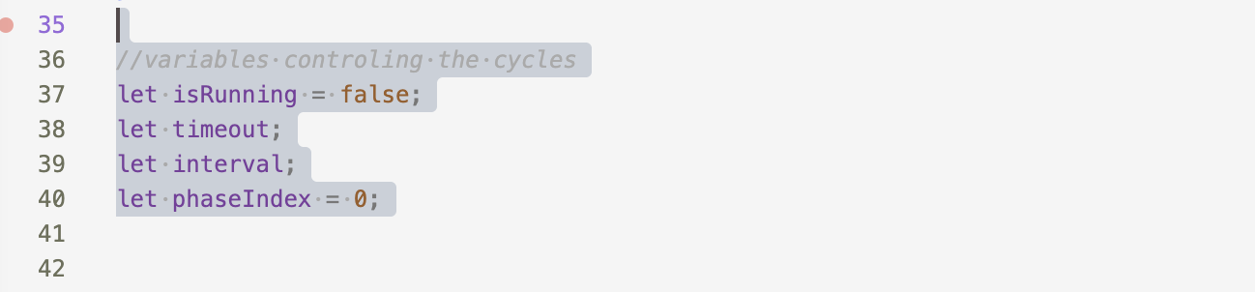

These variables manage the execution and progression of the breathing cycle. Initially I found it difficult to synchronise the animation with the instructions and the timer. Early versions of my code often resulted in inconsistent behaviour, where the animation would not match the instructions properly or the timer would reset at the wrong time. This made the feature confusing to use and highlighted that my logic needed to be improved. To address this I restructured the animation logic by using predefined breathing patterns. Each pattern was stored as an array of objects, with each object containing the instruction such as “Inhale”, “Hold”, or “Exhale” and a time value.

A key design decision was the use of structured JavaScript objects to represent both breathing patterns and difficulty levels. The ‘levels’ object maps the users selected difficulty options to values which are then used to dynamically adjust the speed of the breathing cycle. Similarly, the patterns object defines each breathing technique as sequence of phases with each phase containing instruction text and a time duration.

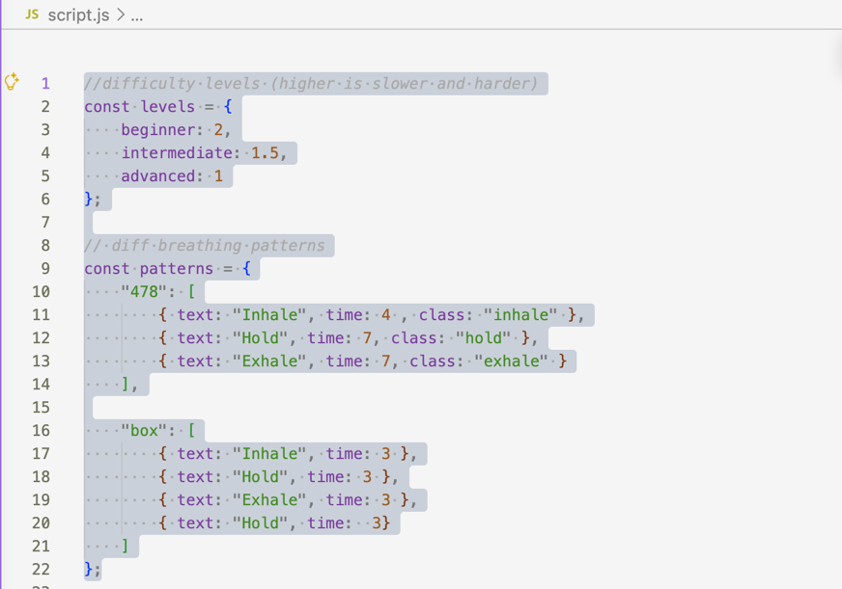

Another issue I encountered was with the start and stop functionality. At first, clicking the “Start” button multiple times caused multiple timers to run at once, which made the animation behave unpredictably. Similarly, the “Stop” button did not fully reset the animation, leaving some processes running in the background. I resolved this by introducing a Boolean variable to track whether the animation was currently active and by using clearTimeout() and clearInterval() to stop any running timers when needed. This ensured that only one animation cycle could run at a time and that it was more stable overall.



In addition to the animation, I also implemented validation within the breathing tools section. Users are required to select both a breathing method and a difficulty level before starting the exercise. In earlier versions, users could continue without making these selections which caused errors in the program. To fix this I added validation checks that display clear error messages if required inputs are missing. These messages are updated dynamically giving immediate feedback and improving the overall usability of the feature.

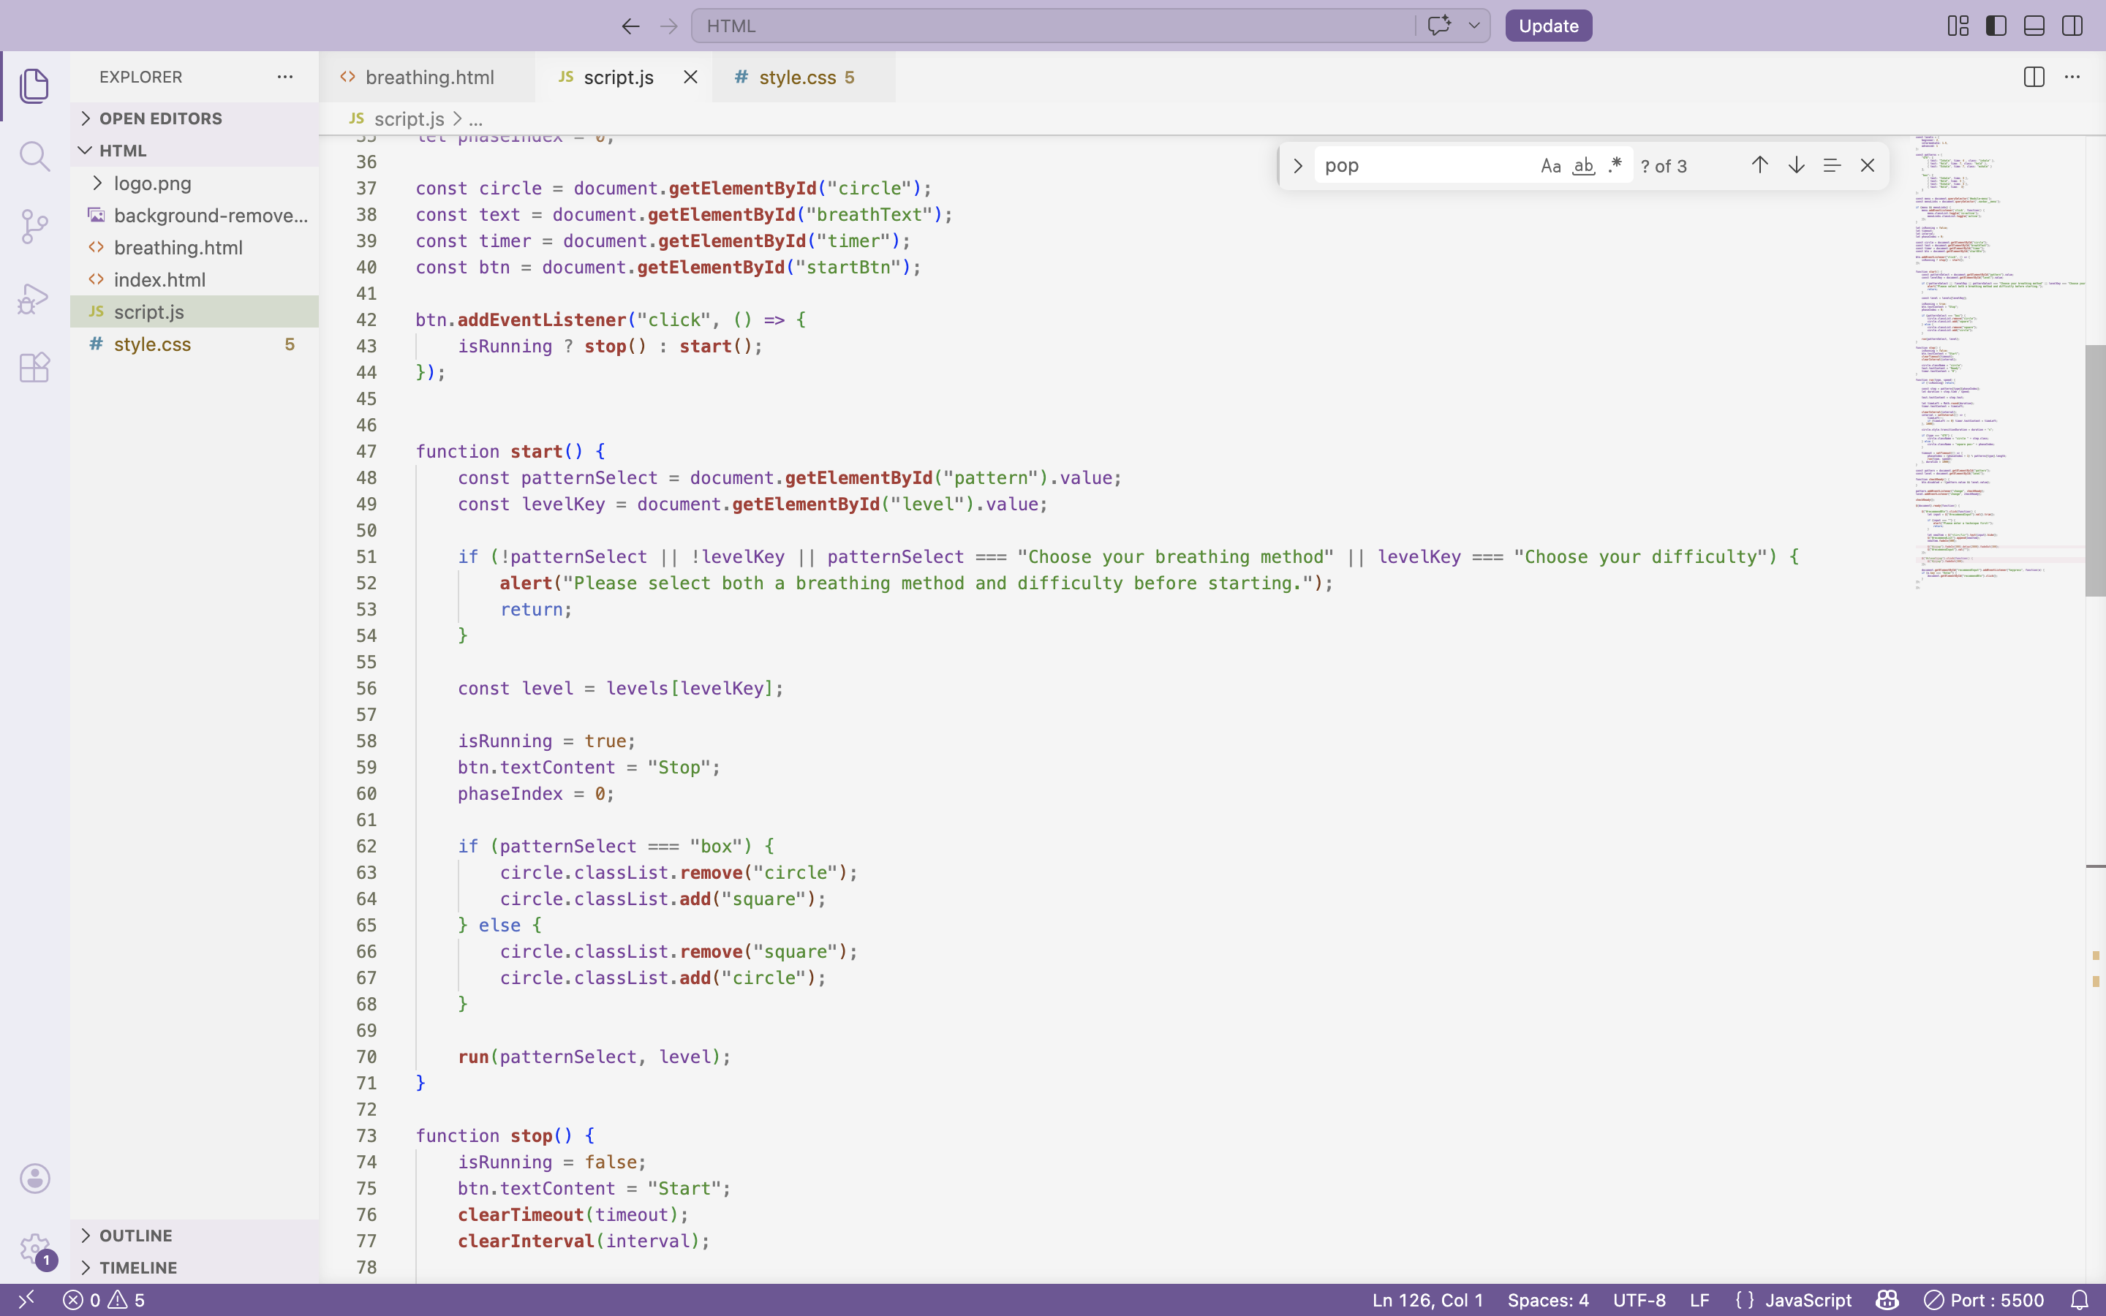

I implemented hover effects on my buttons so that it is clear to the user what they are selecting, increasing user engagement.

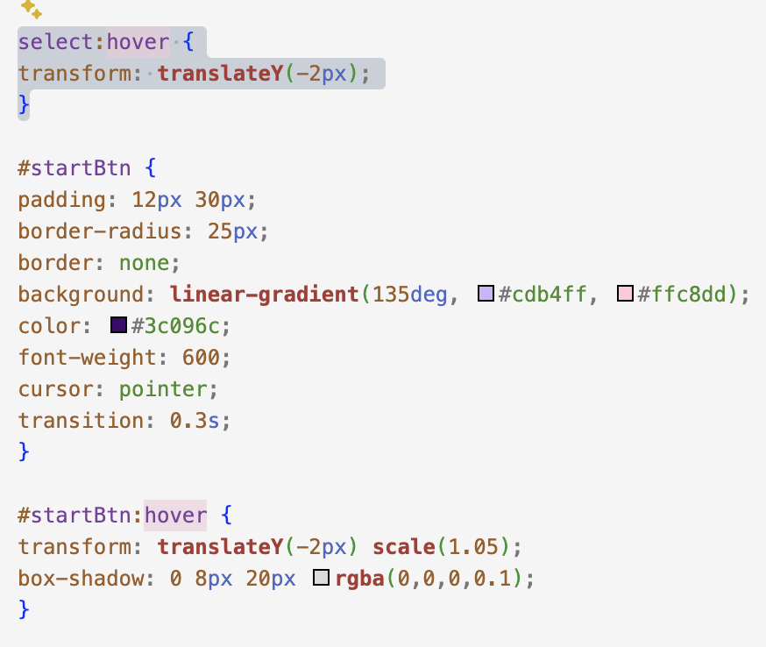

I also developed a recommendation feature that allows users to submit their own breathing techniques. This involved dynamically adding new items to the page using jQuery. Initially the feature allowed for empty and duplicate submissions, which reduced its effectiveness. To improve this, I added validation to trim whitespace, check for empty inputs and prevent duplicate entries by comparing the new input with existing list items. The recommendation system demonstrates dynamic DOM manipulation using jQuery.

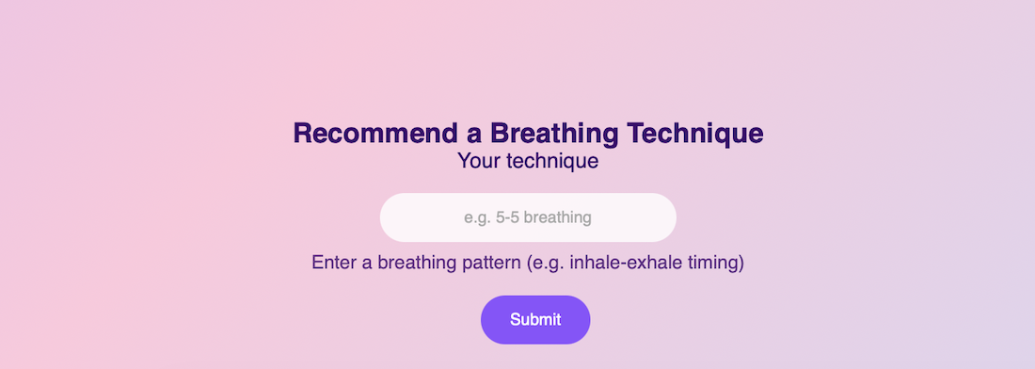

When a user submits a new breathing technique, the application validates the input, checks for duplicates, and then updates the interface in real time without refreshing the page. This improves user experience and reflects modern web development practices. The inclusion of visual feedback through animations and popups further enhances interactivity.
I would have preferred to have had more than one jQuery implemented, but I needed to balance my workload and have a good well-rounded webpage. If I was to work on this further or have more time this is definitely something I would have done. Having to work on other coursework and study for other exams meant that I couldn’t devote all of my time to this page.

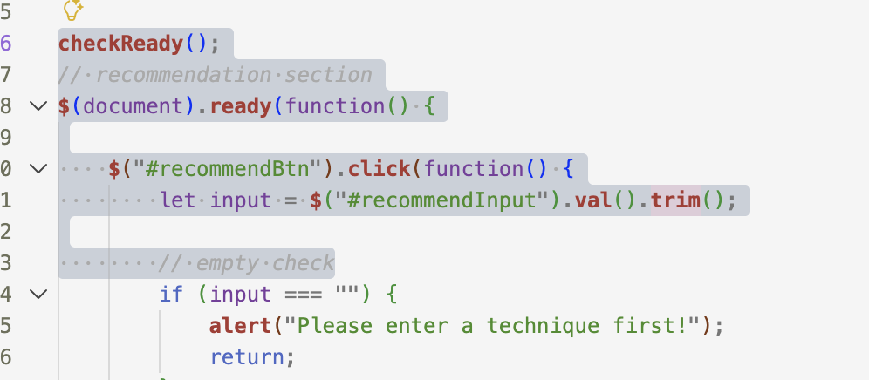

To make the interaction feel more engaging I added a popup confirmation message when a user submits a recommendation, providing clear feedback that their input has been received. These small details help improve the overall user experience and make the website feel more responsive.
From a visual perspective, CSS transitions and transformations were dynamically controlled through the JavaScript. As well as the circular animation a box breathing technique was implemented using a square that moves between positions. This was achieved using CSS transformations.
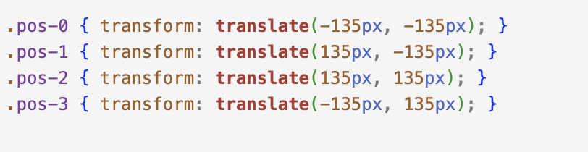

I also made the Favicon so that it was visibly identifiable to users instantly among multiple open browser tabs. It also acts as a reinforcement of our brand identity, acting as a miniature logo.

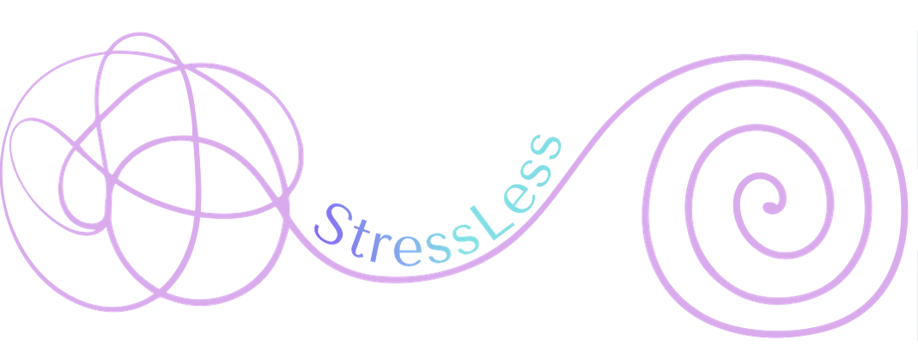
(Logo)


(Favicon)

From a design perspective, we intentionally aimed to develop the webpage with calm colours. We did this to keep the interface simple clear and calming. I used a soft gradient colour scheme with shades of purple, pink and blue to reflect the theme of relaxation, (135deg, #cdb4ff, #ffc8dd, #bde0fe). Research suggests that colours directly impact a person’s emotions therefore a gentle palette was selected to align with the purpose of stress reduction The layout was designed to centre the main breathing tool so that it is easy for users to focus on the primary function of the site. Additionally, consistent font usage and rounded UI elements were implemented to create a modern interface. This design approach ensures that users feel comfortable and not overwhelmed when interacting with the application. However, achieving this layout was not as straightforward as I initially thought it would be. My initial use of absolute positioning caused alignment issues and overlapping elements. I later switched to using Flexbox, which allowed for better control over positioning and made the layout more consistent and easier to manage. This use of flexbox significantly improved my layout compared to my original use of absolute positioning.

Accessibility and Testing

Accessibility was also considered throughout the development process. I ensured that form inputs were linked with labels and included ARIA attributes such as aria-required and aria-live to support screen readers. I also made sure that users could interact with the site using the keyboard, for example by allowing the Enter key to submit input. These decisions help make the application more inclusive and accessible to a wider range of users. These considerations align with inclusive design principles ensuring that our website can be used by a wider range of users. While ARIA attributes improved accessibility, testing was not conducted with actual screen reader users, which limits my confidence in real-world usability. I used W3schools to help me implement the ARIA attributes.

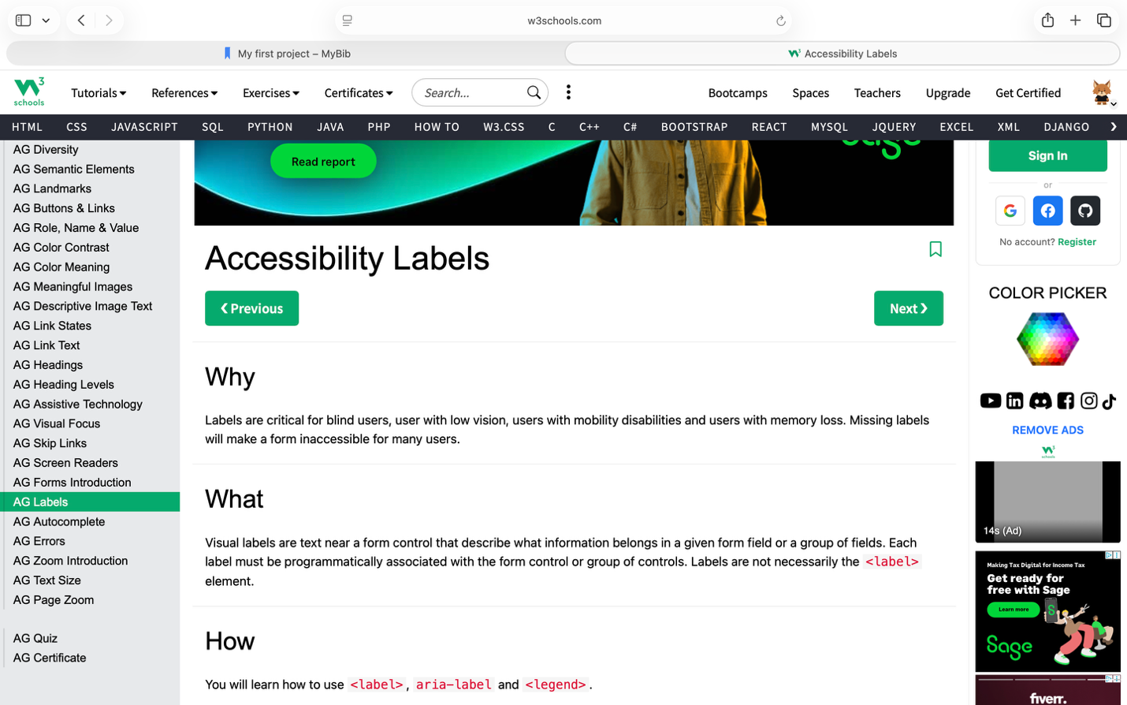

Testing was carried out continuously during development. I tested different user inputs to ensure validation worked correctly and checked that the breathing animation behaved as expected under different conditions. I also focused on identifying timing issues, as these had a direct impact on the user experience. Testing was mainly carried out on desktop devices and changes were made based on any issues that were identified. However, there was limited mobile testing which may affect performance on smaller devices highlighting an area for future improvement.

Overall, this project was a valuable learning experience both technically and in terms of teamwork. It helped me develop a stronger understanding of JavaScript particularly when working with timing functions, DOM manipulation and event handling. It also highlighted the importance of planning, communication and dividing tasks effectively within a group. If I were to continue developing this project, I would focus on improving responsiveness for mobile devices, adding more advanced validation and implementing a way to store user input permanently. These improvements would further enhance both the functionality and user experience of the application. The interface was designed with usability in mind, ensuring that all key features are easily accessible. Clear labels, consistent styling, and immediate feedback help users understand how to interact with the system. However, further improvements could include accessibility enhancements such as more keyboard navigation. We used GitHub put everything together, although I did not understand how to use it during development I just uploaded all of my work at the end instead of gradually adding things in as I developed it. When working in a group in the future I would learn how to use GitHub more effectively.

Reference list
Codynn (2025). Build a Breathing App with HTML, CSS & JavaScript | Beginner Project + JS Tricks Explained. [online] YouTube. Available at: https://www.youtube.com/watch?v=jCj56AU6Ivk [Accessed Mar. 2026].
Learn Computer Academy (2025). Calm in Code: Building an Interactive Breathing Exercise Web App. [online] DEV Community. Available at: https://dev.to/learncomputer/calm-in-code-building-an-interactive-breathing-exercise-web-app-4433 [Accessed Mar. 2026].
London Image Institute (2020). Color psychology: How Do Colors Affect Mood & emotions? [online] London Image Institute. Available at: https://londonimageinstitute.com/how-to-empower-yourself-with-color-psychology/ [Accessed Apr. 2026].
Shneiderman, B. (2016). The Eight Golden Rules of Interface Design. [online] Umd.edu. Available at: https://www.cs.umd.edu/users/ben/goldenrules.html [Accessed Apr. 2026].
W3Schools (n.d.). Accessibility Labels. [online] www.w3schools.com. Available at: https://www.w3schools.com/accessibility/accessibility_labels.php [Accessed Apr. 2026].
W3Schools (n.d.). CSS 2D Transforms. [online] www.w3schools.com. Available at: https://www.w3schools.com/css/css3_2dtransforms.asp [Accessed Apr. 2026].

