Group 39 Individual Report – Lily Lockhart, B01016864
INTRODUCTION
For our coursework 2 as a group we decided on a mindfulness website that aims to reduce stress and anxiety around schoolwork which is where we came up with the name Stress Less. Stress is something that everyone deals with so we thought we could offer a site with a range of services to help reduce these anxieties. Our main focus for this project was to provide a good user interface and user experience along with consistency and accessibility such as including alt tags for photos. We were trying to implement as many of Shneiderman’s eight golden rules as possible because these are the crucial foundations for providing a user-friendly website.

REQUIREMENTS
In our first meeting we researched likeminded websites and came across mind.org where we took creativity from it in regard to what pages we should include and what features we thought looked good such as a “back to top” button and a virtual assistant chat box. With this in mind we decided our website should consist of five pages: Home, about us, coping tools, resources and a contact page. Other requirements we thought would be good to implement was providing our users with a chance to give feedback allowing user interaction and a chance for them to suggest improvements for our website. Other requirements we thought could be useful were a hamburger menu, a navigation bar at the header as this makes it easier for the user to navigate between pages and button hover effects. Since we wanted to provide a calm, peaceful environment it was decided that pastel colour scheme would be best way to implement this, so we decided on #FFE7FD as our background colour and a gradient of this for the breathing techniques. We also used Miro as our collaborative tool to store all ideas so when it came to implementing them, we could refer back. In our second meeting we decided it would be best to split the workload into pages and as a result, I was assigned the home page. A wireframe was created on Canva to help provide a visual aid and what the main page should look like.
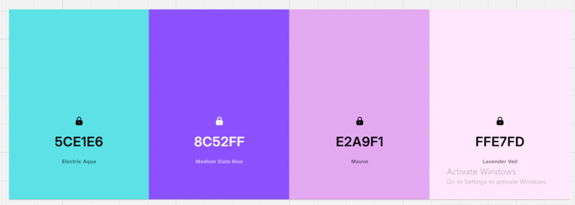
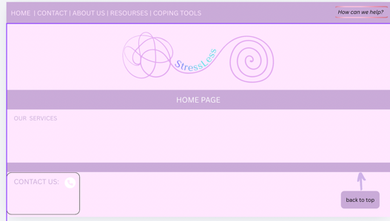
Canva wireframe: Colour scheme:

DESIGN
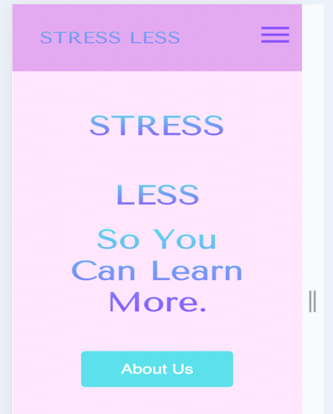
For the creation of the home page, I used a range of tools consisting of HTML5, JavaScript, CSS3 and jQuery along with Visual Studio Code and GitHub to combine everyone’s work. Being tasked with the home page meant it was crucial everything looked appealing and pleasing to the eye which as a result would entice users to explore more of the website and see the services we have to offer. To attain this idea, I created an inviting hero section which was done by using a container. The container was formatted so it controlled how my text and image sat. This along with the background image selector allowed me to generate the gradient for the text creating a warm and inviting environment for our clients. I also provided an “about us” button below so if users had any inquiries at the start, they would hopefully be answered in that page aiding accessibility. A problem I ran into when developing this was when I went to split screen the text and image started to overlap. To combat this, I added media queries throughout the home page to change the layout to a single column on smaller screens so it would be more responsive.
Media query in action
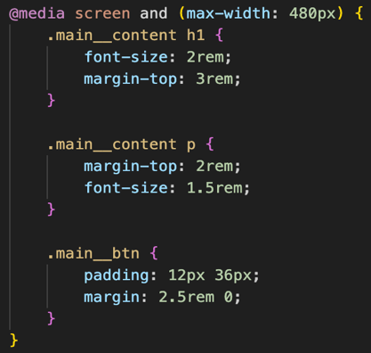
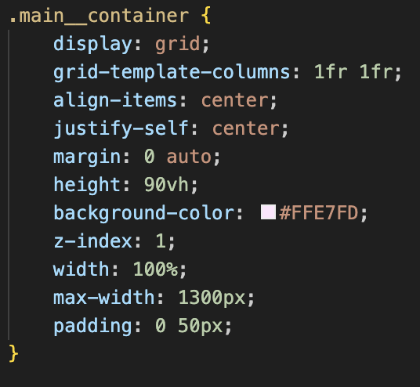

To aid navigation and accessibility in the website, I designed a fully functional header and footer which was shared on GitHub so everyone in the group could download and use further aiding the consistency of each page. The navigation bar provides full and easy navigation around the website. To make it fully functional and more responsive, when the user goes into split screen mode it automatically turns into a hamburger menu because likewise with above, the text started to become cramped and unappealing to the eye. JavaScript was used to implement this through an event listener which detected when the navigation menu icon was clicked. By doing this the user can now still easily move between the different pages. Another feature of the navigation bar is that when the user scrolls down the page it will still remain at the top further aiding functionality. With the footer it consists of the “most popular” links such as FAQs and social media links, further enhancing responsiveness and useability to the website.
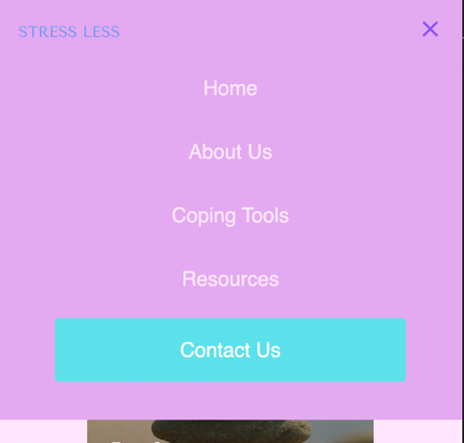
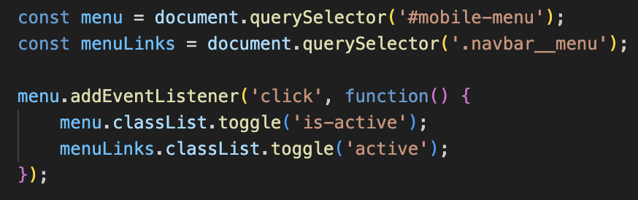

To show off what services we have to offer I thought it would be best to implement these using cards since it helps to structure the content better in terms of organising information clearly, improving readability and focus and helping to guide user action since there is a button at the bottom of each card to guide users to each service available. To make this section feel more modern I added hover effects over each card with the hope of improving engagement as it makes users feel like they are being enticed to click on the button and explore.
Example of hover:
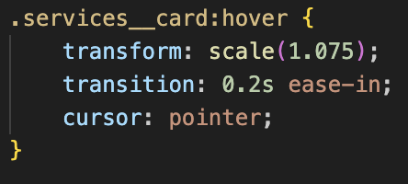
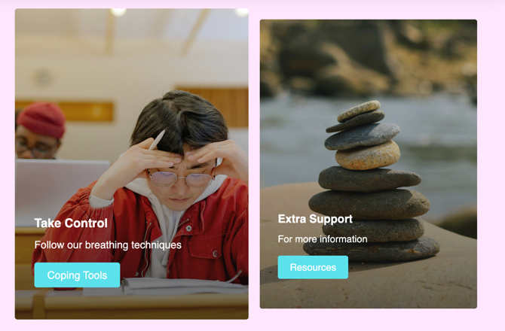

When creating the buttons I made sure they followed the same structure to keep a consistent and professional feel to the page. To make this feature even more engaging, I decided to add hover effects that were implemented in CSS using the :hover class. I opted for a transition to make it smooth instead of instant because it draws the users’ attention gradually. Using smooth animations also make the website feel more modern and of a higher quality.
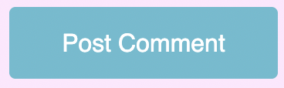
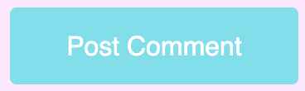
Example of hover effect:

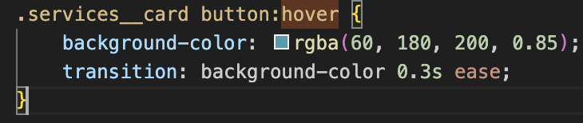

Although the hamburger menu and cards were the main way in which I fulfilled my user requirements for the home page I also included other features which assisted me in improve functionality and accessibility. I decided to add a student testimonial section along with a “leave your own comment” feature where students could post comments to the page. To add new comments to the webpage I used a jQuery. By doing this it further aids user involvement due to the option of feedback providing a sense of community and therefore possibly leading to return use. Since it was created using the form element, I ensured that I used validation meaning the form could not be submitted without input. To further validate it even after the user hits post another check comes up confirming if they want to post it or not.
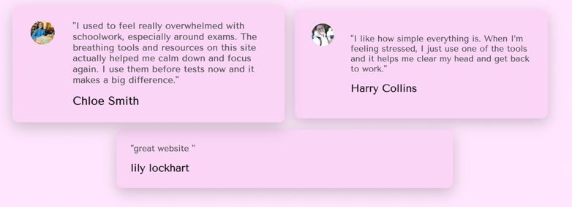
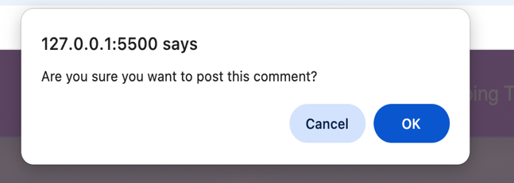
Pop up check: Comment added:
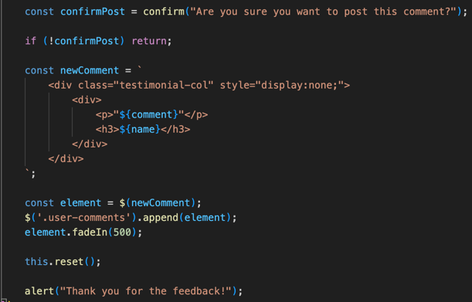

Another interactive feature that was a good addition to the website was the virtual chat box that Rosie created for the contact page. With the aim of a user-friendly system in mind we decided to implement this feature on all of the pages because it provides them with constant access to help and with this reduces user frustration. Since our website is about reducing stress, it fits with the image and makes it more effective. A feature that I changed to the chat box was when the user clicks on the button, it opens to the left instead of the right. This was so it doesn’t interfere and block the “back to top” button that Joe created and enhances user experience by making the feature constantly accessible. However, a problem with this chat box is that it may not be clear that it’s a help chat box and so as a result this helpful feature may go unrecognised.
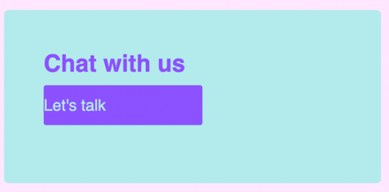
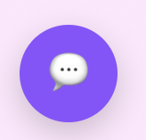
Chat box in contact page: chat box in other pages:

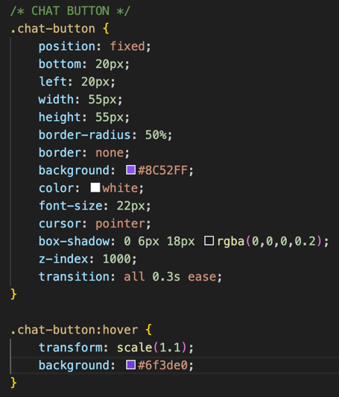

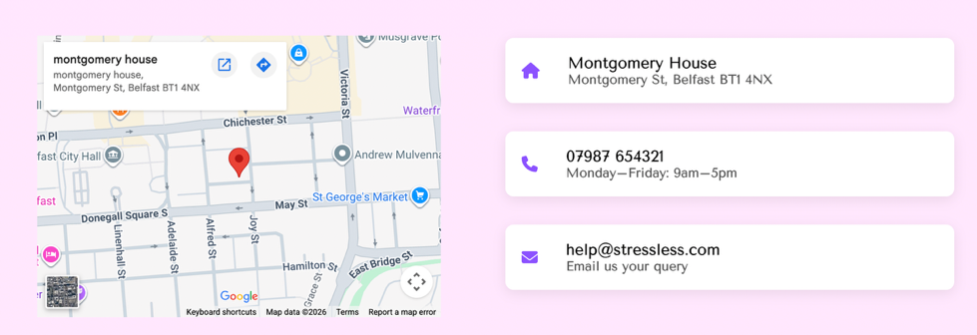
To further assist the idea of a user-friendly system, I adopted a “reach out” section to provide users with clear and accessible contact information. To attain this, I added an embedded map which shows the location and contact details which use a flexbox layout to organise the content side by side. I styled this section to make it visually distinct from the rest of the page which helps to draw attention and ensure users can easily find information. Likewise I also implemented media queries to allow the layout to adapt on smaller screens.

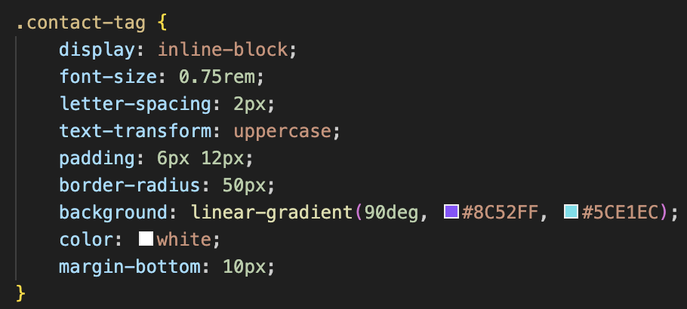

I created a quote box using JavaScript to display motivational messages to users. When the button is clicked, a random quote is selected from an array using a random number generator and displayed on the screen. This adds interactivity to the website and provides users with positive reinforcement, which supports the overall theme of stress reduction. The feature improves user engagement by allowing users to generate new messages whenever they choose. However, a problem I ran into with this is that since the quote box uses a fixed array of messages, users will see the same quotes repeated which can make the feature feel less engaging if clients are constantly using it. If I had more time to do this again, I would link the quotes to an external database or categorise them based on mood or context, so it doesn’t become repetitive.

IMPLEMENTATION
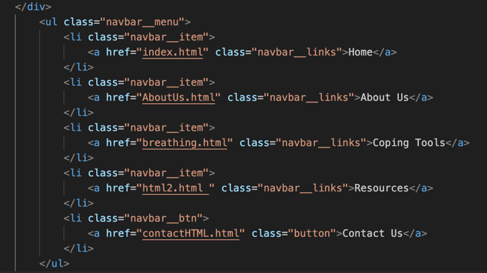
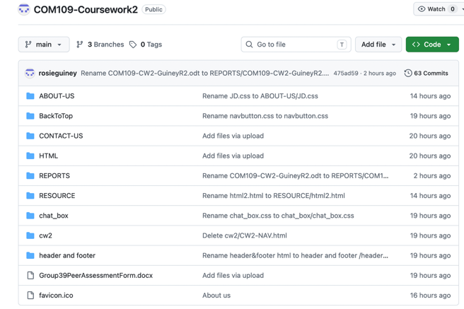
As a group we decided on the final date that we would have our webpages complete and uploaded this to GitHub. This allowed for ease of use as every member could see what was uploaded and when. It also made it easier for me to connect everything together in the navigation bar to make the website complete and seamless. Using GitHub meant that there was always an extra copy in case something got corrupt or it failed. The webpages were linked using the href element in the navigation bar.

TEST
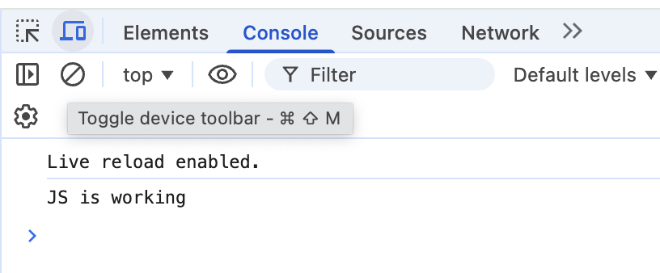
To ensure my webpage worked as it should, I carried out a number of tests. The first one was to ensure that my JavaScript link was working in my html document. To carry out this test I used a console log to confirm it appeared in the console and so consequent JavaScript would work.

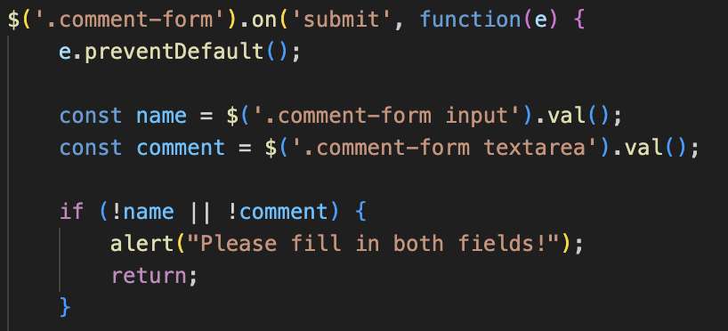
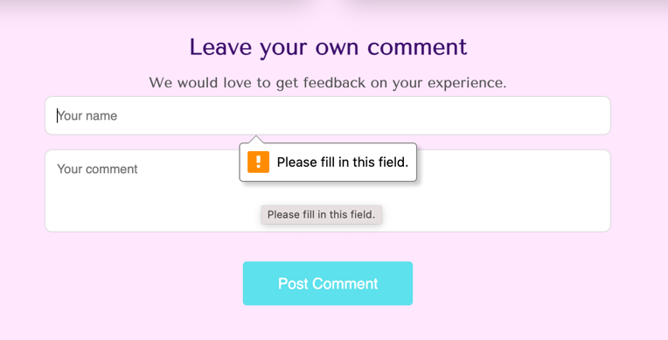
The second test was to ensure that in my “leave a comment” feature, I couldn’t submit it with the fields blank. To achieve this a jQuery was used with this implementation for checking if the fields are empty and using DOM manipulation to add the new comments dynamically. It also makes sure the form is reset afterwords.

Another test that I carried out was to make sure that the navigation links actually worked in the header like they were supposed to. To test this I simply clicked on every link and made sure it took me to the correct place on the webpage.

OVERVIEW
Overall, we worked well as a group with constant communication and feedback with each other on WhatsApp and GitHub. Over coursework 2 we were able to create an interactive and user-friendly system that could obtain user feedback and met our requirements outlined at the start. If I was to complete this project again, I would consider implementing different features such as a dark mode or even interactive map improvements such as allowing users to search for locations or get directions.

Reference list
Design, B. (2020). HTML CSS and Javascript Website Design Tutorial - Beginner Project Fully Responsive. YouTube. Available at: https://www.youtube.com/watch?v=FazgJVnrVuI [Accessed Apr. 2026].
Easy Tutorials (2021). How To Make Website Using HTML & CSS | Full Responsive Multi Page Website Design Step by Step. YouTube. Available at: https://www.youtube.com/watch?v=oYRda7UtuhA [Accessed Apr. 2026].
Krukau, Y. (2021). Woman in Blue Long Sleeve Shirt Sitting on Chair · Free Stock Photo. [online] Pexels. Available at: https://www.pexels.com/photo/woman-in-blue-long-sleeve-shirt-sitting-on-chair-8199559/ [Accessed Apr. 2026].
Krukau, Y. (2022). Man in Red Jacket Studying at a Classroom · Free Stock Photo. [online] Pexels. Available at: https://www.pexels.com/photo/man-in-red-jacket-studying-at-a-classroom-8197500/ [Accessed Apr. 2026].
Milada Vigerova (2022). Photo of Stacked Pebbles · Free Stock Photo. [online] Pexels. Available at: https://www.pexels.com/photo/photo-of-stacked-pebbles-13032613/ [Accessed Apr. 2026].
Natan Karnushin (2021). A Man Smiling at the Camera · Free Stock Photo. [online] Pexels. Available at: https://www.pexels.com/photo/a-man-smiling-at-the-camera-9568826/ [Accessed Apr. 2026].
w3Schools (n.d.). jQuery Tutorial. [online] www.w3schools.com. Available at: https://www.w3schools.com/jquery/default.asp [Accessed Apr. 2026].

