COM109 Coursework 2 – Rosie Guiney’s Report

Introduction
For this coursework our group choose to create a website revolving around mental health support, we thought this would work well for the coursework as we could meet all of the criteria and create a design without too much difficulty or it being too easy. My group consists of five members (Me, Lily, Siân, Joe & Malak) and during our first meeting we decided on some basic details for our website such as the name, logo, colour scheme and what pages we would like to include. We also created a WhatsApp group so we could communicate easier and created an area on GitHub to upload our code though none of us have used it before, so it was quite confusing. We used the app/website Canva to help design our logo and we used the website Miro to help plan everything else.
Before we came up with the basic design, we looked at similar websites to get an idea of what we should include on each page. We split the workload so that each of us would do one webpage each and we spun a random wheel to decide who would do each page to make it fair – After this we started the code. A few of us including myself designed our own navigation bar which probably wasn’t necessary as we ended up just choosing one to keep our website consistent. During our coursework we had a 2-week break for easter so we ensured that we had everything we needed so that we could work individually on each page as it would have been challenging to meet up during this break. During this break we kept each other updated and once we came back we met up a few times to connect each webpage together and add final details.

Navigation Bar & Footer
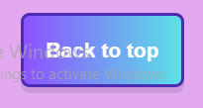
The navigation bar and footer for our website were created by Lily. It is the same on every page to keep it consistent and it is very clear and accesible to users trying to navigate our website. The footer includes quick links that make it easy for users to find specific resources.
Joe created a back to top button which appears once you try scroll down on the website – we added this to make it easy for users to return back onto the top of the page. This would be useful if they wanted to reach the navigation bar to quickly change page.

Contact page
This will be the largest section in this report as it was the page that I developed. I used HTML, CSS, JavaScript and jQuery to develop my webpage. I was happy to be able to create the contact page as I thought it would be able to implement it very well and I am happy with the outcome. My webpage has features such as animations, interactivity and form validation.
(Please ignore the “Activate Windows” in the corner of any screenshots it is part of my laptop screen and I cannot remove it)

Contact form
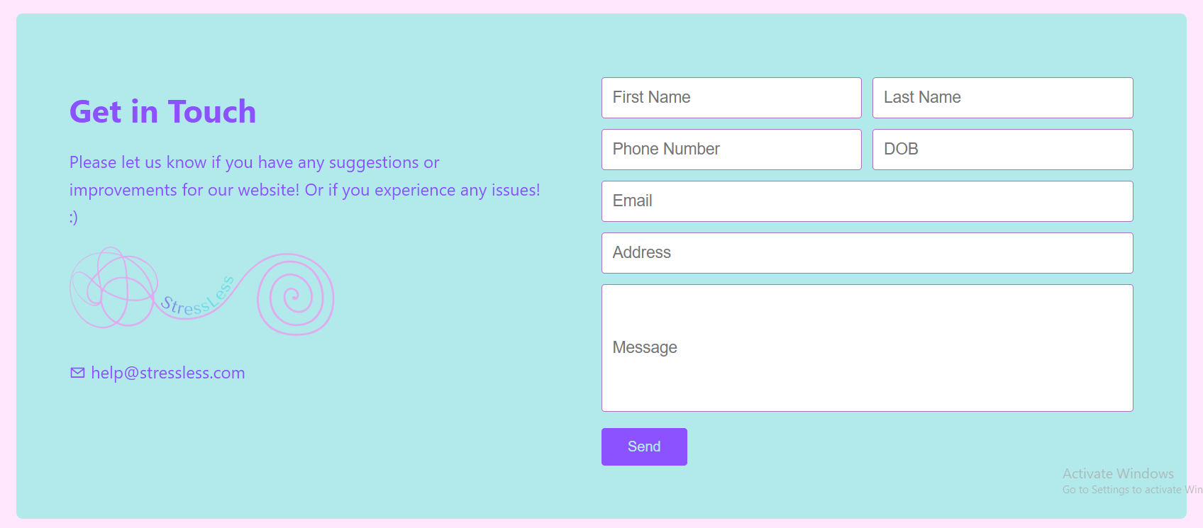
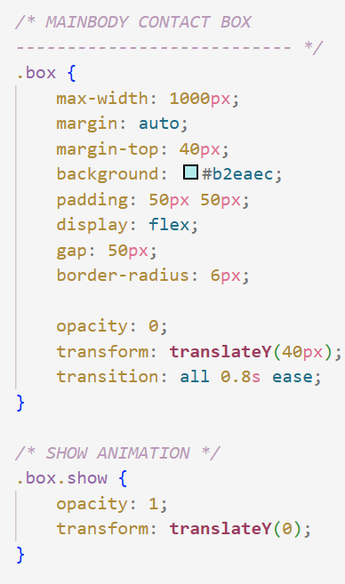
The image below shows the main part of my webpage the contact form.
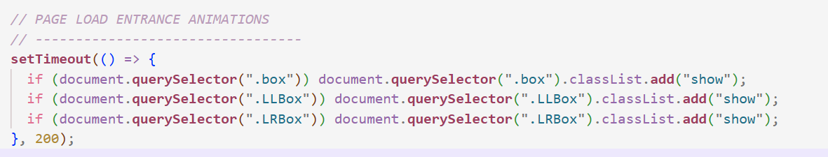
I added each section including this in a box container to make the design look clean and to separate each element. I used the colour scheme our group picked out to keep it consistent looking. I added clear labels on the form inputs using placeholder text to make is easily accessible to the user. When the webpage loads in the box has an animation where it fades in and moves up, I added this to make the website less static, and I used mainly CSS and a small amount of JavaScript to achieve this as I thought it would be the most efficient way . The JavaScript works by waiting 200 milliseconds after the page loads then checks if the box element exists and then adds the CSS Class ‘show’. The default CSS for the box element opacity is 0 so it is invisible and the transform moves the element down 40px, so when the show CSS is added it changes the opacity to 1 and transforms the box back up to its original position. I used the same code for each of the 3 boxes on this page.
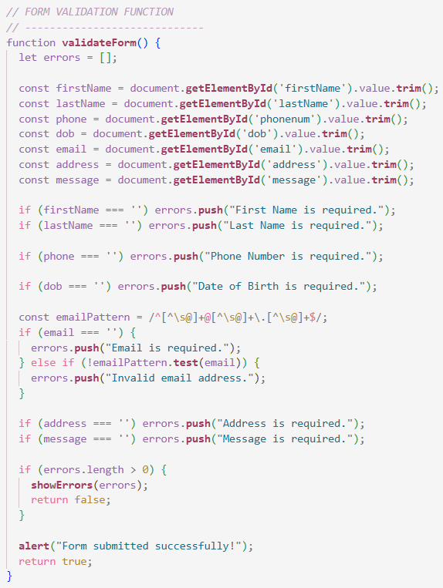
The main part of this section is the form and the form validation. The form validation was achieved using JavaScript and took me a while to get it right – specifically the error message which informs the user of any errors in the form.
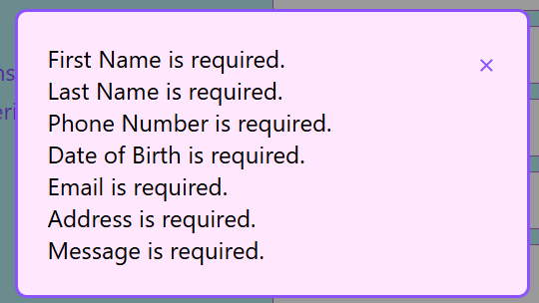
The image to the right shows the main JavaScript function which holds the code for the validation – it runs after the submit button is clicked. I added a hover animation and a submit animation to the button to make it clear to the user that it works. This code works by creating a variable for each value entered into each form box and then uses if statement to check if it matches the requirements. Each element is required so it will check to see if the variable is empty or not, the email one also checks to ensure it has a valid email. If there is no errors then an alert pops up to inform the user the form has been submitted successfully – if there is any errors then each error message is added to a list and this list will then pop up in a box on the screen which the user can then close using the X in the corner after they have read it. As the user fixes the information in the form and resubmits the error messages will no longer appear.
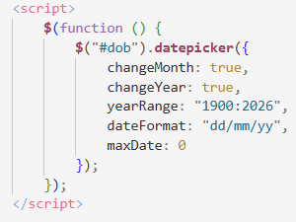
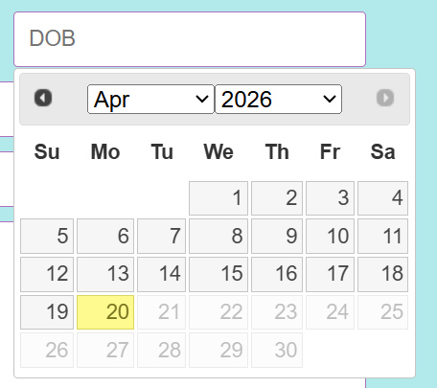
I used jQuery for the DOB which is why there is not much validation in the JavaScript for it. It was easy to use jQuery as it makes it much easier for the user as they can pick a date off the calendar instead of typing it in manually – this makes the website more accessible and it is very user friendly. The jQuery also ensures that the date is not a date from the future as that would not be a valid DOB. jQuery is great as it makes some tasks a lot quicker and easier to do as I was able to do this in only a few lines, unfortunately this was the only jQuery I added to my webpage as I was unsure where else I would be able to add it or found it easier to not use it. Maybe if I had of had more time I would of found more ways to include jQuery but I was working on other bits of coursework at the same time so my time was limited.

Chat bot
The next section of my webpage includes 2 more boxes – these were originally not part of my design but I felt like it needed more.
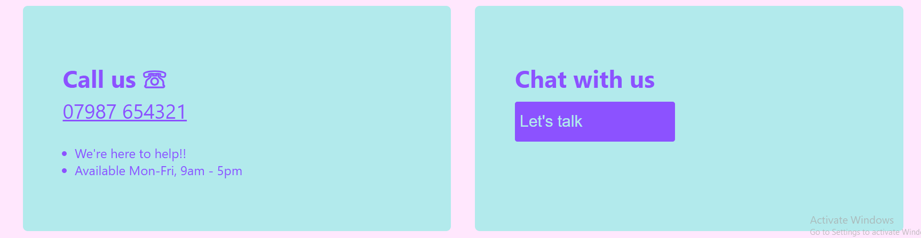
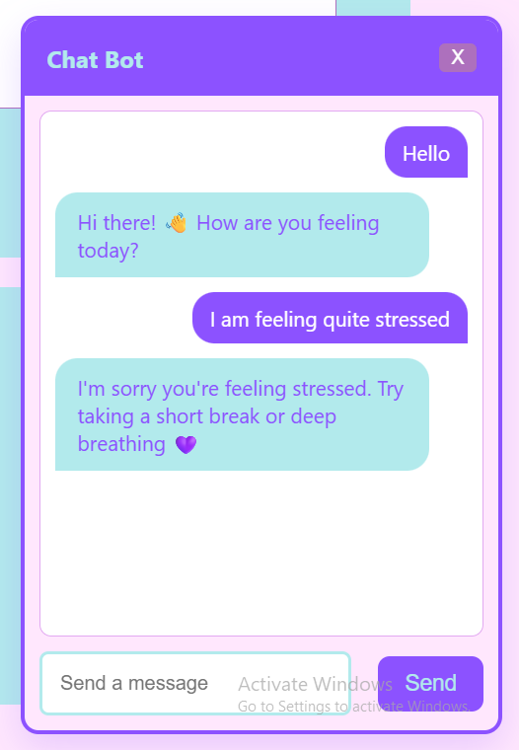
The first box is just a simple box with text in it. The box on the right has a button which when clicks opens up a chat bot popup – I decided to add this as when researching other websites, I found that a lot of them had one of these. I found this quite challenging to do but I do enjoy a challenge, so I didn’t mind it. There were a few parts of this I struggled with and had to get a small amount of help from AI to fix things. This Chat bot works by allowing users to send a message which appear to the right and then is followed up by a pre-made message on the left, there is a few variations of messages and will change depending on certain words sent by the user - for example a message containing ‘stress’ will have a different message.
I used CSS to style this to match the rest of my webpage. I used a large amount of JavaScript for this section as there was multiple buttons and the response feature require a lot of JavaScript Aswell. While reflecting on this I think it would have been cool to make this box draggable so that the user can move it around the screen but I think this might be too advanced for me to do.
Some more of the features this chat bot has is that the messages are animated when they appear and there is a slight delay when the bot message appears to simulate it thinking and writing the message itself – it is also possible to send a message by hitting the enter key Aswell as the send button as this is a common feature on other websites. As messages are sent they will automatically scroll to the latest messages sent so as not to confuse the user where their message went, this was very easy to do as it only requires one line of code and makes a big difference to the user.
For each of the boxes I made them flexboxes using CSS to hopefully keep the layout responsive and so that it adapts to different screen sizes.

Testing
Since the contact form had a lot of validation, I had to test it multiple times with incorrect data and correct data to ensure the validation worked properly. I also tested the chat box by entering in different phrases with the keywords and without the keywords it looks for to see what the response would be and to ensure that it was the correct one.

Other pages
The page that I developed was the contact page, but the other pages included on our website were the home page, about us page, coping tools page and resource page. These were the pages we felt were crucial for our website. Each of us kept a consistent colour palette and similar design to make the whole website feel very consistent.

Conclusion
Overall we spent a lot of time and effort on our website with actual passion to have a good outcome, although there is a few things we might change we are pleased with how our website has turned out and we believe it meets each condition as it is accessible, has interactive features, has good validation, use of jQuery and consistency. We used the website w3Schools to help us code some parts of our website when there was bits, we couldn’t fully do ourselves as it was very helpful.
We tested each webpage multiple times to ensure that everything worked well and we used GitHub to share our code with each other. I believe we worked very well as a group, and the good collaboration improved the quality of our website.

References
Canva (2025). Canva. [online] Canva. Available at: https://www.canva.com/.
GitHub. (n.d.). GitHub: Let’s build from here. [online] Available at: https://github.com/dashboard.
Miro (2022). Miro. [online] Miro Available at: https://miro.com/app/dashboard/.
OpenAI (2025). ChatGPT. [online] ChatGPT. Available at: https://chatgpt.com/.
W3Schools (2025). W3Schools online web tutorials. [online] W3schools.com. Available at: https://www.w3schools.com/.
‌

‌

‌

‌

‌

