Joseph Davidson Individual report
For this project, I made use of multiple web technologies in the About Us page, being HTML5, CSS, JavaScript and frameworks including jQuery & jQuery UI, Web storage API, localStorage and regex.
The chosen brand focus for our group is on health and wellbeing. Based on this, each element of the website was created with user calming measures and website accessibility, UX design
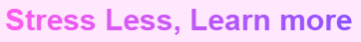
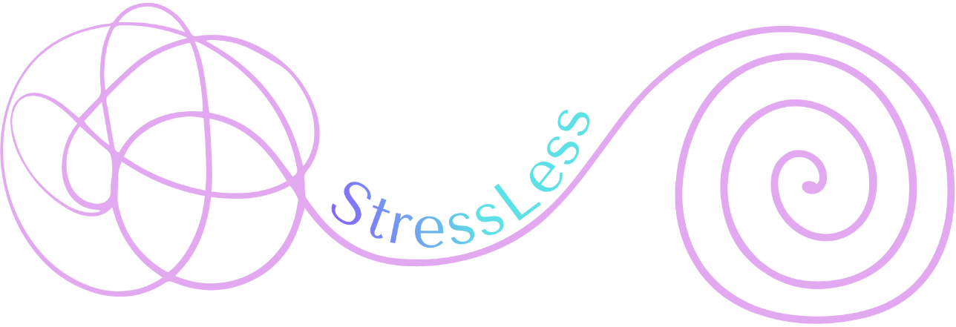
I created the slogan “Stress Less, Learn More”, taking to name company “StressLess”. As a group we looked online for the creation of our logo and decided on a template from Canva, which we adapted using our colour scheme to create this logo:
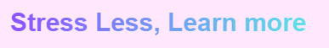
We chose this design for its clear visual storytelling & messaging that our website aims to transform mental clutter to calming clarity, shown by the overlapping squiggle lines into the StressLess brand name, ensuring a clean, minimalist design.
Contrast is created against the pink lines putting the StressLess as the solution to user’s problems. The controlled spiral on the right represents the result of the user’s journey using Stressless to improve their wellbeing.

The audience of the website was decided to be university students. I tailored the background of the company that it was made by former students, who truly understood the pressures of university life and of exams, deadlines and worries that relate to the user. “StressLess was made by students, for students”. This choice ensured to form a close connection with users.

2: Requirements
Before starting the design of our pages, each group member planned our page designs carefully to implement all of the below requirements from the specification.
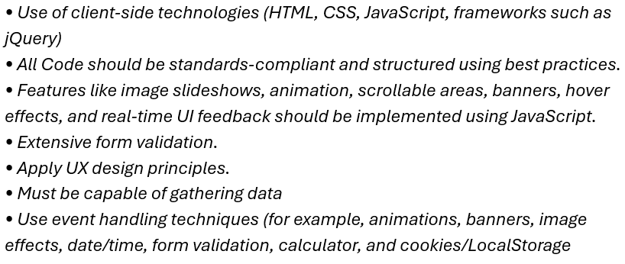

Website Design
As our branding of a health & wellbeing website, we researched services that offer support and tools for users physical and mental health that we would tailor to our own website. We ensured to have calming features from the layout of the content, the colour scheme used and UI elements that are simplistic and easy to navigate for users, which was our priority for our site.
As part of our website design, we first made sure to use the same Header/footers on each page of the website so that it is easy to navigate and a familiar layout for users. We also used the same fonts across all 5 pages for to reinforce brand identity.
User experience and interactivity was incorporated in all pages through a sticky navigation bar, ensuring primary page navigation is essential at each part of the page. Hover elements were also used for containers and buttons, signifying that these elements can be engaged with to confirm user actions. A chat bot is included in each page of the website on the bottom left side, so that users can instantly have interaction for answers. Clicking the chat circle, typing the word “stress” and hitting the send button prompts a tailored response to help the user’s wellbeing.

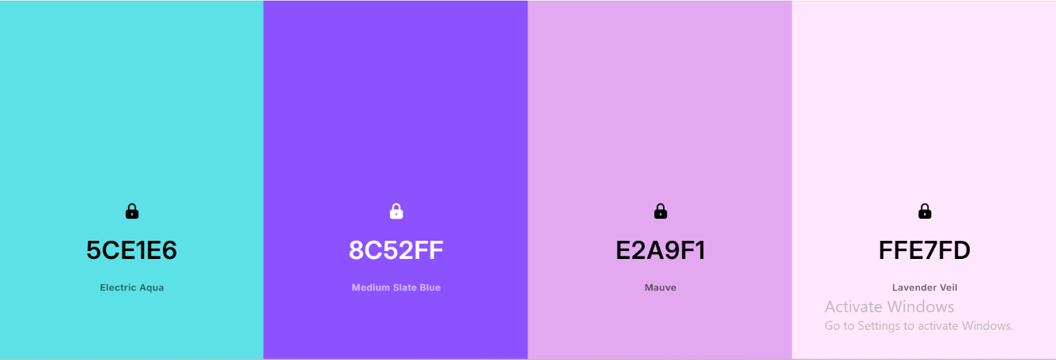
For the colour scheme, it implemented across all pages of our website, chosen as high contrast against text and images, using Electric Aqua and Medium slate blue. I additionally used “Rebecca purple” for the page dividers to create clear visual hierarchy of the page and its sections.

Below is my wireframe design for the About us page, which I used to visualize the requirements

Wireframe:
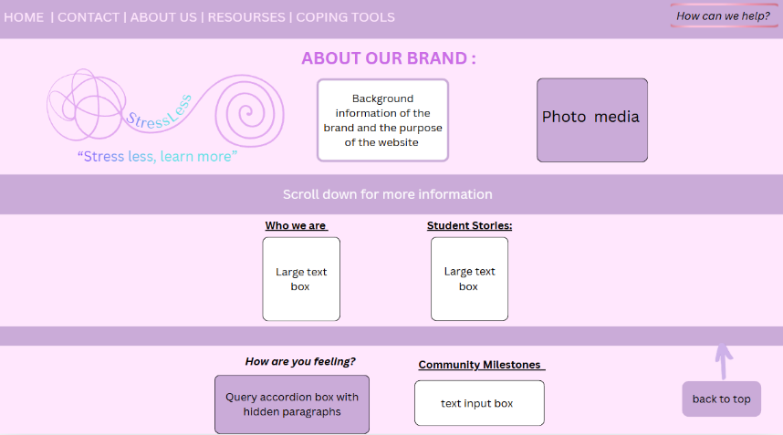


I created the slogan “Stress Less, Learn More”, which we took to name the company “StressLess”. As a group we looked online for the creation of our logo and decided on a template from Canva, which we adapted using our colour scheme to create this logo:

We chose this design for its visual storytelling that our website aims to transform mental clutter to calming clarity, shown by the overlapping squiggle lines into the StressLess brand name, ensuring a minimalist design.
This helps to create contrast and put StressLess as the solution to user’s mental health problems. The controlled spiral on the right represents the result of the user’s journey using Stressless to improve their wellbeing.
As a group, we decided on the final navigation bar which includes are logo, button links, my search bar and contact form using our cyan colour, ensuring users are drawn toward each element.

Search Bar:
For my About-us page, I implemented a search bar so that users can easily find information they are looking for as quickly as possible when they enter the website.

I had trouble in choosing how I wanted the search to look against the rest of the elements, deciding on a high-contrast white background to distinct against the purple navigation bar, to show that the search bar is interactive. On hover, the purple icon provides immediate visual feedback that the element is clickable, reducing user anxiety.

In the HTML, I used the <mark> tag to provide visual confirmation that users found what they were looking for. Using jQuery for the coding of the search bar, usability was achieved through .animate() and scrollTop, which positions the screen directly in front of the highlighted text users were looking for. I ensured constraint handling by requiring term.length > 2, so that one letter words don’t get picked up. I used a negative lookahead regular expression to ensure HTML tags and part of image sources are not highlighted, only the intended text.

Screenshot of the jQuery code of the search bar:
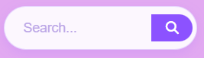
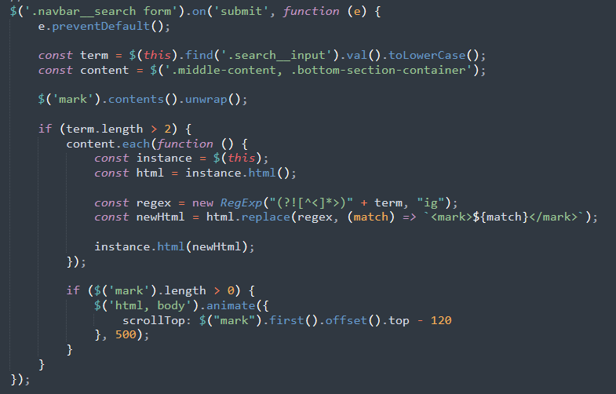
On the page:

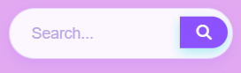
On hover:

Navigation button paragraph:
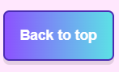
To enable seamless navigation across each page, I created the “Back to top” navigation button using an event listener that only appears visible at a 300-pixel threshold when the user scrolls down, minimizing visual clutter. I ensured the button works across different browsers e.g. chrome, Firefox by checking both document.body.scrollTop and document.documentElement.scrollTop.
To enhance interactivity, I placed the button using position: fixed; at the bottom-right of the page, following website accessibility standards. The UX was improved by enabling behaviour: ‘smooth’ to make an intuitive transition to the top of the page.

Screenshot of the JavaScript
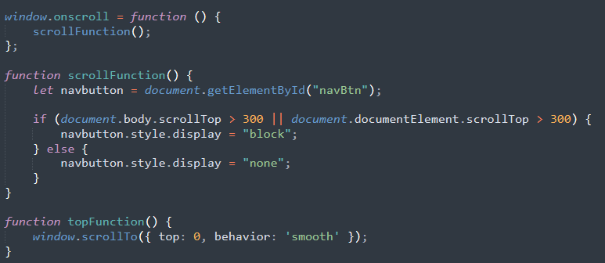

I used CSS in creating the gradient background of button, with the text “Back to top” displayed clearly for enhanced navigation for the user. On hover, a title attribute appears and the background changes from a purple border to white, confirming interactivity with this element. I included an upward movement animation using translateY(-3px), moving the button 3 pixels up. On click, the active state changes and moves 1 pixel down, mimicking the button being pressed.

Screenshot of the CSS navigation button
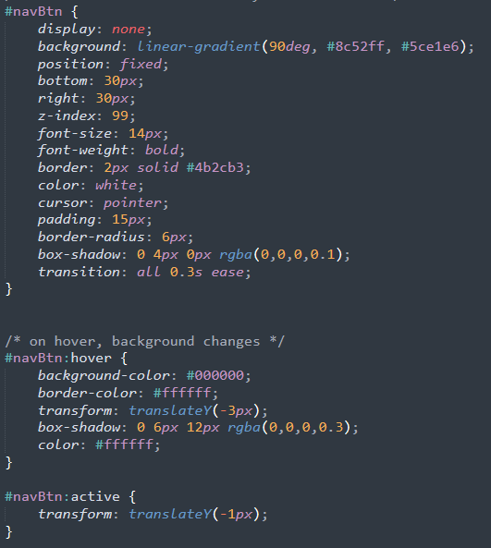
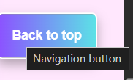
On hover

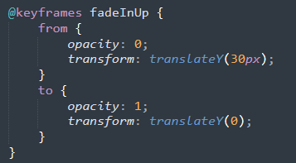
Text box paragraph:
When the user enters the site, the “About our brand” top text box grabs the user’s attention using animations including @keyframes and fadeInUp . When the page is opened, the helps to create a more dynamic user experience. The text box smoothly fades up the page using opacity and transform, establishing a professional look when the page is opened.
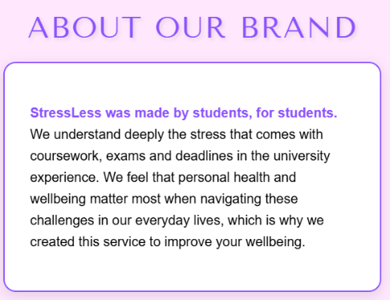


Inside the hero section on the right, I added a student support interaction photo to provide visual context of our services. The image helps to break up text, making the content easier to digest and more visually appealing. I styled the image with a 15px border and used margin-top: 60px; to so elements aren’t cluttered, being easy to navigate.

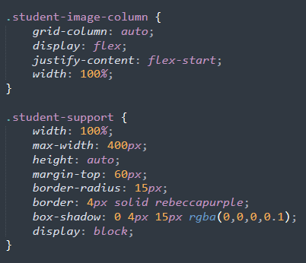
For the text of the page, I globally styled the <b> tag HTML text to the brand’s medium slate blue across the text of the page and added font-weight to the CSS. This helped to improve readability, so vital keywords are picked up with ease.
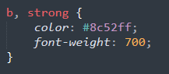

The top page divider was used to create clear visual hierarchy of the page, using the background-colour Rebeccapurple to add contrast. The “Scroll down for more information” call-to-action text ensures the user is informed at each step of the website. On hover, the colour to #5ce1e6 appears to prompt the user to scroll. Beside it, I placed arrow using the Font Awesome Library, which was very useful when adding icons to my page.


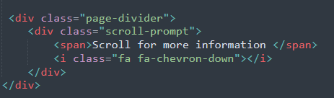

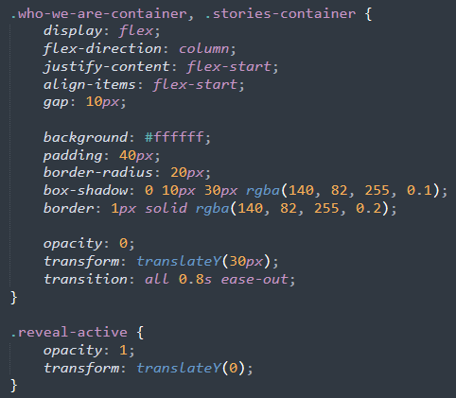
Who we are & Student Stories:
To improve UI feedback, I added a scroll-triggered reveal to the middle section of the page to ensure elements to help improve the user experience as they navigate down the page. Upon entering the page, only the top hero section is visible to the user, ensuring elements are not visually cluttered to reduce cognitive load. For this I used opacity: 0; and transform: translate(30px); and reveal-active to change the opacity and position when the scrolling action is complete.

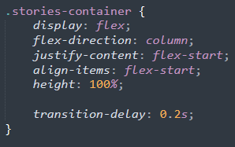
For the titles of the containers, I used Tenor Sans with text underlined. I had trouble with visualizing how I wanted it to look but settled on a CSS grid layout to create a balanced visual hierarchy between the brand information and student stories. I increased interactivity by adding transition-delay: 0.2s, to this container to create a staggered reveal effect, guiding the user to read the “who we are” container first. Whitespace is provided on each side of the containers, ensuring users are focused on those two elements.

Screenshot of the containers
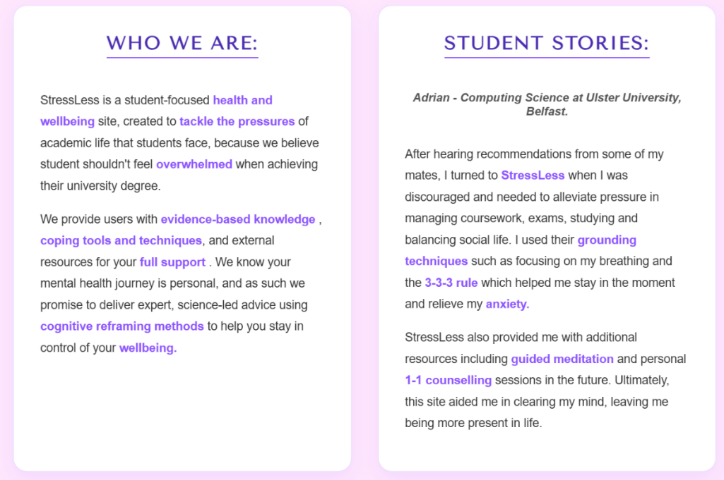

Student quote bar:
I implemented a student testimonial container to act as a visual anchor between the ‘Who we are’ and ‘Student Stories’ sections. Using a blue background, I created a calming contrast against vibrant brand colours across the page, enabling a focused environment on the quote itself. I utilized a Flexbox wrapper to define the max width and margin to be centred and responsive. For mobile optimisation, I included an @media query to maintain a high level of readability, so the quote doesn’t become cramped.
Additionally, I used a quote icon left and right from the Font awesome library, ensuring users know this is a direct quote from a student using the website. When users see that a specific named person, “Adrian” had good experience using StressLess, they are more likely to interact with the site.

Accordion:
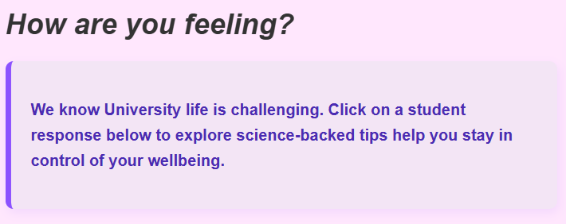
I implemented an interactive accordion section at the bottom section, providing wellbeing tips commonly asked student quotes to help improve their mental and physical health. Direct call-to-action is given, so the user know that the accordion can be interacted with.

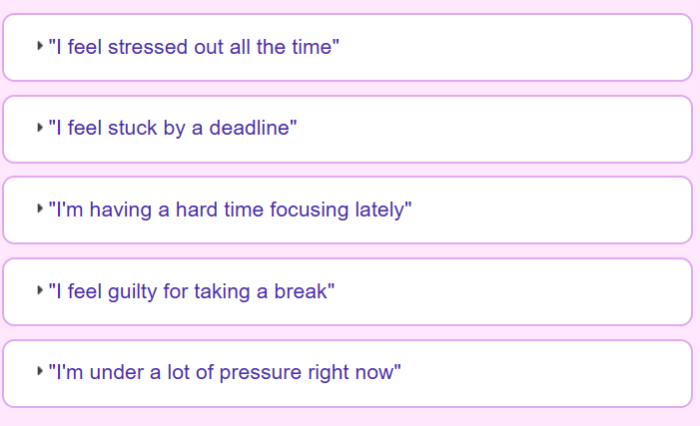
Screenshot of accordion quotes

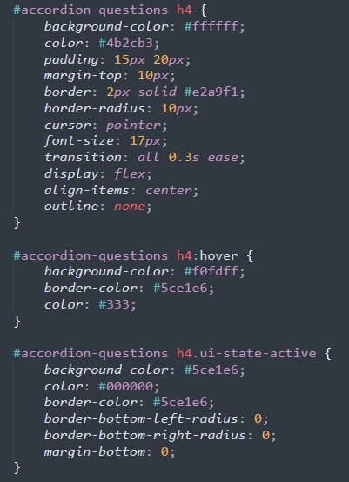

Using CSS, I added an On-hover class to each quote, changing the border cyan to encourage engagement with the accordion. Using progressive disclosure UX design, I added an On-click reveal to a StressLess curated response, so users can select the advice most relevant to their mood.

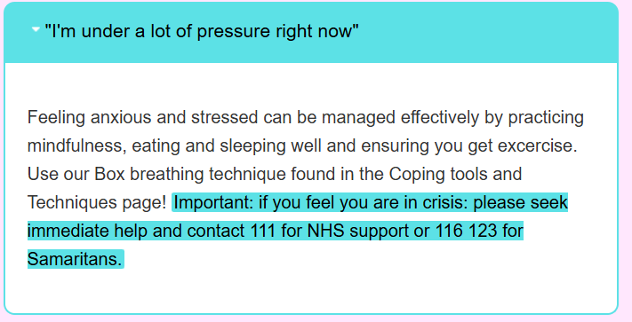
Under the “I’m under a lot of pressure right now” accordion response, I included a high-visibilty <mark> tag the NHS and Samaritans helplines for immediate support for users under pressure. Text is highlighted to show importance.

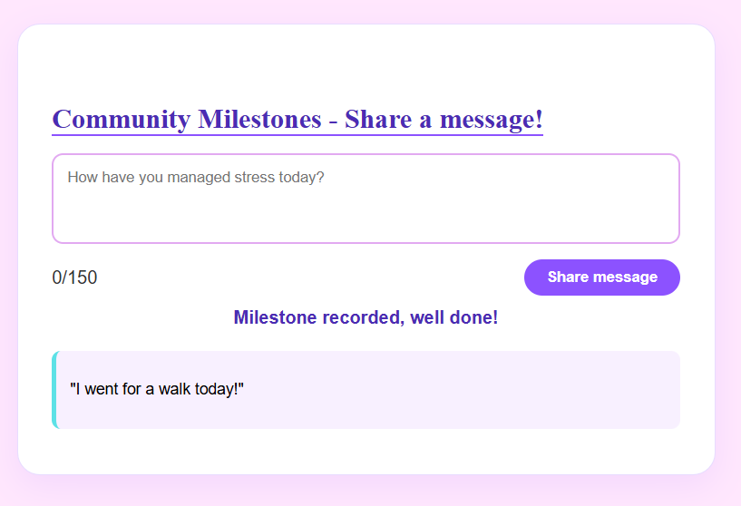
The Community Milestones feature allows users to anonymously share wellbeing success wins, creating a sense of community success using StressLess. I implemented an input box that utilizes LocalStorage to save messages underneath. Real-time feedback is given by the text: “Milestone recorded, well done!” in purple.

I created a 48-hour message deletion logic using parseInt, to keeping feed clear of clutter, allowing other users of the site to write their message. Additionally, a limit was made that only one message can be sent per day.
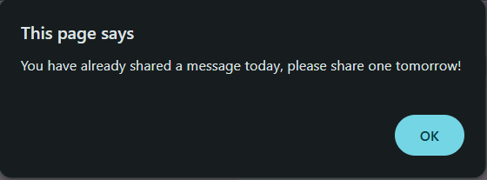
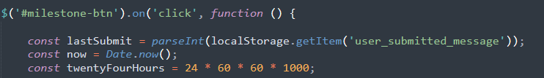

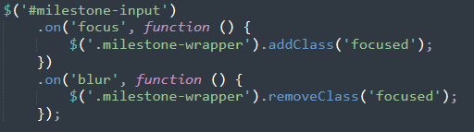
Using jQuery, I added focus() and blur() that changes the border colour to #8c52ff when the user clicks the text area, signalling to the user that it is ready to receive input.
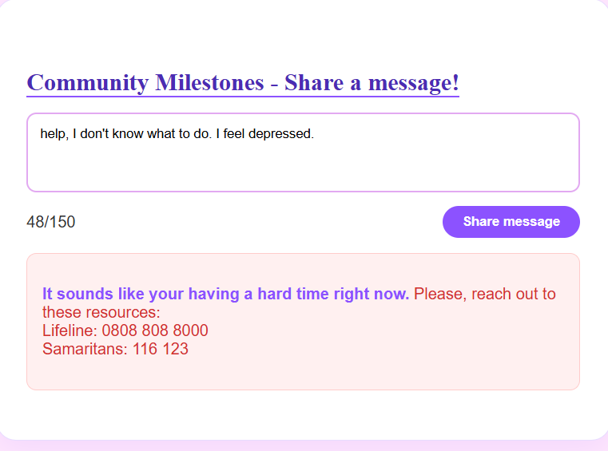
I also used keyword filtering through the crisis Words array. Key words like “depressed” & “suicide” are scanned in the algorithm and emergency resource links are provided to provide professional help immediately.

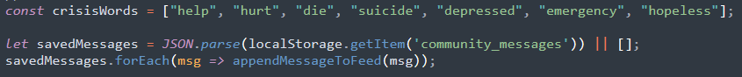
Screenshot to show crisis filters

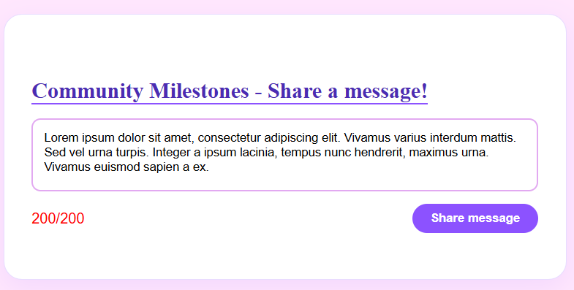
Finally, I imposed a 200-word limit to the text box highlighted in red, so that user’s do not go over the limit and take up the page.

Reflection:
This project strengthened my understanding on UX principles, use of jQuery, CSS and the importance of valuing the user’s experience of using the website. If I were to redo, I would improve keyboard navigation and adding ARIA labels to my HTML, further enhancing accessibility.

References documentation:

W3Schools (2025). W3Schools online web tutorials. [online] W3schools.com. Available at: https://www.w3schools.com/.

JS Foundation - js.foundation (2019). jQuery UI. [online] Jqueryui.com. Available at: https://jqueryui.com/.

Krug, S., October 2020. Don't make me think: A common sense approach to web usability.

University of St. Augustine for Health Sciences (2023). 9 Popular Time Management Techniques and Tools. [online] University of St. Augustine for Health Sciences. Available at: https://www.usa.edu/blog/time-management-techniques/.
‌
How (2015). Always Well Within. [online] Always Well Within. Available at: https://www.alwayswellwithin.com/blog/2015/10/04/stress-less-deadlines [Accessed 22 Apr. 2026].

‌www.careerexplorer.com. (n.d.). What does a school counselor do? - CareerExplorer. [online] Available at: https://www.careerexplorer.com/careers/school-counselor/.
‌

