Compile on host

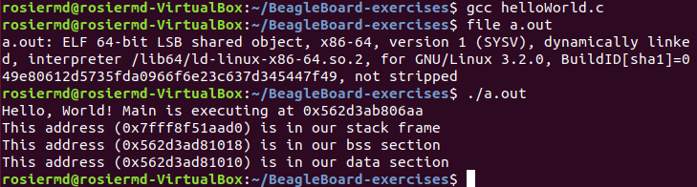

compilers

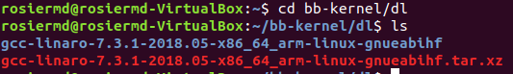

Set cross-compile

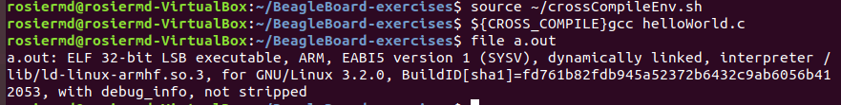

Cross-compile on beaglebone

