**SympMeds**

**Specifications Document**

**Ver. 1.0**

**Application Name:** SympMeds

System Metaphor: Pharmacist

Authors: Milena Fernandez & Randall Rosing

**Use Case Diagram:**

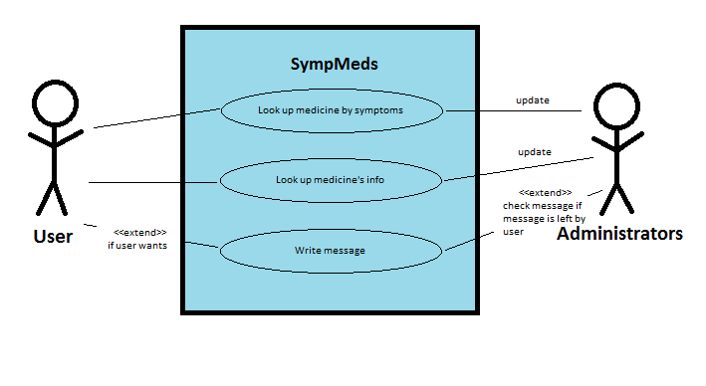

**User Stories:**

Pre-alpha Release 0.1:

* What I am looking for as the customer is for an app that allows me to look up information on a non-prescription drug, such as the symptoms it treats and any side-effects or other warnings it has. Also, if I am not sure of which drug I want, I can get a list of a lot of drugs by searching for a symptom that I or a loved one has.

Pre-alpha Release 0.2:

* Be able to filter drugs by symptom.
* Be able to see and easily read information on a drug.

Alpha Release 0.1:

* Once selected medication info window is open, one should be able to view the symptom related to the medication under that same window and click on it to be detoured to view the symptom’s information.

Alpha Release 0.2:

* After choosing a symptom, the user is able to see a simple description of the symptom. This will be useful for the user to be able to check that the symptom is what is being experienced.

**Test Plan:**

|  |  |  |  |  |
| --- | --- | --- | --- | --- |
| Test ID | Description | Expected Results | Actual Results | Opacity |
| 1 | MainActivity class starts up. | Screen is filled with MainActivity activity. |  |  |
| 2 | Medication info page is up. User wants to view the description of the applicable symptoms and clicks on the name of a symptom at the bottom of the page. | System will surf user to a different page in which the symptom name gets defined. |  |  |
| 3 | Medication(s) is searched based on symptom. More than one medication is listed on the system to treat that symptom. User chooses one medication. | Only one of the medication’s information shows up as a new page. |  |  |
| 4 | User is able to view the symptom’s description | User chooses a symptom and is able to see its description. |  |  |