**SympMeds**

**Specifications Document**

**Ver. 1.0**

**Application Name:** SympMeds

System Metaphor: Pharmacist

Authors: Milena Fernandez & Randall Rosing

**Use Case Diagram:**

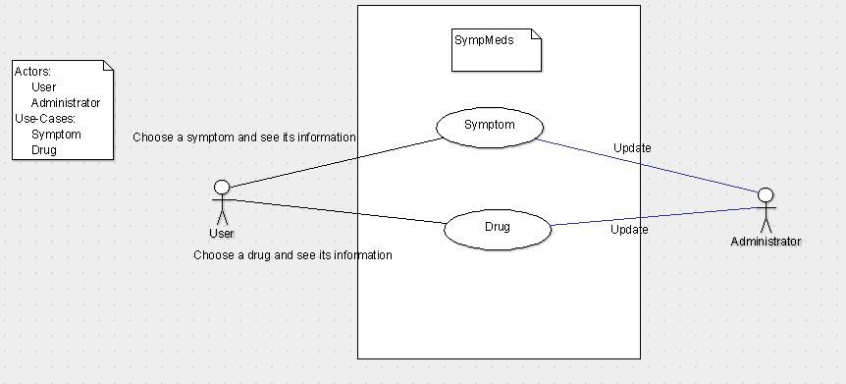

**Class Diagram:**

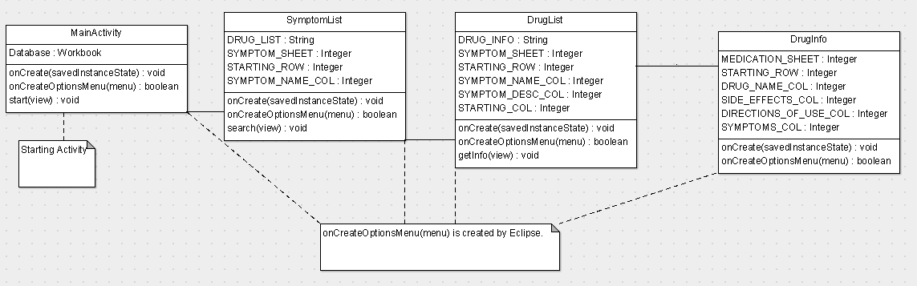

**User Stories:**

Pre-alpha Release 0.1:

* What I am looking for as the customer is for an app that allows me to look up information on a non-prescription drug, such as the symptoms it treats and any side-effects or other warnings it has. Also, if I am not sure of which drug I want, I can get a list of a lot of drugs by searching for a symptom that I or a loved one has.

Pre-alpha Release 0.2:

* Be able to filter drugs by symptom.
* Be able to see and easily read information on a drug.

Alpha Release 0.1:

* Once selected medication info window is open, one should be able to view the symptom related to the medication under that same window and click on it to be detoured to view the symptom’s information.

Alpha Release 0.2:

* After choosing a symptom, the user is able to see a simple description of the symptom. This will be useful for the user to be able to check that the symptom is what is being experienced.

Beta Release 0.1

* There is a welcome screen that explains what the app does as well as a disclaimer.

Beta Release 0.2

* The app is able to look on Google Maps to find the nearest pharmacy to the user’s location.

**Time Line:**

|  |  |  |  |  |  |  |  |  |  |  |  |  |  |  |
| --- | --- | --- | --- | --- | --- | --- | --- | --- | --- | --- | --- | --- | --- | --- |
| Week | 2 | 3 | 4 | 5 | 6 | 7 | 8 | 9 | 10 | 11 | 12 | 13 | 14 | 15 |
| Documentation |  |  |  |  |  |  |  |  |  |  |  |  |  |  |
| UI |  |  |  |  |  |  |  |  |  |  |  |  |  |  |
| Database |  |  |  |  |  |  |  |  |  |  |  |  |  |  |
| Implementing |  |  |  |  |  |  |  |  |  |  |  |  |  |  |
| Testing |  |  |  |  |  |  |  |  |  |  |  |  |  |  |

**Test Status:**

|  |  |  |  |  |
| --- | --- | --- | --- | --- |
| **Release Name** | **Release Date** | **% Of Tests** | | **Code Coverage** |
| **passed** | **failed** |
| Alpha Release 0.2 | 7/11/2013 | 100% | 0% | 0% |
| Beta Release 0.1 | 7/18/2013 | 100% | 0% | 0% |
| Beta Release 0.2 | 7/25/2013 | 25% | 75% | 0% |
| Release Candidate | 8/1/2013 | 100% | 0% | 0% |
| Final Release | 8/9/2013 | 100% | 0% | 0%* |

* Believe this comes from the fact that almost all the code for the activities happen at the creation of the activities. This means that the individual tests cannot interact with the activities and test the code, they can only test the changes that were made to the activities during creation.

**Test Plan:**

|  |  |  |  |  |
| --- | --- | --- | --- | --- |
| **Test ID** | **Description** | **Expected Results** | **Actual Results** | **Opacity** |
| 1 | MainActivity class starts up and everything is initialized. | Screen is filled with MainActivity activity and the widgets are not null. | Pass | Black-Box |
| 2 | The MainActivity’s Start button is clickable. | The user is able to initialize the sequence to go to the next page. | Pass | Black-Box |
| 3 | SymptomListActivity class starts up and everything is initialized. | Screen is filled with SymptomListActivity activity and the widgets are not null. | Pass | Black-Box |
| 4 | The SymptomListActivity’s Search button is clickable. | The user is able to initialize the sequence to go to the next page. | Pass | Black-Box |
| 5 | The Symptom spinner is the correct size to show that the app read the Database file correctly | The Symptom spinner contains 15 items. | Pass | Black-Box |
| 6 | DrugListActivity class starts up and everything is initialized. | Screen is filled with DrugListActivity activity and the widgets are not null. | Pass | Black-Box |
| 7 | DrugListActivity shows the name of the symptom chosen from previous activity. | The SymptomName TextView displays "Fever". | Pass | Black-Box |
| 8 | DrugListActivity shows the Description of the symptom chosen from previous activity. | The SymptomDesc TextView displays the description of fever found in the Database file. | Pass | Black-Box |
| 9* | The DrugListActivity’s Get Info button is clickable. | The user is able to initialize the sequence to go to the next page. | Pass | Black-Box |
| 10 | The Drug spinner is the correct size to show that the app read the Database file correctly | The Symptom spinner contains 3 items. | Pass | Black-Box |
| 11 | The DrugListActivity’s Nearest Pharmacy button is not clickable. | The user is not able to initialize the sequence to find the nearest pharmacy. | Pass | Black-Box |
| 12 | DrugInfoActivity class starts up and everything is initialized. | Screen is filled with DrugListActivity activity and the widgets are not null. | Pass | Black-Box |
| 13 | DrugInfoActivity shows the Name of the drug chosen from previous activity. | The DrugName TextView displays the "Advil". | Pass | Black-Box |
| 14 | DrugInfoActivity shows the symptoms that advil treats. | The DrugSymptoms TextView displays the symptoms advil treats as found in the Database file. | Pass | Black-Box |
| 15 | DrugInfoActivity shows the side-effects that advil might have. | The DrugSideEff TextView displays the side-effects advil might have as found in the Database file. | Pass | Black-Box |
| 16 | DrugInfoActivity shows the directions to use advil. | The DrugDir TextView displays the directions to use advil as found in the Database file. | Pass | Black-Box |
| 17* | The DrugInfoActivity’s Nearest Pharmacy button is not clickable. | The user is not able to initialize the sequence to find the nearest pharmacy. | Pass | Black-Box |

*The Nearest Pharmacy buttons are not yet initialized so the tests were changed to make sure they are not clickable so errors won’t appear when the user clicks them. These tests will be changed when the buttons get implemented.

**User Acceptance Test Plan:**

|  |  |  |
| --- | --- | --- |
| **Test ID** | **Description/Expected Results** | **Actual Results** |
| 1 | The app shows a disclaimer at the beginning. | Pass |
| 2 | Every step in the process has its own activity (Disclaimer, List of Symptoms, List of Drugs, Drug Information). | Pass |
| 3 | Only the drugs that treat the chosen symptom are displayed. | Pass |
| 4 | A description of the chosen symptom is shown so the user can be sure they are suffering from that symptom | Pass |
| 5 | The chosen drug's name, side-effects, directions, and the symptoms it treats are shown. | Pass |
| 6 | The user is able to go back to previous activities | Pass |
| 7 | The app shows where the nearest pharmacy is in relation to the user's current location | Fail** |

**Look at note from previous table.