SAUDI HYPERMARKET
Retail Performance & Customer Insights Analytics
Python Data Analytics + Power BI Dashboard Project

Project Report
Analysis period: January 2024 – May 2026
Geographic scope: Saudi Arabia (KSA)
Currency: Saudi Riyal (SAR)
Executive Summary
This project presents an end-to-end retail analytics study of Saudi Hypermarket branch performance. The work combines Python-based data cleaning, preprocessing, feature engineering, exploratory data analysis (EDA), statistical relationships and business interpretation with an interactive Power BI dashboard.
The supplied notebook describes a dataset containing 3,000 records and 10 original columns, covering branch-level sales performance, transaction activity, product categories, payment methods and customer satisfaction. The analysis focuses on identifying revenue drivers, regional performance differences, store-size effects, payment behaviour and customer experience patterns.
- Total revenue is described in the notebook as approximately SAR 28 million (SAR 27.95M in the Power BI dashboard) across 35 branches and 12 regions.
- Transaction volume has the strongest reported relationship with total revenue, with a Pearson correlation of 0.87.
- Revenue per transaction has a moderate positive relationship with total revenue (0.55).
- Customer satisfaction has a weak relationship with total revenue (0.19), indicating that satisfaction and sales volume should be monitored as separate performance dimensions.
- Large branches are reported as the main revenue contributors, especially in major markets such as Riyadh and Central.
- Groceries and Fresh Produce are highlighted as major revenue categories, with Mada and Apple Pay contributing strongly to digital-payment revenue.
- The Power BI dashboard converts these findings into executive KPIs, trend visuals, category analysis, payment-channel analysis and interactive slicers.

2. Business Problem & Objectives
Operating hypermarkets across multiple Saudi regions requires clear visibility into sales trends, customer preferences and store operational efficiency. The project aims to support evidence-based decisions rather than relying only on manual reporting.

Objectives
- Clean and prepare branch-level retail data for reliable analysis.
- Identify regional and branch-size revenue patterns.
- Analyse transaction volume and revenue-per-transaction behaviour.
- Understand product-category and payment-method performance.
- Measure customer satisfaction and compare it with financial indicators.
- Create business-ready visualizations in Python.
- Build an interactive Power BI dashboard for management reporting.
- Translate analytical findings into actionable recommendations for inventory, marketing, store expansion and checkout operations.

3. Dataset Overview
Item | Details
Dataset | Saudi Hypermarket Branch Performance
Domain | Retail & Hypermarket Operations Analytics; Supply Chain & Financial Management
Source | Prime Levels Data Hub
Format | CSV
Rows | 3,000
Original columns | 10
Analysis period | January 2024 to May 2026
Geography | Saudi Arabia
Currency | SAR
Branches / regions | 35+ branches; 12 regions (as stated in the notebook)
Source URL recorded in the notebook: https://prime-levels.com/data-hub/saudi-hypermarket-branch-performance-2024-2026

3.1 Original Dataset Columns
Column | Business meaning
transaction_date | Date of the transaction record
branch_name | Hypermarket branch name
region | Administrative region in Saudi Arabia
branch_size | Large, XLarge, Medium or Small store format
product_category | Main category of goods sold
total_revenue_sar | Total sales revenue in SAR
number_of_transactions | Number of transactions recorded
average_basket_sar | Average spend per transaction in SAR
payment_method | Customer payment method
customer_satisfaction_score | Customer satisfaction score on a 1.0–5.0 scale

4. Python Analytics Methodology
The notebook follows a structured analytics workflow:
- Problem definition and dataset selection.
- Initial data inspection and structural checks.
- Missing-value treatment and duplicate checks.
- Column standardization and unwanted-column removal.
- Outlier detection using the IQR method.
- Skewness checking and log transformation of revenue.
- Data-type conversion and date parsing.
- Feature engineering for revenue per transaction, revenue category, quarter, weekend flag, CSAT category and digital-payment indicator.
- Univariate, bivariate and multivariate EDA.
- Business interpretation after each visualization.
- Export of the cleaned dataset for downstream use.

4.1 Data Cleaning & Pre-processing
- Numerical missing values were filled using median imputation for revenue, transaction count, average basket and satisfaction score.
- Categorical missing values were filled using mode imputation for branch size, product category and payment method.
- Duplicate records were checked.
- Column names were standardized to lowercase with underscores.
- customer_satisfaction_score was renamed to sat_score for easier analysis.
- number_of_transactions.1 was removed when present.
- Revenue outliers were detected using 1.5 × IQR boundaries and filtered.
- A log-transformed revenue feature, total_revenue_sar_log, was created to address right-skewed revenue behaviour.
- number_of_transactions was converted to integer.
- transaction_date was converted to datetime.

4.2 Feature Engineering
Feature | Purpose
year | Year-based trend analysis
month | Monthly analysis
day_name | Day-of-week analysis
rev_per_trans | Revenue per transaction KPI
revenue_category | LOW / MEDIUM / HIGH revenue segmentation
quarter_period | Quarter-over-quarter analysis
weekends | Saudi weekend flag: Friday and Saturday
csat_category | Low / Medium / High satisfaction segmentation
digital_payment | Indicator for Mada, Credit Card and Apple Pay
total_revenue_sar_log | Log-transformed revenue for skewness handling

5. Exploratory Data Analysis & Key Findings

5.1 Revenue Distribution
The revenue histogram shows a right-skewed distribution. Most revenue observations are concentrated in lower-to-middle ranges, while a smaller number of high-value observations extend the upper tail.
Business meaning: the network has a broad baseline of regular activity with a smaller set of high-value periods or transactions.

5.2 Transaction Volume
The transaction-count boxplot indicates a stable central operating range with higher-volume outliers. The notebook interprets these as possible high-footfall or promotional periods rather than automatically treating them as data errors.

5.3 Customer Satisfaction
Customer satisfaction is concentrated toward higher ratings, with scores 4 and 5 forming the largest share. This indicates generally positive customer sentiment in the analysed records.

5.4 Regional Revenue Performance
- Riyadh and other primary urban markets are identified as top revenue contributors.
- A substantial share of enterprise revenue is concentrated in the top two regional markets.
- Lower-performing regions provide opportunities for localized promotions, product-mix adjustments and targeted inventory planning.
- Regional sales patterns can guide supply-chain and fulfilment-resource allocation.

5.5 Revenue and Transaction Correlation
The notebook reports a strong positive Pearson correlation of 0.87 between total_revenue_sar and number_of_transactions. This supports the conclusion that transaction volume/footfall is a major revenue driver.
Revenue per transaction has a moderate positive correlation of 0.55 with total revenue, while customer satisfaction has a weak correlation of 0.19.

5.6 Branch Size Performance
- Large branches generate the highest total revenue contribution, followed by Medium and Small branches.
- Large formats dominate high-volume markets such as Riyadh and Central in the notebook's analysis.
- Medium branches provide a stable contribution across locations.
- Small branches in lower-footfall areas show potential for product-mix and local-demand optimization.

5.7 Product Category & Payment Method
- Groceries and Fresh Produce are highlighted as major revenue categories.
- Mada and Apple Pay are identified as strong digital-payment channels for high-demand categories.
- Cash remains relevant for lower-basket or everyday purchases.
- Credit-card payments contribute to steady revenue, particularly for higher-value non-perishable purchases.
- Fast digital POS lanes can help support peak-period checkout flow.

5.8 Quarterly & Digital-Payment Behaviour
The quarterly analysis compares revenue by digital-payment usage across Large, Medium and Small branches. The notebook highlights higher revenue contribution from digital transactions, particularly in Large and Medium formats, and notes seasonal differences between quarter periods.

6. Power BI Dashboard
The Power BI report contains three interactive pages: Executive Performance, Channel Analytics and Quality Analytics. Each page has its own slicers (Product Category, Time Period, Region and Branch Size, depending on the page), KPI cards, four to five visuals and a side panel of written insights. A page navigator in the header lets management move between pages. The review notes in Section 6.4 list the corrections made to this report and the matching fixes still needed in the Power BI file.

6.1 Executive Performance – Executive Performance & Revenue Summary
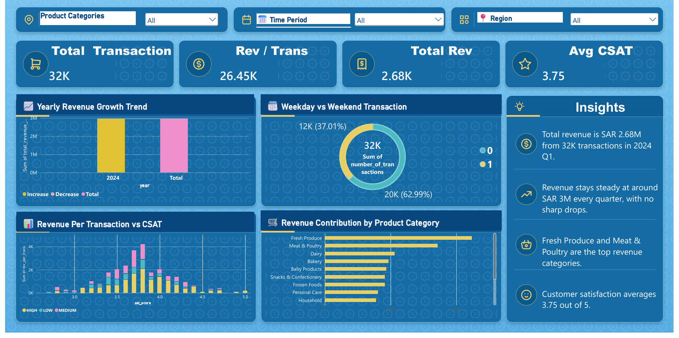
Overview. This page gives leadership one view of transaction volume, revenue, basket value and customer satisfaction. It is filtered by Product Category, Time Period and Region, and opens on the 2024 Q1 baseline context.

Key KPI Cards
KPI | Value on dashboard | Meaning
Total Transactions | 32K | Transactions in the baseline filter (2024 Q1).
Revenue per Transaction | 26.45K (as shown) | Row-level sum on the card. Correct KPI: average ≈ SAR 84 (SAR 2.68M ÷ 32K).
Total Revenue | SAR 2.68M | Card displays “2.68K”; the unit should read M (million).
Avg CSAT | 3.75 / 5.0 | Average customer satisfaction score.

Key Visuals
- Yearly Revenue Growth Trend (waterfall): the 2024 bar and the Total bar both sit near SAR 3M, with no decrease segments.
- Weekday vs Weekend Transaction (donut): Weekday 20K (62.99%) and Weekend 12K (37.01%) of 32K transactions; daily routine shopping drives footfall.
- Revenue per Transaction vs CSAT (stacked column): activity clusters between CSAT scores 3.0 and 4.5, peaking near 3.8, split into High, Medium and Low CSAT tiers.
- Revenue Contribution by Product Category (bar): Fresh Produce leads (~16.25%), then Meat & Poultry (~9.84%), Dairy, Bakery, Baby Products, Snacks & Confectionery, Frozen Foods, Personal Care and Household.

Side-Panel Insights
- Total revenue is SAR 2.68M from 32K transactions in 2024 Q1.
- Revenue stays steady at around SAR 3M every quarter, with no sharp drops.
- Fresh Produce and Meat & Poultry are the top revenue categories.
- Customer satisfaction averages 3.75 out of 5.

6.2 Channel Analytics – Revenue & Payment Channel Analytics
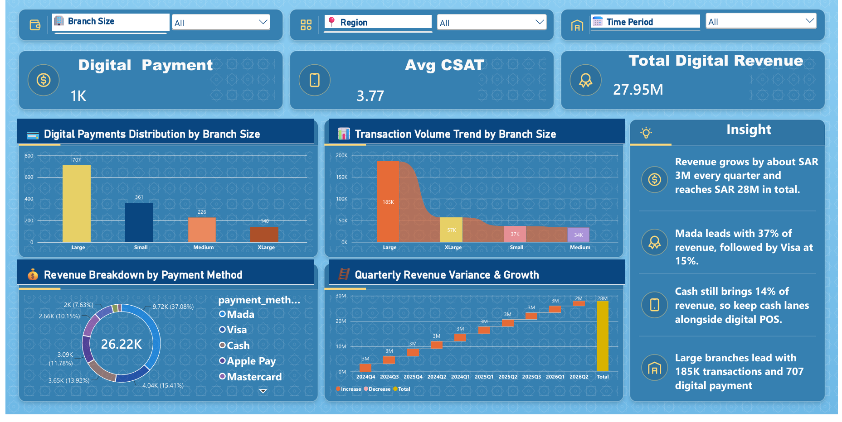
Overview. This page evaluates payment-method mix, digital adoption by branch size and quarterly revenue stability. It is filtered by Branch Size, Region and Time Period.

Key KPI Cards
KPI | Value on dashboard | Meaning
Digital Payment Count | 1K (rounded) | Branch-size bars total 707 + 361 + 226 + 140 = 1,434 digital payment records.
Avg CSAT | 3.77 | Average satisfaction across the filtered records.
Total Revenue | SAR 27.95M | Cumulative revenue across all payment methods, including cash (~14%). Labelled “Total Digital Revenue” on the dashboard.

Key Visuals
- Digital Payments Distribution by Branch Size: Large 707, Small 361, Medium 226, XLarge 140.
- Transaction Volume Trend by Branch Size: Large 185K, XLarge 57K, Small 37K, Medium 34K transactions.
- Payment Method Share (donut, 26.22K records): Mada 37.08% (9.72K), Visa 15.41% (4.04K), Cash 13.92% (3.65K), Apple Pay 11.78% (3.09K), Mastercard 10.15% (2.66K); STC Pay, BNPL (Tabby/Tamara) and others about 11.66% combined.
- Quarterly Revenue Variance & Growth (waterfall): about SAR 3M added per quarter, with 2026 Q2 about SAR 2M (partial, data ends May 2026), reaching SAR 28M in total.

Side-Panel Insights
- Revenue grows by about SAR 3M every quarter and reaches SAR 28M in total.
- Mada leads with 37% of payment records, followed by Visa at 15%.
- Cash still brings 14%, so keep cash lanes alongside digital POS.
- Large branches lead with 185K transactions and 707 digital payment records.

6.3 Quality Analytics – Regional Service Quality Analytics
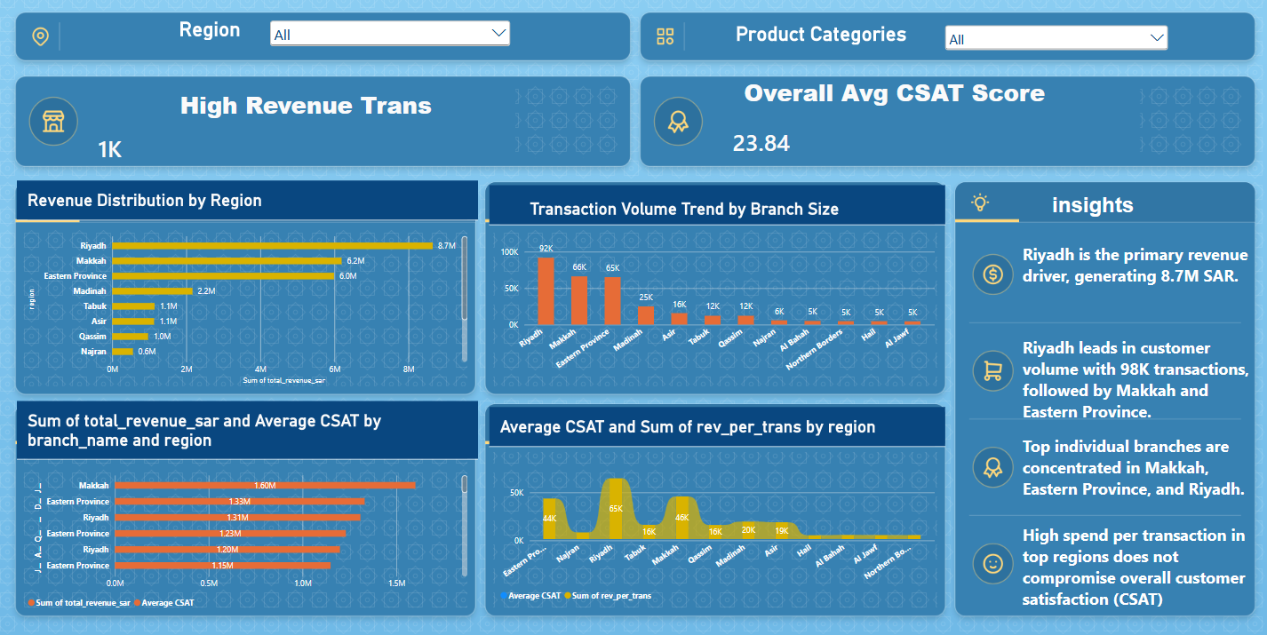
Overview. This page compares revenue, transaction volume, branch performance and customer satisfaction across regions. It is filtered by Region and Product Category.

Key KPI Cards
KPI | Value on dashboard | Meaning
High Revenue Trans | 1K | Number of transactions in the HIGH revenue category.
Overall Avg CSAT Score | 23.84 (as shown) | This value is a sum, not an average. Correct value: average ≈ 3.78 out of 5.

Key Visuals
- Revenue Distribution by Region: Riyadh SAR 8.7M, Makkah 6.2M, Eastern Province 6.0M, Madinah 2.2M, Tabuk and Asir 1.1M each, Qassim 1.0M, Najran 0.6M.
- Transaction Volume by Region: Riyadh 92K, Makkah 66K, Eastern Province 65K, Madinah 25K, then Asir 16K, Tabuk and Qassim 12K each.
- Top Branches by Revenue and Avg CSAT: Makkah SAR 1.60M, Eastern Province 1.33M and 1.23M, Riyadh 1.31M and 1.20M, Eastern Province 1.15M.
- Revenue per Transaction by Region (area): Riyadh 65K, Makkah 46K, Eastern Province 44K, Madinah 20K, Asir 19K, Tabuk and Qassim 16K.

Side-Panel Insights
- Riyadh is the primary revenue driver, generating SAR 8.7M.
- Riyadh leads in customer volume, followed by Makkah and Eastern Province.
- Top individual branches are concentrated in Makkah, Eastern Province and Riyadh.
- High spend per transaction in top regions does not compromise overall customer satisfaction (CSAT).

6.4 Dashboard Review Notes & Recommended Fixes
The following corrections were made in this report. Items marked “Fix in Power BI” still need to be changed in the .pbix file so the dashboard matches the report.
Page | Issue found | Correction / fix
Executive | Total Revenue card shows 2.68K while the insight says SAR 2.68M | Report uses SAR 2.68M. Fix in Power BI: set the card display unit to Millions.
Executive | Revenue per Transaction card shows 26.45K (a sum of row-level values) | Report uses the average (≈ SAR 84). Fix in Power BI: use total revenue ÷ total transactions.
Executive | Report listed “Electronics” as a top category; donut legend shows 0 / 1; axis titles use raw field names | Report now shows Baby Products and Weekday / Weekend. Fix in Power BI: rename legend values and axis titles.
Channel | KPI “Total Digital Revenue” (SAR 27.95M) includes cash | Report calls it Total Revenue. Fix in Power BI: rename the card or filter to digital methods only.
Channel | Payment donut is titled revenue but its shares are record counts (26.22K); earlier SAR amounts (10.41M, 4.40M and so on) could not be traced | Report shows record counts only. Fix in Power BI: use Sum of total_revenue_sar if a revenue share is needed.
Channel | Quarter waterfall is sorted by value, not by time | Fix in Power BI: sort the axis chronologically (2024 Q1 to 2026 Q2).
Quality | Overall Avg CSAT shows 23.84 (a sum) | Report uses the average (≈ 3.78). Fix in Power BI: change the aggregation to Average.
Quality | Insight text says Riyadh has 98K transactions; chart shows 92K | Report uses 92K. Fix in Power BI: update the insight text.
Quality | Chart titled “by Branch Size” is plotted by region, two titles use raw field names, and Average CSAT is hidden by axis scale | Report uses Transaction Volume by Region. Fix in Power BI: rename titles and put Average CSAT on a secondary axis.
All | Page names differ from the original report (Channel Performance, Satisfaction Performance) | Pages named Executive Performance, Channel Analytics and Quality Analytics, as in the .pbix file. Branch sizes now list all four formats (Large, XLarge, Medium, Small).

7. Business Recommendations
- Prioritize high-volume regions such as Riyadh and other leading markets for inventory availability and fulfilment capacity.
- Use transaction volume as a primary operational KPI because the notebook reports the strongest correlation between transaction count and revenue.
- Protect and expand high-performing Large-branch formats where demand and location economics support additional investment.
- Use localized promotions and product-mix adjustments in lower-performing regions instead of applying the same strategy across all markets.
- Strengthen digital POS capacity and fast checkout lanes, particularly during high-volume periods.
- Monitor high-revenue product categories such as Groceries and Fresh Produce closely to reduce stock-out risk.
- Track revenue per transaction alongside transaction count to distinguish traffic growth from basket-value growth.
- Maintain CSAT as a separate customer-experience KPI because its reported correlation with revenue is weak.
- Use quarterly trends to plan seasonal inventory, staffing and promotional activity.
- Continue using the Power BI dashboard as a management reporting layer for interactive filtering and decision support.

8. Tools & Technologies Used
Tool / Technology | Usage
Python | Data cleaning, preprocessing, feature engineering and analysis
Pandas | Data loading, transformation, grouping and feature creation
NumPy | Numerical calculations and log transformation
Matplotlib | Data visualization
Seaborn | Statistical and business visualizations
Power BI | Interactive dashboard and executive reporting
CSV | Source / cleaned analytical dataset format

9. Project Outcome
The project successfully combines Python analytics with Power BI reporting to create a practical retail decision-support workflow. The analysis identifies transaction volume, regional concentration, branch size, product category and payment behaviour as important dimensions of hypermarket performance. The dashboard then packages these findings into an interactive management view.

10. Conclusion
The Saudi Hypermarket Retail Performance & Customer Insights Analytics project demonstrates how raw retail records can be transformed into actionable business intelligence. Python provides the analytical foundation through cleaning, feature engineering, EDA and statistical interpretation, while Power BI provides an executive-friendly interface for monitoring revenue, transactions, customer satisfaction, branch size and payment-channel performance.
Overall, the analysis supports a data-driven strategy focused on increasing transaction volume, protecting high-performing markets, optimizing store formats and product availability, improving digital checkout capability and continuously monitoring customer experience.

