//
// Test case 3: Deleted "Line 3" in right file
//
Left file | Right file
Line 1 | Line 1
Line 2 | Line 2
Line 3 | Line 4
Line 4
Output original algorithm
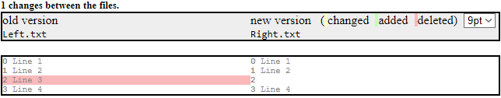
Output adapted algorithm (see unit tests)

leftDiffPartition =
{
{"Line 1", Normal},
{"Line 2", Normal},
{"Line 3", Deleted},
{"Line 4", Normal},
}

rightDiffPartition =
{
{"Line 1", Normal},
{"Line 2", Normal},
{"", Normal},
{"Line 4", Normal},
}

//
// Test case 4: Cleared "Line 3" (set to empty) in right file
//
Left file | Right file
Line 1 | Line 1
Line 2 | Line 2
Line 3
Line 4 | Line 4
Output original algorithm
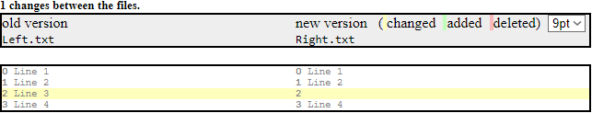
Output adapted algorithm (see unit tests)

leftDiffPartition =
{
{"Line 1", Normal},
{"Line 2", Normal},
{"Line 3", Changed},
{"Line 4", Normal},
}

rightDiffPartition =
{
{"Line 1", Normal},
{"Line 2", Normal},
{"", Changed},
{"Line 4", Normal},
}

//
// Test case 5: Deleted "Line 2" in left file
//
Left file | Right file
Line 1 | Line 1
Line 3 | Line 2
Line 4 | Line 3
 | Line 4
Output original algorithm
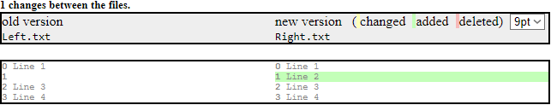
Output adapted algorithm (see unit tests)

leftDiffPartition =
{
{"Line 1", Normal},
{"", Normal},
{"Line 3", Normal},
{"Line 4", Normal},
}

rightDiffPartition =
{
{"Line 1", Normal},
{"Line 2", Added},
{"Line 3", Normal},
{"Line 4", Normal},
}

Testcase 6 → see next page

//
// Test case 6: Mixed it up with 6 changes
//
Left file | Right file
Line 1 | Line 1
Line 4 | Line 2
Line 5 | Line 3
Line 6 | Line 4
Line 7 | Line 5
Line 8 | Line 8
ab | Line 9
Line 9 | cd
Line 10 | Line 10
Output original algorithm
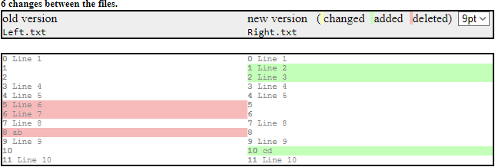
Output adapted algorithm (see unit tests)

leftDiffPartition =
{
{"Line 1", Normal},
{"", Normal},
{"", Normal},
{"Line 4", Normal},
{"Line 5", Normal},
{"Line 6", Deleted},
{"Line 7", Deleted},
{"Line 8", Normal},
{"ab", Deleted},
{"Line 9", Normal},
{"", Normal},
{"Line 10", Normal},
}

rightDiffPartition =
{
{"Line 1", Normal},
{"Line 2", Added},
{"Line 3", Added},
{"Line 4", Normal},
{"Line 5", Normal},
{"", Normal},
{"", Normal},
{"Line 8", Normal},
{"", Normal},
{"Line 9", Normal},
{"cd", Added},
{"Line 10", Normal},
}

