//

// Test case 3: Deleted "Line 3" in right file

//

|  |  |
| --- | --- |
| **Left file** | **Right file** |
| Line 1 | Line 1 |
| Line 2 | Line 2 |
| Line 3 | Line 4 |
| Line 4 |  |

**Output original algorithm**

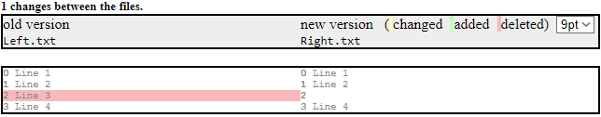

**Output adapted algorithm (see unit tests)**

leftDiffPartition =

{

{"Line 1", Normal},

{"Line 2", Normal},

{"Line 3", Deleted},

{"Line 4", Normal},

}

rightDiffPartition =

{

{"Line 1", Normal},

{"Line 2", Normal},

{"", Normal},

{"Line 4", Normal},

}

//

// Test case 4: Cleared "Line 3" (set to empty) in right file

//

|  |  |
| --- | --- |
| **Left file** | **Right file** |
| Line 1 | Line 1 |
| Line 2 | Line 2 |
| Line 3 |  |
| Line 4 | Line 4 |

**Output original algorithm**

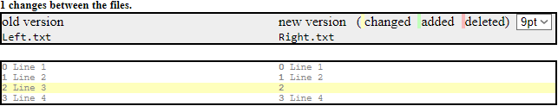

**Output adapted algorithm (see unit tests)**

leftDiffPartition =

{

{"Line 1", Normal},

{"Line 2", Normal},

{"Line 3", Changed},

{"Line 4", Normal},

}

rightDiffPartition =

{

{"Line 1", Normal},

{"Line 2", Normal},

{"", Changed},

{"Line 4", Normal},

}

//

// Test case 5: Deleted "Line 2" in left file

//

|  |  |
| --- | --- |
| **Left file** | **Right file** |
| Line 1 | Line 1 |
| Line 3 | Line 2 |
| Line 4 | Line 3 |
|  | Line 4 |

**Output original algorithm**

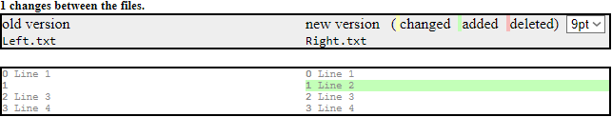

**Output adapted algorithm (see unit tests)**

leftDiffPartition =

{

{"Line 1", Normal},

{"", Normal},

{"Line 3", Normal},

{"Line 4", Normal},

}

rightDiffPartition =

{

{"Line 1", Normal},

{"Line 2", Added},

{"Line 3", Normal},

{"Line 4", Normal},

}

Testcase 6 🡺 see next page

//

// Test case 6: Mixed it up with 6 changes

//

|  |  |
| --- | --- |
| **Left file** | **Right file** |
| Line 1 | Line 1 |
| Line 4 | Line 2 |
| Line 5 | Line 3 |
| Line 6 | Line 4 |
| Line 7 | Line 5 |
| Line 8 | Line 8 |
| ab | Line 9 |
| Line 9 | cd |
| Line 10 | Line 10 |

**Output original algorithm**

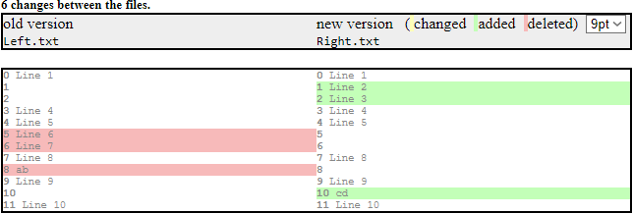

**Output adapted algorithm (see unit tests)**

leftDiffPartition =

{

{"Line 1", Normal},

{"", Normal},

{"Line 3", Normal},

{"Line 4", Normal},

}

rightDiffPartition =

{

{"Line 1", Normal},

{"Line 2", Added},

{"Line 3", Normal},

{"Line 4", Normal},

}