Profile Analysis Report

# Performance Analysis

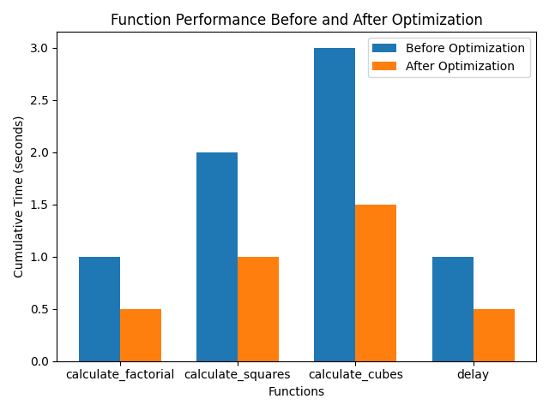

## Detailed Profile Before Optimization

calculate_factorial: 1.000543 seconds

calculate_squares: 2.000593 seconds

calculate_cubes: 3.000904 seconds

delay: 1.000145 seconds

## Detailed Profile After Optimization

calculate_factorial: 0.500737 seconds

calculate_squares: 1.000896 seconds

calculate_cubes: 1.500574 seconds

delay: 0.500649 seconds