# Design document

## Introduction

This is my design document, within this I will outline the different design features of my program and how I will build it.

This program is a car dealership app that allows users to search for cars, employees and customers within a system and view all of the details on those provided that they login to system as a valid employee.

First I will show a flowchart showing an overview of how my program will execute.

Then I will show a class diagram to show how my program links together.

Then I will show a story board showing how my program will look including designs of my GUI screens.

Finally I will give a quick overview of the different inputs and outputs of this program.

## Flowchart

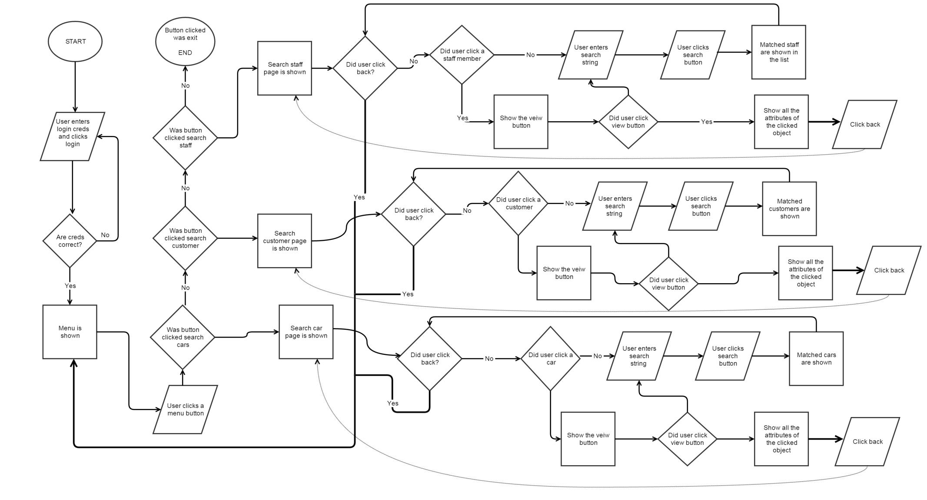

## Class diagram

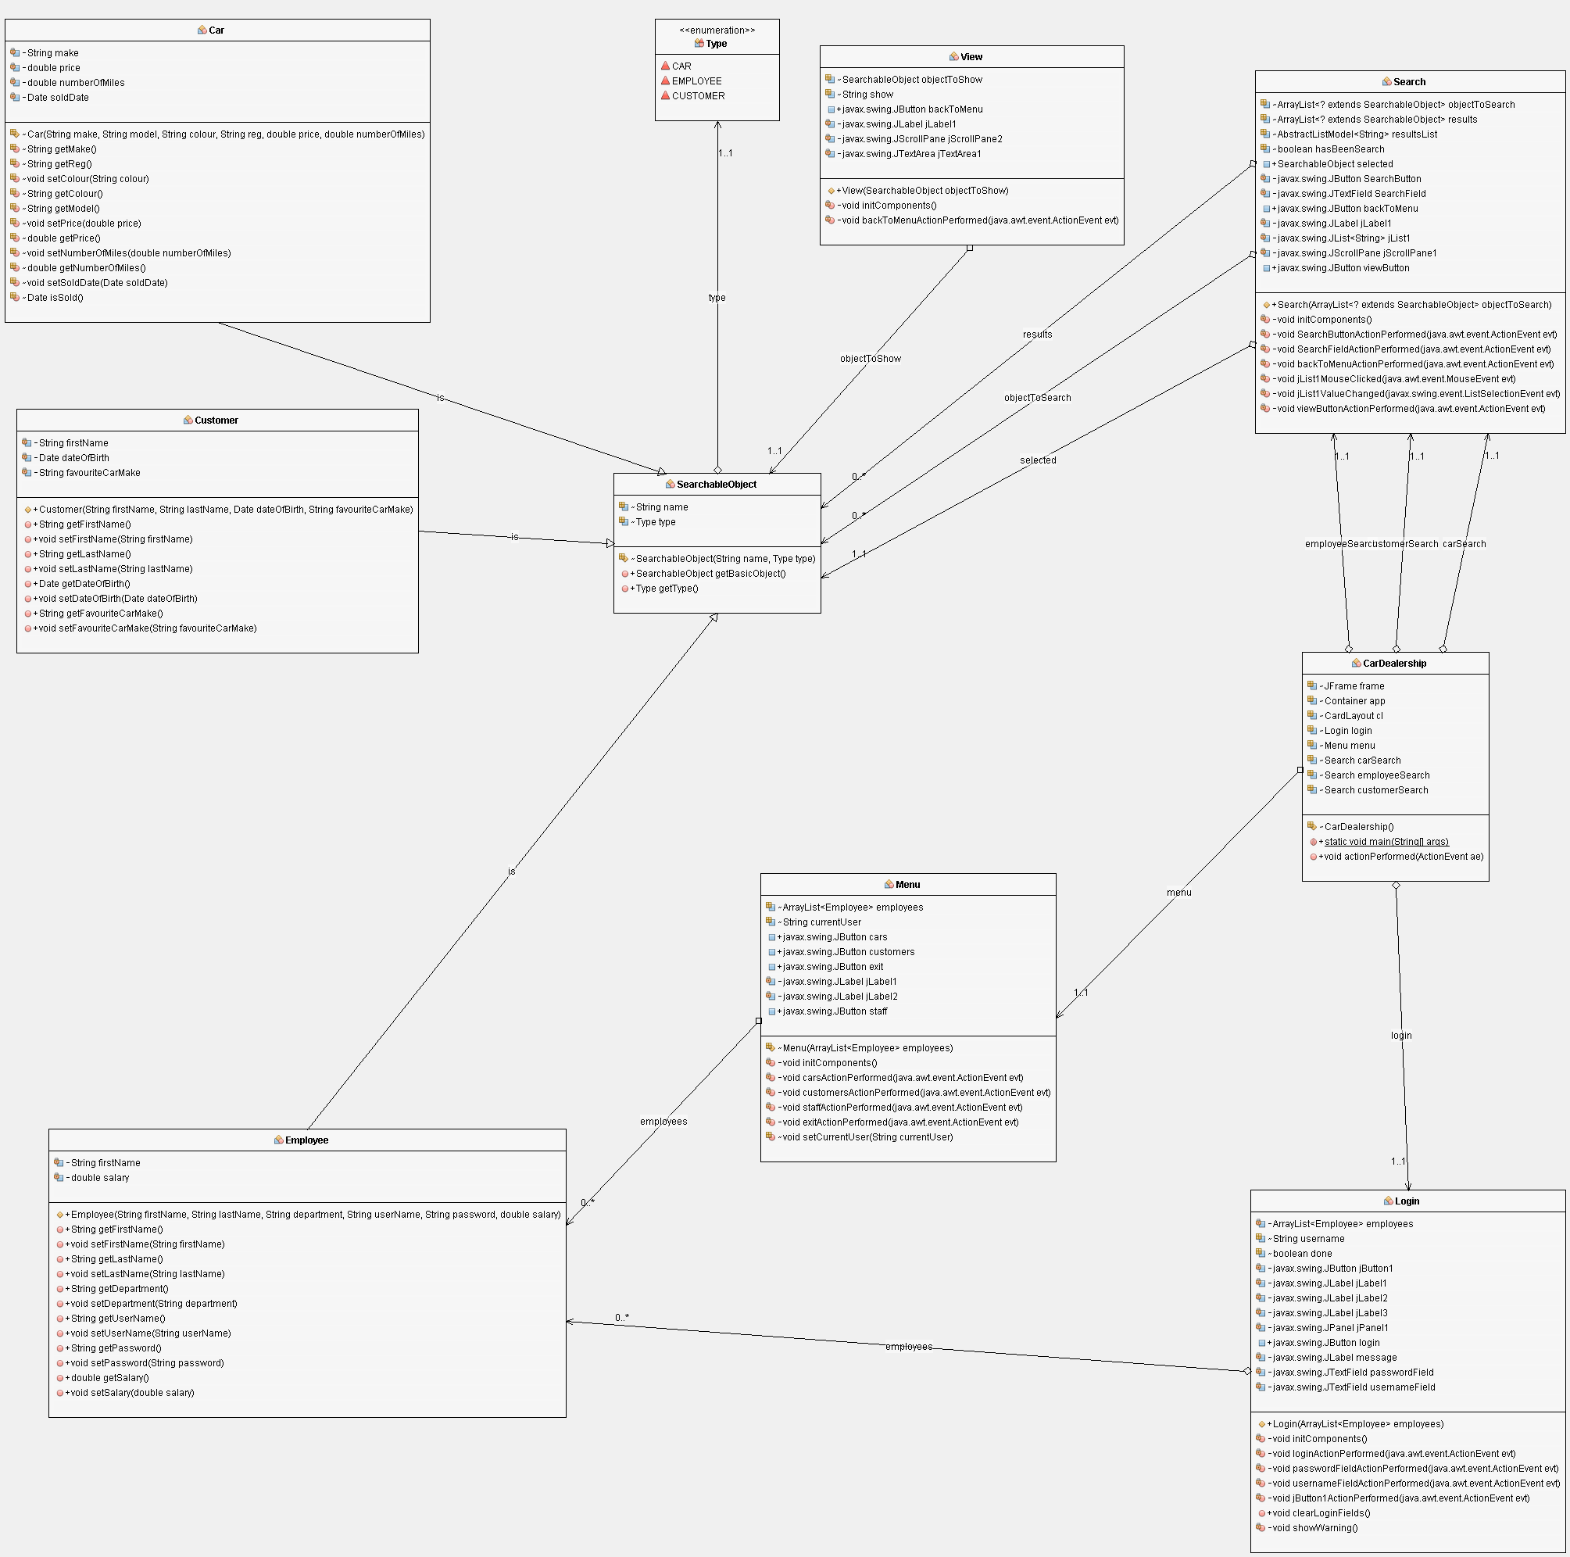

## Story boards

To the left is the design for the login page, this will be the first screen that the user sees.

This allows the user to login and see the rest of the app

If the user enters wrong credentials then a warning message of Incorret username and password will be show.

**Login**

Login

Help

User

Password

To the left is the design for the menu page,

This allows the user to login and see the rest of the app

**Menu**

Search cars

Search customer

Search employee

Logout

List of results

Search

←

Object properties

View

←

## Input output

In my program I have used different inputs and outputs to allow data to be used and processed.

### Inputs

When compiling the program from source, all the data used in the app is constructed in the main. This allows users to customise the program by putting their own data in the constructors and create their own set of employees, customers and cars.

My program also takes inputs through Java swing classes; there is a number of JButtons that will take input for actions like submissions and searches. My login panel also includes 2 JTextField’s that will take input from the user and then use that input to validate if the user is allowed to login to the system or not.

When searching in the app the user will be able to input a partial string and get back all of the results that will match it.

### Output

My program outputs everything using Java Swing GUI, this means that everything that is output will be shown in a graphical user interface that the user can click and interact with. When logging in the user will be notified if they are entering incorrect credentials and whenever they click the help button they will be presented with a modal popup that will give them guidance on how to use the program.

When searching for objects, the app will output all of the objects that match the inserted partial string. The user can then select to view one of these objects and be presented with an output of all of the attributes on that object.