This is my test plan document within this I will demonstrate how I have tested my program and how I fixed a bug that I found

|  |  |  |  |
| --- | --- | --- | --- |
| Test step | Expected result | Actual result | Evidence |
| Open the program | The login page is shown | As expected |  |
| Click help | The help screen is shown | As expected |  |
| Enter invalid credentials | The user is told that the credentials are incorrect | As expected |  |
| Enter correct credentials | The user is taken to the search page | As expected |  |
| Click search cars | The user is taken to the search cars page and some cars are shown in the search results | As expected |  |
| Enter some search text and press search | The results are updated with different cars | As expected |  |
| Click on a car | The view button is shown | As expected |  |
| Click the view button | All of the attributes on that object are shown | As expected |  |
| Press the back button | User is taken back to the menu | As expected |  |
| Click search customers | User is taken to the search customers page | As expected |  |
| Enter a name and click search | The name results list is updated | As expected |  |
| Search for a partial name | The results are updated to the ones that contain the search term | As expected |  |
| Click a customer name then click the view button | Details of that customer are shown including their favourite car make | As expected |  |
| Click to go back to the menu | The menu is shown | As expected |  |
| Click the search staff button | The search staff page is shown | As expected |  |
| Enter text and press search | The matched employees are shown | As expected |  |
| Click one of the results then click view | The details of that employee are shown including their salary, department and username | As expected |  |
| Click to go back to the menu then press logout | The user is taken back the login page and the fields have been cleared | Not as expected – the incorrect username and password message is still shown from an earlier test  This is a bug that I walkthrough fixing in the white box section below. |  |

Above I showed how I found a bug in my program; I used the debugging tools within my IDE to find out why this problem was occurring. The screenshot below shows me using a breakpoint where the method is called that validates the login.

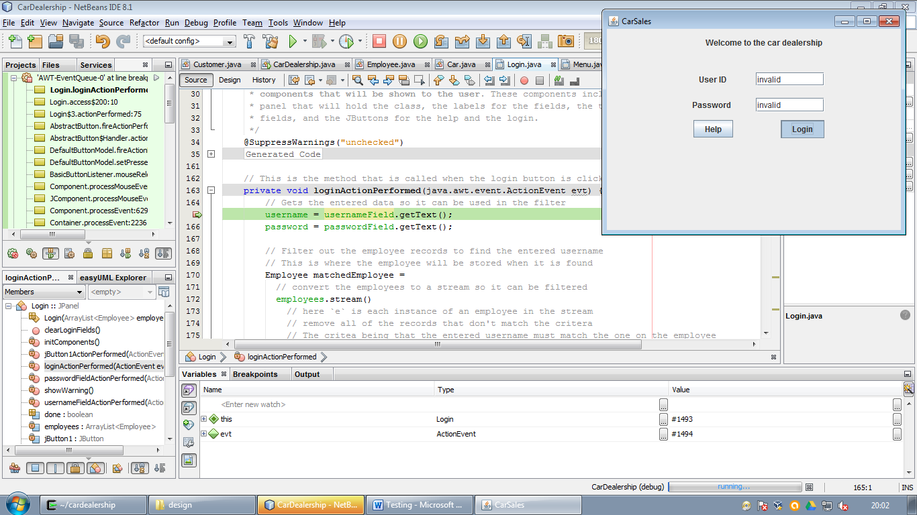

If I enter invalid credentials, I can then click the cursor to the place where the warning prompt is shown – clicking ‘run to cursor’ will then cause the program to be executed up to that point

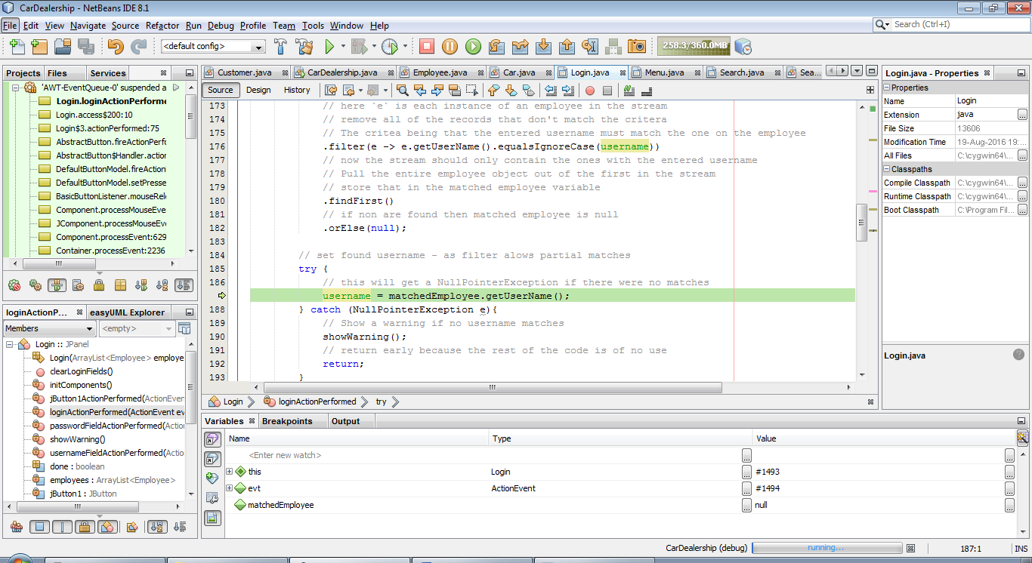

After running to the cursor I can now press the step over button and as the credentials were invalid the NullPointerExpection should have been caught into the variable ‘e’.

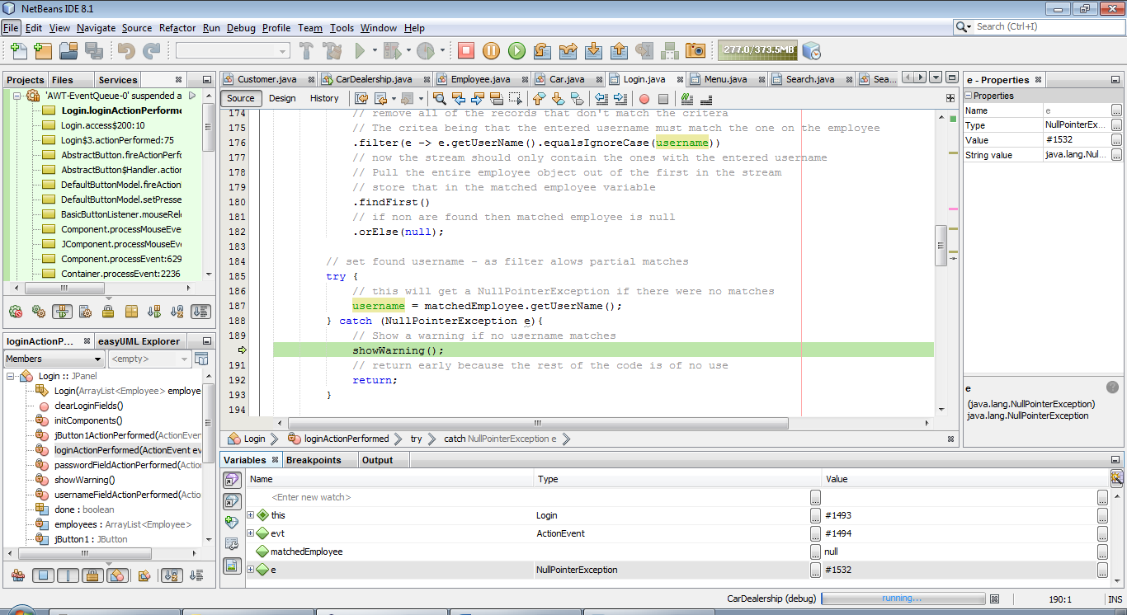

I can see this variable on the variable debugger panel. Now I can step into the show warning method to see how displaying the JLabel is handled.

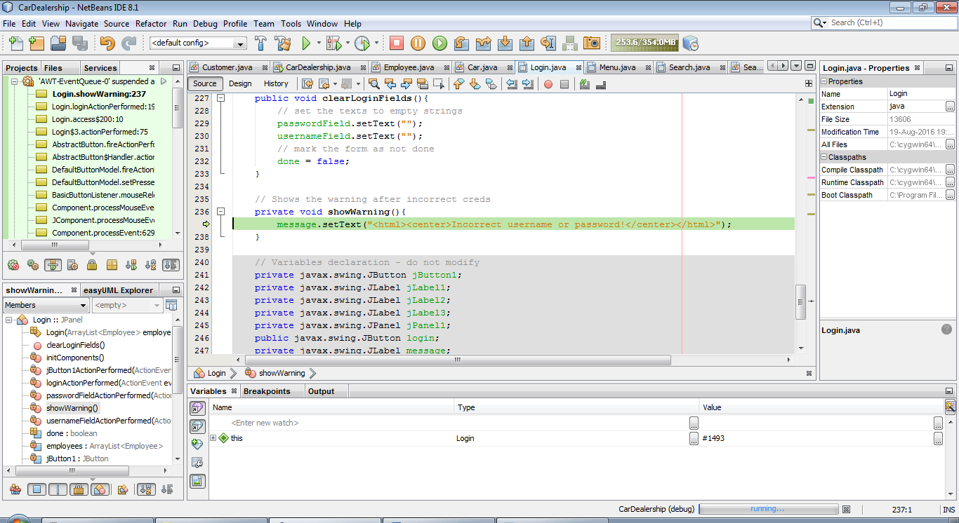

Now I can see that the message text is set by passing though some HTML into the set method.

I now need to look at the point in the code where the login fields get cleared, while the program is still running in debug I can place a breakpoint inside that method.

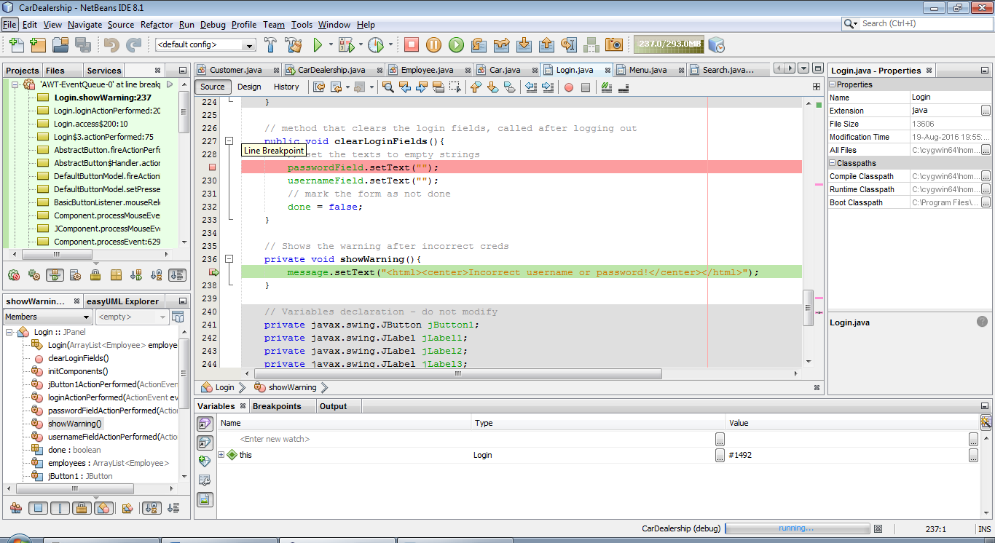

Now I can see that when the login fields are being cleared the error message text is not being cleared so I can now use the program until it stops at that breakpoint

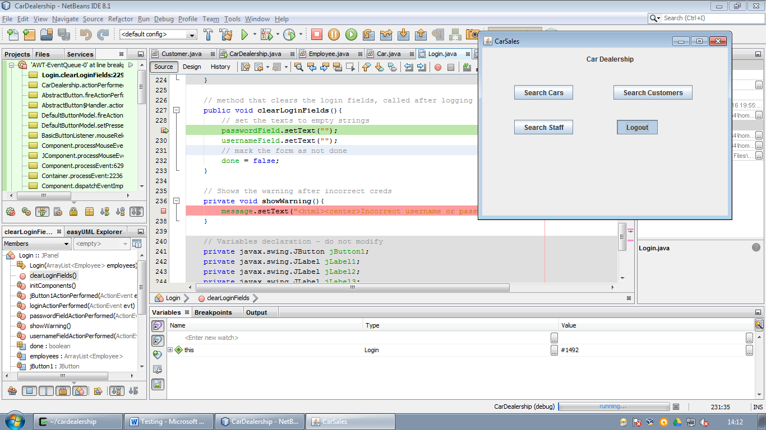

Now I know here to make changes, I can now add a line to set the error message text back to empty when clearing fields.

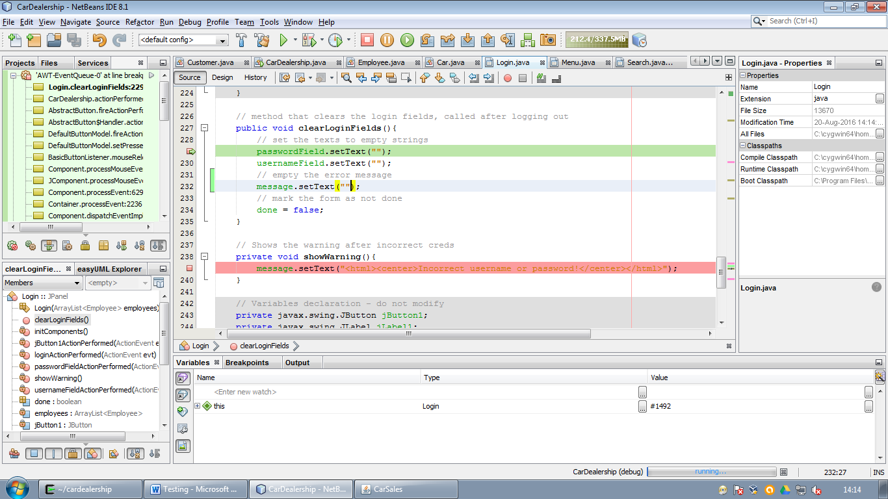

Now that I’ve changed the source code the ‘Apply Code Changes’ button has enabled itself in the debugger tool bar, this allows me to apply the changes I’ve just made and see if they fixed the problem without having to rerun the whole program.

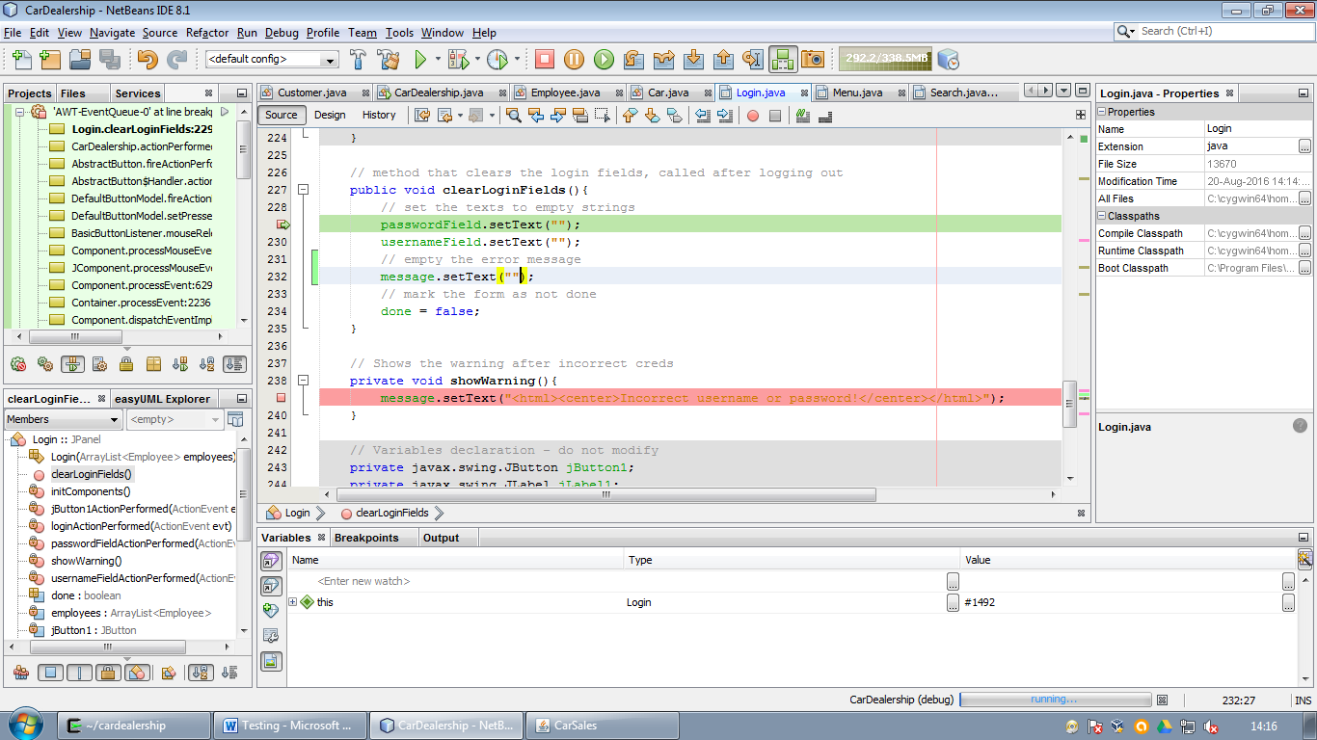

Pressing this button will substitute the code that hasn’t run yet with any new changes.

I can now press continue and the bug should be fixed.

