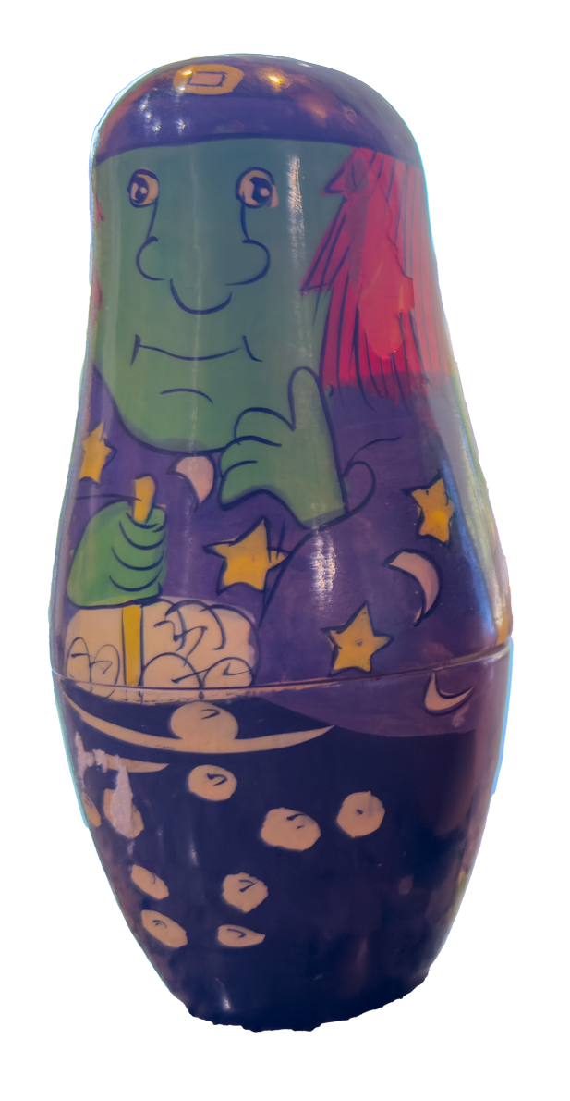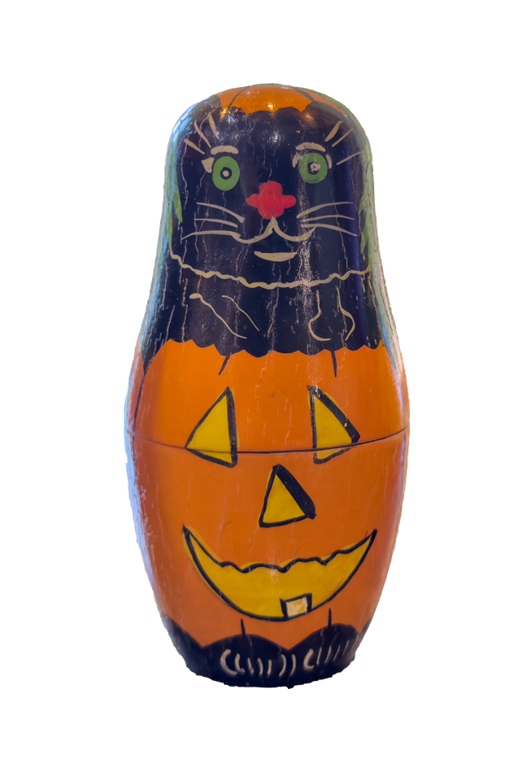

What’s in the Box? Container-based File Format Identification
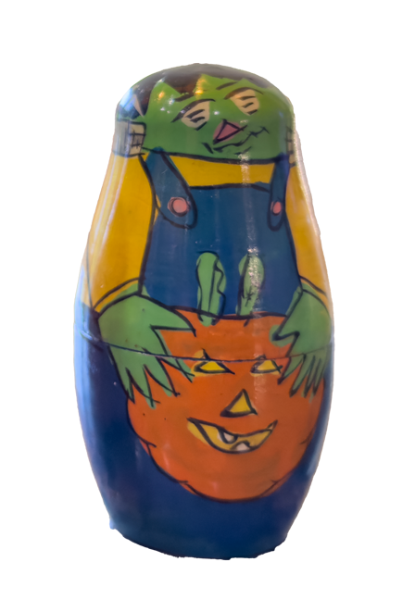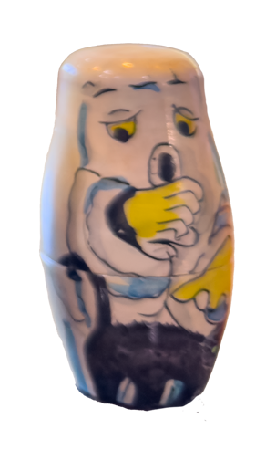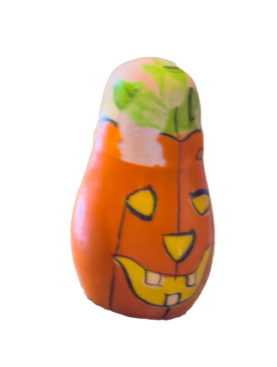AN IPRES 2024 WORKSHOP by

David Clipsham - Preservica
Francesca Mackenzie - The National Archives (UK)
Ross Spencer - Independent researcher/developer.
Tyler Thorsted - Brigham Young University

—-

What will we be doing?
What tools will we be using?
Form groups
File Format Structures
Standalone Binary Formats
Multi-part Assets
Container-based Formats
Container-based Formats
Microsoft Word DOCX Format
Binary Signature File Format Identification Recap
Binary Signature File Format Identification
Binary Signature File Format Identification example - ZIP
Open the latest container signature file
How DROID Identifies Container-based File Formats
Container signatures in the PRONOM database
A (very brief) XML primer
Container Signature File Structure
Container Triggers
File Format Mappings
Container Signature Structures - Overview
Container Signature Structures - Files
Container Signature Structures - Sequences
Container Signature Syntax
Manually create your signatures using template.
Finding Format Examples
Testing signatures
Final Topics

What will we be doing?
- Introduction (10 Minutes)
- File Format Structures (20 Minutes)
- The Microsoft Word DOCX Format (10 Minutes)
- Binary Signature File Format Identification Recap (10 Minutes)
- How DROID Identifies Container-based File Formats (20 Minutes)
- Creating and Testing Container Signatures (20 Minutes)
- Finding Format Examples (10 Minutes)
- Q&A (10 Minutes)
- Final Topics (10 Minutes)

—-

What tools will we be using?
- Menti- an interactive audience participation software (you may want to use a phone or laptop to login)
- Hex Editor (this can be in a browser if you don’t have one pre-installed)
- 7-Zip / Built in zip tools
- You will also be creating files using your office suite

—-

Form groups
- For this workshop there are a number of practical exercises
- You may want to work together on these (optional)
- Try and find one or two people to work with:
  - Close by
  - One of whom has a laptop
  - Preferably who you haven’t met before

—-

Mentimeter
www.menti.com 5136 8099

—-

File Format Structures
- “A standard way that information is encoded for storage in a computer file. It specifies how bits are used to encode information in a digital storage medium” – Wikipedia ‘File Format’ entry retrieved 14 August 2024
- Defined in a file format specification, which may or may not be made public
- Format identification may possibly be determined by:
  - Extension, e.g. myfile.docx
  - Internal metadata, e.g. Magic Numbers, signature sequences
  - External metadata, e.g. Mac OS type-codes
- Digital objects can consist of individual standalone files, multi-file/multipart items distributed across a folder/file system/web URLs, or multi-file/multipart items stored in a single container, e.g. Zip, OLE

—-

Standalone Binary Formats
- Consists of a single file that contains everything needed to be rendered by appropriate software
- No overarching, mandatory structure, but common elements include a header containing information about the file, and potentially a magic number that makes file format identification easier
- Highly portable
- Examples include: Microsoft Word (.doc) prior to Office ‘95, Photoshop .psd, GIF, JPEG

—-

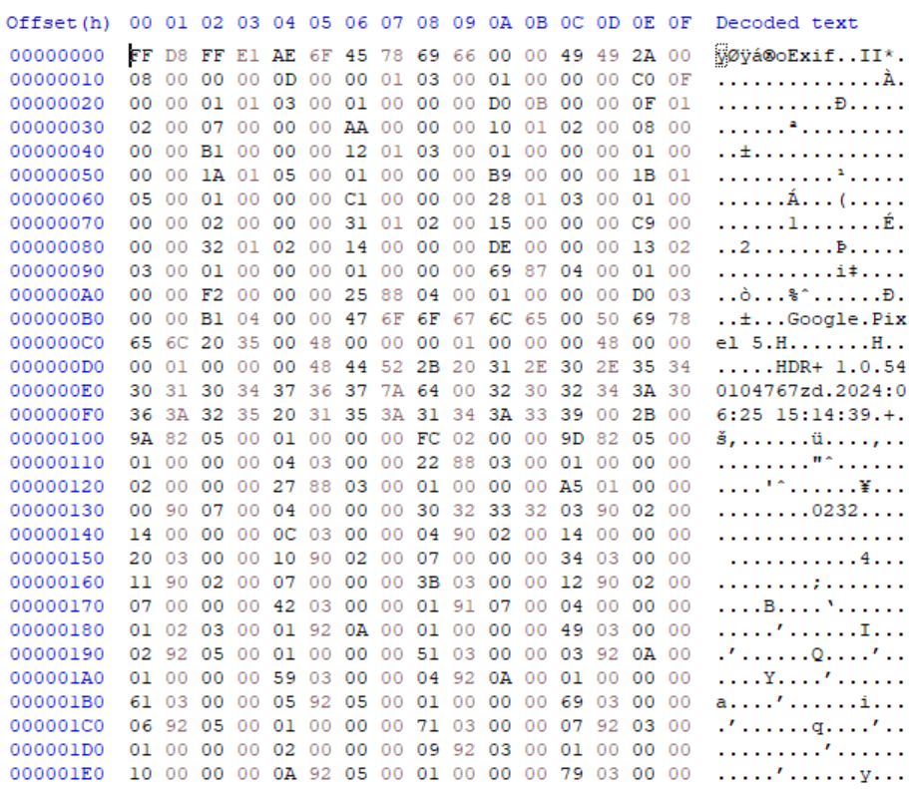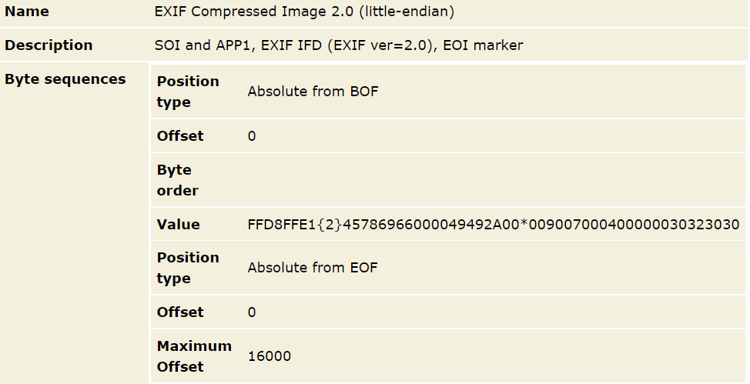.jpg image of two horses
Same .jpg image displayed in a hex editor
File format magic bytes that identify this file format entry in PRONOM
—-

Multi-part Assets
- Consists of multiple files
- Often co-located, i.e. in a single folder on a file system or across multiple folders
  - Examples include Advanced Video Coding High Definition (AVCHD), Interoperable Master Format (IMF), some iWork versions.
- Could be distributed across web resources
  - Examples include a web page with separate HTML, JS, CSS elements.

—-

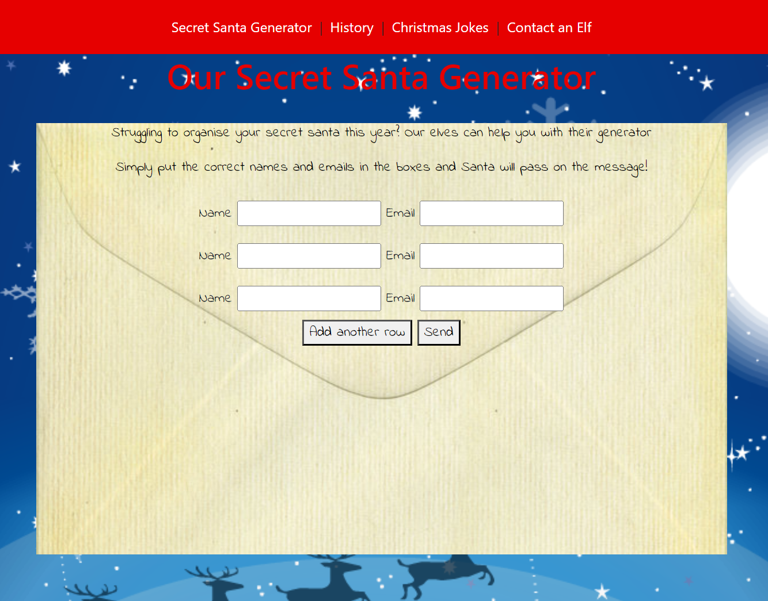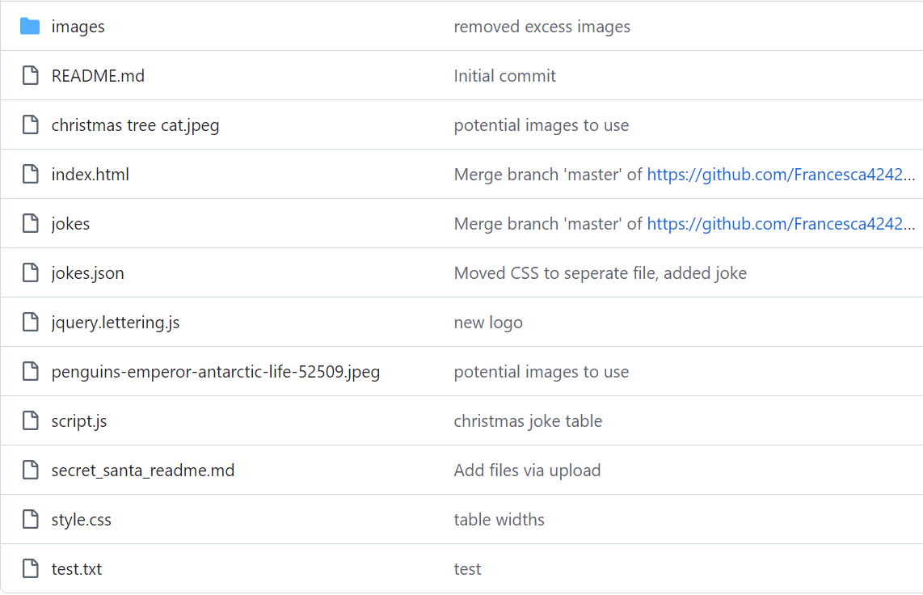Is a group of files such as jpeg, css, JavaScript, html and more
A website displayed in a browser

—-

Task
Can you think of other multi-part assets? Are there any that you are working with in your organization?

www.menti.com 5136 8099
Multi-part assets
—-

Container-based Formats
Consists of multiple items/subfiles, contained within a single containing file structure.

What containers are (DROID @ present) | What Containers are not
ZIP & OLE-based contained formats  Examples include Microsoft Word 97-2003 .doc (OLE-based), Microsoft Word 2007 onwards .docx (Zip-based), ePub (Zip-based). | Not currently supported by DROID include Info-Tech Storage Format (ITSF), installer files (e.g. .msi), GZIP (often used to compress otherwise inefficient formats, such as the XML-based Gnumeric file format)
> Within A/V, formats such as MP4 and MXF are also referred to as container formats, and they may contain distinct audio and video streams, subtitles and more. DROID does not deal with these at a container level, just binary identification (MediaInfo is your best friend!)

—-

Container-based Formats
Consists of multiple items/subfiles, contained within a single containing file structure.

Examples on the just solve it wiki:

OLE2:
- http://fileformats.archiveteam.org/wiki/Category:Microsoft_Compound_File

ZIP:
- http://fileformats.archiveteam.org/wiki/Category:ZIP_based_file_formats

—-

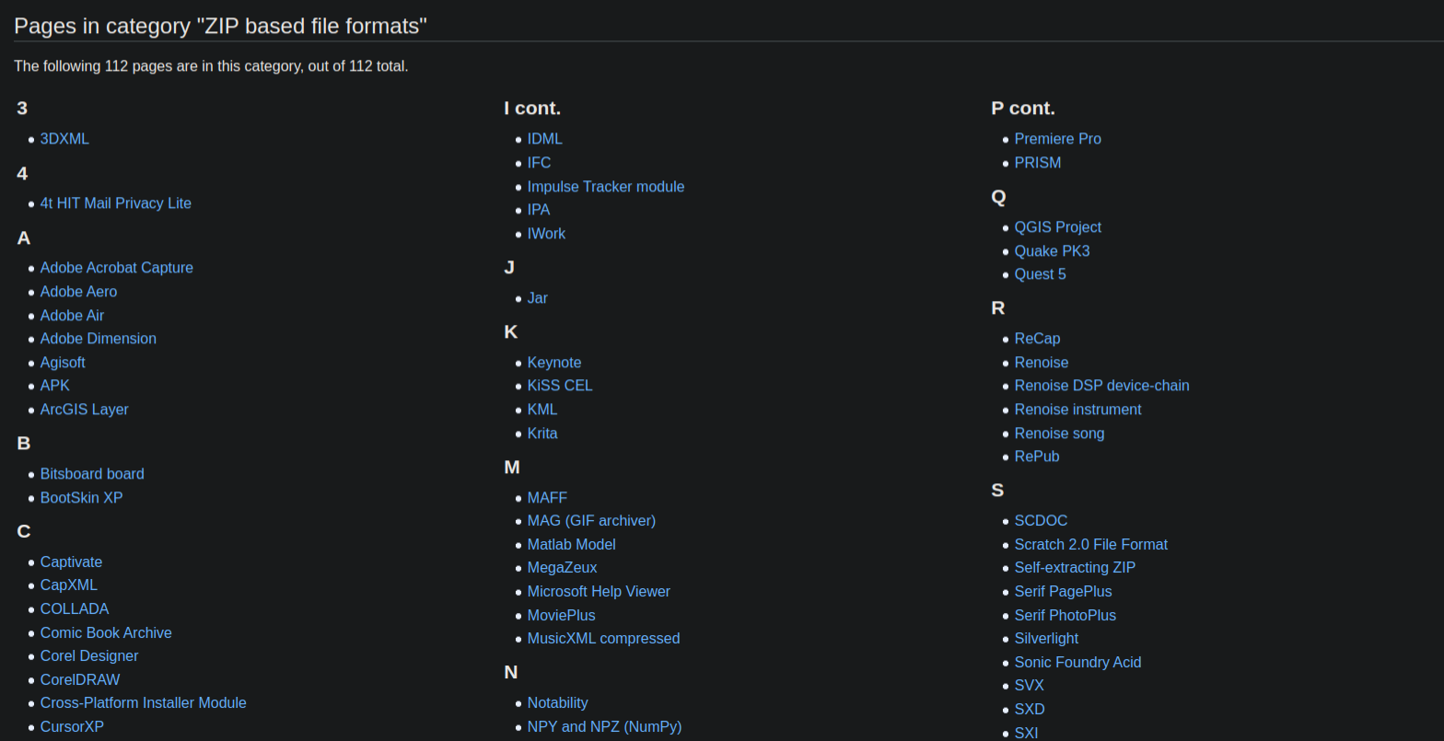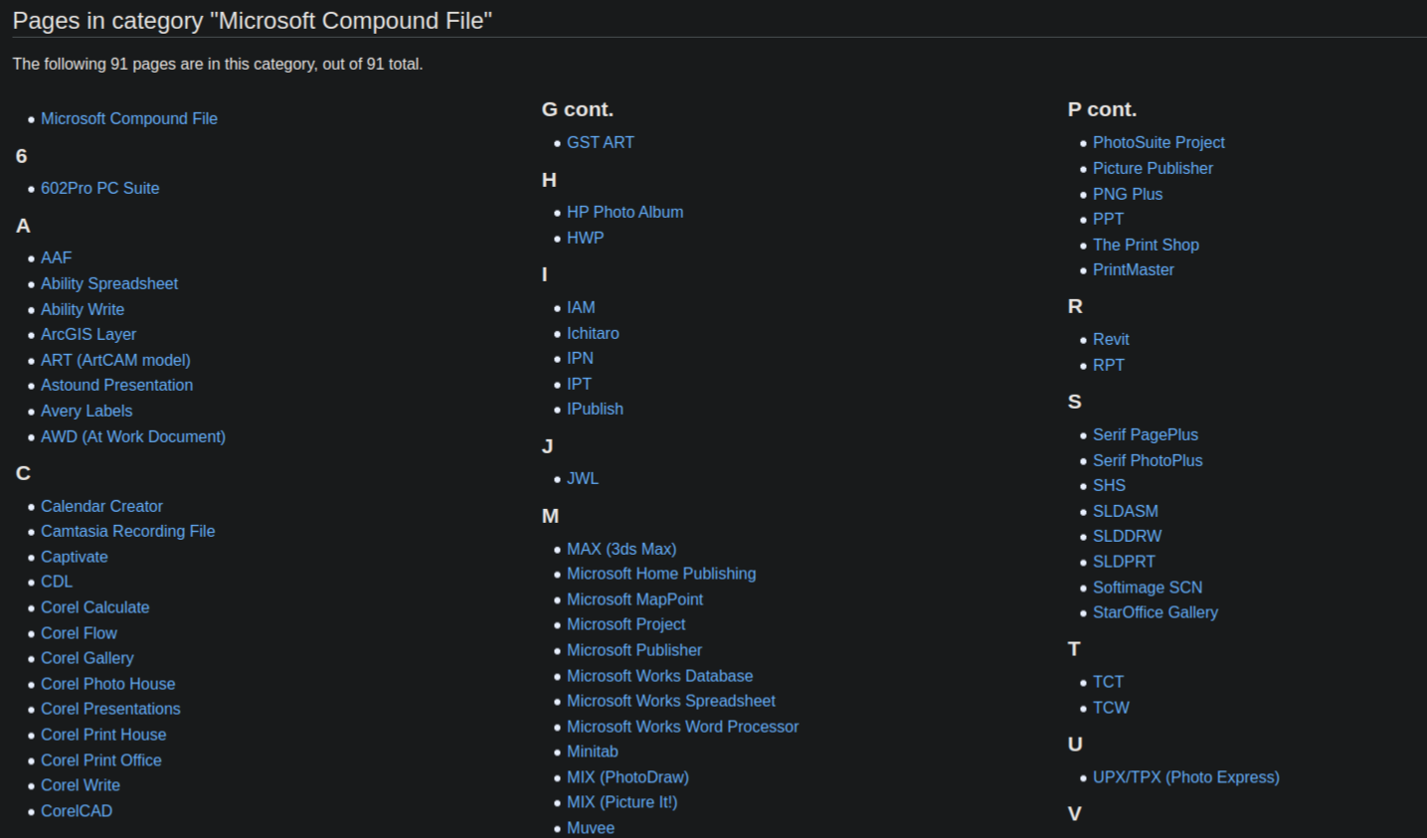OLE2: 91 Pages
ZIP: 112 Pages
—-

Like Matryoshka Dolls, but the Dolls are directory paths, filenames and file formats…
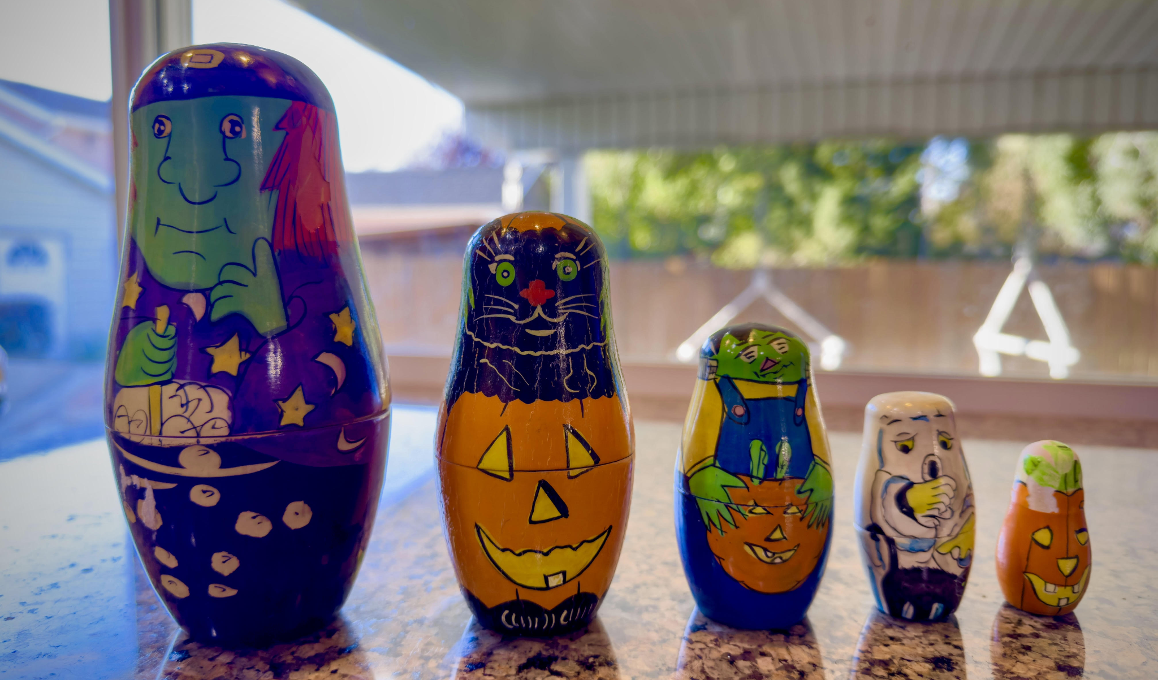zip
xml
ole2
jpg
 *
 *
json

—-

Microsoft Word DOCX Format
- Structurally follows the Office Open XML standard - ISO/IEC 29500, ECMA-376
- Is a Zip file, containing mostly XML files
- XML files define the structure of the document, along with any textual and formatting elements
- XML files also control the meta-structure, describing where other file elements can be found within the zip
- Embedded objects (such as images) are stored in full
- Can be unpacked or explored with a tool such as 7zip, or through Windows Explorer after changing the file extension to .zip
- May also contain a thumbnail image of the rendered document
—-

The Microsoft Word DOCX Format
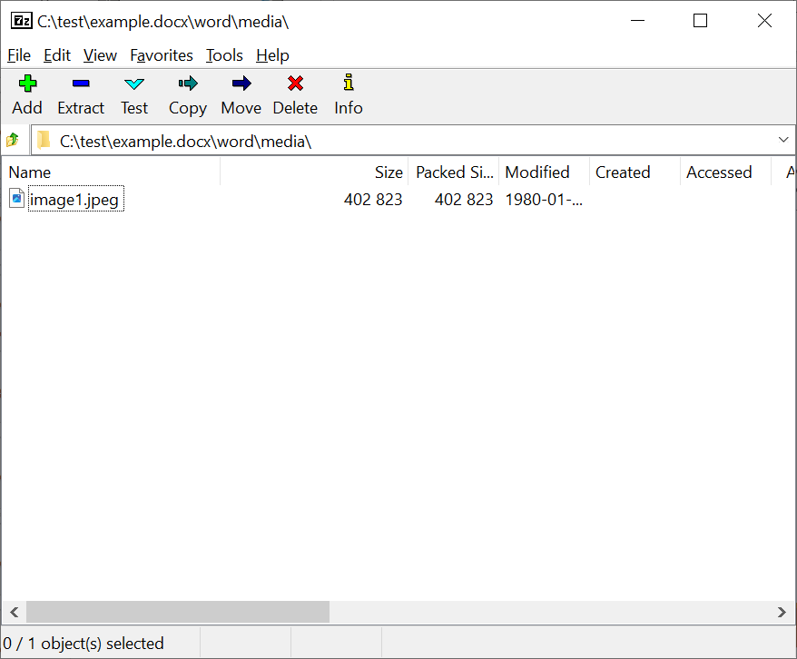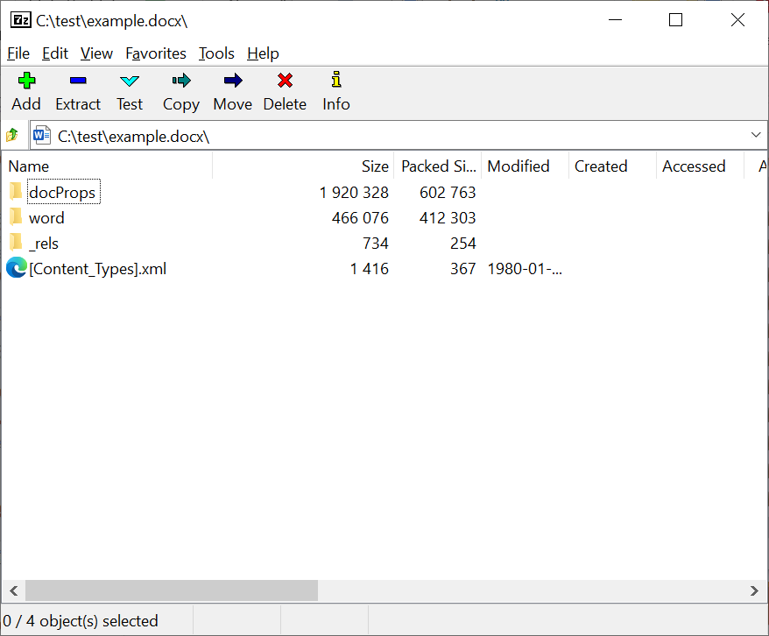
—-
The Microsoft Word DOCX Format
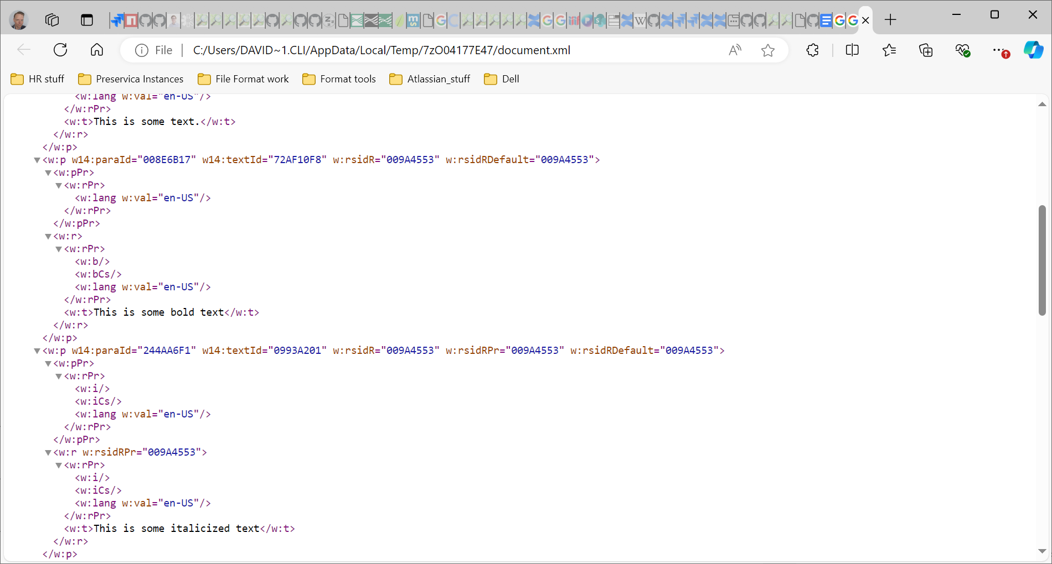
—-
Task
Explore a Word, Excel, or PowerPoint document and discuss what you see and any interesting findings with your peers.

> The container can be accessed by using a tool such as 7-zip to unpack the contents, or by changing the file extension to .zip,

www.menti.com 5136 8099
Exploring a Container Format

—-

Binary Signature File Format Identification Recap
- Deals with internal bytecode - the ones and zeros that make up a digital file
- Identification based on pattern matching of hexadecimal values
- Ideally based on elements clearly defined by the format creator - ‘magic number’ sequences
- However, such sequences may not be specified so other elements may need to be used
- File format specifications really help. May not be readily available
- Sequences may need to be inferred based on observation, ideally from a representative and diverse set of known-good file instances
- Main tool used by a file format researcher is a Hex Editor
- Based on your pre-workshop feedback, we will look to deliver a workshop on this topic in the near future!
—-
Identification based on specification example:

TZX Header - information recreated from original source: https://web.archive.org/web/20191028200053/https://worldofspectrum.org/TZXformat.html
length: 10 bytes
Offset | Value | Type | Description
0x00 | "ZXTape!" | ASCII[7] | TZX signature
0x07 | 0x1A | BYTE | End of text file marker
0x08 | 1 | BYTE | TZX major revision number
0x09 | 20 | BYTE | TZX minor revision number
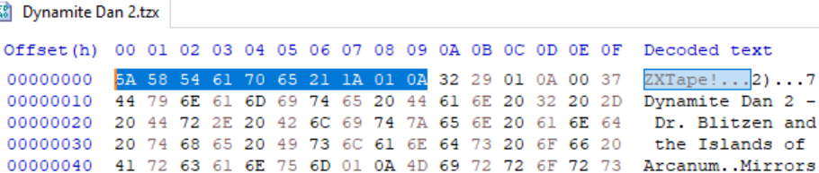

—-

Identification based on specification example:
Signature: 5A5854617065211A01


—-

The text file and other formats
- Some files are completely unpredictable and have no official structure.
- For example a .txt file consists of whatever you choose to type in ASCII.
- Other examples of this may include some coding languages or files made up of strings of data.
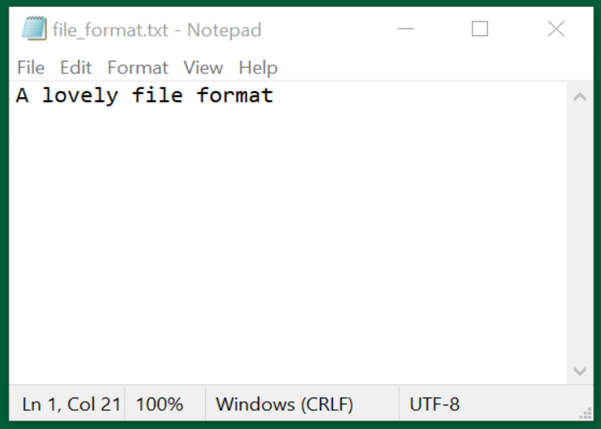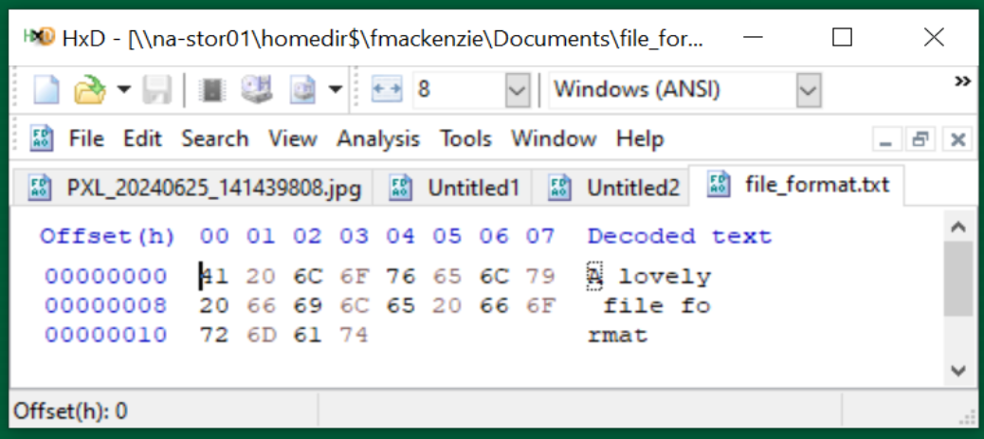

—-
Task

Look at the internal bytecode of any file. Do you notice any consistencies in the file? Any patterns in the head, body, and tail?

Use hex editor you have installed, or one online one, such as:

https://hexed.it/

> Always be wary of uploading sensitive files or data to random web pages!

www.menti.com 5136 8099

Hex Editors

—-

Binary Signature File Format Identification
- A PRONOM file format entry can be associated with zero-to-many file format signatures. Matching any signatures will return a hit
- A File Format signature can be anchored to the beginning of the file (BOF), the end of the file (EOF), or at a variable (VAR) location within the file. It can also be offset to the BOF or EOF, either absolutely, or by a range
- Binary signatures in PRONOM are always expressed using hexadecimal notation

—

Binary Signature File Format Identification additional syntax
- ??: wildcard matching any pair of hexadecimal values (i.e. a single byte).
e.g.: 0x0A FF ?? FE would match 0x0A FF 6C FE or 0x0A FF 11 FE.

- *: wildcard matching any number of bytes (0 or more).
e.g.: 0x0A FF * FE would match 0x0A FF 6C FE or 0x0A FF 6C 11 FE.

- {n}: wildcard matching n bytes, where n is an integer.
e.g.: 0x1C 20 {2} 4E 12 would match 0x1C 20 FF 15 4E 12.

- {m-n}: wildcard matching between m-n bytes inclusive, where m and n are integers or ‘*’.
e.g.: 0x03 {1-2} 4D would match 0x03 3C 4D or 0x03 3C 88 4D.
e.g.: 0x03 {2-*} 4D would match 0x03 3C 88 4D or 0x03 3C 88 3F 4D.

—
Binary Signature File Format Identification additional syntax
- (a|b): wildcard matching one from a list of values (e.g. a or b), where each value is a hexadecimal byte sequence of arbitrary length containing no wildcards.
e.g.: 0x0E (FF|FE) 17 would match 0x0E FF 17 or 0x0E FE 17.

- [a:b]: wildcard matching any sequence of bytes which lies lexicographically between a and b, inclusive (where both a and b are byte sequences of the same length, containing no wildcards, and where a is less than b).
e.g. 0xFF [09:0B] FF would match 0xFF 09 FF, 0xFF 0A FF or 0xFF 0B FF.

- [!a]: wildcard matching any sequence of bytes other than a itself (where a is a byte sequence containing no wildcards).
e.g. 0xFF [!09] FF would match 0xFF 0A FF, but not 0xFF 09 FF.

—-

Binary Signature File Format Identification additional syntax
- [!a:b]: wildcard matching any sequence of bytes which does not lie lexicographically between a and b, inclusive (where a and b are both byte sequences of the same length, containing no wildcards, and where a is less than b)
e.g. 0xFF [!01:02] FF would match 0xFF 00 FF and 0xFF 03 FF, but not 0xFF 01 FF or 0xFF 02 FF.

—-

Binary Signature File Format Identification example - ZIP

Name | ZIP Format Signature 1
Byte sequences | Position type | Absolute from BOF
 | Offset | 0
 | Maximum Offset | 4
 | Value | 504B0304
 | Position type | Absolute from EOF
 | Offset | 0
 | Byte order | Little-endian
 | Value | 504B01{43-65531}504B0506{18-65531}
Name | ZIP Format Signature 2
Byte sequences | Position type | Absolute from BOF
 | Offset | 0
 | Maximum Offset | 0
 | Value | 504B05060000
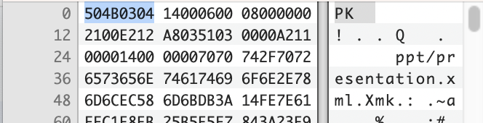

—-

Task

Open the latest container signature file

In your web browser, or text editor of choice:

Directly:

https://cdn.nationalarchives.gov.uk/documents/container-signature-20240715.xml

Or via PRONOM > DROID Signature Files > 15 July 2024 (at the bottom of the page):

https://www.nationalarchives.gov.uk/PRONOM
The Container Signature File

—-

How DROID Identifies Container-based File Formats
- Initial identification of certain container formats acts as a Trigger for DROID to check for container identification matches
- DROID then checks the internal structure of these container format instances, seeking matching Paths to required subfiles (files or directories within the container)
- If a matching path is found, DROID then checks the InternalSignatures of the subfile(s), seeking matching identification Sequences
- All elements of a container signature must be present for it to return a hit
- A format (PUID) can have multiple container signatures, in which case matching against any will return a hit
- If no matching trigger identification is found, or no matching paths are found, or where declared no matching sequences are found, binary identification continues as normal

—-

Container signatures in the PRONOM database
- PRONOM won’t show container signatures within the database. If a format is in the database usually there is a note on the page mentioning that it has a container signature attached as below.
- Container signatures are not entered into our database in the same way as binary signatures and can only be seen via the downloaded xml files.
- Container signatures are written manually in xml before being published. You can therefore see different stylistic decisions that may have been made within the xml.
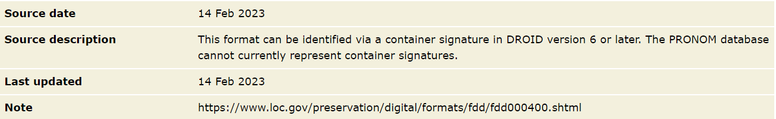
—-

A (very brief) XML primer
- XML = eXtensible Markup Language
- Consists of Elements, Attributes, and Data
- Usually starts with a Prolog:
<?xml version="1.0" encoding="UTF-8"?>
- Indentation helps with readability, but is not mandatory and whitespace (tabs, carriage returns, spaces) are ignored by the XML parser
- Elements must have a closing tag
- Elements are hierarchical - they can have child elements
- Attribute values must be quoted (single/double)

<ContainerSignatureMapping schemaVersion="1.0" signatureVersion="38">

<ExampleElement>Example data</ExampleElement>

</ContainerSignatureMapping>

—-

Container Signature File Structure
Consists of three sections:
- ContainerSignatures - the actual signature data that is used to identify files
- FileFormatMappings - the relationship (or key) between formats in PRONOM proper and Container Signatures
- TriggerPuids - the formats in PRONOM that, where initially identified, will prompt container signature processing and detection

<ContainerSignatureMapping schemaVersion="1.0" signatureVersion="38">
<ContainerSignatures>
...
</ContainerSignatures>
<FileFormatMappings>
...
</FileFormatMappings>
<TriggerPuids>
...
</TriggerPuids>
</ContainerSignatureMapping>

—-

Container Triggers
The identification of certain container formats acts as a trigger for DROID to check for container identification matches. These triggers are:

- fmt/111: OLE2 Compound Document Format
- fmt/189: Microsoft Office Open XML 2007 Onwards
- x-fmt/263: Zip Format

> NB: fmt/189 is a specific type of zip

If your file identifies as any of these then it may well be a candidate for a container signature!

Triggers are found in the ‘TriggerPuids’ section at the bottom of the Container Signature File:

<TriggerPuids>
<TriggerPuid ContainerType="OLE2" Puid="fmt/111"/>
<TriggerPuid ContainerType="ZIP" Puid="fmt/189"/>
<TriggerPuid ContainerType="ZIP" Puid="x-fmt/263"/>
</TriggerPuids>
—-

File Format Mappings
The relationship (or key) between formats in PRONOM proper and Container Signatures, which includes SignatureID and PUID attributes.

- SignatureID maps to items in the ContainerSignatures section and is assigned manually by the PRONOM team
- PUID maps directly to a PRONOM identifier.
- Includes a comment line containing the format name and usually the type of container trigger
- A PUID can be mapped to multiple ContainerSignatures by SignatureID. In this case a match against any of the listed container signatures will return a match

<!-- Microsoft Word Document 6.0/95 (OLE2) -->
<FileFormatMapping signatureId="1000" Puid="fmt/39"/>
<!-- Microsoft Word Document 97-2003 -->
<FileFormatMapping signatureId="1020" Puid="fmt/40"/>
<!-- Microsoft Word OOXML (ZIP) -->
<FileFormatMapping signatureId="1030" Puid="fmt/412"/>

—-

Container Signature Structures - Overview
- At the top level, Container Signatures consist of an ID attribute which matches the File Format Mapping.
- The ContainerType attribute (either ZIP or OLE2) is informational and relates to the Trigger.
- The Description usually matches the format name, but may include additional information (e.g. ‘variant 2’).
- The Files element must exist and contains one or more File elements.

<ContainerSignature Id="1000" ContainerType="OLE2">
<Description>Microsoft Word 6.0/95 OLE2</Description>
<Files>
<File>
...
</File>
<File>
...
</File>
</Files>
</ContainerSignature>

—-

Container Signature Structures - Files
- File elements contain one to many Path elements
- Paths represent a filepath to a resource (directory or file) relative to the root of the container
- A Container Signature must minimally have one File & Path, but can have many
- A File can have zero-to-many BinarySignatures
- A Container Signature must match against all given Paths and BinarySignatures to return a match

<Files>
<File>
<Path>WordDocument</Path>
</File>
<File>
<Path>CompObj</Path>
<BinarySignatures>
...
</BinarySignatures>
</File>
</Files>

—-

Container Signature Structures - Sequences
- A Path can have zero-to-many InternalSignatures
- InternalSignatures represent a byte sequence found within a file specified by a Path
- An InternalSignature can be formed of many sub-Sequences
- As with binary signatures, InternalSignatures can be positioned relative to the BOF, EOF, or Variable within the file
- Sequences in a Container Signature can be expressed as hexadecimal, or ASCII where appropriate (usually standard western alphanumeric characters from the 7-bit ASCII range). If in doubt use hexadecimal!
- The value of InternalSignature ID is arbitrary, but in later versions we usually match them to the Container Signature ID
—-

Container Signature Syntax
- Syntax for container signatures can differ from binary signature syntax
- The most obvious of these is the option to write in ASCII with inverted commas or in hexadecimal whereas binary signatures are only written in hexadecimal
- Binary signature syntax elements, such as wildcards and byte ranges cannot be applied in the same way - instead signatures are more similar to the post-processed versions found in the binary signature file

—-
Container Signature Example - fmt/412
<ContainerSignature Id="1030" ContainerType="ZIP">
<Description>Microsoft Word OOXML</Description>
<Files>
<File>
<Path>[Content_Types].xml</Path>
<BinarySignatures>
<InternalSignatureCollection>
<InternalSignature ID="302">
<ByteSequence Reference="BOFoffset">
<SubSequence Position="1" SubSeqMinOffset="0" SubSeqMaxOffset="32768">
<Sequence>'ContentType="application/vnd.openxmlformats-officedocument.wordprocessingml.document.main+xml"'</Sequence>
</SubSequence>
</ByteSequence>
</InternalSignature>
</InternalSignatureCollection>
</BinarySignatures>
</File>
</Files>
</ContainerSignature>

—-
Container Signature Example - fmt/39
<ContainerSignature Id="1000" ContainerType="OLE2">
<Description>Microsoft Word 6.0/95 OLE2</Description>
<Files>
<File>
<Path>WordDocument</Path>
</File>
<File>
<Path>CompObj</Path>
<BinarySignatures>
<InternalSignatureCollection>
<InternalSignature ID="306">
<ByteSequence Reference="BOFoffset">
<SubSequence Position="1" SubSeqMinOffset="40" SubSeqMaxOffset="1024">
<Sequence>10 00 00 00 'Word.Document.' ['6'-'7'] 00</Sequence>
</SubSequence>
</ByteSequence>
</InternalSignature>
</InternalSignatureCollection>
</BinarySignatures>
</File>
</Files>
</ContainerSignature>

—-
Container Signature Example - fmt/1196
<ContainerSignature ContainerType="ZIP" Id="31020">
<Description>SIARD 2.1</Description>
<Files>
<File>
<Path>header/siardversion/2.1/</Path>
</File>
</Files>
</ContainerSignature>

—-
Container Signature Example - fmt/1190
<InternalSignature ID="28200">
<ByteSequence Reference="BOFoffset">
<SubSequence Position="0" SubSeqMinOffset="0" SubSeqMaxOffset="0">
<Sequence>3C 3F 78 6D 6C 20 76 65 72 73 69 6F 6E 3D 22 31 2E 30 22 20 3F 3E</Sequence>
</SubSequence>
</ByteSequence>
<ByteSequence Reference="BOFoffset">
<SubSequence Position="1" SubSeqMinOffset="23" SubSeqMaxOffset="50">
<Sequence>3C 73 77 63 20 78 6D 6C 6E 73 3D 22 68 74 74 70 3A 2F 2F 77 77 77 2E 61 64 6F 62 65 2E 63 6F 6D 2F 66 6C 61 73 68 2F 73 77 63 63 61 74 61 6C 6F 67 2F</Sequence>
</SubSequence>
</ByteSequence>
</InternalSignature>

—-
Container Signature Example - fmt/978
<ContainerSignature Id="30020" ContainerType="OLE2">
<Description>3DS Max</Description>
<Files>
<File>
<Path>DocumentSummaryInformation</Path>
<BinarySignatures>
<InternalSignatureCollection>
<InternalSignature ID="30020">
<ByteSequence Reference="BOFoffset">
<SubSequence Position="1" SubSeqMinOffset="0" SubSeqMaxOffset="1024">
<Sequence>33 64 73 20 4D 61 78 20 56 65 72 73 69 6F 6E </Sequence>
</SubSequence>
</ByteSequence>
</InternalSignature>
</InternalSignatureCollection>
</BinarySignatures>
</File>
</Files>
</ContainerSignature>

—-

Manually create your signatures using template.

FFDev.info https://ffdev.info/ provides a form for ease of creation of standard and container signature files.

To use new signatures they will need to be added to the right folders in the droid config:

$ROOT/$USERHOME/.droid6/…
Task
Hidden Folder
Creating and Testing Container Signatures

20 mins
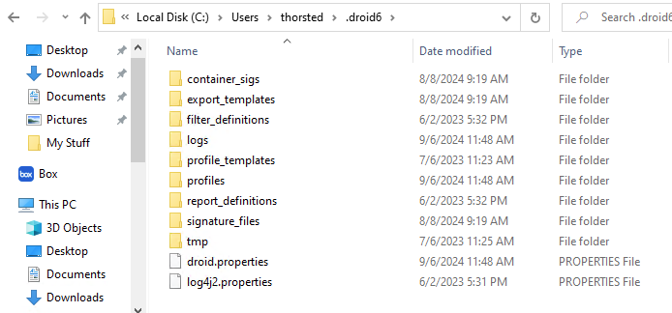
—-
—-
ffdev.info
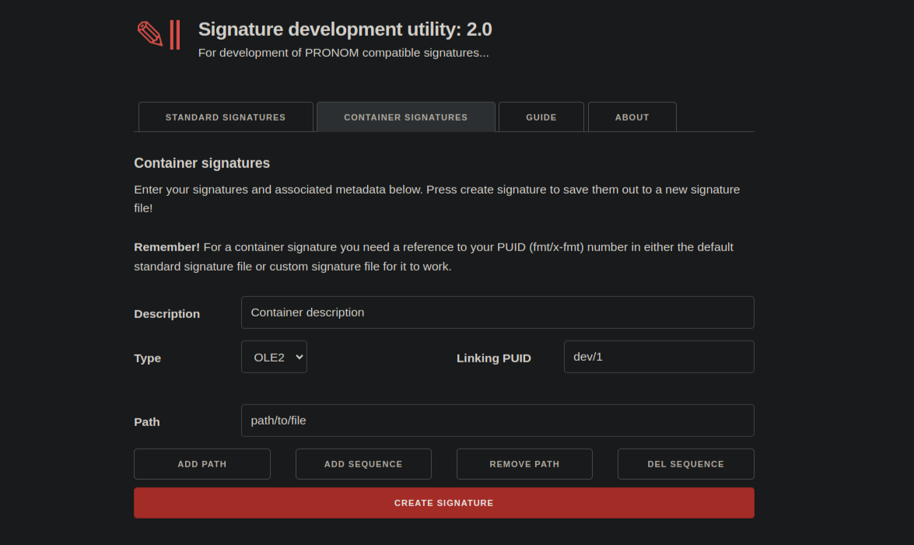Pronom Signature Development Utility
—-

Finding Format Examples
The more Samples you can find, the more precise the signatures can be.

File format examples can can found on:
- Search Engines, e.g. <search term> filetype:pdf
- Just solve it: File Formats Wiki
- Internet Archive
- eLearning Sites
- Compiled Corpuses.
- Make your own!

Tyler’s format finding guide! https://github.com/thorsted/fileformat

—

Testing signatures
We want to identify false-positives and collisions.
The Skeleton Suite Homepage:

Builder: Current Skeleton’s, Maintained by Richard Lehane
- Updated when a new PRONOM is released
- Contains standard and container skeleton samples.
https://github.com/exponential-decay/skeleton-test-suite-generator
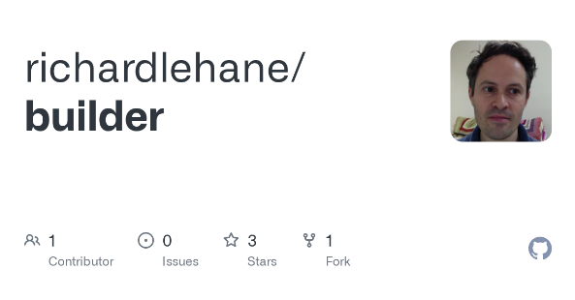
—-
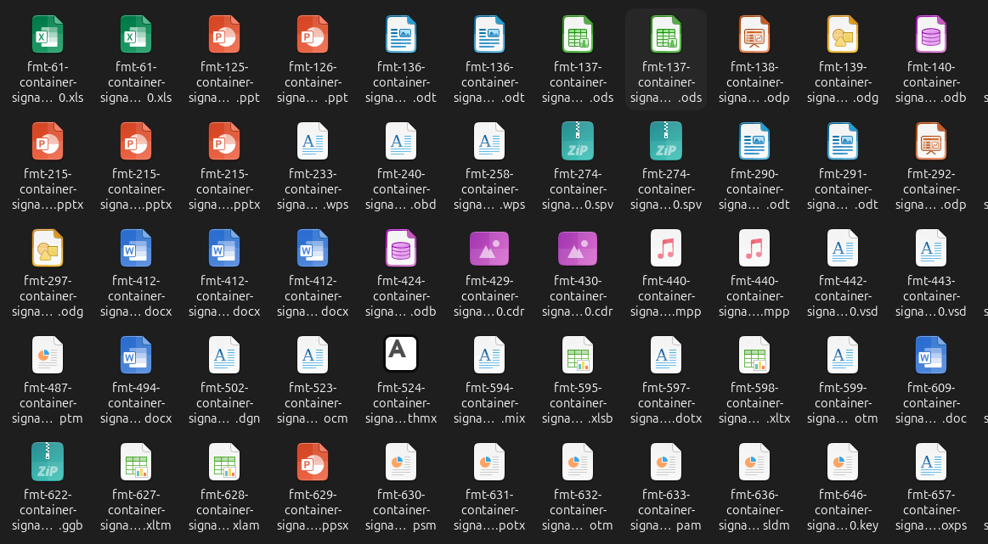
—-
Q & A (10 mins)
www.menti.com 5136 8099

—-

Final Topics
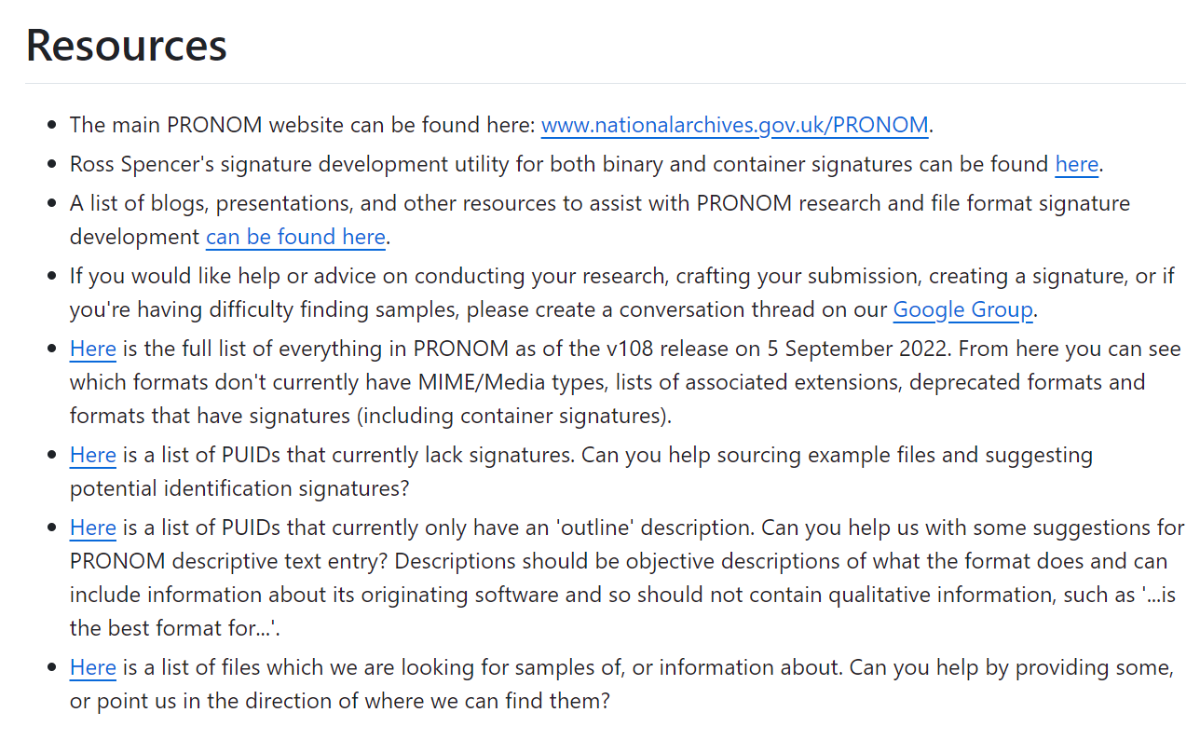How to get in touch:
Email- pronom@nationalarchives.gov.uk
Google Groups- PRONOM - Google Groups
GitHub- https://github.com/digital-preservation/PRONOM_Research
PRONOM Open Drop-In

—-
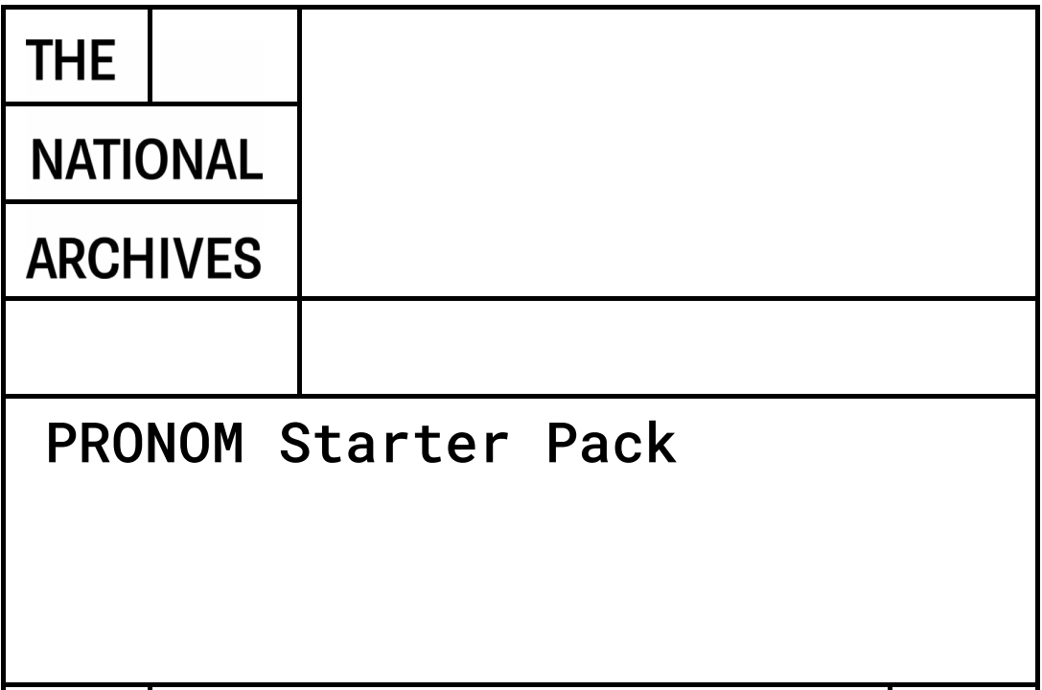PRONOM Starter Pack
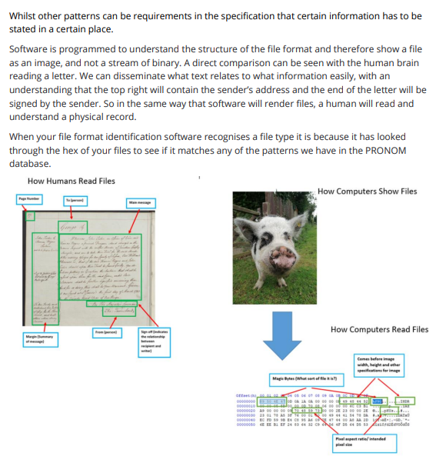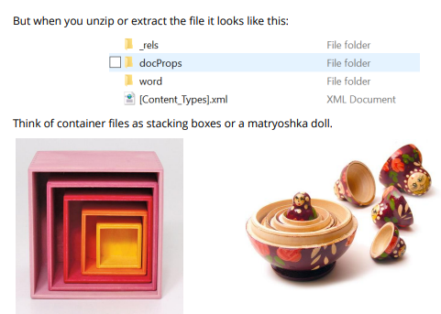
—-
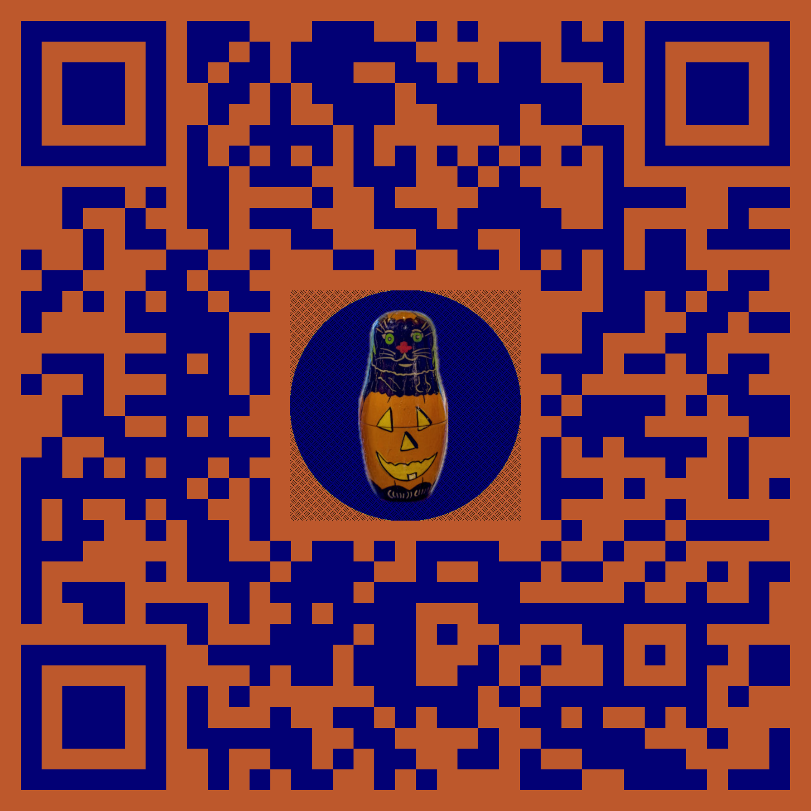Useful links
https://linktr.ee/pronom.whats.in.the.box

-

