**Look, no hands: The contribution of handgrip to maximal power output during sprint cycling**

Ross D. Wilkinson1, Cristian Riveros-Matthey2, Andrew G. Cresswell2, and Glen A. Lichtwark2

1Locomotion Laboratory

Department of Integrative Physiology

University of Colorado

Boulder, CO, USA

2School of Human Movement and Nutrition Sciences

University of Queensland

Brisbane, QLD, Australia

Submitted as Original Research

to

*TBD*

Word count:

Corresponding author:

Ross D. Wilkinson

Department of Integrative Physiology

University of Colorado Boulder

1725 Pleasant Street, Clare Small 114, Boulder, CO 80309-0354

Phone: +1 720 727 4774

E-mail: [ross.wilkinson@colorado.edu](mailto:ross.wilkinson@colorado.edu)

# 

# Abstract

**Keywords:**

# Introduction

Previous research shows that the upper-body muscles contribute significantly to maximal power output during sprint cycling by acting on the handlebar. Researchers have speculated that the mechanism underlying this contribution relates to the prevention of upward acceleration of the rider’s center of mass during the downstroke, which allows leg extension power to generate greater levels of crank power.

Here, we investigated the contribution of the upper body to maximal power output and rider center of mass movement during sprint cycling by having riders sprint in both a seated and non-seated posture while either gripping or not gripping the handlebar. In the “no-grip” conditions, we asked riders to rest their closed fists on top of where they would usually grip the handlebar. Our first hypothesis was that maximal power output would be higher when gripping the handlebar. We also tested the null hypothesis that there would be no effect of gripping the handlebar on vertical acceleration of the rider’s center of mass during the crank cycle in either posture. Additionally, we explored differences in joint power contribution from the legs and upper body.

# Methods

Eleven healthy adults volunteered (9 males/ 2 females, age: 23 ± 3 years, height: 1.79 ± 0.09 m, mass: 76 ± 13 kg, mean ± one standard deviation).

Here, we define maximal power as the highest average crank power over a complete crank cycle.

## Statistical analysis

We used a two-way, repeated-measures, analysis of variance (ANOVA) to test for main and interaction effects (posture $×$ handgrip) on maximal power. We used one-dimensional statistical parametric mapping (Pataky, 2010) to test for the effect of handgrip on vertical center of mass acceleration during the maximal crank power cycle. Due to available time and resources, we collected data on 11 participants. A *post-hoc* power analysis using G*Power v3.1 (Faul et al., 2013) determined that our sample size of 11 could detect effect sizes >1.09 at our desired power (90%) and alpha level (0.05). The smallest detectable effect size was 0.67. For multiple comparisons, we corrected p-values using the Dunn-Sidak method and tested whether the distribution of each variable violated the assumption of normality using a Jarque-Bera test. For main and interaction effects, we report the effect size as generalized eta squared ($η_{G}^{2}$). For paired t-tests, we report the effect size as Hedge’s gav (ES). Descriptive data are reported as the group mean ± standard error.

# Results

## Maximal power

There were significant main effects of grip, F1,10 = 77, p < .001, $η_{G}^{2}$ = 0.52, and posture, F1,10 = 29, p < .001, $η_{G}^{2}$ = 0.45, and a significant interaction, F1,10 = 6.6, p = .027, $η_{G}^{2}$ = 0.02. On average, gripping the handlebar increased maximal power by 10 ± 2% when seated, t10 = 5.2, p = .002, CI95% [6,14], ES = 1.4, and by 14 ± 1% when non-seated, t10 = 9.8, p < .001, CI95% [11,17], ES = 2.7 (See Figure 2). Thus, we accept our first hypothesis.

## Center of mass acceleration

For the seated posture, we did not detect any statistically significant effect of gripping the handlebar on vertical center of mass acceleration. When non-seated, gripping the handlebar increased upward center of mass acceleration from 24-39°, t10 = 5.1, p = .01, and from 135-163°, t10 = 5.3, p < .001, during the crank cycle. Additionally, gripping the handlebar increased downward center of mass acceleration from 207-217°, t10 = 4.7, p = .04, and from 318-350° (t10 = 6.4, p < .001) during the crank cycle (See Figure 3). Thus, we fail to accept the null hypothesis.

## Net upper-body power

On average, gripping the handlebar increased net upper-body power by 59 ± 31% when seated, however, the effect was inconclusive likely due to our small sample size, t10 = 1.9, p = .09, CI95% [–11,129], ES = 0.56. When non-seated, gripping the handlebar increased net upper-body power by 49 ± 13%, t10 = 3.7, p = .004, CI95% = [19,79], ES = 1.1. Additionally, gripping the handlebar increased net upper-body power as a percentage of net crank power when seated (Grip = 6% vs. No Grip = 4%) and when non-seated (Grip = 9% vs. No Grip = 6%) (See Figure 4A-B).

## Net leg power

On average, gripping the handlebar increased net leg power by 8 ± 1% when seated, t10 = 5.6, p < .001, CI95% [5,11], ES = 1.7, and by 11 ± 1% when non-seated, t10 = 8.7, p < .001, CI95% = [8,14], ES = 2.6. But, gripping the handlebar decreased net leg power as a percentage of net crank power when seated (Grip = 94% vs. No Grip = 96%) and when non-seated (Grip = 91% vs. No Grip = 94%) (See Figure 4C-D).

# Discussion

# Declarations

## Funding

R.D.W. and C.R-M. were supported by an Australian Government Research Training Program Scholarship.

## Conflict of interest statement

No conflicts of interest to disclose.

## Availability of data

Data can be found at [INSERT URL].

## Authors’ contributions

R.D.W. and G.A.L. conceptualized and designed experiment. C.R-M. and G.A.L. conducted experiment. R.D.W. analyzed data, prepared figures, and drafted manuscript. R.D.W., C.R-M., A.G.C., and G.A.L. interpreted results, revised manuscript, and approved final version of manuscript.

# References

# Figures and captions

**Figure 1.** Hand position in the grip (left) and no-grip (right) conditions. For the no-grip condition, we asked participants to rest their closed fists on top of the handlebar drops. Participants performed the all-out sprints on a cycling ergometer set to isokinetic mode at 120 revolutions per minute (RPM).

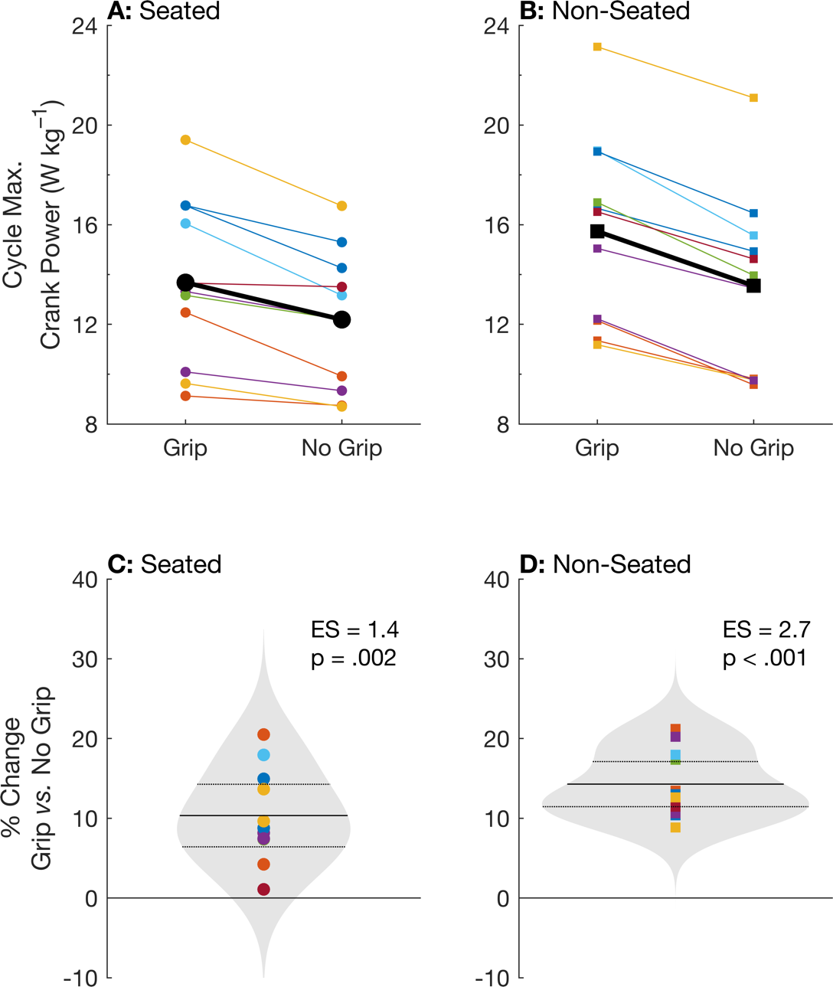

**Figure 2.** Individual (color) and group mean (black) maximum crank power over one crank cycle during the grip and no-grip conditions in a seated (A) and non-seated (B) posture. Panels C and D show the individual (color) and group mean (solid line) percentage change in maximum power during the no-grip condition compared to the grip condition in a seated and non-seated posture, respectively. The grey patches show the kernel distribution of the percentage changes, and the horizontal dotted lines show the 95% confidence intervals. ES, effect size.

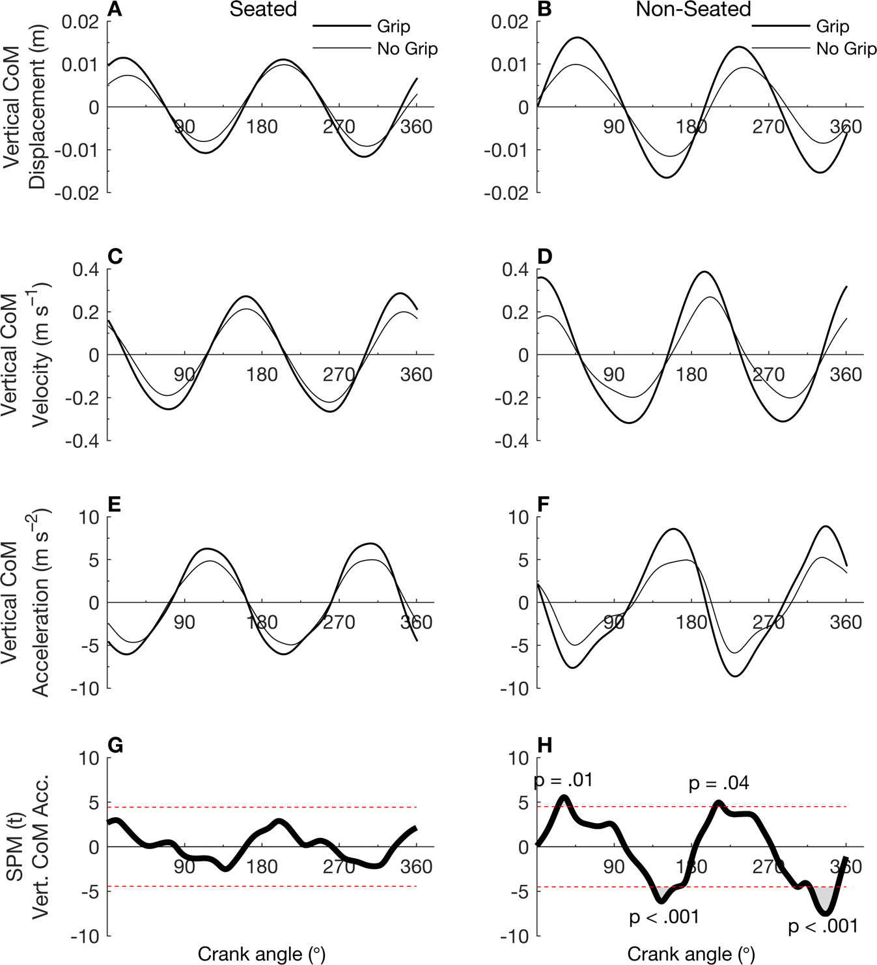

**Figure 3.** Angle-series plots of group mean (n=11) rider center of mass (CoM) displacement (A-B), velocity (C-D), and acceleration (E-F) during the maximum crank power cycle in a seated (left) or non-seated (right) posture while either gripping (thin) or not gripping (thick) the handlebar. One-dimensional Statistical Parametric Mapping (SPM) analyses (G-H) were used to test for statistical differences in vertical CoM acceleration between handgrip conditions over a complete crank cycle. The red dotted lines in panels G and H show the critical-t threshold at the corrected alpha level.

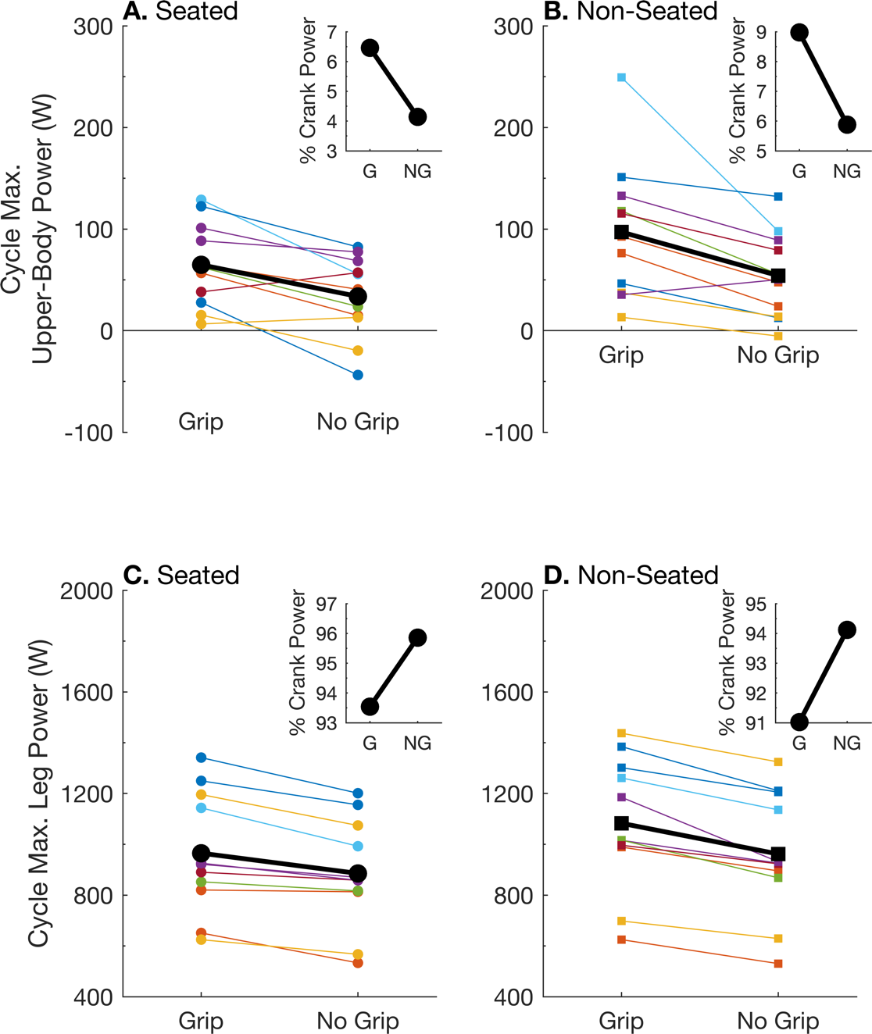

**Figure 4.** Individual (color) and group mean (black) upper-body power (A-B) and leg power (C-D) over the maximum crank power cycle in a seated (left) and non-seated (right) posture in watts (A-D) and as a percentage of total crank power (inset). Leg power was calculated as the sum of hip, knee, and ankle power from both legs. Upper-body power was calculated by subtracting leg power from the sum of crank and CoM power. Note: Net CoM power over a crank cycle is approximately equal to zero. G, grip. NG, no grip.