**Look, no hands: The contribution of handgrip to maximal power output during sprint cycling**

Ross D. Wilkinson1, Cristian Riveros-Matthey2, Andrew G. Cresswell2, and Glen A. Lichtwark2

1Locomotion Laboratory

Department of Integrative Physiology

University of Colorado

Boulder, CO, USA

2School of Human Movement and Nutrition Sciences

University of Queensland

Brisbane, QLD, Australia

Submitted as Original Research

to

*TBD*

Word count:

Corresponding author:

Ross D. Wilkinson

Department of Integrative Physiology

University of Colorado Boulder

1725 Pleasant Street, Clare Small 114, Boulder, CO 80309-0354

Phone: +1 720 727 4774

E-mail: [ross.wilkinson@colorado.edu](mailto:ross.wilkinson@colorado.edu)

# 

# Abstract

**Keywords:**

# Introduction

Previous research shows that the upper-body muscles contribute significantly to maximal power output during sprint cycling by acting on the handlebar. Researchers have speculated that the mechanism underlying this contribution relates to the prevention of upward acceleration of the rider’s center of mass during the downstroke, which allows leg extension power to generate greater levels of crank power.

Here, we investigated the contribution of the upper body to maximal power output and rider center of mass movement during sprint cycling by having riders sprint in both a seated and non-seated posture while either gripping or not gripping the handlebar. In the “no-grip” conditions, we asked riders to rest their closed fists on top of where they gripped the handlebar for the gripped condition. Our first hypothesis was that upper body power would be higher when gripping the handlebar. Our second hypothesis was that maximal power output would be higher when gripping the handlebar. Additionally, we tested the null hypothesis that there would be no effect of gripping the handlebar on vertical acceleration of the rider’s center of mass during the crank cycle in either posture.

# Material and methods

## Experimental design

Eleven recreational cyclists volunteered (9 males/2 females, age: 22.7 ± 2.6 years, height: 1.79 ± 0.09 m, mass: 76.4 ± 13.3 kg, mean ± one standard deviation). All participants gave informed written consent as per the University of Queensland Human Research Ethics Committee and in accordance with the Declaration of Helsinki.

All participants rode the same cycling ergometer (Excalibur Sport, Lode BV, Groningen, Netherlands) and used the same model of clip-in shoes (SH-R070, Shimano, Osaka, Japan) and pedals (SH-R540, Shimano, Osaka, Japan). We adjusted saddle height and handlebar position of the cycling ergometer to match each participant’s personal preference. The ergometer was equipped with pre-calibrated, wireless, instrumented force cranks (Axis, Swift Performance, Brisbane, Australia) set to a length of 175 mm. The cranks sample tangential and radial force and angular velocity at 200 Hz and transmit digital signals wirelessly to a base receiver connected to a digital-to-analogue converter (USB-2533, Measurement Computing Corporation, Norton, MA, USA).

We secured a full-body marker set (Wilkinson et al., 2020a; 2020b), consisting of individual and lightweight clusters of reflective markers, to each participant using a combination of double-side tape and self-adhesive bandage. We also secured three reflective markers in a triangular pattern to the rear legs of the ergometer to create a local coordinate system and define the orientation of the ergometer. An eight-camera, opto-electronic motion capture system (Oqus, Qualisys AB, Gothenburg, Sweden) collected the three-dimensional position of the 48 markers at 200 Hz and the accompanying software recorded the motion-capture data synchronously with the crank force and angle signals.

Participants warmed up by cycling for 5 min at a low intensity (~100 W) with the ergometer in “iso-power” mode. The ergometer’s “iso-power” mode ensures that power remains constant independent of cadence. This was followed by four 5-s warm-up sprints with the ergometer in “iso-kinetic” mode set to 120 revolutions per minute (RPM). The ergometer’s “iso-kinetic” mode ensures that cadence remains constant independent of torque. These warm-up sprints familiarized participants to the experimental conditions, which consisted of four different combinations of posture (seated and non-seated) and handgrip (grip and no grip). In the “no-grip” conditions, we asked riders to rest their closed fists on top of where they gripped the handlebar for the gripped conditions.

Prior to the experimental trials, participants rested for 5 min. For each experimental trial, participants completed a maximal 5-s sprint from rest. Participants performed 12 experimental sprints — three in each of the four conditions — with 3-min rest between each sprint. We split the 12 sprints into three blocks of four sprints and randomized the order of conditions within each block.

## Data analysis

We imported the marker-trajectory, crank-force, and crank-angle data into MATLAB (R2020a, The MathWorks Inc, Natick, MA, USA) and low-pass filtered (zero-lag, second-order, 12-Hz cutoff, Butterworth) them using custom scripts. To match the coordinate systems for the crank-force and marker-trajectory data, we transformed them, respectively, from the crank and motion capture coordinate systems to the ergometer coordinate system. We calculated crank power as the product of crank torque and crank angular velocity and parsed the data between each top dead center (TDC) location of the right crank. Here we define maximal power within each trial as the highest average crank power achieved over a complete crank cycle (TDC-TDC). For each participant, we calculated the maximal power for each condition as the mean value from the three replicate trials.

To calculate individual joint powers, we used a previously developed generic full-body musculoskeletal model (Rajagopal et al. 2016; refined by Lai, Arnold, and Wakeling, 2017) within OpenSim software (Delp et al., 2007; Seth et al., 2011) to create participant-specific models and perform inverse dynamic analyses. OpenSim generates participant-specific models by scaling the segment lengths and segment masses of the generic model to each participant’s static trial data. The participant-specific model can then be used to calculate hip, knee, and ankle net joint moments by combining inverse-kinematic results with reaction forces at the left and right cranks. The inverse-kinematics results also provide an estimate of the model’s center-of-mass (CoM) displacement, velocity, and acceleration.

At each instant, total joint power generated by the rider (Ptot) is equal to the sum of crank power (Pcranks) and the rate of mechanical energy lost or gained by the rider’s center of mass (PCoM) (van Ingen Schenau and Cavanagh, 1990).

|  |  |
| --- | --- |
| $$P_{tot}=P_{cranks}+P_{CoM}$$ | (1) |

Pcranks is the summed product of torque and angular velocity measured at each crank. PCoM is the change in total mechanical energy (potential + kinetic) of the CoM divided by the change in time; in this case based on inverse-kinematic results. We then further considered power generation from the legs and upper body:

|  |  |
| --- | --- |
| $$P_{leg}+P_{ub}=P_{cranks}+P_{CoM}$$ | (2) |

Leg power (Pleg) was calculated as the summed product of net joint moments and joint angular velocities at the hip, knee, and ankle of each leg. Upper-body power (Pub) was assumed to be the difference between Ptot and Pleg. Further details regarding the application of power equations in cycling can be found elsewhere (van Ingen Schenau and Cavanagh, 1990; Martin et al., 1998; Wilkinson et al., 2020a; 2020b).

## Statistical analysis

We used a two-way, repeated-measures, analysis of variance (ANOVA) to test for main and interaction effects (posture $×$ handgrip) on maximal power. We used one-dimensional statistical parametric mapping (Pataky, 2010) to test for the effect of handgrip on vertical center of mass acceleration during the maximal crank power cycle. Due to available time and resources, we collected data on 11 participants. A *post-hoc* power analysis using G*Power v3.1 (Faul et al., 2007) determined that our sample size of 11 could detect effect sizes >1.09 at our desired power (90%) and alpha level (0.05). The smallest detectable effect size was 0.67. For multiple comparisons, we corrected p-values using the Dunn-Sidak method and tested whether the distribution of each variable violated the assumption of normality using a Jarque-Bera test. For main and interaction effects, we report the effect size as generalized eta squared ($η_{G}^{2}$). For paired t-tests, we report the effect size as Hedges’ gav (ES). Descriptive data are reported as the group mean ± standard error.

# Results

## Maximal power

There were significant main effects of grip, F1,10 = 77, p < .001, $η_{G}^{2}$ = 0.52, and posture, F1,10 = 29, p < .001, $η_{G}^{2}$ = 0.45, and a significant interaction, F1,10 = 6.6, p = .027, $η_{G}^{2}$ = 0.02. On average, gripping the handlebar increased maximal power by 10 ± 2% when seated, t10 = 5.2, p = .002, CI95% [6, 14], ES = 1.4, and by 14 ± 1% when non-seated, t10 = 9.8, p < .001, CI95% [11, 17], ES = 2.7 (see Figure 2).

## Net upper-body power

On average, gripping the handlebar increased net upper-body power by 59 ± 31% when seated, however, the effect was inconclusive likely due to our small sample size, t10 = 1.9, p = .09, CI95% [–11, 129], ES = 0.56. When non-seated, gripping the handlebar increased net upper-body power by 49 ± 13%, t10 = 3.7, p = .004, CI95% = [19, 79], ES = 1.1. Additionally, gripping the handlebar increased net upper-body power as a percentage of net crank power when seated (Grip = 6% vs. No Grip = 4%) and when non-seated (Grip = 9% vs. No Grip = 6%) (see Figure 4A-B).

## Net leg power

On average, gripping the handlebar increased net leg power by 8 ± 1% when seated, t10 = 5.6, p < .001, CI95% [5,11], ES = 1.7, and by 11 ± 1% when non-seated, t10 = 8.7, p < .001, CI95% = [8,14], ES = 2.6. But gripping the handlebar decreased net leg power as a percentage of net crank power when seated (Grip = 94% vs. No Grip = 96%) and when non-seated (Grip = 91% vs. No Grip = 94%) (see Figure 4C-D).

## Center-of-mass acceleration

For the seated posture, we did not detect any statistically significant effect of gripping the handlebar on vertical CoM acceleration. When non-seated, gripping the handlebar increased upward CoM acceleration from 24-39°, t10 = 5.1, p = .01, and from 135-163°, t10 = 5.3, p < .001, during the crank cycle. Additionally, gripping the handlebar increased downward CoM acceleration from 207-217°, t10 = 4.7, p = .04, and from 318-350° (t10 = 6.4, p < .001) during the crank cycle (see Figure 3).

# Discussion

Gripping the handlebar increased maximal power by 10% when seated and 14% when non-seated. Thus, we accept our first hypothesis.

Gripping the handlebar increased peak upward and downward CoM acceleration during the crank cycle. Thus, we fail to accept the null hypothesis or the alternative hypothesis that gripping the handlebar decreases upward CoM acceleration during the downstroke.

We found that the increase in maximal power when gripping the handlebar was due to both an increase in leg and upper-body power.

Why is leg power decreasing? Is this due to lower CoM accelerations? Reduced peak crank force and lower resistance?

Power is the product of force and velocity; therefore, the velocity of the CoM determines whether additional power is simultaneously generated on the cranks and the CoM.

# Declarations

## Funding

R.D.W. and C.R-M. were supported by an Australian Government Research Training Program Scholarship.

## Conflict of interest statement

No conflicts of interest to disclose.

## Availability of data

Data can be found at [INSERT URL].

## Authors’ contributions

R.D.W. and G.A.L. conceptualized and designed the experiment. C.R-M., G.A.L., and A.G.C. conducted the experiments. R.D.W. analyzed data, prepared figures, and drafted manuscript. R.D.W., C.R-M., A.G.C., and G.A.L. interpreted results, revised manuscript, and approved final version of manuscript.

# References

* Delp et al. (2007)
* Seth et al. (2011)

# Figures and captions

**Figure 1.** Hand position in the grip (left) and no-grip (right) conditions. For the no-grip condition, we asked participants to rest their closed fists on top of the handlebar drops. Participants performed the all-out sprints on a cycling ergometer set to iso-kinetic mode at 120 revolutions per minute (RPM).

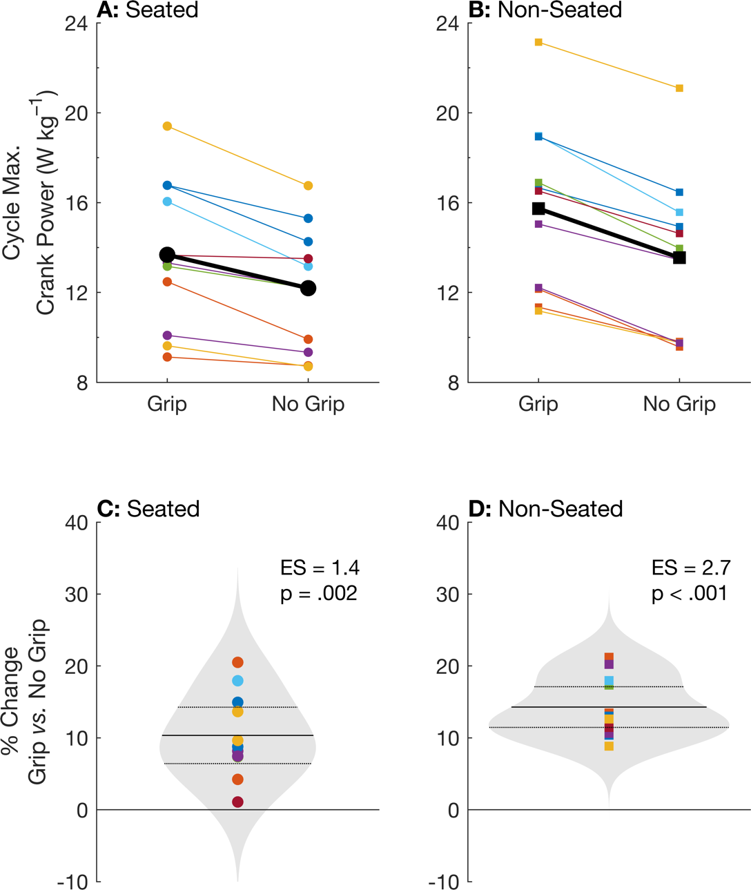

**Figure 2.** Individual (color) and group mean (black) maximum crank power over one crank cycle during the grip and no-grip conditions in a seated (A) and non-seated (B) posture. Panels C and D show the individual (color) and group mean (solid line) percentage change in maximum power during the no-grip condition compared to the grip condition in a seated and non-seated posture, respectively. The grey patches show the kernel distribution of the percentage changes, and the horizontal dotted lines show the 95% confidence intervals. ES, effect size.

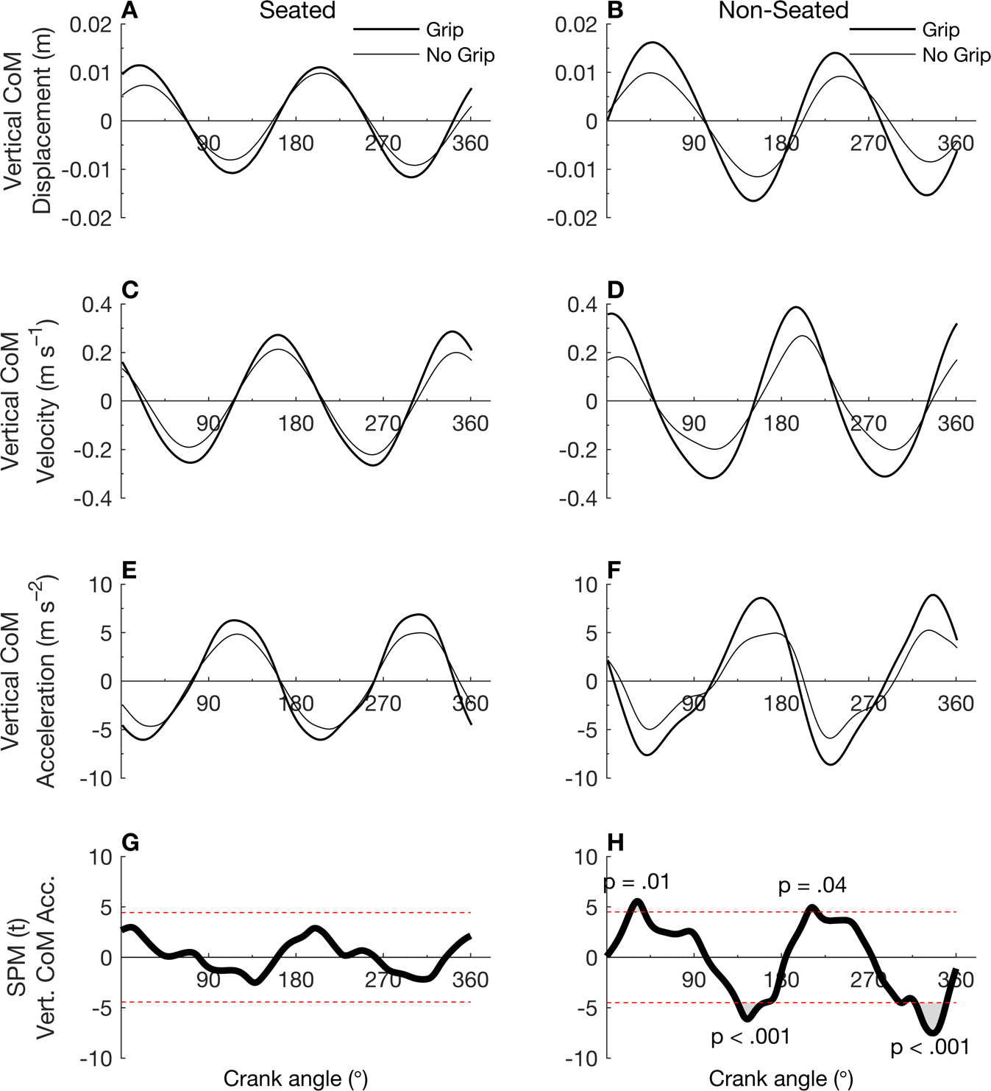

**Figure 4.** Angle-series plots of group mean (n=11) rider center of mass (CoM) displacement (A-B), velocity (C-D), and acceleration (E-F) during the maximum crank power cycle in a seated (left) or non-seated (right) posture while either gripping (thin) or not gripping (thick) the handlebar. One-dimensional Statistical Parametric Mapping (SPM) analyses (G-H) were used to test for statistical differences in vertical CoM acceleration between handgrip conditions over a complete crank cycle. The red dotted lines in panels G and H show the critical-t threshold at the corrected alpha level.

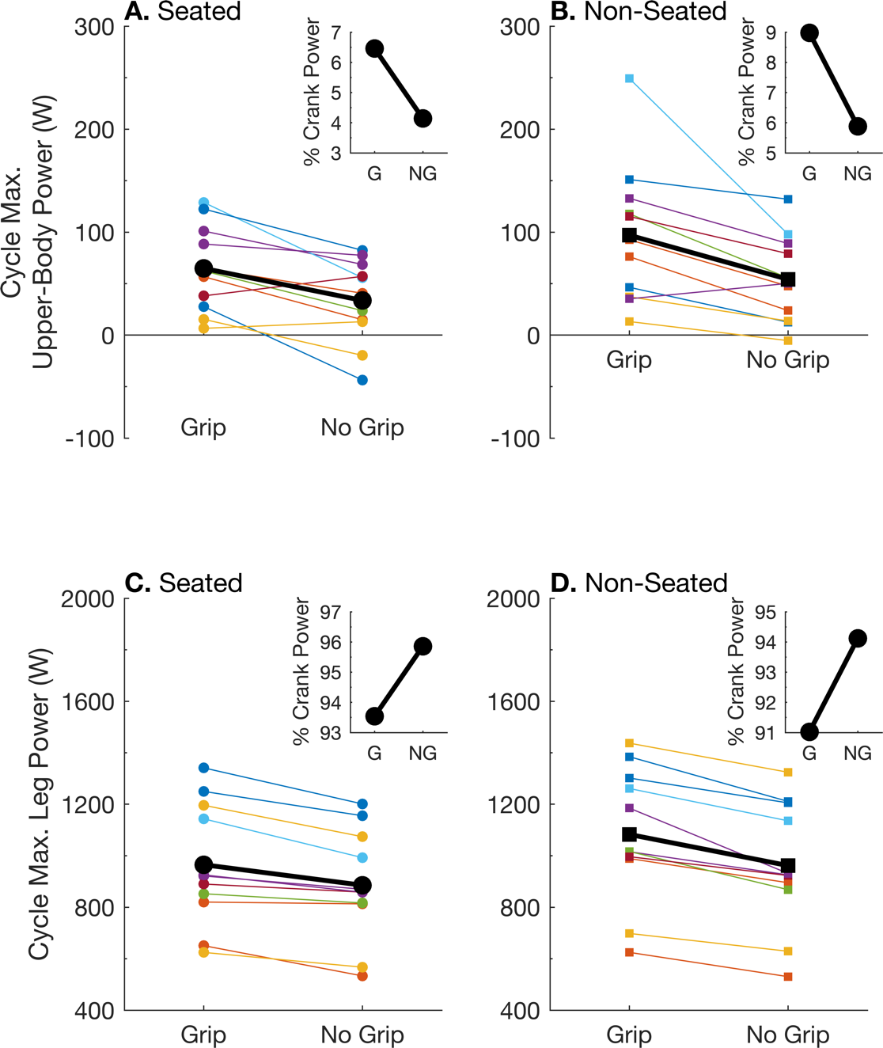

**Figure 3.** Individual (color) and group mean (black) upper-body power (A-B) and leg power (C-D) over the maximum crank power cycle in a seated (left) and non-seated (right) posture in watts (A-D) and as a percentage of total crank power (inset). Leg power was calculated as the sum of hip, knee, and ankle power from both legs. Upper-body power was calculated by subtracting leg power from the sum of crank and CoM power. Note that net CoM power over a crank cycle is approximately equal to zero. G, grip. NG, no grip.

**Supplementary Digital Content 1.** Experimental setup.

**Supplementary Digital Content 2.** Patterns of lower- and upper-body power production.