**The influence of bicycle lean on maximal power output during sprint cycling**

**Ross D. Wilkinson** and Rodger Kram  
Locomotion Laboratory, The University of Colorado, Boulder, CO, USA  
Email: ross.wilkinson@colorado.edu

**Summary** We used a modified cycle ergometer to investigate if leaning (or not leaning) a bicycle side-to-side affects sprint power output. We found that leaning the ergometer *ad libitum* did not enhance maximal 1-s crank power compared to a locked condition. However, trying to minimize ergometer lean decreased maximal 1-s crank power by compared to leaning *ad libitum*.

**Introduction** Competitive cyclists typically sprint out of the saddle and alternately lean their bikes from side-to-side, away from the downstroke pedal [1]. Yet, there is no direct evidence as to whether leaning the bicycle, or conversely attempting to minimize lean, affects maximal power output during sprint cycling. Here, we investigated two questions related to maximal 1-s power output during non-seated, sprint cycling: 1) Does *ad libitum* lean affect maximal power output compared to a traditional stationary ergometer? and 2) Does trying to minimize lean affect maximal power output compared to *ad libitum* lean? To address these questions, we modified a cycle ergometer so that it could lean from side-to-side or be locked to prevent lean. This modified ergometer made it possible for riders to sprint under three different conditions: locked (no lean), *ad libitum* lean, and minimal lean. In the minimal lean condition, the ergometer could lean but we asked the subjects to try to minimize lean. Our first hypothesis (null) was that *ad libitum* lean would result in the same maximal 1-s crank power as the locked condition. Our second hypothesis was that trying to minimize lean would decrease maximal 1-s crank power compared to the *ad-lib* and locked conditions.

**Methods** Nineteen healthy recreational cyclists (M/W, y, m, kg, meanSD) pedaled a friction-loaded ergometer mounted atop a hinged chassis. The ergometer was equipped with a crank-based mechanical power meter (Quarq DZero, SRAM, Corp, Chicago, IL, USA) and a Monark 827E flywheel. In the *ad-lib* lean and minimal lean conditions, springs attached to the rear legs of the ergometer provided a restoring torque proportional to lean angle. In the locked condition, aluminum struts prevented lean. Subjects performed 9 maximal 5-s sprints from rest in a non-seated posture—3 locked, 3 *ad-lib* lean, and 3 minimal lean. We measured crank angle and ergometer lean angle at 500 Hz using two IMUs.

**Results** *Maximal 1-s crank power:* In support of our first hypothesis, maximal 1-s crank power in the *ad-lib* condition ( W) was similar to the locked condition ( W), , . In support of our second hypothesis, crank power was reduced by W () in the minimal lean condition ( W), compared to the ad-lib condition , .

*Range of ergometer lean:* The range of lean in the *ad-lib* condition ( deg.) was ten-times the locked condition ( deg.), , , and more than twice the minimal lean condition ( deg.), , .

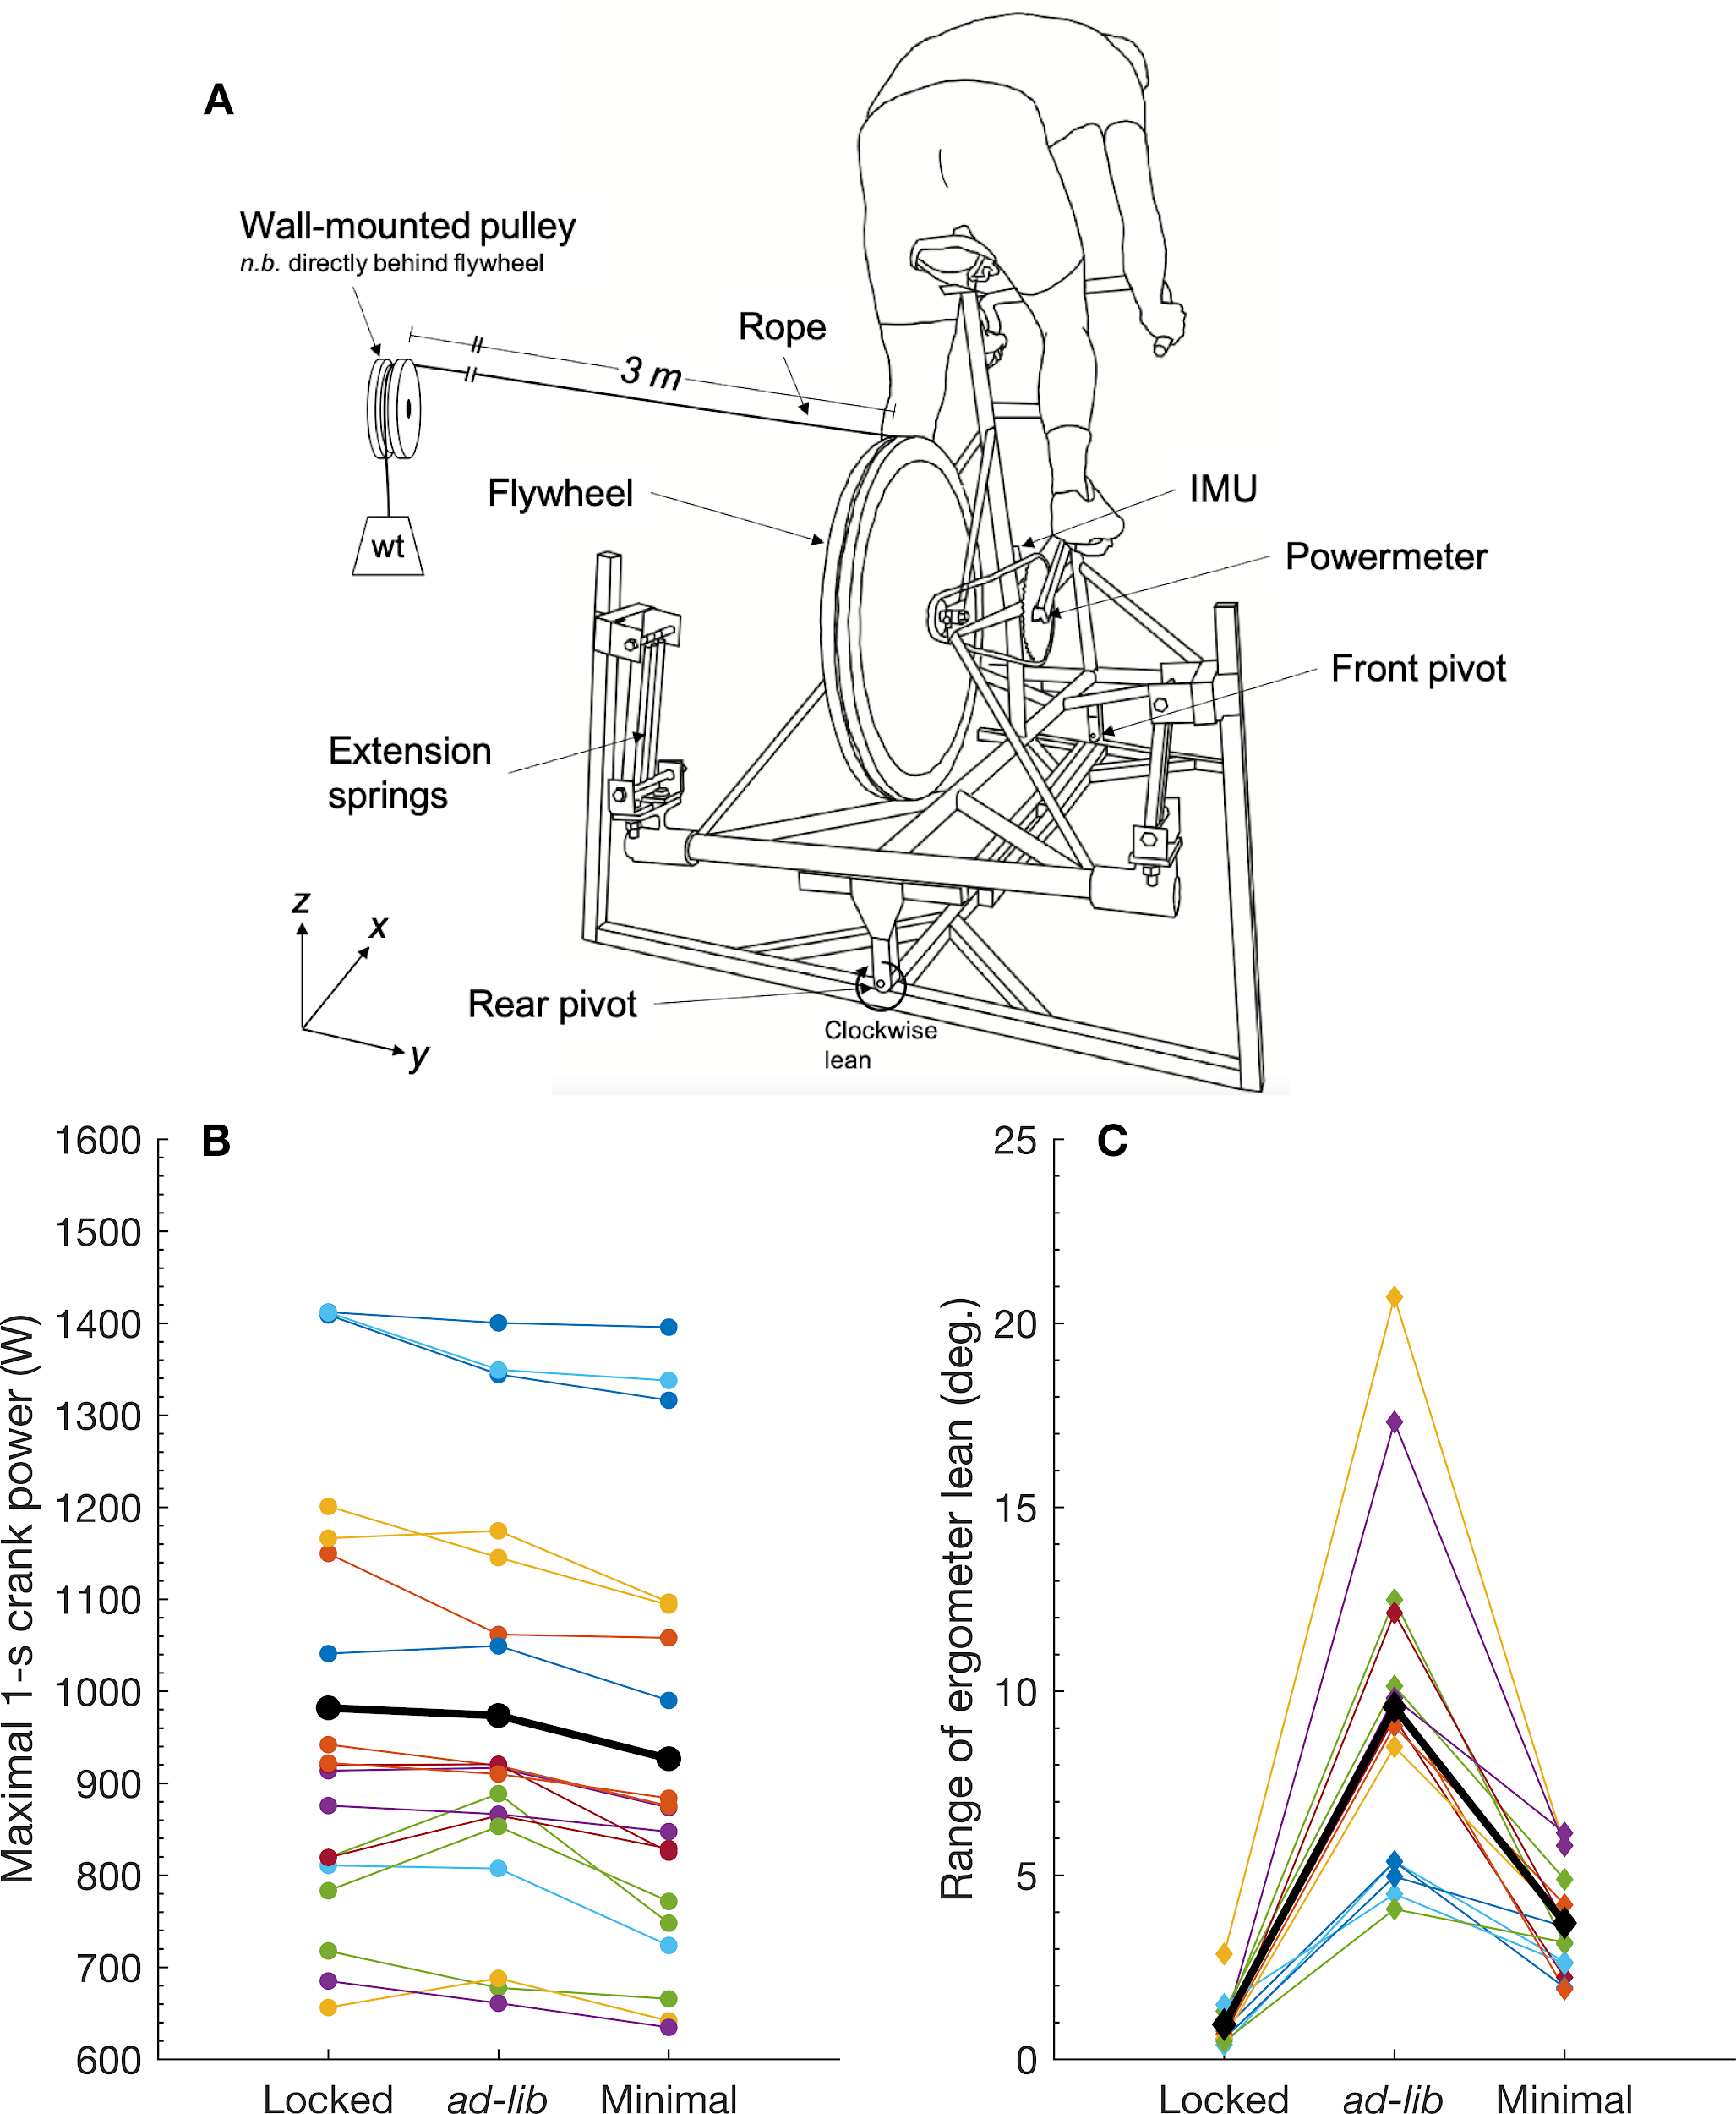

**Figure 1:** A. Diagram of modified cycle ergometer. B-C. Individual (color) and group mean (black) maximal 1-s crank power and range of ergometer lean, respectively.

**Conclusion** Leaning the bicycle *ad libitum* did not enhance maximal 1-s crank power compared to a traditional stationary ergometer. Trying to minimize bicycle lean decreased maximal 1-s crank power by compared to leaning *ad libitum*.

**Acknowledgments** Supported by an ISB Student International Travel Grant to RDW.

**References**

[1] Soden, P. and Adeyefa, B. (1978). *J Biom*, **12**:527-541