Cyclists Needed for Biomechanics Study

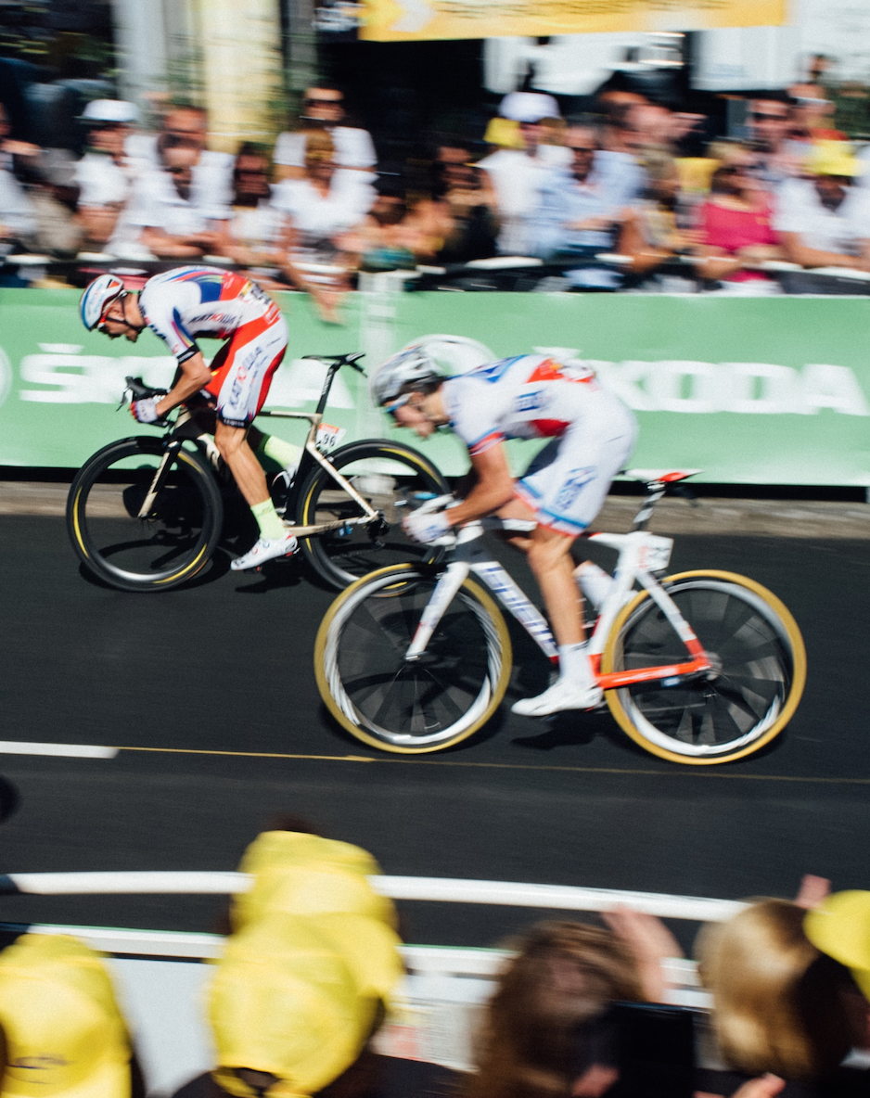The Locomotion Lab of the Integrative Physiology Department at CU Boulder is studying the effect of bicycle lean on maximal power output in cycling. This experiment will involve a series of 5-second cycling sprints on a stationary bike. Due to COVID-19, the study will take place outdoors.

To be eligible for this study, you must:

* Be between 18-49 years old
* Be in good health (unexposed/free from coronavirus)
* Cycle (outdoors or indoors) at least 4 hours per week
* Have your own clip-in pedals and shoes

The study consists of one, 2-hour session at CU Boulder.

This experiment is completely non-invasive.

You will receive a $25 Amazon Gift Card as compensation for taking part in the study.

If you are interested in participating, please contact: [culocomotionlab@gmail.com](mailto:culocomotionlab@gmail.com)

**Cyclists Needed for Biomechanics Study**

[**culocomotionlab@gmail.com**](mailto:culocomotionlab@gmail.com)

**Cyclists Needed for Biomechanics Study**

[**culocomotionlab@gmail.com**](mailto:culocomotionlab@gmail.com)

**Cyclists Needed for Biomechanics Study**

[**culocomotionlab@gmail.com**](mailto:culocomotionlab@gmail.com)

**Cyclists Needed for Biomechanics Study**

[**culocomotionlab@gmail.com**](mailto:culocomotionlab@gmail.com)

**Cyclists Needed for Biomechanics Study**

[**culocomotionlab@gmail.com**](mailto:culocomotionlab@gmail.com)

**Cyclists Needed for Biomechanics Study**

[**culocomotionlab@gmail.com**](mailto:culocomotionlab@gmail.com)

**Cyclists Needed for Biomechanics Study**

[**culocomotionlab@gmail.com**](mailto:culocomotionlab@gmail.com)

**Cyclists Needed for Biomechanics Study**

[**culocomotionlab@gmail.com**](mailto:culocomotionlab@gmail.com)

**Cyclists Needed for Biomechanics Study**

[**culocomotionlab@gmail.com**](mailto:culocomotionlab@gmail.com)

**Cyclists Needed for Biomechanics Study**

[**culocomotionlab@gmail.com**](mailto:culocomotionlab@gmail.com)