Ross Miller

1. $f\left(x\right)=e^{x}-x-1$ [-1, 1]

$$f^{'}\left(x\right)=e^{x}-1$$

From x = [-1,0] we see that $f^{'}\left(x\right)$ is negative so likewise f(x) is decreasing.

From x = [0,1] we see that $f^{'}\left(x\right)$ is positive so likewise f(x) is increasing.

At x = 0 $f^{'}\left(x\right)$ = 0 so 0 is a critical point. Moreover it is a local minima since f(x) is decreasing before x = 0 and increasing after x = 0. Here is a graph of $f\left(x\right)$ and $f^{'}\left(x\right)$

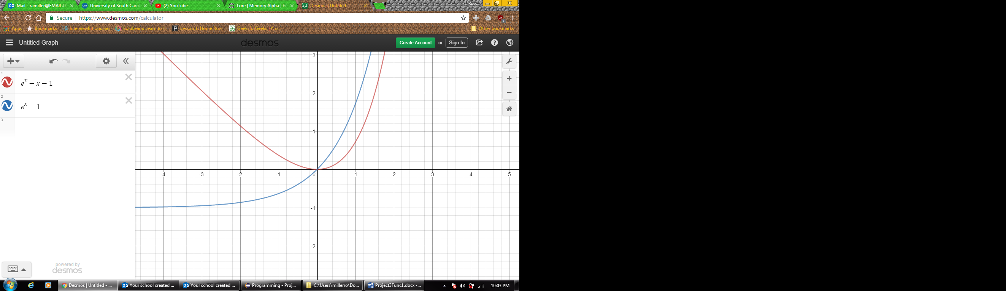

Now using newtons method and Secants method to approximate when f(x) = 0 with an intial guess of x = 0.5

n | Pn | P̂n |

-------------------------------------

01 0.27075 0.00000

02 0.14147 0.00000

04 0.03664 0.05820

06 0.00924 0.02265

08 0.00232 0.00870

10 0.00058 0.00333

12 0.00014 0.00127

14 0.00004 0.00049

16 0.00001 0.00019

18 0.00000 0.00007

20 0.00000 0.00003

22 0.00000 0.00001

We can see that Pn converges to the answer (0) in fewer iterations then P̂n. Note that we had to use two iterations of Newtons method before we could generate the first term for P̂n. Also were only printing out every other term though each one is being generated.