Ross Miller

1. $f\left(x\right)=e^{x}+2^{-x}+2\cos\left(x\right)-6$ [1, 2]

$$f^{'}\left(x\right)= e^{x}+\left(2^{-x}\right)\left(-\ln\left(2\right)\right)-2sin⁡(x)$$

This function is somewhat more complicated then the previous polynomials we’ve dealt with so far. Instead of analyzing the derivative and attempting to find the intervals where f(x) is increasing and decreasing we’ll go straight to the iterations. Running the our procedure with P0 = 1.5 and E = 1e-5, we find that Newton’s takes four iterations and Secant’s takes five iterations (including two iterations to find P̂n-1 and P̂n-2).

n | Pn | P̂n | P̂n-1 P̂n-2 |

--------------------------------------------------

01 1.95649 0.00000 1.84153 0.00000

02 1.84153 0.00000 1.84153 1.95649

03 1.82951 1.83060 1.84153 1.95649

04 1.82938 1.82940 1.83060 1.84153

05 1.82938 1.82938 1.82940 1.83060

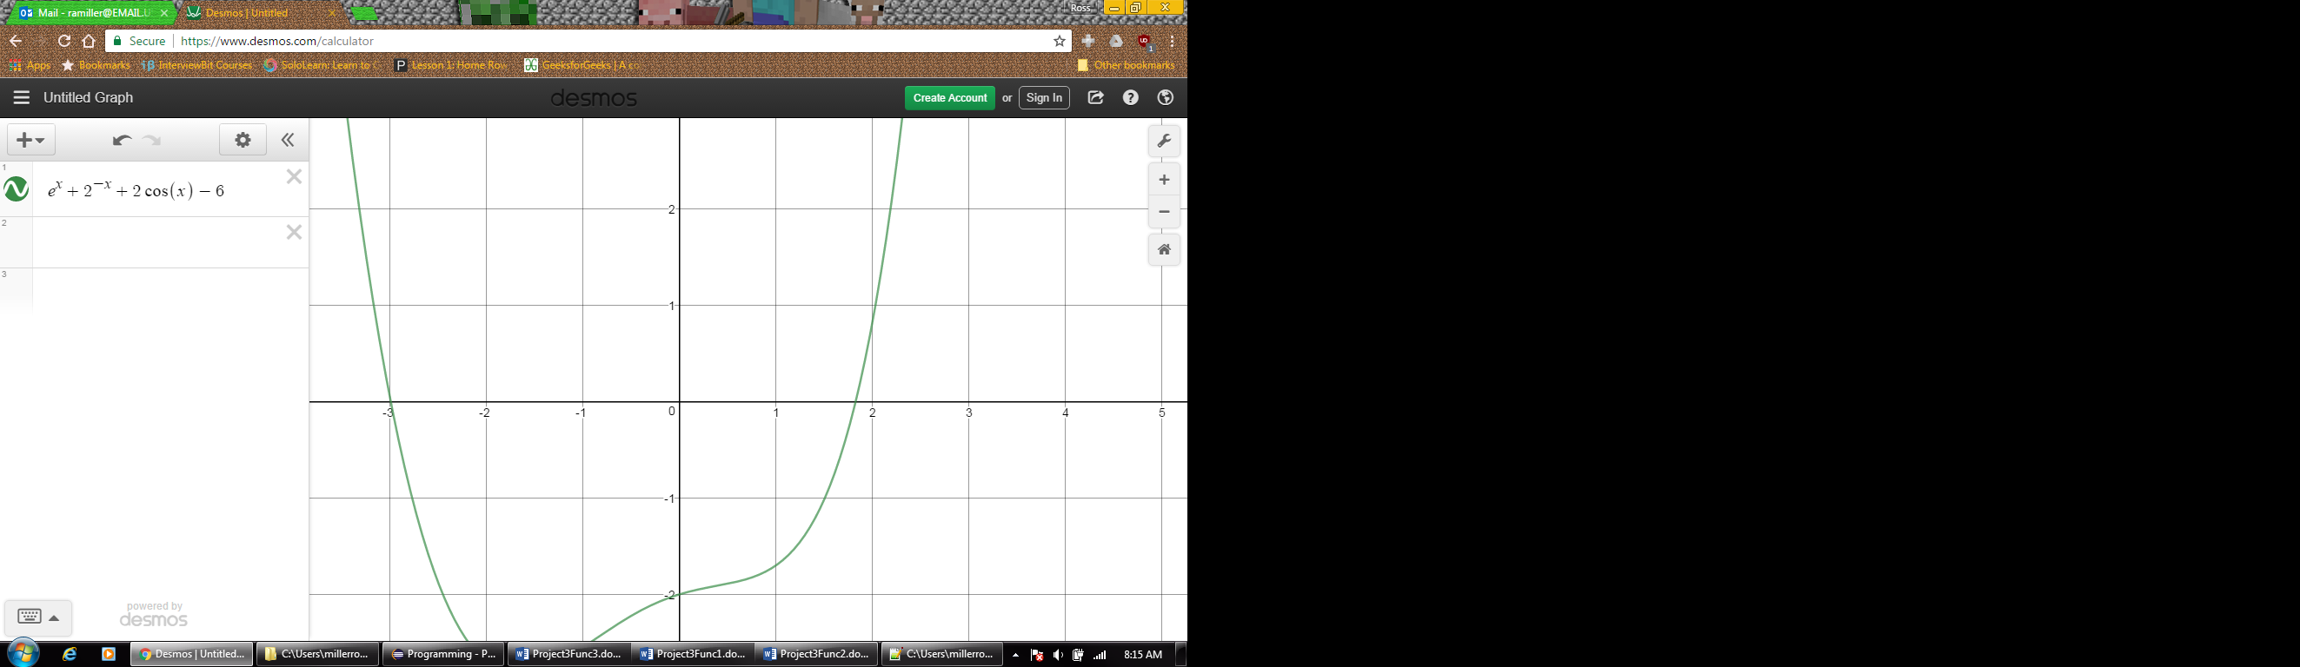

$f\left(x\right)=\frac{2-e^{x}+x^{2}}{3}$

$f^{'}\left(x\right)= \frac{2^{x}-e^{x}}{3}$

Again for P0 = 1.5 and E = 1e-5, it takes Newton’s method three iterations and Secant’s method four iterations (including the two to generate P̂n-1 and P̂n-2), to approximate the correct x such that f(x) = 0.

n | Pn | P̂n | P̂n-1 P̂n-2 |

--------------------------------------------------

01 1.34363 0.00000 1.31955 0.00000

02 1.31955 0.00000 1.31955 1.34363

03 1.31907 1.31908 1.31955 1.34363

04 1.31907 1.31907 1.31908 1.31955

In these cases at least it seems that Secant’s method performs very similarly to Newton’s method, with the additional benefit of not having to use $f^{'}\left(x\right)$.

