BRITIFY ME!
AKA, THE ADVENTURES OF ROX AND BEN

MIFFED
HOBS AND BOBS

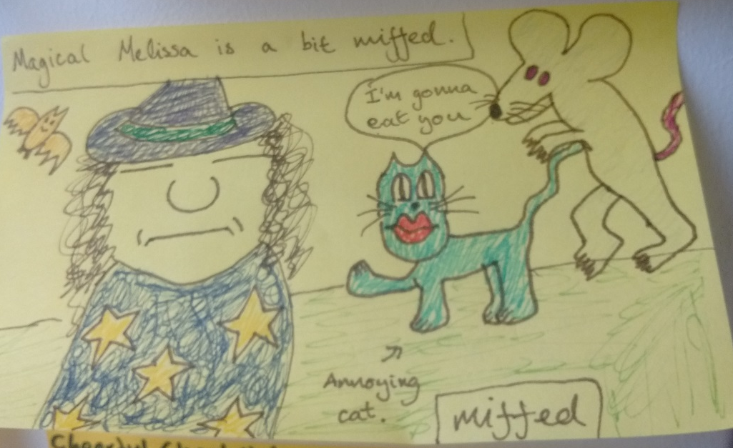

Magical Melissa is a bit miffed

