A Grading Strategy Based on Accounting Milestones
Cover Page
Intended Track: High Impact Practice
Ken Guo
California State University, Fullerton
kguo@fullerton.edu

Author Bio
Ken Guo is an assistant professor at California State University, Fullerton. He teaches accounting information systems. His research has appeared or will appear in journals such as Journal of Management Information Systems, Information Systems Journal, Information and Management, Auditing: A Journal of Practice and Theory, and Critical Perspectives on Accounting, among others. He is a CPA/CMA (Canada) and SAP certified consultant (TERP10).

A Grading Strategy Based on Accounting Milestones
Abstract
Grading student work has been a big challenge for those faculty who incorporate SAP business process curricula in their courses. In this paper I propose a grading strategy based on accounting milestones. This strategy can help faculty keep track student progress while lowering the workload on grading.
Keywords: Grading; Accounting Milestone; Business Process Integration

Introduction
It is a big challenge for faculty to grade student work that uses SAP. This is particularly true if the curriculum involves long business processes (e.g., the curricula for introduction to ERP system or configuration). One reason is that the completion of business processes often requires many small, detailed steps.
Depending on class size, grading student assignments can be a significant burden for faculty. There are two general options for faculty:
- Check data in the SAP system. Faculty use this method can have some sense of student progress but it will be extremely time-consuming.
- Require students to submit reports detailing steps they completed. This approach can alleviate the burden on faculty to a certain extent but still requires significant time. In addition, faculty would not be able to know student progress.
Thus in the paper I aim to address the above issue by proposing a grading strategy based on accounting milestones. This approach utilizes the reporting function of SAP and can help alleviate the burden on faculty and allow them to monitor student progress more easily.

Accounting Milestones
Business processes are often very long and involves many detailed steps. But only a few of the steps are critical from the accounting standpoint. I call them "accounting milestones" because they have impact on financial statements. For controllers only such accounting milestones matter. For faculty, accounting milestones can be used as critical steps that students must pass in order to complete their SAP business process assignments.
Take for example the processes shown in Figure 1. This is the typical sales and purchase processes related to trading goods. All steps except SO and PO have impact on accounting (accounting milestones indicated by red dots). The impact of each step is also different in terms of either one of the following: 1) Account, or 2) Debit or Credit. For example, the Goods Receiving step of purchase has the following impact: Debit: Inventory account; Credit: GR/IR account. The Invoice Receiving step, on the other hand, has the following impact: Debit: GR/IR account; Credit: Accounts Payable account. So here if we can show the debit and credit totals of the GR/IR account, we can find out whether a student has completed the related steps or not.
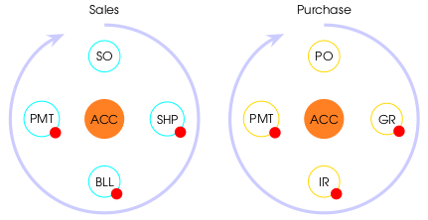
Figure 1. Accounting and Business Processes

SAP Reporting Tools for Grading
We can use the Report Painter/Writer tool to grade student work. It is flexible in terms of what data we need to show on a report. An example is shown in Figure 2.

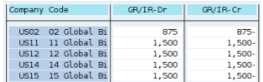
Figure 2. Accounting Milestone Report

As we can see on the report, we know all students have completed two steps: goods receiving and invoice receiving. Student 002 (responsible for company code US02), however, did something wrong, at least in terms of quantity/amount.
Some additional advantages of this grading strategy include: 1) It’s flexible. We can simply change the accounts in order check/grade other steps. 2) It’s reusable. This is probably the most important advantage. We don’t want to re-create everything from scratch every semester. We can simply save the design by exporting it to a text file and then import to future clients. 3) It does not require any configuration at the system administration level. So there is no need to bug your UCC for help.

Conclusion
In this paper I have proposed a grading strategy based on the accounting milestones of business processes. I hope this approach can alleviate the burden on faculty to spend unreasonable time to grade and keep track student progress.

