Proceedings of the 20th SAP Academic Conference Americas: Pedagogical Innovations with SAP Technology in Classroom

Chaired and Edited by:

Michael Bliemel, Dalhousie University and pierre-majorique léger, HEC Montreal

Conference organized by:



2017

**Foreword**

Pedagogical innovations have never been so crucial in information technology education. On the one hand, it is undeniable that innovation has accelerated over the past few years. Software developers such as SAP are introducing a constant stream of new products every year. Educators must update and adapt their course content to reflect what is now possible with these new technologies. On the other hand, knowledge in information technologies has never been so accessible with innovative and free massive open online courses. These trends disrupt educational models, colleges and universities must constantly strive to elevate their teaching by creating engaging active learning curriculum. Professors must innovate to compete for the students’ attention, with active learning approaches that provide memorable experiences.

In 2017, the SAP University Alliance celebrates its 20th anniversary of the SAP Americas Academic Conference. This community of passionate educators has always celebrated pedagogical innovations. Over the years, the academic conference has offered wide range of opportunities to faculty members to share their pedagogical innovations. In collaboration with SAP, our community members will continue to build on a growing library of academic content with new ideas and adaptations of successful learning approaches.

The five short articles presented at this years’ conference reflect this tradition of innovative material created by our community of professors who make up the academic alliances members of North America. Yvonne Antonucci shows how to integrate a design thinking methodology into an existing business course using the application SAP Build.me. Ellen Monk and her colleagues explain how they have organized a regional ERPsim simulation and detail how to reproduce their approach. Mark Angolia adapts the ERPsim Logistics game to a supply chain management course and explains the additions on he developed to support advance supply chain concept in the game. Chelley Vician and Elizabeth Pierce have proposed a novel approach to extend the analysis company profitability in ERPsim to enhance analytics education. Gary Hackbarth and his colleagues present an inter-disciplinary and multi-course approach to analyzing and interpreting big-data using SAP technology.

We hope these examples will to continue inspire our community to continue to develop and share new innovative pedagogical material.

Pierre-Majorique Léger

Michael Bliemel

**SAP University Alliances North American Board and Academic Conference Committee 2016-2017**

Alex McLeod, Texas State University

Bipin Prabhakar, Indiana University

David Douglas, University of Arkansas

Donna Covington, Delaware State University

Fawzi Noman, Sam Houston State University

James Connolly, California State University Chico

Lou Thompson, University of Texas at Dallas

Michael Bliemel, Dalhousie University

Nitin Kalé, University of Southern California

Orneita Burton, Abilene Christian University

Paul Kurchina, ASUG

Pierre-Majorique Léger, HEC Montréal

Ross Hightower, University of Wisconsin Milwaukee

Simha Magal, Grand Valley State University

Thomas Case, Georgia Southern University

Thomas Wilder, California State University Chico

Yvonne Lederer Antonucci, Widener University

**Table of Contents**

Design-Led Transformation: Deploying a Student-Led Application Development Project Using SAP Build.me to Connect Project Stakeholders and Developers, by Yvonne Antonucci 1

Competition Beyond the Classroom: A Regional Collaboration to Enhance ERP Instruction, by Ellen F. Monk, Yvonne Antonucci, Lauren Eder, William, and Lynda H. Murray-Jackson5

The ERPsim Logistic Games, a Supply Chain Management Application, by Mark Angolia10

Where is my profit? Learning basic analytics skills with a company profitability simulation, by Chelley M. Vician and Elizabeth M. Pierce 15

An Interdisciplinary Approach to Marketing Analytics, by Gary Hackbarth, Jie Fowler, and Karin P. Roland 19

**Design-Led Transformation: Deploying a**

**Student-Led Application Development**

**Project Using SAP Build.me to Connect Project Stakeholders and Developers**

**Yvonne Antonucci**

Widener University yantonucci@widener.edu

**Abstract**

*You don’t need a design lab to start integrating design-thinking in your curriculum. You can deploy a phased approach to integrating design-led transformation into various courses. This presentation describes the integration of design thinking methodology into an existing business course resulting in student-led application transformations of various processes in the university community. The students utilized Build.me to design, prototype, and collaborate with not only their group members but the process stakeholders. Using their prototypes, applications were developed with a few of them actually adopted by the university stakeholders. This experiential learning opportunity helped student understanding of the program development life-cycle assisted with design-thinking to promote collaboration. In addition of how to deploy a design-led transformation project using Build.me in a course, additional takeaways of the assignment detailing steps to use Build.me and the project specifications with a grading rubric will be provided.*

**Keywords**: Design Thinking, SAP Build.me, collaboration, Application Development.

# Introduction

Design thinking methods are increasingly being used in industry (Bernstein 2015; Liedtka 2014). As a result the need for design-thinking skills continues to be requested by potential employers in order to improve organizational processes and the customer experience. Most recently our school of business advisory board requested an increase of design experiences in the curriculum, supporting the need for skilled individuals to be creative in finding and solving industry problems and having experience collaborating with process stakeholders. Developing a design thinking lab would be ideal, however with resource constraints a phased approach to integrating design thinking methodology was adopted. A current course involving object oriented development within the business school was chosen to include design-thinking in an application development project. By integrating the application development life-cycle with the design thinking methodology for industry (Brown 2008; d.School Stanford 2015; SAP 2016) a class project process was developed allowing the students to identify a need, collaborate with process stakeholders, develop a storyboard and prototype using SAP Build.me, and develop the solution in Java. Projects chosen by the students ranged from improving campus processes, such as the Financial Aid application process and decreasing the food line wait at various cafes around campus, to assisting a community ministry with donation administration. This experiential learning opportunity was conducted throughout the semester. The project was entirely student-led with the faculty playing a consulting role. This presentation describes the project deployment process and shares the project description including detailed steps to using SAP Build.me.

# Design Thinking Integrated into Application Development

Many applications are developed to support organizational processes that involve people which are part of the core Design Thinking initiative (Jensen et al 2016). The value of bringing external stakeholders involved with programmers and designers early in a process application development life-cycle saves time and increases the value of the application (Cooper 2009). Furthermore research has shown that an end-to-end innovation process includes design thinking (Furr and Dyer 2014). Therefore an application development process that integrates design thinking with an emphasis on collaboration with process stakeholders was developed for a class project synthesizing how technology can support the needs of people and the requirements for business success (Brown 2008) (see Figure 1).

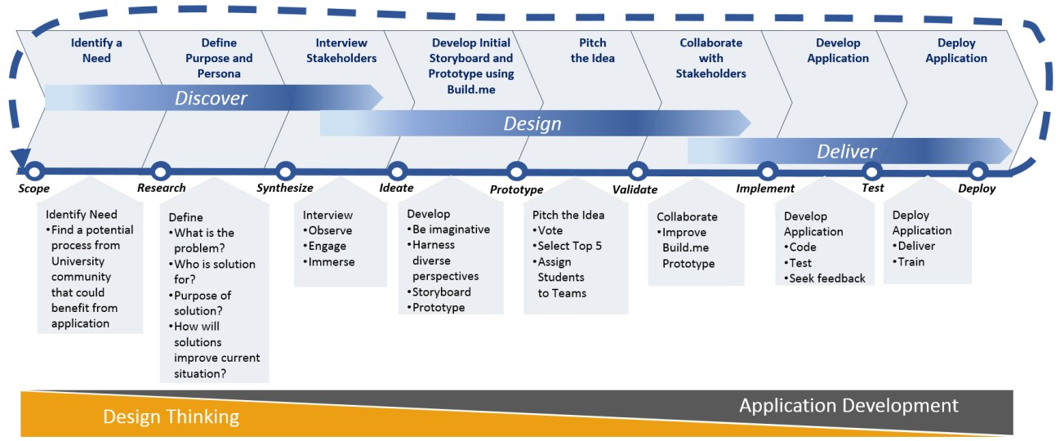

**Figure 1. Class Project Application Development Process**

The purpose of this class project was to experience team application development, use design thinking to formalize and validate the project, communicate project value, and present a solution. The project focused on application solutions for needs within the university or its surrounding community. Project development and team collaboration were interwoven throughout the semester along with class activities, suggested readings and videos as indicated in Table 1.

The project application development process began with students first tasked to individually identify a potential situation that could benefit from an automated solution. At this early stage they were required to identify the process stakeholders of this need area and interview a few of them involved with various aspects of the process. Each student was required to develop a presentation to ‘pitch’ their idea and define the purpose and persona of their idea by answering questions such as:

What is the business problem? Who is the solution for? What is the expectation of the solution? What will it do? How will the proposed solution improve the current situation? What is the purpose of the solution? What is the business objective?

Once the initial project idea was defined the students then were tasked with interviewing additional stakeholders in order to integrate user insights into their project definition. Each student then developed initial storyboard sketches of their project idea, uploaded them into SAP Build.me and developed active navigation features (Figure 2). These storyboards were published in SAP Build.me producing URL links to their designs. Their associated Build.me link was included in each of their presentations of which were shared to the entire class.

In order to reduce the number of projects and give students experience working in teams, the class was asked to vote for their top five project ideas. The class was then divided into five project groups each consisting of 4- 6 students. The project idea originator shared their SAP Build.me project with each of their team members and stakeholders allowing the team to collaborate on the design, improve it based on new ideas, and build a prototype (Figure 3).

|  |  |  |
| --- | --- | --- |
| **Semester Timeline** | **Project Topics interwoven within the course** | **Project Related Material/ Labs/ Assignments** |
| Weeks 1 - 2 | Introduction to Design  Thinking And Build.me    Introduction to Object oriented app development | Developing BUSINESS solutions  -Define the Business need; Visualize the solution – develop a story Videos shown in class:  -Designing for the User: <https://youtu.be/CCZ51TsKLBw>  -Prototyping:<https://standard.build.me/splashapp/learningDetail/640>  -Build.me[: http://Build.me ;](http://build.me/) Buildme learning site[: https://standard.build.me/](https://standard.build.me/)  -dschool boot camp on Vimeo:<https://vimeo.com/21568668>  In Class Lab week 1: introduction to Build.me: Creating a Storyboard  In Class Lab week 2: Part C Developing Build.me objects  Assignment: Deploying Design Thinking to Build an Application Solution – Project Idea Assignment- not due till week 5: Each student required to find a potential project, interview stakeholders, use Build.me to develop an initial storyboard solution, prepare a presentation to ‘pitch’ their idea. |
| Weeks 3-4 | Program logic design methods, object oriented concepts, UML | How to develop solutions. |
| Week 5 | Project Ranking | Students Pitch their project ideas – rank them using a survey |
| Weeks 6-7 | Java program development | How to use Java for project solutions. |
| Week 7 | Top 5 Class Projects revealed | Groups assigned: Class time for groups to meet – Share initial Build.me of project – Define next steps: Interview additional Stakeholders; develop revised Storyboard and Prototype in Build.me. |
| Week 8-9 | Program development | How to integrate database connectivity for projects |
| Week 10 | Project Group Check-in | Class time for group project: Instructor meets with each group – finalize designs and start developing the solution |
| Week 12 | Project Group Check-in | Class time for group project: Instructor meets with each group – review solutions |
| Week 13 | Group Presentations | Stakeholders invited |

**Table 1. Project semester timeline, class activities, and assignments**

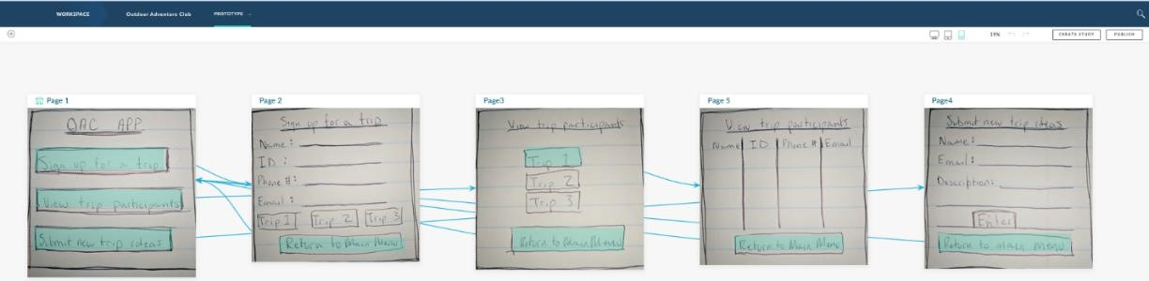

**Figure 2. Build.me Storyboard of Initial Project idea Sketches**

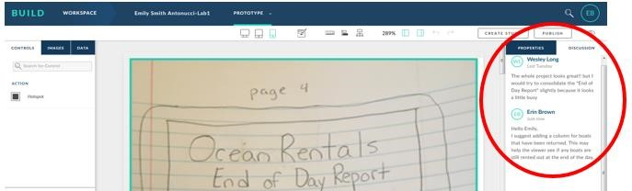

**Figure 3. Collaboration within Build.me**

A logical design along with the development of the application in JAVA was required for this project. The goal was to have a working prototype of the application. The final solution was presented to the class and the stakeholders. An example of a project solution is shown in Figure 4.

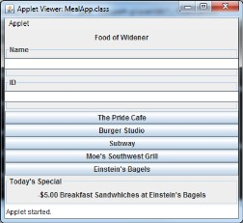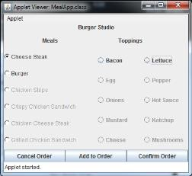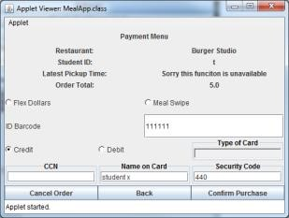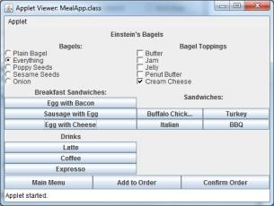

**Figure 4. Project Solution Example**

# Conclusion and Takeaways

Design-thinking methodology can be integrated into existing curriculum using a phased approach by identifying one course to start. The course chosen was an application development course within the business school curriculum. If your curriculum has project-based assignments in existing courses, this is a good place to begin. The class project process developed included design thinking methodology integrated with application development life-cycle. The use of SAP Build.me for design and collaboration in teams was highly regarded by the students. The students not only enjoyed working on their own ideas, but also were able to remotely collaborate on the project design. The students were engaged in this project and enjoyed seeing them come to fruition. Several of the project solutions were immediately adopted by the stakeholders probably due to the fact they were included in the design process. This learning activity helped to develop several IIAB BABOK competencies as indicated in Table 2. Additional research is needed to measure student and stakeholder (user) satisfaction along with the effectiveness of the IIAB BABOC competencies. By limiting the number of projects the professor’s time was utilized more efficiently. In addition to sharing the project process, assignment and the detailed steps to using Build.me, a grading rubric developed specifically for this project will be shared.

|  |  |
| --- | --- |
| **IIAB BABOK Competencies** | **Student Activities** |
| 8.1 – Analytical Thinking & Problem Solving   * Creative thinking * Decision Making * Learning * Problem Solving | -Students generate and produce consideration of new ideas, Identify and propose alternatives, ask questions to stakeholders.   * As a group students are tasked to gather information relevant to the project idea and ways to solve the problems; they must identify the most feasible solution method for the user population within an application - Students gain knowledge and skills in how to approach application development, how to collaborate as a team and with stakeholders and how to develop a solution from their design * Students must resolve differences among themselves, communicate a group and stakeholder approved design, identify assumptions, present solutions |
| 8.4 – Communication Skills  - Oral communication | – through personal meetings with stakeholders and team members, each student expresses ideas, collaborates |
| 8.5 – Interaction Skills | - students work in teams, negotiate ideas and solutions |
| 8.6 – Software Applications | – students apply tools such as build.me and java to complete requirements |

**Table 2. Student Activities aligned with IIAB BABOK Competencies**

# References

Brown, T. 2008. “Design Thinking”, *Harvard Business Review*, June, pp. 84-92.

Cooper, R., S. Junginger, & T. Lockwood. 2009. “Design thinking and design management: a research and practice perspective. *Design Management Review* (20:2), pp 46-55.

d.school Stanford. 2015. “An Introduction to Design Thinking Process Guide”, Hasso Plattner Institute of Design, Stanford University, Hasso Plattner Institute of Design. Bootcamp Bootleg [Online]. Available: *http://dschool.stanford.edu/wp-content/uploads/2013/10/METHODCARDS-v3-slim.pdf* [Accessed 1/20/2017]

Furr N., & J. Dyer. 2014. “Choose the Right Innovation Method at the Right Time”, Harvard Business Review, December 31, [Online]. Available: *https://hbr.org/2014/12/choose-the-right-innovationmethod-at-the-right-time* [Accessed 3/12/2017]

IIBA. 2015. "BABOK Guide - IIBA | International Institute of Business Analysis"*.* Available: *http://www.iiba.org/babok-guide.aspx* [Accessed2017-05-16]

Jensen, M. B., F. Lozano, & M. Steinert. 2016. “The Origins of Design Thinking and the Relevance in Software Innovations”, In *Product-Focused Software Process Improvement: 17th International Conference,* November 22-24, 2016. Trondheim, Norway,pp. 675-678.

Liedtka, J. 2014. "Innovative ways companies are using design thinking", Strategy & Leadership, Vol. 42 Issue: 2, pp.40-45.

SAP. 2016. “Design Thinking TTT Workshop”, *SAP University Alliances,* Potsdam. SAP Design Thinking site: <https://designthinkingwithsap.com/en/>

**Competition Beyond the Classroom: A**

**Regional Collaboration to Enhance ERP Instruction**

# Ellen F. Monk Yvonne Antonucci

University of Delaware Widener University

monke@udel.edu yantonucci@widener.edu

# Lauren Eder William Cantor

Rider University Penn State University eder@rider.edu Wpc2@psu.edu

**Lynda H. Murray-Jackson**

Delaware State University lmurrayjackson@desu.edu

**Abstract**

*Creating a rich educational experience for university students is a continued goal of faculty across the SAP University Alliance Community. The developers of ERPsim at HEC Montreal have provided the SAP Community a platform that can be extended for additional educational high impact practices. Using the ERPsim international competition as a model, SAP faculty from several regional universities deployed an enhanced regional ERPsim competition in order to provide students additional interuniversity collaboration opportunities coupled with enhancing SAP, analytics, business knowledge, critical thinking, and teamwork skills; several supporting School Accreditation objectives (AACSB). Additional benefits emerged through promotions and regional press of the event. Takeaways will include the process of creating a similar event in addition to analytics assignments designed to analyze competition results.*

**Keywords**: ERPsim, SAP, interuniversity, competition, collaboration.

# Introduction

Competition is an important avenue to learning that increases student engagement and encourages students to become proficient in their subject matter. Studies have shown that competition highly motivates students (Cagiltay 2015), increases knowledge retention (Tucker 2017), and teaches how to handle loss while developing an appreciation for others.

Faculty continue to develop and encourage learning activities that not only contribute to students’ career goals but provide educational experiences aligned with organizational trends and accreditation requirements. Today’s organizations seek graduates with critical thinking skills who work well in teams. New AACSB accreditation guidelines promote extending information systems use, analytics, and critical thinking across disciplines (AACSB.edu). Additionally, one of the top four information systems skills expected by the American Accounting Association includes experience using enterprise resource planning (ERP) software (Geerts 2015).

ERP software integrates data from different areas of a firm including planning, purchasing, inventory, sales, human resources, and accounting. SAP AG is the largest provider of ERP software to date. The developers of the ERPsim simulation game (Léger et al 2007) created a platform based on SAP ERP software that encourages teamwork (Charland et al 2015), enhances understanding of business processes (Seethamraju 2011), and requires analysis of business data across disciplines to make informed decisions. Using a live version of SAP ERP software, student teams manage companies in a real-time, competitive gaming environment, similar to ERP training used by industry (Luokai et al 2017).

Using the ERPsim international competition as a model (Léger et al 2007), several faculty from SAP University Alliance schools in the northeastern U.S.A. collaborated to deploy an enriched regional ERPsim competition in order to provide students additional inter-university collaboration opportunities coupled with enhancing SAP, analytics, business knowledge, critical thinking, and teamwork skills. This experiential learning enabled students to apply what they had learned in class to an expanded competitive situation. The students, ranging from sophomore to senior level, novice SAP users to ERP majors, and across several disciplines in Business, Computer Science, and Information Technology, were truly engaged in this competition. This presentation describes the process and faculty requirements to implement a regional ERPsim competition and its high impact on pedagogy.

# Regional ERPsim Competition Process

## The Competition

The process to deploy a regional ERPsim competition is shown in Figure 1. The competition consisted of 15 teams from five different SAP University Alliance (UA) universities who competed remotely from their own campuses with one student working with his team from his home. One university hosted the event using the web conferencing platform Zoom (zoom.us), providing audio and video so all participants could see and hear each other and the game results in real-time. The ERPsim Muesli manufacturing game was chosen due to its complexity. Student teams managed their companies in this fast-paced, real-time business simulation game using Excel analytics to support decision making. The company with the highest company valuation in the marketplace at the end of the game was the winner.

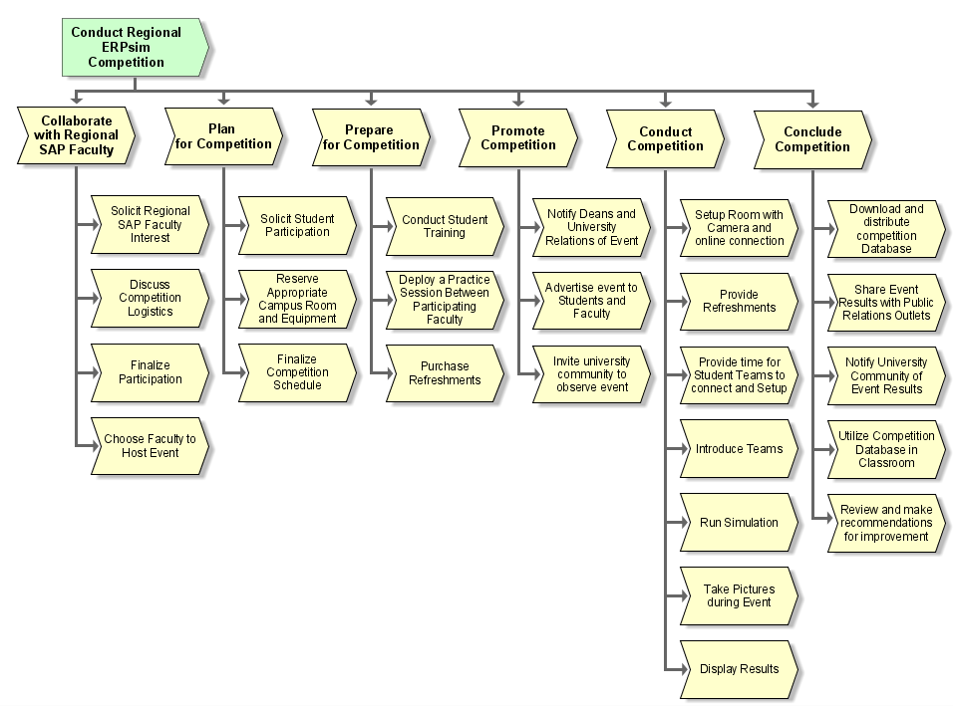

**Figure 1. Regional ERPsim Competition Process**

## Competition Coordination

Initial collaboration among the faculty determined the level of interest, approximate date and time, and type of ERPsim game. Two additional conference calls determined the event host. The host contacted the ERPsim Lab at HEC Montreal for an ERPsim client and set up the web conferencing platform for the event. ERPsim rules of engagement were established along with the event schedule as follows:

3:00-3:30 -- log into SAP, team planning, professors introduce their teams; 3:30-3:50 – Round 1;

3:50-4:00 – 10 minute break; 4:00-4:20 – Round 2; 4:20-4:30 – 10 minute break; 4:30-4:50 –

Round 3; 4:50-5:00 – 10 minute break; 5:00-5:20 – Round 4 ; Game end

Planning for the competition required each faculty to recruit students. Faculty had varying methods for recruitment as shown in Table 1. Students were expected to participate in the competition on their own free time, scheduled for a late Friday afternoon in November 2016. In addition, appropriate campus rooms that allowed video and audio displays with student computers needed to be reserved.

|  |  |  |  |
| --- | --- | --- | --- |
| **Participating University** | **Student Participation/ Incentive** | **Faculty Involvement** | **Extended Value** |
| Delaware State University | * Juniors and seniors from MIS class, mix of accounting, finance and MIS. * -volunteer | * Main faculty facilitator: collaborate with other faculty; time in practice session and competition. * Three faculty served as technical support. * One faculty worked with students two weeks prior to event, training (approx. 6 hours). | * Students asked to do this again * Helped prepare for ERPsim international competition * Students’ word of mouth advertising * Reported in AACSB files |
| Penn State University | * Juniors and seniors, * Information Sciences and * Technology degree program * Required for a class | * Collaborate with other faculty * Time in practice session and competition. * Arrange for and setup Polycom for a remote student. * Provide incentives for entire class to participate on a Friday afternoon. | * Students reported that this enhanced their learning for the class * Gave technology students extra incentive to understand the integrated business processes |
| Rider University | * Juniors and Seniors, business students Volunteers, given extra credit for participation Used classroom experience with SAP and dashboard analytics to extend to competition | * Collaborate with other faculty * Time in practice session and competition. * Advertise | * Student newspaper article * High student satisfaction * Reported in AACSB files |
| University of Delaware | * Sophomores, business * Volunteers from: business information systems class given extra credit, and another class no extra credit Used classroom experience to extend to competition | * Collaborate with other faculty * Time in practice session and competition. * Advertise * Purchase refreshments | * Featured School News Article * Reported in AACSB files |
| Widener  University  [event host] | * Juniors and Seniors, mix of business and computer science * Volunteers from an ERP class, given extra credit Used classroom experience to extend to competition | * Main faculty-collaborate with other faculty, notify administration and public relations, send invitations to event, set up room and equipment, solicit student volunteers, purchase refreshments, send several emails to student participants prior to the event with event details, attend practice session and competition. * Second faculty – attended event to assist event deployment * Event host – set up and administer Zoom, arrange game client with HEC and practice session, set up game client, assign teams, MC competition, record, download results and database then distribute. | * Press Release * Use of competition database in class analytics assignment using SAP Lumira (assignment will be provided as a takeaway) * Reported in AACSB files |

**Table 1. Competition demographics, Involvement, and Value per Participating University**

To prepare for the event, the hosting university shared connection details for the ERPsim client and the zoom session details. Prior to playing the game, students were assigned teams and allowed to practice on their own. All teams were provided with the same pre-formatted Excel analytics dashboard to use for the competition. The participating faculty scheduled a practice run a week before the competition in order to test all connections, video and audio.

During the competition, computer cameras were activated from each university, and each team was able to view the desktop display of the host. The host displayed team information in the beginning of the game, data as the game progressed, during and end-of-round round results, and analytics. Students were able to observe team results and live videos of all schools during the rounds and utilize analytics for decision making. Results from each round were displayed based on company valuation, as shown in Figure 2.

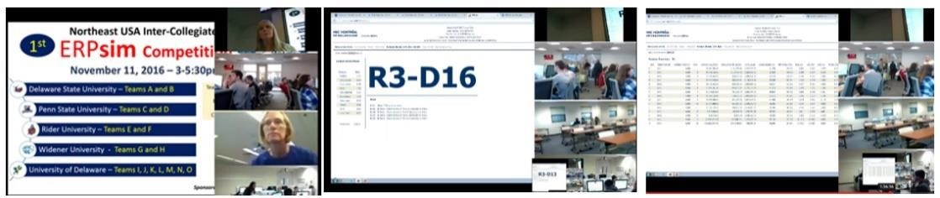

**Figure 2. Game Operations, Results and Remote Participant Displays in Zoom**

Promoting the event is important to give recognition to students and also to promote SAP curriculum to the regional communities. A poster was created and shared to generate excitement and advertising among the university communities. The competition also generated publicity within the universities. In several universities a public relations representative or school newspaper writer was present for the competition, took pictures and interviewed professors and students, resulting in press releases and news publications highlighting the students and their knowledge operating a business using SAP software.

# Value and Results

The results of the local competition were five-fold. (1) Students gained additional experience using SAP for business operations and real-time data analytics using the Excel analytics dashboard. (2) Students were proud to represent their school, using the experience as a talking point in job interviews and resume writing. (3) Results were used to enhance classroom analytics content. (4) Positive public relations promoted innovative curricula. (5) Evidence in one university indicated increased student performance, supporting the notion that competition motivates students and helps them have a higher retention of material (Tucker 2017; Cagiltay 2015). Future events could include data collection for perceived and actual learning. One advantage of running a regional ERPsim event is that it is relatively easy to organize with a small group of schools. In addition, it can engage students in an inter-university competition during the semester while they are learning the material in class, providing students with reinforcement of the material as well as the opportunity to extend what they are learning outside of the classroom.

# Acknowledgements

We would like to thank ERPsim Lab at HEC Montreal for sponsoring this competition by providing the ERPsim client.

# References

Cagiltay, N.E., Ozcelik, E. & Ozcelik,N . 2015. "The effect of competition on learning in games," *Computers and Education* (87), pp. 35-41.

Charland, P., Leger, P-M., Cronan, T.P., & Robert, J. 2015. “Developing and Assessing ERP Competencies: Basic and Complex Knowledge,” *The Journal of Computer Information Systems* (56:1), pp. 31-39G.L.

Geerts, G., Chang, J., Lamberton, B., and Raschke, R. “Top 25 Technology List” presented at the 2015 Annual Meeting of the American Accounting Association.

Léger, P.-M., Robert, J., Babin, G., Pellerin, R. and Wagner, B. 2007, ERPsim, *ERPsim Lab*, HEC Montréal, Montréal, Qc.

Luokai, H., Zhenyu, H.,Chen, G., & Cappel, J.J. 2017. “A Meta-Analysis of Enterprise Resource Planning (ERP) Learning Game Research,” *ASBBS Proceedings of the 23rd Annual Conference*, March 23, 2017. Las Vegas, NV. pp. 238-247.

Seethamraju, R. 2011. “Enhancing Student Learning of Enterprise Integration and Business Process Oientation through an ERP Business Simulation Game,” *Journal of Information Systems Education* (22:1), pp. 19-29.

Tucker, K. 2017. Positive & Negative Effects of Competition on Academic Achievement, [Online]. Available:*http://classroom.synonym.com/positive-negative-effects-competition-academic-achievement6928.html* [Accessed 3/12/2017]

**The ERPsim Logistic Games, a Supply Chain Management Application**

**Mark Angolia**

East Carolina University

angoliam@ecu.edu

**Abstract**

*This innovative utilization of the ERPsim Logistics' simulation adapts the games from a target audience of Management Information System (MIS) students to undergraduate students of Supply Chain Management (SCM). The fundamental simulation objectives of cross-functional information sharing and communication are maintained, but MIS-specific goals are replaced by SCM-focused concepts. These new goals and objectives to develop through ERPsim’s experiential learning include distribution requirements planning, purchasing and transportation planning, and Microsoft Excel-based analytics. Deeper dives are taken into the inbound transportation strategies in addition to the simulation’s outbound transfer strategy function. Supplier schedules, tractor-trailer capacity, and “total landed cost” concepts come to the forefront of the analysis as sales, purchase orders, and freight statistics are tracked and analyzed with a series of Excel spreadsheets and pivot tables. Strategies and inventory targets are developed in concert with sales and financial data and measured through a series of logistic related metrics. Active learning from the simulation is enhanced as students create operational plans on a virtual-month-by-month basis and then report on results.*

*ERPsim provides an outstanding active learning platform, and the approach detailed within provides resources for instructors and students. The project has been developed over two semesters of a 300 level undergraduate Transportation Logistics course at a U.S. public university. Adoption of this project may benefit ERPsim practitioners teaching supply chain management or any supply-chain-related course considering transportation, purchasing, or inventory management within a supply chain.*

**Keywords:** ERP, transportation, distribution requirements planning, logistics, inventory management, supply chain simulation

# Introduction

The ERPsim Logistics *introductory* game is an excellent tool to understand the SAP transactions needed to manage inventory and sales functions within a basic supply chain distribution network. The hands-on activities provide experience in how computer information systems integrate data and impact decision making. The ERPsim Logistics *extended* simulation increases the complexity of the introductory game and presents a unique opportunity to model a three tier supply chain consisting of a supplier, a central distribution center (CDC), and multiple regional distribution centers (DC) as shown in Figure 1. One of the main purposes of the ERPsim simulations is to provide hands-on learning for Management Information System (MIS) students in order to introduce Enterprise Resource Planning (ERP) as a system to integrate information flow horizontally across an organization. The stated experiential objectives of ERPsim Logistics introductory and extended games include learning how to create, execute, and adapt a business strategy in a real-time environment and how to work in a team to support the value chain. This paper supports these objectives and the ERPsim Lab’s recommendation to complete the introductory game early in a semester and follow later with the extended game. The proposed modifications add objectives to focus on key supply chain management operational metrics for transportation and logistics. Also, although ERPsim provides downloads for Microsoft Access, typical corporate recruiters of undergraduate students show a preference for Excel training 6and expertise. Thus, data from the games are exported and analyzed through a series of provided Excel worksheets and pivot table requirements.

There are two primary additions to the original simulation structure: 1) Distribution Requirements Planning (DRP), and 2) management of freight inbound to the CDC. The DRP algorithm is similar to Materials Requirement Planning (MRP), but rather than planning sub-components to support manufacturing, DRP uses forecast sales at each DC (branch) to determine quantities needed by the CDC to support the distribution network. The required CDC volumes are then translated into needed material purchases from the supplier. By incorporating all three supply chain “tiers” of DC, CDC, and supplier, this approach to the logistic simulations focuses on supply chain and inventory management.



Supplier

(

Dairy Cooperative

)



istribution

Central D

Center

(CDC

)

(

Main W

arehouse

)



Distribution Center

DC

)

(

West

Branch

(

Storage Location

)



Distribution Center

)

DC

(

South

Branch

(

Storage

Location)



Distribution Center

(

DC

)

North

Branch

Storage Location

)

(

**Figure 1. A 3 Tier Supply Chain for the Extended Game**

In accordance with the ERPsim lab recommendation, the introductory game is played at the start of the semester, and the extended game is played later after SCM concepts are taught within the course. The introductory game uses automated purchasing for CDC replenishment inventory, while the extended game requires planned purchases by students. In the proposed approach, the game’s original six dairy components carry new parameters of size and weight, which becomes a constraining factor for inbound logistics as tractor-trailer capacity is incorporated. Students in the extended game are not allowed to place a purchase order (PO) for quantities that exceed U.S. carrier weight restrictions. The purchasing processes must now involve not only quantity needed, but planning and scheduling of inbound freight, which is also challenged by “frozen” supplier delivery schedules. Finally, students compute total landed costs and a fully burdened product cost with total logistic expense in order to determine a break-even sales price.

The following discussion details the approach used for each simulation, introductory and extended. The projects integrate ERPsim operational decisions with stand-alone exercises for purchasing strategies, inbound transportation logistic planning, coordination of sales and inventory management, and financial analysis. Although ERPsim provides an automated business intelligence (BI) platinum game for MIS students (which may be phased out), this pedagogy is designed around Microsoft Excel spreadsheet analysis supported by pivot tables.

# ERPsim Logistics, Introductory Game Modifications

The ERPsim Lab recommended approach allows students free experimentation with sales and transfer strategies from the CDC to the DCs, while focusing attention on communication processes and information technology as facilitators of organizational efficiency. The proposed application maintains these goals, but students are given a set of required transfer strategies as shown in Table 1. The intent is to create common background for class discussion and exercises which includes training for DRP, inventory planning, sales strategy coordination, and Excel pivot tables. Concepts such as total landed cost, total logistic costs, activity based costing (ABC), and absorption costing are introduced and discussed during Rounds 1 – 3. Rounds 4 – 5 introduce the Just-In-Time (JIT) inventory philosophy to a distribution network, facilitated by discussions on estimating daily sales and target inventory levels at each DC. These activities require coordination among sales, purchasing, and transportation.

|  |  |  |  |
| --- | --- | --- | --- |
| Round | Mode | Days | Objective |
| 1 | Push | 3 | Demonstrate product flow, push distribution method, game reports/functions |
| 2 | Push | 1 | Discussion on CDC stock management and cost of transfers |
| 3 | Push | 5 | Intentionally overload storage capacity for income statement cost review |
| 4 | Pull | 3 | Discuss pull strategy, target level, and transfer quantity calculations |
| 5 | Pull | 1 | Discuss JIT inventory approach; intentionally build up CDC inventory |
| 6 - 8 | Push | 2 | Create plan to achieve total system inventory of 4,000 total boxes and Branch JIT inventory at 2 days' supply |

**Table 1. Introductory Game Required Strategies**

Experience shows it takes approximately four one-hour classes for this pedagogy. One classroom hour is needed to explain the game and to set up and then play the first round. Game play uses the ERPsim Lab recommendations for SAP-training-related pauses. A second contact hour covers Rounds 2 – 5, followed by an extended break to develop pivot table analysis from sales and purchasing data. Using this data, students then work with a provided DRP planning tool aimed at creating transfer plans to achieve prescribed inventory goals for the final three rounds. A one-week gap is recommended for the instructor to validate homework to develop DRP plans to meet the prescribed CDC and branch inventory goals. A third class contact hour is then used to resume the simulation and execute the plan as designed. Finally, the fourth contact hour is used for general discussion and comparing results to validate the planning process.

# ERPsim Logistics, Extended Game Modifications

The ERPsim extended game increases complexity for the student by eliminating the automated supplier purchase orders and requiring students to complete a manual process. To execute the process, students modify the planned independent requirements (PIR) and run MRP to create planned orders, then convert these to purchase orders through an additional SAP transaction. This three-step process is one of the key focal points of the proposed modifications since, as previously stated, this approach adds tractor-trailer capacity as a constraint to each PO. To allow students time to create properly sized purchase orders, several in-round pauses are needed to freeze the current inventory and allow the PIR-MRP-PO process to be manipulated by the student to deliver a desired purchase quantity. To facilitate this, a freight analysis spreadsheet is provided that serves multiple purposes. First, a table to convert product quantity into weight allows students to demonstrate understanding of transportation gross, tare, and net weight concepts. Next, the table uses current network inventory positions (copied directly from SAP) to “reverse engineer” PIR values needed so that MRP generates a pre-planned PO quantity. This rather involved procedure adds considerable time and complexity to the simulation, but is required to achieve the transportation-related intent of the simulation modifications. The freight analysis worksheet also uses PO data in conjunction with product and shipping cost to determine the inbound “activity based cost” of transportation for each stock keeping unit (SKU). This develops an understanding of both ABC and the “total landed cost” concept. The game’s warehousing and transfer costs are tracked separately and used to develop the concept of (full) absorption cost as an alternative to ABC. That said, the combined ABC and absorption cost are used to determine break-even pricing for each product.

Beyond PO quantity and freight analysis, the other logistic concept being developed is DRP. An Excel worksheet is provided as a template for students to input sales and branch demand data to establish weekly sales forecasts for each branch in Figure 1. DRP computations are much like MRP, utilizing sales forecasts minus on-hand inventory to determine individual requirements. The weekly sales projections are rolled-up to the CDC to determine how much new material will be required on a weekly basis from the supplier. The provided Excel worksheet also generates CDC to DC transfer quantities based on push scheduling frequency.

The extended game modifications convert game play from “round based” to a virtual month format using two rounds of 10 days to define a month. The Month 1 objective is to demonstrate the flow of product in a three tier supply chain, experience inbound freight planning, and demonstrate the push distribution strategy for regional branch warehouses. Students experiment with transfer frequency and push allocations to observe inventory level impact. The goal is to support sales while minimizing cost and properly positioning inventory; transportation must be subservient to sales, not the other way around. The Month 2 and 3 objectives are very similar, both requiring use of DRP to determine weekly CDC supplier purchasing requirements and scheduling of inbound trucks to meet the plan. Once total supplier quantity for each SKU is determined at the start of the month, order quantities are frozen for each week and must be delivered. Teams plan inbound logistics on either an ad-hoc basis or with a standard “milk-run” delivery. The Month 4 objective is to demonstrate the pull method of distribution and understand target inventory calculations based on expected daily demand, lead time, and safety stock.

The proposed modifications provide a pre-determined set of transfer policies similar to the introductory game, as well as Excel worksheets for data collection and analysis. Specific “pre-month” activities are defined in the instructions and include tasks for sales, logistics, and purchasing. Game play is structured with pre-determined mid-round pauses and defined end-of-month activities that include exporting data from SAP, Excel-based analysis, planning for the next month, and comparing results to the plan. Thus, the three tiered supply chain is planned, operated, and analyzed four times. Game play requires four classroom contact hours, staggered over at least two weeks in order to provide time for data analytics, sales and operating planning, and month-end analysis. One hour per virtual month of classroom time for conceptual discussions is recommended, for a total investment of eight contact hours.

# Conclusion

Using both of the above projects requires a total of 12 classroom hours, twice the amount of the ERPsim lab recommendations, when both games are played in a semester. The project is best utilized by students within a supply chain management curriculum, and preferably after experiencing business process management using the SAP UA curriculum content. These modifications include all the benefits of the ERPsim games and add deeper development of transportation logistics planning and Excel-based analytical tools. The modifications also incorporate real-world constraints on product movement with the addition of PO weight limits and the restrictive nature of committed supplier schedules and lead times. Thus, the free flexibility of the original games is traded for a more structured, instructor-led simulation experience rather than the typical ERPsim student experimentation model of engaging with the simulation. These modifications and supporting materials will deliver the ERPsim intent of educating students on benefits of information technology in organizations and business analytics, while also delivering experiences and skills sought by companies recruiting supply chain management undergraduates. Instructors may request all support materials by emailing the author at angoliam@ecu.edu.

# References

Babin, G., Ortiz de Guinea, A., Lyle, D., Leger, P-M., Tams, S., Cameron, A., Titah, R., Talbot, J., Mainville, M., Bourdeau, S., Wybo, M. (2012). In Robert J. (Ed.), *Information technologies in organizations*. Montreal, Qc, ERPsim Lab, HEC Montréal.

Léger, P.-M., Robert, J. et Babin, G. (2011*). ERP Simulation Game: Changing the Way We Teach and Learn ERP Systems*, ERPsim Lab, HEC Montréal, Montréal, Qc.

Léger, P.-M., Robert, J., Babin, G., Pellerin, R., Lyle, D. (2011). *ERP Simulation Game with SAP ERP: Logistics Game*, ERPsim Lab, HEC Montréal, Montréal, Qc.

Léger, P.-M., Robert, J., Babin, G., Pellerin, R. and Wagner, B. (2007), *ERPsim*, ERPsim Lab, HEC Montréal, Montréal, Qc.

**Where is my profit? Learning basic analytics skills with a company profitability simulation**

**Chelley M. Vician Elizabeth M. Pierce**

University of St. Thomas Saginaw Valley State University cvician@stthomas.edu empierce@svsu.edu

**Abstract**

*Data analytics is a broad, umbrella-like term used to describe the repeated examination of data and information to discover new understandings for future decisions. Industry leaders continue to note the importance of having new employees enter the workforce with awareness and skills in this important emerging technology area. This poster presentation describes an instructional resource developed around the SAP-ERP simulation game and a simple post-hoc analytics exercise completed with visualization software. The resource immerses student teams in active decision-making with SAP-ERP Sales, Procurement, and Planning processes for the purpose of company profitability goals. The post-hoc analytics exercise introduces students to visualization software features as well as a real world example of using analytics software for business needs. The visualization software in-use includes SAP Lumira. The conference poster presentation will include preliminary efficacy results from a spring 2017 pedagogical research study.*

**Keywords**: experiential learning, ERP, analytics, visualization, accounting education.

# Introduction and Background

Data analytics is a broad, umbrella-like term used to describe the repeated examination of data and information to discover new understandings for future decisions. Accounting professionals are expected to evidence fundamental analytics skills and knowledge in order to utilize "decision support and analytics" in their professional work (Byrnes et al., 2014; Cohn, 2016; Forbes Insights, 2015; PricewaterhouseCoopers, 2015a, 2015b). The American Accounting Association (AAA) is now hosting an annual conference for practitioners and academics to jump-start development of more research and teaching efforts in the Analytics and Big Data topical areas. Yet, existing instructional materials that address these topics for future accountants are in short supply and often lack the use of ERP data sources (Igou and Coe, 2016; Janvrin, Raschke and Dilla, 2014; Dilla and Raschke, 2015; Sledgianowski, Gomaa and Tan, 2017).

This instructional resource addresses the need for analytics instructional materials and leverages SAP enterprise system learning experiences. We combine the active learning of the SAP ERPsim game experience with a post-hoc analysis of company profitability visualizations derived from the data generated by the ERPsim game. Our early implementation and testing of this instructional resource provided anecdotal evidence of its success in increasing student awareness of analytic software capabilities. We have since designed a study to investigate (a) the usefulness of Analytics exercises in addressing student learning about Analytics fundamentals and Analytics software skills and (b) student perceptions about the learning effectiveness of the Analytics exercises. This research fits within existing accounting education research on instructional materials and cases. The study is important due to the critical practice need for additional accounting preparation in an era of increasing usage of Analytics activities and software tools in business organizations and accounting firms.

# Literature Review

Enterprise resource planning (ERP) software packages like SAP provide the main source of contemporary accounting data (Simkin, Rose, and Norman 2015). Accounting practitioners recognize that ERP systems host the financial and accounting transactions comprising a company’s internal and external valuation (AAA, 2015; Bradford, 2015). Business analytics initiatives are increasingly reliant upon these “systems of record” as key data sources (Forbes Insights 2015; PricewaterhouseCoopers 2015b).

Accounting educators recognize the importance of adding spreadsheet and database software experiences to accounting curriculum (Simkin et al. 2015), but there exist few educational resources that combine ERP experiences with exposure to analytics fundamentals and analytics software skills. There exist a few published accounts of ERP experiences within the accounting discipline (Bandyopadhyay et al., 2013; Blount et al., 2016; Watson et al., 2016), but none address analytics skills and knowledge.

General business curriculum research has shown that hands-on experiences with ERP software can positively influence student-learning outcomes. Léger and colleagues (2010) showed how SAP usage influenced student understanding of the importance of integrated information systems. More recently, Charland and colleagues (2015) evidenced increased student decision-making within complex ERP systems through the implementation of an integrated business simulation. More important to this instructional resource, ERP simulations may enhance student learning in ill-structured problem situations (Léger et al. 2012). Professional accountants will likely encounter both complex ERP systems and ill-structured problem situations in future professional activities.

# Instructional Resource

The instructional resource has two main sections: (a) the ERPsim game administration and (b) the posthoc analytics exercise. At minimum, instructors must be (or have a colleague that is) a Level 1 ERPsim Certified Instructor (per HEC Montreal ERPsimLab) in order to access and use the simulation resources. This section will emphasize the components of the post-hoc analytics exercise as HEC Montreal guides and resources provide the full details for the ERPsim game administration (Léger, Robert, & Babin, 2013).

## ERPsim administration

We utilize the ERPsim Bottle Water Distribution Game scenario. In this setting, the company operations move from a focus on Sales and Marketing decisions (Quarter 1) to adding Procurement decisions (Quarter 2) and finally layering on additional Forecasting decisions in Quarter 3.

During the game, we emphasize company profitability and the use of standard SAP reports. Each company actively fills out the instructional resource’s “Company Worksheet” to keep track of operational decisions (pricing, marketing, and replenishment), organizational strategies, information technology strategies, and financial results. Filling out the worksheet helps the students with the later analysis of company profitability, as the actual simulation moves quickly and leaves little time for reflective actions.

We review company valuation and operational results (sales, profit, etc.) at the end of each quarter and at the end of the game. We capture screenshots of quarterly and final results to share with students in the course management system for later analysis. At the end of the simulation, the instructor uses the HEC Montreal Microsoft Access Data Extraction tool to download the ERPsim data. The instructor then extracts and transforms (calculating Contribution Margin) the Sales data to load into an Excel spreadsheet.

***Post-hoc analytics exercise***

We use an instructional packet that introduces analytics software (SAP Lumira, Tableau) to explore company sales results from the ERPsim experience. Students analyze company performance compared to other companies based on student-identified metrics that might help explain company financial outcomes in the simulation experience. The instructional packet provides a primer covering visual analytics concepts and analytics software features. The packet guides student exploration of sales data using measures (e.g., sales revenue, contribution margin, and pricing) and dimensions (e.g., team/company, quarter, and product). Early anecdotal evidence indicates that this additional visual analysis helps students understand the effects of their ERPsim decision-making and outcomes (e.g., Sales, Expenses, Profit, Contribution Margin), as well as gain an appreciation for the growing topic of business analytics.

# Research Design and Methods

We collected data from two sections of an Accounting Information Systems class in spring 2017. We collected demographic information, pre-test/post-test data for analytics fundamentals and software features, and student feedback about the exercise. We intend to present preliminary data analyses in the poster presentation at the conference.

# Suggestions for Faculty Adoption

We use the combined ERPsim and analytics exercise in Managerial Accounting, Accounting Information Systems, and Accounting Software classes. Instructors may use only the SAP Lumira version of the resource.

Instructors could present exercises that are more challenging by extending analyses to include Excel Pivot Tables/Charts and/or Tableau visualizations with direct connection to the Microsoft Access database.

# Conclusion

Based on anecdotal evidence and personal observations, combining the use of integrated enterprise software (like SAP) with analytics visualization software appears to be a potent, positive educational experience for students. Empirical efficacy results are important to understand. This instructional resource can be useful to educators in general business curriculum or accounting-focused instruction. When used early in a curriculum, the resource can be a fun and engaging introduction to SAP software.

# Acknowledgements

We wish to acknowledge the *[anonymized University affiliation]* SAP student experts who helped test initial exercise materials and continue to assist with classroom administration of the ERPsim game and subsequent analytics activities.

# References

American Accounting Association (AAA). 2015. Accounting IS Big Data (AiBD). <http://commons.aaahq.org/groups/cea5c9d7d1/summary>(July 6, 2016).

Bandyopadhyay, K., Moss, G.J., and Flosi, A. 2013. “ERP integration in the accounting curriculum.” *Competition Forum*, (11:2) pp. 215-219.

Blount, Y., Abedin, B., Vatanasakdakul, S. and Erfani, S. 2016. “Integrating enterprise resource planning (SAP) in the accounting curriculum: a systematic literature review and case study.” *Accounting Education*, (25:2) pp. 185-202.

Bradford, M. 2015. *Modern ERP: Select, Implement and Use Today’s Advanced Business Systems, 3rd edition*. Raleigh, NC: Lulu.com.

Byrnes, P., Criste, T., Stewart, T., Vasarhelyi, M., Pawlicki, A., and McQuilken, D. 2014. “Reimagining

Auditing in a Wired World,” AICPA white paper, [http://www.aicpa.org/interestareas/  
frc/assuranceadvisoryservices/downloadabledocuments/whitep](http://www.aicpa.org/interestareas/frc/assuranceadvisoryservices/downloadabledocuments/whitep)[aper_blue_sky_scenario-pinkbook.pdf](http://www.aicpa.org/interestareas/frc/assuranceadvisoryservices/downloadabledocuments/whitepaper_blue_sky_scenario-pinkbook.pdf) (July 6, 2016).

Cohn, M. (2016). “Companies Seeking Accountants with Data Analytics Skills,” *Accounting Today* (April 15, 2016), [https://www.accountingtoday.com/news/companies-seeking-accountants-with-dataanalytics-skills](https://www.accountingtoday.com/news/companies-seeking-accountants-with-data-analytics-skills) (April 30, 2017).

Charland, P., Léger, P-M., Cronan, T.P., and Robert, J. 2015. “Developing and Assessing ERP Competencies: Basic and Complex knowledge.” *Journal of Computer Information Systems*, (56:1) pp. 31-39.

Dilla, W.N. and Raschke, R.L. (2015). “Data Visualization for Fraud Detection: Practice Implications and a Call for Future Research,” International Journal of Accounting Information Systems, (16) pp. 1-22, <http://dx.doi.org/10.1016/j.accinf.2015.01.001>.

Forbes Insights. 2015. “Audit 2020: A Focus on Change.” June. [http://www.forbes.com/forbesinsights  
/kpmg_audit/index.html](http://www.forbes.com/forbesinsights/kpmg_audit/index.html) (July, 6. 2016).

Igou, A. and Coe, M. (2016). “Vistabeans coffee shop data analytics teaching case,” *Journal of Accounting Education*, (36) pp. 75-86, [http://dx.doi.org/10.1016/j.jaccedu.2016.05.004.](http://dx.doi.org/10.1016/j.jaccedu.2016.05.004)

Janvrin, D.J., Raschke, R.L., and Dilla, W.N. (2014). “Making Sense of Complex Data using Interactive Data Visualization,” *Journal of Accounting Education* (32) pp. 31-48, <http://dx.doi.org/10.1016/j.jaccedu.2014.09.003>.

Léger P-M., Robert, J., Babin, G., Lyle, D., Cronan, T.P., and Charland, P. 2010. “ERP Simulation Game: A Distribution Game to Teach the Value of Integrated Systems.” *Developments in Business Simulation and Experiential Learning*, (37) pp. 329-334.

Léger, P-M., Cronan, T.P., Charland, P., Pellerin, R., Babin, G., and Robert, J.. 2012. “Authentic OM Problem-Solving in an ERP Context.” *International Journal of Operations & Production Management*, (32:12) pp. 1375-1394.

Léger, P-M., Robert, J., and Babin, G. 2013. *ERP Simulation Game: Changing the Way We Teach and Learn about Enterprise Systems – Teaching Notes for Instructors using ERPSim*. Montreal, Canada: HEC Montreal - ERPSim Lab.

PricewaterhouseCoopers. 2015a. “Data driven: What students need to succeed in a rapidly changing business world.” (New York, NY: PwC firm publication, February[) http://www.pwc.com/us/en/facultyresource/data-driven.html](http://www.pwc.com/us/en/faculty-resource/data-driven.html) .

PricewaterhouseCoopers. 2015b. “Point of View: The evolution of auditors – how skillsets are changing.” (New York, NY: PwC firm publication, October) [http://www.pwc.com/us/en/cfodirect/  
publications/point-of-view/evolution-of-auditor-skills](http://www.pwc.com/us/en/cfodirect/publications/point-of-view/evolution-of-auditor-skills)[technology-accounting.html](http://www.pwc.com/us/en/cfodirect/publications/point-of-view/evolution-of-auditor-skills-technology-accounting.html) .

Simkin, M.G., Rose, J.M., and Norman, C.S. (2015). *Core Concepts of Accounting Information Systems, Thirteenth Edition*, John Wiley & Sons, Hoboken, NJ.

Sledgianowski, D., Gomaa, M., and Tan, C. (2017). “Toward Integration of Big Data, Technology, and Information Systems Competencies into the Accounting Curriculum,” *Journal of Accounting Education*, <http://dx.doi.org/10.1016/j.jaccedu.2016.12.008>.

Watson, M.W., Klamm, B.K., Segovia, J. and Lehman, M.W. 2016. “Enterprise System Case using Microsoft Dynamics GP via DynamicsCloud.” *Journal of Accounting Education*, 37, pp. 67-92.

**An Interdisciplinary Approach to Marketing Analytics**

**Dr. Gary Hackbarth Dr. Jie Fowler**

Valdosta State University Valdosta State University ghackbarth@valdosta.edu jgfowler@valdosta.edu

**Dr. Karin P. Roland**

Valdosta State University kroland@valdosta.edu

**Abstract**

*Knowledge of Enterprise Resource Planning (ERP) Systems and Customer Relationship Management (CRM) systems and how to analyze its shared data must be required skills of all marketing students. As such, marketing students need to require an inter-disciplinary, multi-course approach to analyzing and interpreting big-data generated across the enterprise, The study suggests that implementation of common ERP SAP tools and technologies across the business school curriculum, not just one discipline, provides marketing students a competitive advantage. Success requires buy-in from a core group of faculty who are technologically savvy, collaborative, willing to adjust course content inclusive of data analytics, and recognize data visualization as an essential business skill.*

**Keywords:** ERP Systems, SAP, Big Data, Marketing Analytics. Marketing Research, Data Visualization

**Introduction**

Knowledge of Enterprise Resource Planning (ERP) Systems and Customer Relationship Management (CRM) systems and its shared data should be a required skill of all marketing students as implementation of ERP and CRM systems becomes more commonplace. These systems, built upon digital information, have profoundly reshaped how organizations do business and the workforces with them over the last quarter century. As with so many employment sectors, that transformation has crept into marketing and with it the need for our marketing students to better understand the interconnectedness of organizations and the use of big-data applications (Brooke, 2017). In recent years, there has been a subtle shift in competitive and market intelligence where organizations who rely on solely on operators, working within silos, are moving towards an organizational structure that rely on collaboration with and between organizations (Fleisher and Hursky, 2016). Hauser (2007) required the marketing analyst to mine, analyze, interpret, and be able to present relevant information at every touchpoint through the life cycle of the business (Hauser, 2007). There is substantial and notable evidence to suggest that doing collaborative market intelligence work is accomplished by taking advantage of emerging technologies, adapting best practices from adjacent fields, and benefiting from academic and scholarly research (Fleisher and Hursky, 2016). It is believed that marketing students now require an inter-disciplinary, multi-course approach, to analyzing and interpreting big-data generated across the enterprise because decision makers recognize marketing expertise and marketing’s role in visualizing and presenting complex data in visually impactful ways that are appreciative of how data interconnects across business units.

Marketing education has long recognized the importance of developing integrative business programs in response to such external factors such as the emergence of “Big Data” and “Data Analytics”. At issue, is the need for marketing education to address the current and future needs of marketing students who will need the ability to analyze, critically evaluate, and recommend effective business solutions to complex problems. For students to properly gather, analyze, interpret and report Big Data in its intended context, they must have an integrated understanding of the business life cycle. Many of our marketing courses, as well as courses in the other business disciplines, are by some necessity, silo courses focused on a single aspect of the business life cycle.

However, there is the realization that ERP and CRM information systems share data across traditional organizational silos and that marketing education, in general, has not effectively communicated these relationships in our traditional approach to marketing education and the overall business curriculum. As such, we suggest the introduction of ERP and CRM training systems into the overall marketing curriculum, across associated multi-disciplinary business courses, that would allow marketing students to see an integrated business life cycle at every turn, the importance of marketing type decisions in the context of the entire business, the impact of data analysis, the interpretation of that data, and reporting of that information in a collaboration business organization as an important skill set for students to develop. Thus, this paper provides a case study in the implementation of SAP training materials within marketing and across a college business curriculum in its first year.

**Literature Review**

Today, the list of digital business roles and functions aligns a company’s activities, culture, and structure with organizational goals (Kiron, Kane, Palmer, Phillips, and Buckley, 2016). Barber et al. (2001) suggests three general models of integration as ways to address rapid and effective responses to industry needs: (1) integration across disciplines (e.g., integration of engineering and business), (2) integration of functional areas within business (e.g. integration of marketing, management information systems, and finance), and (3) integration with a functional area (e.g., integration of financial reporting issues with tax and auditing issues in an accounting program) (Barber, Borin, Cerf, and Swartz, 2001). In

2011, the MIT Sloan Review Management Review and the IBM institute for Business Value reported that 58% of organizations apply analytics to create a competitive advantage with those same organizations being twice as likely to outperform their peers (Kiron, Shockley, Kruschwitz, Finch, and Haydock, 2012).

Big Data is no longer defined by the 3V Model – high volume, high velocity, and high variety but by a more business like definition that reflects the integrated nature of the data found in Enterprise Resource Planning (ERP) and Customer Relationship Management (CRM) systems commonly found in today’s business environment. Big data can be defined as “building new analytic applications based on new types of data, in order to better serve your customers and drive a better competitive advantage”(Bertolucci, 2013) (De Prato and Simon, 2015). For example, *Hortonwork.com* has subdivided types of data into five categories: social media; server logs; Web clickstream; machine/sensor; and geolocation. Understanding, analyzing, interpreting, and presenting these types of data requires skill sets from across the business disciplines because actionable marketing data impacts supply chain, finance, accounting, IS, etc. decisions. Marketing professionals must consider the impact of marking data in the context of the overall profitability of the firm. Marketing literature has addressed the use of technology in higher education due to its connection to the marketplace (Lamont and Friedman, 1997; Peterson, 2001). The curriculum increasingly includes courses such as E-commerce, Internet marketing, electronic marketing, and using the internet for marketing research. In essence, the integration of technology in marketing education has been hailed in the literature as both inevitable and beneficial (Lamont and Friedman, 1997). As such, the traditional marketing research course which usually focuses upon “design and conduct of a research study,” were broadened to teach the application of technology (Lamont and Friedman, 1997). Topics such as database retrieval, software for data analysis, and visual graphics have been included in the basic research marketing course (Atwong, Lange, Doak, and Aijo, 1996).

However, there is debate that marketing is interdisciplinary because of its roots in economics, psychology, sociology and anthropology (Alden, Laxton, Patzer, and Howard, 1991; Ramocki, 1993). As a result, marketing educators have called for cross functional links with other business disciplines (Lamont and Friedman, 1997). The implication is that marketing educators need to move beyond narrow, multiple course majors and begin to design curricula that requires students to integrate business disciplines. Marketing may need to forge stronger links with finance, accounting, management, information systems, and other business areas, through team teaching, collaborative courses, and the development of cross functional teaching materials (Lamont and Friedman, 1997). Within this context, an interdisciplinary approach to teach data analytics and data visualization was proposed, developed, and implemented.

Traditional marketing research relies on analytics dealing with small data sets with limited analytic platforms and implementation capacity (Xu, Frankwick, and Ramirez, 2016). However, recent changes in marketing and information technologies feature high magnitude, mobility and versatile solutions for strategic activities. The literature refers to the changes as big data analytics (Xu et al., 2016).

Big data is a term that describes data sets that are large, unstructured, and complex (Chen, Chiang, and Storey, 2012). Forrester Research (2011) defined big data as “techniques and technologies that make handling data at extreme scales affordable’ (Hopkins et al., 2011). Per Sathi (2014), big data analysis (BDA) in marketing differs from marketing analysis (TMA) mainly in the revolution rather than evolution of communication channels. Firms use big data analysis techniques to follow the flow of information and analyze massive volumes of data in real time, whereas TMA focuses on providing better insights regarding advertising, pricing, customer relationship management, and product development (Sathi, 2014).

Marketing big data analytics is “technology enabled, and is a model supported approach needed to harness customer and market data to enhance marketing decision making’ (Lilien, 2011). Two types of applications are considered; those that involve the users in a decision support framework; and those that do not (i.e. automated marketing analytics). During last half century, the marketing literature has documented numerous benefits of the use of marketing analytics (e.g., (Zoltners and Sinha, 2005). Kannan, Pope and Jian (2009) reported that marketing analytics led to a better understanding of customers and a better methods of reaching customers (Kannan, Pope, and Jain, 2009). For example, through analytics, the National Academies Press (NAP) built a pricing model that helped to launch its entire range of digital products with a variable pricing scheme. Netflix analyzed millions of real time data points that its viewers create, thus helping the firm to determine if a pilot will become a successful new show. Rhenania, a German Mail order company, used a dynamic, multilevel response modeling system to increase its profitability by analyzing catalog distribution. Marriot used conjoint analysis to identify new locations and launch new product categories. The deployment of marketing analytics allows firms to develop and offer products and services that better align with customer needs and wants which in turn, leads to better performance (Germann, Lilien, and Rangaswamy, 2013). Data driven firms can achieve favorable sustainable performance, especially in a more competitive environment (Germann et al., 2013). It is known that analytical solutions within Customer Relationship Management (CRM) systems are more successful the more innovative, technologically advanced, and process oriented a firm is when they introduce CRM into their business systems (Sebjan, Bobek, and Tominc, 2016).

|  |  |  |
| --- | --- | --- |
| **Competencies** | **Coverage in ERP Courses** | **Functional Areas Involved** |
| Technical Skills | Extensive Experiencer using SAP  Locate Data  Export data | IT |
| Statistical and Analytical Skills | Analyze and Interpret financial data  Forecast and plan | Accounting  Finance  Statistics |
| Knowledge of Data | Learn about Master Data used in  Business Processes  Learn about Transactional data generated in business processes | Accounting  IT  Management  Marketing |
| Know the Business | Learn Common needs addressed by the enterprise system  Learn the specific characteristics of a business and its competitors  (ERPsim simulation) | Accounting  Finance  Management  Marketing |
| Communication & Partnering  Skills | Work with management teams coordinating responsibilities and actions (ERPSim Simulation) Weigh alternatives and make decisions | IT  Management |

**Table 1. Teaching Analytics across Disciplines**

The Association to Advance Collegiate Schools of Business (AACSB) has long encouraged integration across programs to keep up with the rapidly changing business environment (Elam and Spotts, 2004). Taking advantage of new created SAP learning initiatives and opportunities provided through the SAP Academic Alliance the college formed an academic cross-disciplinary team to integrate all business perspectives by using SAP as an analytical platform. To implement this integration, the faculty committed to the sharing of learning/teaching contents (See Figure 1). In other words, this approach was to integrate analytical skills across disciplines as opposed to a focus on a new course (s) or coordinating efforts around a common project or case (Pharr and Morris, 1997).

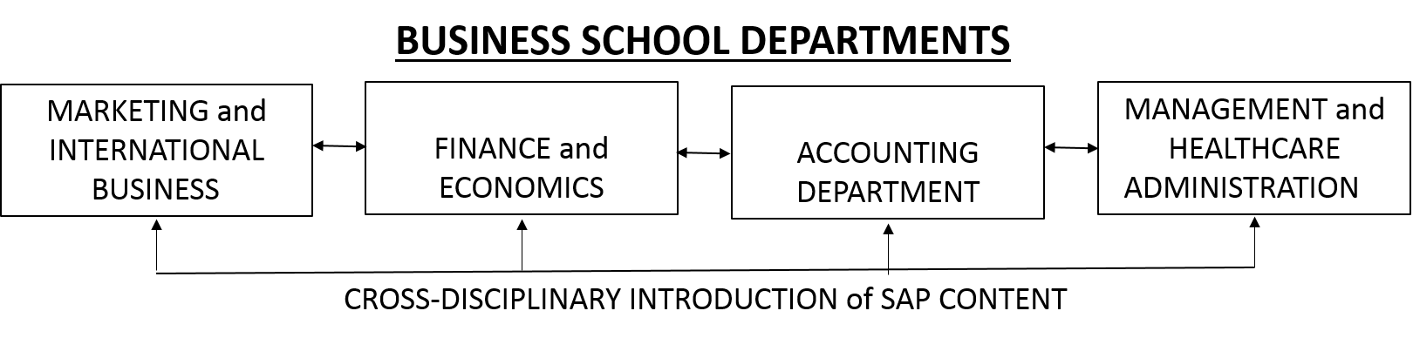

**Figure 1. Organizational Structure**

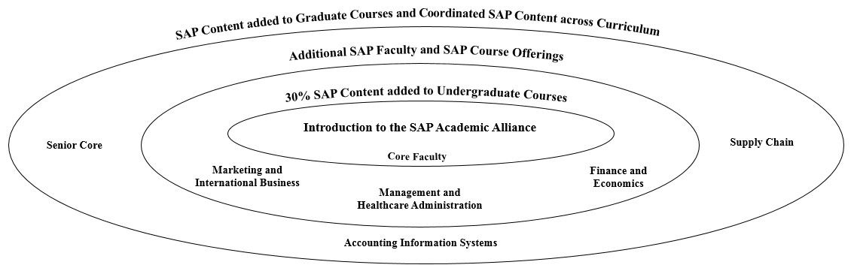

**Figure 2. SAP content and curriculum structure**

**Curriculum Design**

The integrated curriculum design starts with introducing data analytical tools and technologies into Marketing Research, Introduction the Healthcare (management courses), Financial Management and Supply Chain/distribution Management. The integrated approach allows students understand the interconnectedness of data analytics and how big data are the essence of the business. Further, students who participate in three SAP courses, that have at least 30% SAP content, earn a SAP participation certificate. This is an important draw for students as well as administrators looking for ways to stand out and grow programs. While not an industry certification, these certificates are valued by employers as they seek students who have been exposed to ERP systems and understand how individual decisions affect the whole and that a team-based effort, and the for organizational decision-making is essential for organizational financial success.

**Marketing Analytics*: An Integrated Curriculum Design***

SAP University Alliances is a global program with more than 3,100 member institutions in over 106 countries that aims to shape the future of higher education and expose business students to the latest SAP technologies (Anonymous, 2009). Central to our decision to join the SAP Academic Alliance was access to and training for ERPsim and Lumira, as well as access to instructor notes and experiences from other academics around the world. From our experience successful marketers should have analytical skills but also have the ability to look beyond the data per se and analyze trends/patterns that lead to successful marketing efforts (Levine, 2015; Mars, 2016). In marketing, analytical skills are essential. For instance, a study indicated that training for analytical abilities was most often accomplished by mentoring, team-based training, and self-study (Staff Writer, 2013). Importantly, the key to a successful analytical ability includes a proper mindset and understanding of methods rather than any specific software or mathematical skill.

Enterprise Resource Planning (ERP) deals with the fundamental business processes found in every enterprise. They include but, are not limited to, Customer Resource Management (CRM, Supply Chain Management (SCM), Supplier Relationship Management (SRM), Financials, Operations, Human Capital Management (HCM), Corporate Services, and Analytics (Missbach and Anderson, 2016). From our perspective, we sought a closer alignment between industry needs and classroom teaching (Charland, Léger, Cronan, and Robert, 2015). Everwijn et al. (1993) suggested that a business schools mission is how to make ensure that student knowledge acquired in the classroom gets transformed in to the ability to apply to real world situation (Everwijin, Boomers, and Knubben, 1993). As such, Competency Based Training (CBT) suggests a better way for students to manage their cognitive and social resources in actions that result in a certain level of performance. And, as part of the SAP Academic Initiative, the ERP Simulation (ERPsim) is a validated active learning method and is an accepted instructional approach effectively used for many years (Conroy, 2012; Leger et al., 2011; Léger et al., 2012; Loos et al., 2010; Pierre-Majorique, 2006).

SAP has been incorporated into marketing curriculum as an analytical tool. In marketing research, the students are encouraged to learn various SAP functions such as info cube/query, Lumira, and Predictive Analysis. The data are retrieved from Tyson and Sam’s Club. The first step to learn data analytics is creating data, as big data are often unstructured. The students are able to explore the data by creating queries that discover in critical business information, which can help with decision making.

Each computer in the lab installed with the SAP packages that allow the students to have real time experience during the class. In order to create a query, the students need to choose the variables they as rows, and columns. The system also allows students to add “free characteristics” that are variables available to be included in the query but not displayed in the crosstab. After creating the query, the students are able perform various analytics such as Lumira.

Lumira is a data visualization platform that captures patterns with multi-dimensional data generated by business information system such as query. When the dimension is small, we can use standard graphing techniques for visualization such as bar charts and scatter plots. When the number of dimensions is large, there are novel techniques such as geometric projection, and pixel orientated techniques. In the analysis, many non-marketing related variables (e.g., cost, overhead) and marketing related variables (e.g., advertising cost, product, and customer) can be chosen from the database, which requires knowledge in accounting, finance and management.

In addition, the students are required to learn predictive analysis. SAP predictive analytics is design to identify the most significant variables that contribute to the dependent variables. The platform allows researchers apply the model to predict consumers’ behavior such as the likelihood to claim an insurance claim.

The total training duration for the three techniques above is about six weeks in a Marketing course. During the training, each student was assigned a user ID and password to access the data. The instructor also provided hands on experience to facilitate the learning process. Many sample data sets were given to the students to practice each of the analysis. During the last two weeks of training, the students were assigned into a group with other four students to finish the final project. Each group is supposed to create their own query from Info Cube and then perform predictive analysis and Lumira. They are required write down the strategic plan after completing the analysis. Although this is a marketing plan, the students are often encouraged to include variables from finance and accounting.

The project is graded upon the richness of the data sets, Lumira and predictive analytics results, and strategic discussion. The proposed strategies are based upon the data analysis, which required demonstrated in both verbal and visual components. ….

**Discussion**

In the past, students might make decisions and reflect that they did their job without an understanding of a decision they made on other decision makers. For instance, students must set prices on products that reflect different sales performances based on location differences and completion from other teams. Pricing also affects transportation costs, storage costs, manufacturing costs, etc. Students must backtrack from financial reports to see the impact of decisions to change price or inventory levels on the bottom-line. What faculty discover is that students have not read or paid attention to the SAP lectures, how-to videos and that, once in the game, want to change everything at once to quickly improve their rapidly deteriorating bottom-line. Instructors must get students to stop and recognize that changing everything at once does not allow for predicative behavior and that they must be more cautious and fix some variables as they change others to see the impact of decisions. We see that students do not understand how the different areas of business are connected. While we as faculty do understand, using SAP ERPsim may require a review of marketing concepts in a healthcare class or the meaning of accounts receivable in an Information Technology course.

Faculty have a steep learning curve to master Sap ERPsim, Lumira, and SAP access applications. While there is considerable support in the form of sandboxes, instructor notes, training videos, training conferences, industry books, textbooks, etc., faculty must still invest considerable time and effort to master teaching materials. Further faculty must regularly attend conferences and training seminars (inperson or online) to stay current with SAP tools. SAP is now updating software 3-4 times a year, not including minor upgrades. The pace of industry development is inconsistent with an instructor who only teaches SAP once a year. Individual faculty should anticipate using SAP in as many courses as they can

(in person or online) to keep their skills and knowledge base current. Maintaining an effective program requires a substantial commitment of resources both in the short and long-term. Many of the technologies are industry based standards and approaches and may not always conform to what we would like to experience or do in the classroom. A clear advantage to ERPsim is that students are exposed to industry level software. ERPsim uses current production software to input data and create reports that students use to make typical business decisions in a controlled but realistic environment. While faculty may offer suggestions on how a team might proceed, the complexity of the simulation requires students to analyze their own data in real-time, one minute typically equates to one-day of business, so that students must use Excel, or Lumira to analyze their performance and make decisions. It is possible to create dashboards so that data can be presented in close to real-time.

Students and faculty are excited about the introduction of SAP into the curriculum. Positive feedback and support from local industry is positive and further support for initial and ongoing training is being made available. Instructors should be prepared for a steep learning curve and for there to be issues with the technology. Available teaching materials are readily available including how-to videos that students find helpful. The initial challenge for faculty is to explain basic SAP software procedures easily found on the students’ learning aids so that students can focus on using information derived from the ERP system to make better decisions. While ERP systems are very complex in their design, the actual presentation of business processes is very straight forward. Students quickly master the input of relevant business information but then struggle to unify what they have learned in other business disciplines/courses to make marketing, pricing, transportation, fees, etc. decisions that impact the operational bottom-line. Being able to analyze data for these decisions in a way that emphasizes crossdisciplinary understanding of the impacts of individual business decisions in where true learning takes place. This is also where the value to employers is also made known.

**References**

Alden, S. D., Laxton, R., Patzer, G. L., & Howard, L. 1991. Establishing Cross-Disciplinary Marketing Education. *Journal of Marketing Education*, 13, pp. 25-30.

Anonymous. 2009. SAP Launches Online Resource for Academic Community, PR Newswire. New York.

Atwong, C. T., Lange, I. L., Doak, L., & Aijo, T. S. 1996. How Collaborative Learning Spans the Globe. *Marketing News*, 30, 16-18.

Barber, C. S., Borin, N., Cerf, D. C., & Swartz, T. A. 2001. The role of marketing in an integrative business curriculum. *Journal of Marketing Education*, 23, pp. 240-248.

Bertolucci, J. 2013. Big Data: A Practical Defination, Information Week: UBM.

Brooke, Z. 2017. Data Science is the Latest In-Demand Skill Set for Marketing, American Marketing Association Website. Chicago: American Marketing Association.

Charland, P., Léger, P.-M., Cronan, T. P., & Robert, J. 2015. Developing and Assessing ERP Compentencies: Basic and Complex Knowledge. *The Journal of Computer Information Systems*, 56, pp. 31-39.

Chen, H., Chiang, R. H., & Storey, V. 2012. Business Intelligence and Analytics: From Big Data to Big Impact. *MIS Quarterly*, 36, pp. 1165-1188.

Conroy, G. 2012. Business simulations applied in support of ERP training. Unpublished D.M., University of Phoenix, Ann Arbor.

De Prato, G., & Simon, J. P. 2015. The next wave: "big data"? (*). *Communications & Strategies*, pp. 1539.

Elam, E. L. R., & Spotts, H. E. 2004. Achieving Marketing Curriculum Integration: A Live Case Study Approach. *Journal of Marketing Education*, 26, pp. 50-64.

Everwijin, S. E. M., Boomers, G. B. J., & Knubben, J. A. 1993. Ability-or competence-based education:

Bridging the gap between knowledge acquisition and ability to apply. *Higher Education*, 25, pp. 425-438.

Fleisher, C., & Hursky, R. 2016. Empowering insight: The role of collaboration in the evolution of intelligence practice. *South African Journal of Information Management*, 18, pp. 1-10.

Germann, F., Lilien, G. L., & Rangaswamy, A. 2013. Performance Implications Of Deploying Marketing Analytics. *International Journal of Research in Marketing*, 30, pp. 114-128.

Hauser, W. J. 2007. Marketing analytics: the evolution of marketing research in the twenty-first century. *Direct Marketing*, 1, pp. 38-54.

Hopkins, B., Evelson, B., Leaver, S., Moore, C., Cullen, A., Gilpin, M., & Cahill, M. 2011. Expand Your Digital Horizon with Big Data: Forester Research.

Kannan, P. K., Pope, B. K., & Jain, S. 2009. Pricing Digital Content Product Lines: A Model and Application for the National Academies Press. *Marketing Science*, 28, pp. 620-636.

Kiron, D., Kane, G. C., Palmer, D., Phillips, A. N., & Buckley, N. 2016. Aligning the Organization for its Digital Future. *MIT Sloan Management Review*, 58, pp. 0.

Kiron, D., Shockley, R., Kruschwitz, N., Finch, G., & Haydock, M. 2012. Analytics: The Widening Divide. *MIT Sloan Management Review*, 53, pp. 1-22.

Lamont, L. M., & Friedman, K. 1997. Meeting the Challenges to Undergraduate Marketing Education. *Journal of Marketing Education*, 19, pp. 17-30.

Leger, P.-M., Charland, P., Feldstein, H. D., Robert, J., Babin, G., & Lyle, D. 2011. Business Simulation Training inInformation Technology Education_Guidelines for New Approaches in IT Training. *Journal of Information Technology Education*, 10, pp. 39-53.

Léger, P.-M., Cronan, P., Charland, P., Pellerin, R., Babin, G., & Jacques, R. 2012. Authentic OM problem solving in an ERP context. *International Journal of Operations & Production Management*, 32, pp. 1375-1394.

Levine, A. 2015. Seven Skills You Need toLand a High-Paying Digital Marketing Job, MarketingProfs.

Lilien, G. L. 2011. Bridging The Academic–Practitioner Divide In Marketing Decision Models. *Journal of Marketing*, 75, pp. 196-210.

Loos, P., Riedl, R., Müller-putz, G. R., Vom Brocke, J., Davis, F. D., Banker, R. D., & Léger, P.-m. 2010. NeuroIS: Neuroscientific Approaches in the Investigation and Development of Information Systems. *Business & Information Systems Engineering*, 2, pp. 395-401.

Mars, M. 2016. 14 Marketing Skills to Add to Your Resume This Year, The WordStream Blog.

Missbach, M., & Anderson, G. 2016. Sams Teach Yourself SAP in 24 Hours (5th ed.): Pearson Education.

Peterson, R. M. 2001. Course Participation: An Active Learning Approach Employing Student Documentation. *Journal of Marketing Education*, 23, pp. 187-194.

Pharr, S., & Morris, L. J. 1997. The Fourth Generation Marketing Curriculumn: Meeting AACSB's Guidelines. *Journal of Marketing Education*, 19, pp. 31-43.

Pierre-Majorique, L. 2006. Using a Simulation Game Approach to Teach Enterprise Resource Planning Concepts. *Journal of Information Systems Education*, 17, pp. 441-447.

Ramocki, S. P. 1993. A New Model to Implement Marketing Education. *Marketing Education Review*, 3, pp. 18-23.

Sathi, A. 2014. Engaging Customers Using Big Data: How Marketing Analytics Are Transforming Business. New York: Palgrave Macmillan.

Sebjan, U., Bobek, S., & Tominc, P. 2016. Factors Influencing Attitudes Towards the Use of CRM's Analytical Tools in Organizations. *Organizacija*, 49, pp. 28-41.

Staff Writer, A. 2013. Companies See Need to Build Analytical Skills in Their Organizations: A Study of Analytical Skills in the Workforce: American Management Association.

Xu, Z., Frankwick, G. L., & Ramirez, E. 2016. Effects of Big Data Analytics and Traditional Marketing Analytics on New Product Success: A Knowledge Fusion Perspective. *Journal of Business Research*, 69, pp. 1562-1566.

Zoltners, A. A., & Sinha, P. 2005. The 2004 ISMS Practice Prize Winner—Sales Territory Design: Thirty Years of Modeling and Implementation. *Marketing Science*, 24, pp. 313-331.