Assignment 3 (Exercise 6.6)

Ross C. Hoyt

Oct. 14, 2019

**Assignment Objective:** Modify Exercise 5.3 (RotatingColorfulLetter.cpp) so that the letter rotates in response to user input, the letter rotates in three dimensions, and a matrix is used for transformations.

**How Achieved:** Before starting Exercise 6.6, I fixed the problems with discontinuities in my original H letter design by adding more vertices and triangles where needed. Then I completed Exercise 5.3 to better understand Chapter 5 material, duplicated that exercise’s application file (*RotatingColorfulLetter.cpp*) and renamed it to *Rotate3DLetter.cpp*.

Starting Exercise 6.6, I first decided to create more space in *Rotate3DLetter.cpp* source fileby moving the vertex and pixel shaders to separate *.shader* files in an internal project resources folder. I chose the *.shader* file extension because it provides some syntax highlighting in VS 2019. To read the shaders from files, the call to LinkProgramViaCode() in method InitShader() was changed to:

LinkProgramViaFile(“res/shaders/vertex.shader”, “res/shaders/pixel.shader”);

Then, I added code to the Vertex Shader to support the use of a matrix. The full Vertex Shader:

#version 130

in vec2 point;

in vec3 color;

out vec4 vColor;

uniform mat4 view;

void main() {

gl_Position = view * vec4(point, 0, 1);

vColor = vec4(color, 1);

}

Next, I added variables tracking mouse position in the application window and mouse clicks, and how the application should interpret those variables, to *Rotate3DLetter.cpp*:

float rotSpeed = .3f;

vec2 mouseDown(0, 0);

vec2 rotOld(0, 0), rotNew(0, 0);

Then I added callback methods to respond to mouse clicks and mouse movement:

void MouseButton(GLFWwindow* w, int butn, int action, int mods);

void MouseMove(GLFWwindow* w, double x, double y);

These callbacks were registered in *main* by adding lines:

glfwSetMouseButtonCallback(window, MouseButton);

glfwSetCursorPosCallback(window, MouseMove);

Then, I changed method Display()to compute the transformation matrix using routines in *VecMath.h*:

mat4 view = RotateY(rotNew.y) * RotateX(rotNew.x);

SetUniform(program, "view", view);

**Resulting images:**

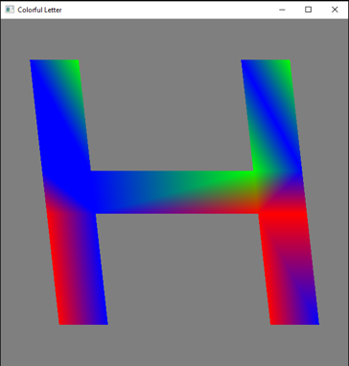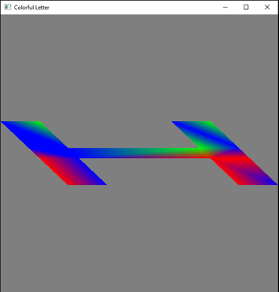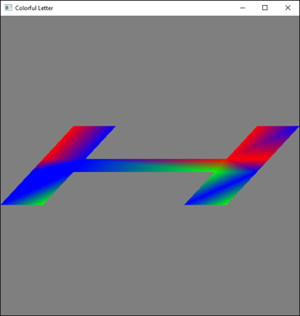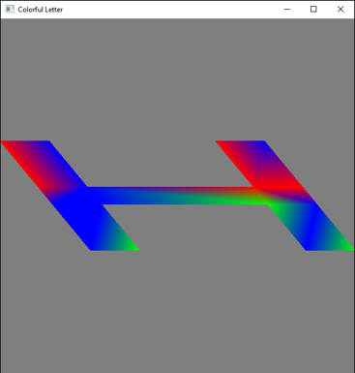

*[Different states of mouse-controlled 3D-rotation of model]*