Assignment 4 (Exercise 8.4)

Ross C. Hoyt

Oct. 22, 2019

**Assignment Objective:** Modify Exercise 7.6 (CubePersp.cpp) to use the Camera class.

**How Achieved:**

Before starting Exercise 8.4, I had to do Exercise 7.6, which also required me to add translation control and MouseWheel handling to exercise 6.4. After adding the Bonus 1: Move to 6.4, adding Bonus 2: Roll proved to be more challenge because interpreting the mouse-wheel data with GLFW was initially confusing.

I then copied my exercise 6.4 file and completed exercise 7.6: Window resize-ability, depth test in display, and other changes including computing modelview matrix and a small change to the vertex shader, were implemented in this exercise.

To enable mouse-wheel to control translation, the mouse-wheel handler (shown after later being moved to Camera.h) was changed to:

void MouseWheel(double xoffset, double yoffset) {

tranNew.z += (yoffset + xoffset) * .25; // scales mouse wheel values

}

*In retrospect, I would also multiply the added offsets by a lower decimal number than .25, because this does not currently allow a great deal of subtlety in the translation performed currently.*

Then, to complete exercise 8.4, I copied exercise 7.6 file and created Camera.h. CubePersp.cpp was then refactored functions and members related to Camera computation and state to Camera.h.

[Program images on next page]

**Resulting images:**

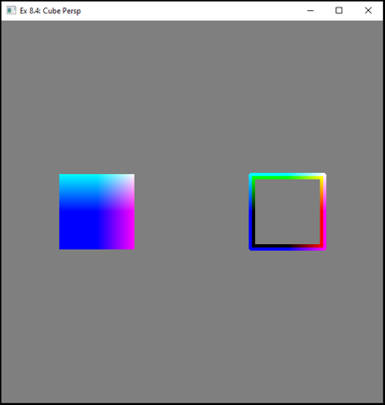 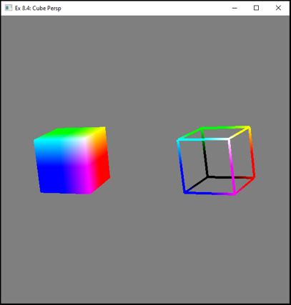 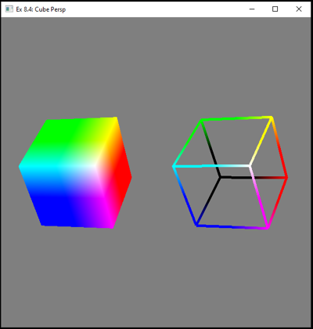

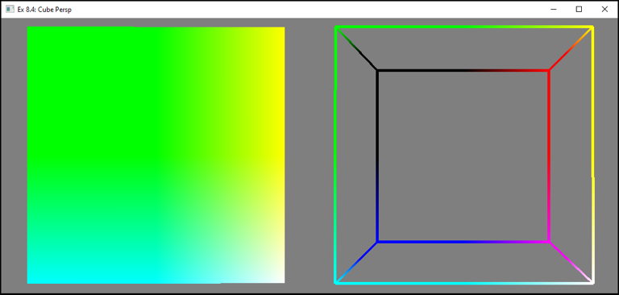

*[Clockwise: Start point of application, mouse controlled rotation, mouse-wheel controlled translation,*

*resized window with more translation ]*