Ross Hoyt and Chris Downing

Assignment 5

Nov. 12, 2019

**Assignment Objective:** To recreate the early work of Gouraud by digitizing a human face.

**How achieved:** To achieve this objective, we first captured front and side (profile) photos after replicating the ‘lined face’ approach shown by Sylvia Gouraud. The front photo had its points numbered, and labelled, and then each point was measured to the closest pixel value. Then, the same point numberings were given to each corresponding point in the side angle photo. These were also measured. The resulting photos are below:

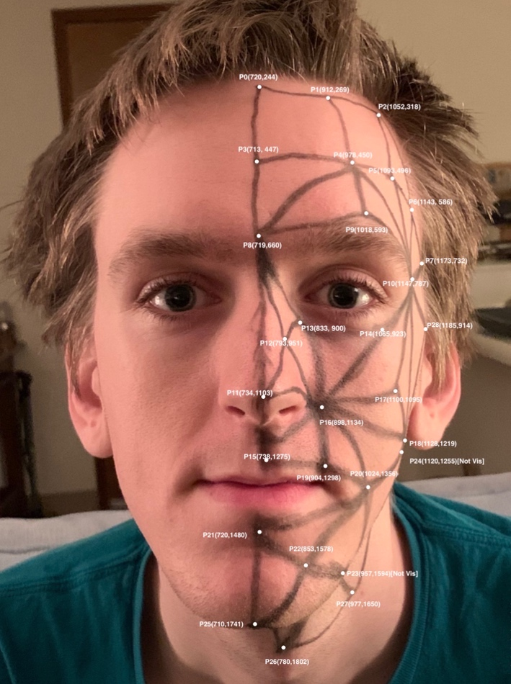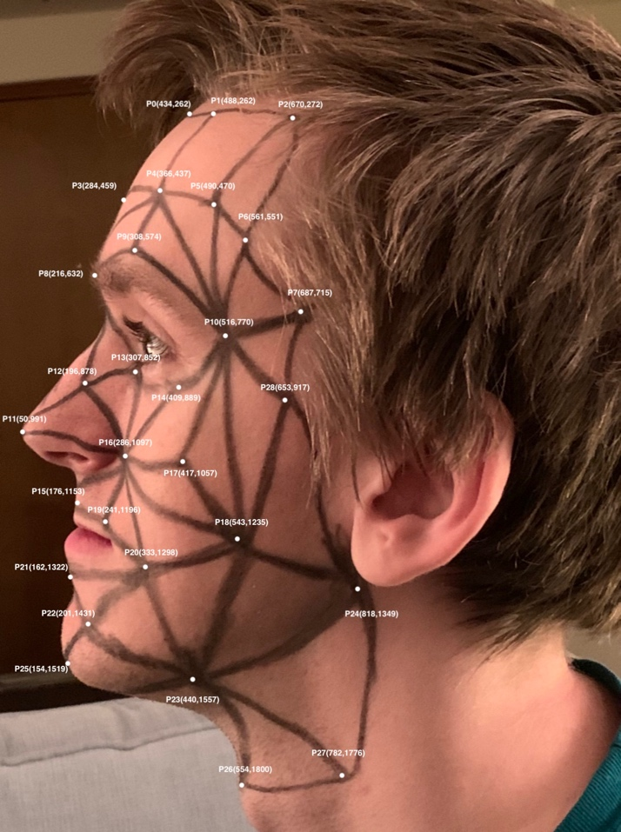

These vertices were placed into CubeColourGouraud.cpp, renamed to FacePhong.cpp. The code was adapted to use the points and triangles mapped above. It was also changed to implement smooth not faceted shading and implement Phong lighting and shading.

**Results:**

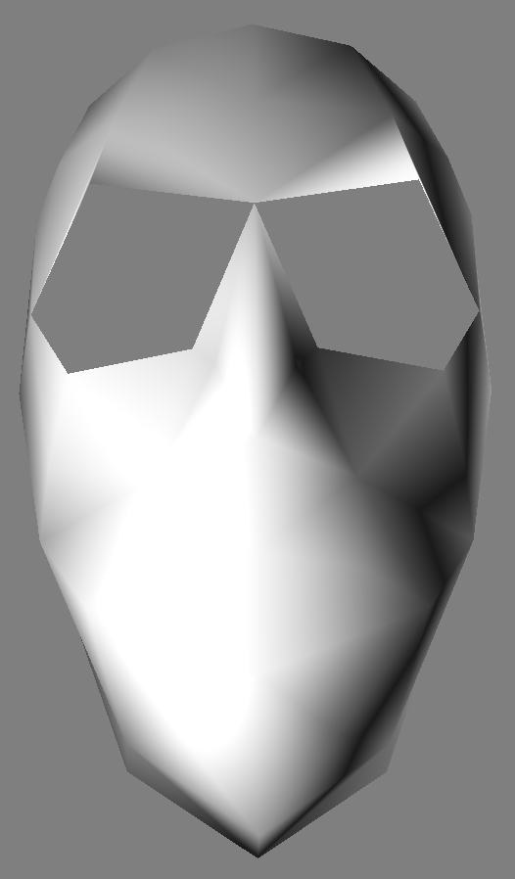 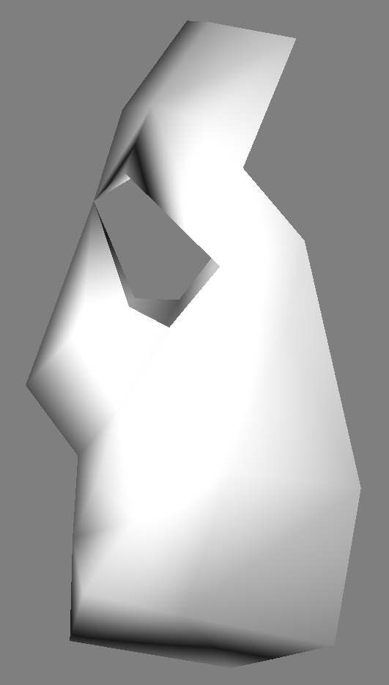

***(Above) Resulting front and side views***