APPENDIX1

**Example of a  
Laboratory Test Report**

**MATERIALS ENGINEERING LABORATORY REPORT**

**REPORT NO. 99073**

|  |  |
| --- | --- |
| TO: | P. Buch, Polymer Processing Division, 2/35/KP |
| TITLE: | Evaluation of Tenter rail materials |
| AUTHOR: | K.G. Budinski, KP Materials Engineering Laboratoy |
| CONTRIBUTORS: | M. Kohler, C. Mroczek |

## **Problem:**

he Polymer Processing Division requested that Maktrials Engineering Laboratory to evaluate the friction and wear characteristics of a new phenolic material as a candidate for improved wear life on tenter rails in polyester sheet manufacturing machines. Hardened chain links (60 HRC) slide against these rails at high sliding speeds (1 to 3 m/s) and at elevated temperatures (up to 260 C). The current rail material is an aramid-reinforced phenolic that occasionally fails producing wear debris that may contaminate the product.The purpose of this study is to determine if a new grade of carbon-fiber reinforced phenolic can provide improved serviceability over the present rail material.The objective is to obtain a rail material that does not fail in service.

## **Investigation:**

Two samples (2 cm x 6 cm x 100 cm) were submitted for wear testing; one was identified as sample 1 (current B317 phenolic), the other as sample 2 (new rail material). The test plan was to perform a block-on-ring wear test on each material and assess the wear on both members. The blocks would be made from the test plastics and the rings would behardened steel. The tester is shown schematically in Fig. Al.1. The test procedure used was ASTM G77 with the following testing parameters:normal force - 44.48Nsliding distance - 10,000 msliding velocity - 1 m/splastic temperature - 120 °Cring roughness - 0.1 umThree blocks were made from each plastic: matching 4620 rings were fabricated and hardened to 60 HRC. The blocks were machined so that an as-molded surface was the test surface.Friction was continuously recorded throughout the test. Evaluation of wear behavior included comparison of running friction, volume loss from the test blocks and volume loss from the test rings. Three replicates were tested from each material. Profilometry was used to measure wear scar volumes.

## **Results:**

The wear test results which are presented in Fig. Al.2 show that there is not a statistically significant difference in the wear behavior of the two materials. The average wear of the new rail material was slightly lower. Neither material produced measurable damage to the hardened steel counterface. The friction test results (Fig. A1.3) show similar results.There is not a significant difference throughout the test.

## **Conclusions:**

The new rail material candidate did not have significant improved friction or wear characteristics over the current rail material.

## **Recomendations:**

If the new rail material is comparable in cost to the present rail material, we recommend production trial of a length on 307 machines where most failures occurred. The slight improvement detected in our laboratory tests may become more significant under active service conditions.

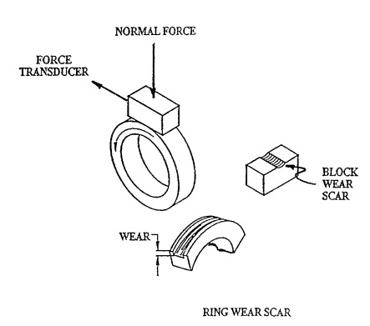

**Fig. A1.1** Schematic of block-on-ring wear test

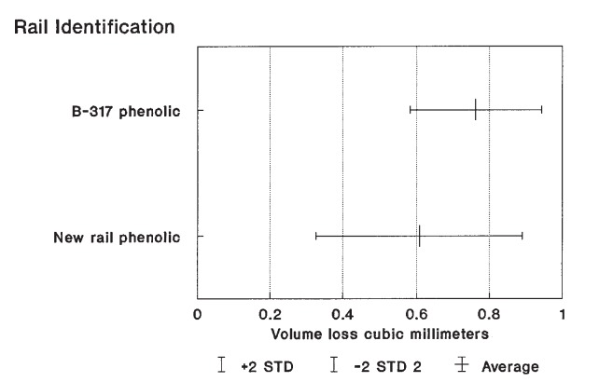

**Fig. A1.2** Average volume loss for B-317 phenolic and new phenolic. Error bars are for ± 2 standard deviations (STD).

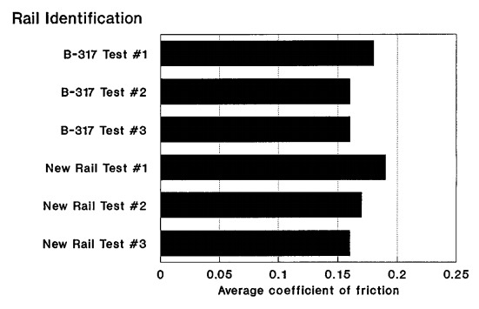

**Fig. A1.3** Coefficient of friction with steel for the current rail phenolic (B-317) and a new phenolic. Test was performed on a LFW-1 block-on-ring tester with a 4620 steel ring with the following conditions: normal force of 44.48 N, ring rotational speed of 1 m/s, 10,000 meters of sliding.