Roshan,

The reason behind for why a special schema is required to be imported for C/C# clients, is that most LDAP servers don’t have the schema for storing non-Java object.

As in the case of OpenLDAP, it comes with the Java schema. Without importing the additional schema you can bind the EMS factory/queue/topic using Java. And the binding will look like this:
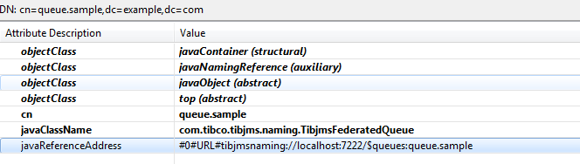

As you can see, the javaContainer/javaNamingReference/javaObject are all native object Classes in openLDAP. Java JNDI API is also aware of how the objects are stored using Java schema in LDAP server, hence it can convert back to Java object when do a lookup.

So here comes the question, how should we retrieve administered objects from LDAP using C# if object is stored using Java schema (because there is no C# schema)? Surely we cannot store it using Java schema. It’s naturally that another new schema should be created for such purpose.

The tibemsSchema.ldif defines an additional objectClass which will hold the object information in a XML document. Internally, EMS JNDI/LDAP API is respecting the schema and serialize the object to XML doc when binding to LDAP, and de-serialize from XML to EMS object in case of lookup.

And here is how the binding looks like when the schema is imported:

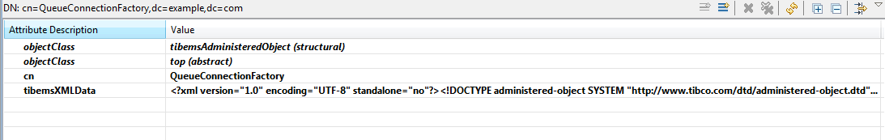

As for EMS Java API, it works properly with/without the schema. Importing schema or not only change the representation on LDAP server (of how the object is stored). When you do a lookup to retrieve the object in java, they are actually the same object.

