

SCS DTACC Messaging Architecture

TIBCO EMS Transport Channel
for

Windows Communication Foundation

Version | 1.1
Date | Aug 21st, 2009
Author | SCS DTACC Messaging Group
Status | Draft Version

Revision History

Version | Date | Author | Description
1.0 | Aug 21st, 2009 | Roshan D’Mello | Original draft version of document.
1.1 | Aug 21st, 2009 | Roshan D'Mello | Incorporated performance results at the WCF Service and Channel Layer

Table of Contents

1 Introduction 1
2 Message Exchange Pattern 1
2.1 Request-Reply 1
2.1.1 Echo Service – Create WCF contract with an interface 1
2.1.2 Echo Service – Implement a WCF Service Contract 2
2.1.3 Echo Service – Host and run a Basic WCF Service 2
2.1.4 Echo Client – Create a WCF Client 3
2.1.5 Echo Client – Configure a Basic WCF Client 4
2.1.6 Echo Client – Configure a Basic WCF Client 4
2.1.7 Configure Echo Service and Client to use TemsTransport 4
2.1.8 Cleanup Tasks 8
2.2 Datagram 8
3 Performance 9

Introduction
Microsoft Windows Communication Foundation (WCF) provides a framework for extending transport channels beyond the standard provided by WCF, i.e., HTTP, TCP, named pipes, and MSMQ. The TIBCO EMS Transport Channel for WCF allows you to use TIBCO Enterprise Message Service (EMS) as a transport channel for Windows Communication Foundation (WCF) services.
The TIBCO EMS Transport Channel for WCF ("TemsTransport channel") allows you to send and receive messages through the TIBCO EMS Server – they can be sent to either a queue or a topic on the server. Note that although WCF itself is Windows based, the TIBCO EMS Server can be running on any platform supported by the TIBCO EMS Server. To use the TemsTransport channel, you will need to create a custom binding that specifies TemsTransport for the transport channel in your channel stack. The TemsTransport channel is configurable on both the client and host (service) ends.
The purpose of this document is to detail step-by-step configuration of TIBCO EMS as a transport channel for Windows Communication Foundation (WCF). This is described by implementing a C#, Echo Service and Echo Client application to demonstrate 3 Message Exchange Patterns (MEP): request-reply, datagram and full duplex.
This document is not intended to be a WCF/EMS primer. Please refer to the appropriate documentation for in-depth understanding of these technologies.

Message Exchange Pattern

Request-Reply
The request-reply MEP demonstrates the Echo Client application requesting the Echo Service application to reply back the requested message. Following are the first of six tasks required to create a basic WCF Echo Service and Echo Client

Echo Service – Create WCF contract with an interface
- Open Visual Studio 2008
- Create a new console application project. Click the File menu and select New, Project. In the New Project dialog, select Visual C#, and choose the Console Application template, and name it Service
- For the C# project Visual Studio creates a file called Program.cs. Re-name this file to Service.cs by right-clicking in the Solution Explorer and choosing “Rename”. The Service class will contain an empty method called Main(). This method is required for console application projects to build correctly, so you can safely leave them in the project
- Change the default Service namespace to CreditSuisse.wcfReqRep.Samples. To do this, right-click the project in the Solution Explorer and select Properties. Make sure that the Application tab on the left side of the Properties dialog is selected. Type CreditSuisse.wcfReqRep.Samples in the edit box labeled Default Namespace. Click the File menu and select Save All to save your changes
- Change the namespace in the generated Program.cs file to CreditSuisse.wcfReqRep.Samples as shown in the following example
namespace CreditSuisse.wcfReqRep.Samples
{
class Service
{
static void Main(string[] args)
{
}
}

- Add a reference to System.ServiceModel.dll to the project:
    - In the Solution Explorer, right-click the References folder under the project folder and choose Add Reference
    - Select the .NET tab in the Add Reference dialog and scroll down until you see System.ServiceModel, select it, and click OK
- Add a using statement for the System.ServiceModel namespace.

using System.ServiceModel;

- Define a new interface called IEchoService and apply the ServiceContract attribute to the interface with a Namespace value of http://CreditSuisse.wcfReqRep.Samples. Specifying the namespace explicitly is a best practice because it prevents the default namespace value from being added to the contract name
[ServiceContract(Namespace="http://CreditSuisse.wcfReqRep.Samples")]
public interface IEchoService

- Declare a method for each of the operations the IEchoService contract exposes (EchoRequest) with the interface and apply the OperationContract attribute to each method that you want to expose as part of the public WCF contract
[OperationContract]
string EchoRequest(string req);

Echo Service – Implement a WCF Service Contract
- Create a new class called EchoService in the same file where you defined the IEchoService interface. The EchoService implements the IEchoService interface
public class EchoService : IEchoService

- Implement each method defined in the IEchoService interface within the EchoService class
public string EchoRequest(string req)
{
return "Reply: " + req;
}

Echo Service – Host and run a Basic WCF Service
The procedure to run a basic WCF Service consists of the following steps:

- Create a base address for the service – Create a URI instance for the base address of the service. This URI specifies the HTTP scheme, your local machine, port number 8000, and the path wcfReqRep/Service to the service that was specified for the namespace of the service in the service contract
Uri baseAddress = new Uri("http://localhost:8000/wcfReqRep/Service");

- Create a service host for the service – Add a using statement for System.ServiceModel.Description and System.ServiceModel.Channels namespace. This line of code should be placed at the top of the Service.cs file with the rest of the using statements
using System.ServiceModel.Channels;
using System.ServiceModel.Description;

Create a new ServiceHost instance to host the service. You must specify the type that implements the service contract and the base address. For this sample the base address is http://localhost:8000/wcfReqRep/Service and EchoService is the type that implements the service contract
ServiceHost serviceHost = new ServiceHost(typeof(EchoService), baseAddress);

Add an endpoint that exposes the service. To do this, you must specify the contract that the endpoint is exposing, a binding and the address for the endpoint. For this sample, specify IEchoService as the contract, wsHttpBinding as the binding and EchoService as the address. The endpoint address in this case is a relative address. The full address for the endpoint is the combination of the base address and the endpoint address. In this case the full address is http://localhost:8000/wcfReqRep/Service/EchoService
serviceHost.AddServiceEndpoint(typeof(IEchoService),
new WSHttpBinding(),
"EchoService"); // Relative address

- Enable metadata exchange – To do this, add a service metadata behavior. First create a ServiceMetadataBehavior instance, set the HttpGetEnabled property to true and then add the new behavior to the service.
ServiceMetadataBehavior smb = new ServiceMetadataBehavior();
serviceHost.Description.Behaviors.Add(smb);
smb.HttpGetEnabled = true;

- Open the Service host and wait for incoming messages. When the user presses the ENTER key, close the ServiceHost
serviceHost.Open();

Console.WriteLine("The service is ready.");
Console.WriteLine("Press <ENTER> to terminate service.");
Console.WriteLine();
Console.ReadLine();

serviceHost.Close();

To verify the service.exe is working:
- Run the service.exe from inside Visual studio
- Open Internet Explorer and browse to the service’s debug page at http://localhost:8000/wcfReqRep/Service/EchoService

Echo Client – Create a WCF Client
This section describes how to retrieve metadata from a WCF service and use it to create a WCF proxy that can access the service. This task is completed by using the Service Model Metadata Utility tool (svcutil.exe) provided by WCF. This tool obtains the metadata from the service and generates a managed source code file for a proxy in the language you choose – in this case C#. In addition to creating the client proxy, the tool also create the configuration file for the client that enables the client application to connect to the service at one of its endpoints. To create a WCF client do the following:
- Create a new project within the current solution for the client in by doing the following steps:
    - In Solution Explorer (on the upper right) within the same solution that contains the service, right-click the current solution (not the project), and select Add, and then New Project
    - In the Add New Project dialog, select Visual C# and choose the Console Application template and name it Client and then Click OK
- Add a reference to the System.ServiceModel.dll for the project
    - Right-click the References folder under the Client project in the Solution Explorer and select Add Reference
    - Select the Recent tab and select System.ServiceModel.dll from the list box and click OK. Because you already added a reference to this assembly in the first step of this tutotial, it is now listed in the Recent tab.
- Re-name Program.cs as Client.cs (as described in the case of the Services project above)
- Add a using statement for the System.ServiceModel.dll namespace in Client.cs file
using System.ServiceModel;

- Start the service created in the previous steps.
- Run the Service Model Metadata Utility tool (SvcUtil.exe) with the appropriate switches to create the client code and a configuration file by doing the following steps:
    - Start a Windows SDK console session by selecting the CMD Shell under the Microsoft Windows SDK entry in the Start menu
    - Navigate to the directory where you want to place the client code
    - Use the command-line tool Service Model Metadata Utility Tool (SvcUtil.exe) with the appropriate switches to create the client code. The following example generates a code file and a configuration file for the service
C:\Roshan\wcfOneWay\Client>svcutil.exe /language:cs /out:generatedProxy.cs /config:app.config http://localhost:8000/wcfOneWay/Service
- Add the generated proxy to the client in Visual Studio, right-click the client project in Solution Explorer and select Add and then Existing Item. Select the generatedProxy file generated in the preceding step

Echo Client – Configure a Basic WCF Client
- Add the app.config configuration file generated in the previous procedure to the client project in the Visual Studio. Right-click the client project in Solution Explorer, select Add and then Existing Item. Next select the app.config configuration file. Click OK

Echo Client – Configure a Basic WCF Client
Once a WCF proxy has been created and configured, a client instance can be created and the client application can be compiled and used to communicate with the WCF service. This procedure does three things
- Create a WCF client – Create an EndpointAddress instance for the base address of the service you are going to call and then create an WCF Client object
EndpointAddress epAddress = new EndpointAddress
("http://localhost:8000/wcfReqRep/Service/EchoService");
EchoServiceClient Client = new EchoServiceClient(new WSHttpBinding(), epAddress);

- Call the client operations from within the Client
Client.EchoRequest("Majama")

- Call Close on the WCF client
Client.Close()

Configure Echo Service and Client to use TemsTransport
As of now the Echo Client application uses the HTTP channel to communicate with the Echo Service application. Configuring your Echo Service and Echo Client application to use the TemsTransport channel can be accomplished using the Microsoft Service Configuration Editor. Three primary tasks involved in adding the TemsTransport channel to the Echo Service and Echo Client project are as follows:
- Creating a binding element extension – this is an extension to the standard WCF binding elements
- Creating a custom binding – this defines the communication elements: transport channel, message encoding, MEP, security and reliability
- Creating endpoints – this defines the client and service endpoints and the service contract

Configuring the Echo Service to use TemsTransport:

- Add reference to TIBCO.EMS.dll and TIBCO.EMS.WCF.dll. Add a using statement for the TIBCO.EMS and com.tibco.wcf.ems namespace in Service.cs file
using com.tibco.wcf.ems;
using TIBCO.EMS;

- Open the Echo Service app.config file with the Service Configuration Editor. To do this, follow these steps:
    - In the Solution Explorer, right-click on app.config and select Open With…
Note that the first time you perform these steps, you will need to add the Service Configuration Editor to the Open With dialog. To do this, click on the Add button, then use the browse button the right of the Program name field to locate the utility. It can be found at the following location:
<Program Files>\Microsoft SDKs\Windows\v6.0a\bin\SvcConfigEditor.exe
Enter the desired name in the Friendly name field, e.g., “SrvConfigEditor”, then click OK
    - Select the Service Configuration Editor in the Open With dialog, then click OK
The Microsoft Service Configuration Editor dialog is displayed
    - In the Configuration tree on the left side of the dialog, expand Advanced > Extensions, then click on binding element extensions. A list of the available binding element extensions appear on the right side of the dialog:

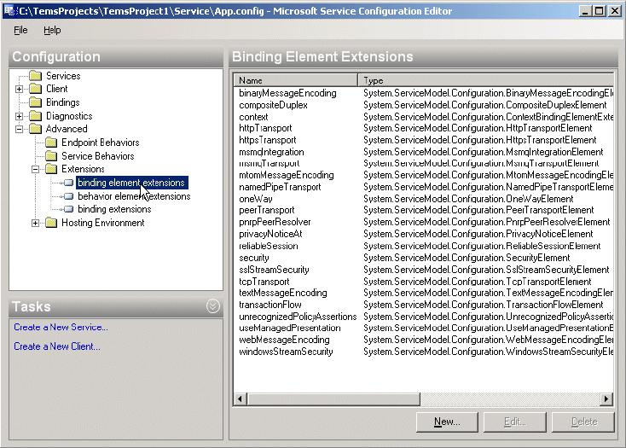
    - Click the New button. The Extension Configuration Element Editor dialog is displayed. This dialog allows you to add a new binding element extension to the list

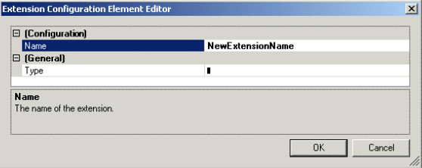

    - Add a new binding element extension by following these steps:
      - In the Name field, enter "TemsTransport"
      - Click in the Type field, then click on the browse button that appears on the right side of the field. The Binding Element Extension Type Browser dialog is displayed.
      - Click on the GAC icon in the section on the left side of the dialog. (Note - The TIBCO.EMS.WCF.dll library is automatically installed in the Global Assembly Cache (GAC) when TIBCO EMS Transport Channel for WCF is installed.)
      - From the list of assemblies that appears on the right, locate and select "TIBCO.EMS.WCF", then click Open
      - Click on the "com.tibco.wcf.tems.TemsTransportExtensionElement" selection that appears, then click Open
      - Click OK on the Extension Configuration Element Editor dialog. "TemsTransport" will now appear in the list of available binding element extensions
    - Select Save from the File menu
    - Click on the Bindings node on the left side of the Service Configuration Editor dialog
    - Click on the New Binding Configuration link. The Create a New Binding dialog is displayed
    - Select “customBinding”, then click OK.
The following is displayed, which allows you to specify the binding elements in the custom binding. These will be used to build the channel stack:

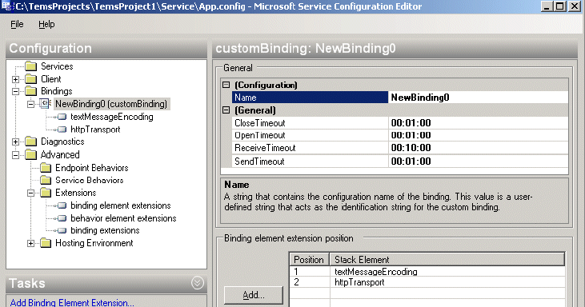
    - In the Name field, enter "TemsBinding". Notice that, by default, two binding elements are specified for the new custom binding: textMessageEncoding and httpTransport. We need to remove httpTransport
    - In the Binding element extension position section, remove httpTransport by selecting it and clicking the Remove button. We will now replace those binding elements with the ones we want in our custom binding.
    - At this point the editor requires that you select File > Save again, otherwise you will get an error message telling you that the extension is not registered in the extension collection ’bindingElementExtensions’.
    - Click the Add button. The Adding Binding Element Extension Sections dialog is displayed.
    - Select "TemsTransport", then click Add
The binding element stack should now appear as follows:

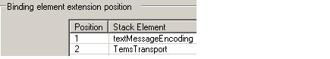

    - Click on the Services node on the left side of the Service Configuration Editor dialog.
    - Click on the “Create a New Service” link. The New Service Element Wizard dialog is displayed
    - Click the Browse button to the right of the Service type field.
    - Locate and select the service file from your service’s \bin\Debug folder, then click Open.
NOTE: The service file is created by generating an Assembly of the Echo Service application. To do this set the application type from “Console Application” to “Assembly”. Copy the Service.dll file to a directory where it can be retrieved. Revert the application type back to “Console Application”
The name of the service implementation will now appear in the Type Browser Window
    - Select the service implementation and click Open
    - Click Next on the New Service Element Wizard dialog. The next window will contain a Contract field that is prefilled with the name of the service contract for the service
    - Click Next.
    - Select the Existing binding configuration radio button
    - From the Binding configuration field drop-down list, select "TemsBinding, customBinding", then click Next
    - Enter the address of the endpoint in the Address field, then click Next. This is the address to the service. It is composed of the following: net.tems://<host>:<port>/<path>
For example: net.tems://localhost:7222/queue/queue.sample
    - Verify the settings, then click Finish
    - Save your changes: select File > Save
    - Change the name of the Service endpoint to EchoService_Endpoint
NOTE: The Service Configuration Editor can be used to modify any of the available configuration parameters.

Configuring the Echo Client to use TemsTransport:
The configuration steps for the Echo Client application is identical to that of the Echo Service application excepting for “Creating a New Client” link instead of “Creating a New Service” link. The steps are as follows:
- Click on the Client node on the left side of the Service Configuration Editor dialog
- Click on the Create a New Client link
- The New Client Element Wizard dialog is displayed
- Ensure that the From service config radio button is selected, then click the Browse button to the right of the Config file field
- Locate and select the App.config file from your service project (not from the client project), then click Open
- The wizard will use the service’s App.config file to generate a configuration for the client
- Click Next on the New Client Element Wizard dialog
- The next dialog contains a Service endpoint field that is prefilled with the endpoint for the service
- Click Next. The next dialog asks for a name for your client configuration
- In the Name field, enter "AccessEchoService", then click Next
- Verify the settings, then click Finish
- Save your changes: select File > Save and exit the editor

Cleanup Tasks
In the client endpoint specification, the contract attribute value will be a fully qualified contract name. Edit the contract name so that it is not fully qualified. For example: contract=”IEchoService”
Because the Service Configuration Editor was used to configure the endpoint, it automatically included an <Identity> element in app.config. The TemsTransport channel does not use this element. Therefore, unless you are working with certificates, this element can be removed from the client’s app.config. Delete the entire <identity> element from under the <endpoint> element

Datagram
The only code change that you would need to make is the following:
Echo Service application:
- Modify the IEchoService interface to declare a new function that does not return any value
[OperationContract(IsOneWay = true)]
void NoEchoRequest(string req);

- Implement the EchoService implementation class
public void NoEchoRequest(string req)
{
// do nothing
}

Echo Client application:
IDisposable proxy = new EchoServiceClient("AccessEchoService");
System.ServiceModel.Description.ServiceEndpoint endpoint =
((EchoServiceClient)proxy).Endpoint;
System.ServiceModel.Channels.BindingElementCollection elements =
((CustomBinding)endpoint.Binding).Elements;
TemsTransportBindingElement bindingElement =
(TemsTransportBindingElement)elements[elements.Count - 1];
((EchoServiceClient)proxy).Open();

System.Console.Out.WriteLine("Before sending messages Time : " +
(startTime = (DateTime.Now.Ticks - 621355968000000000) / 10000));

for (int iLoop = 0; iLoop < count; iLoop++)
{
// Step 2 Call the service operation
((EchoServiceClient)proxy).EchoRequest("No Echo Message…");
}

Performance
The Datagram MEP was used to test and determine the performance differential of the WCF application vs. a native C# EMS application. The results illustrate a base-line test scenario with details tabulated below:

Destination Type | Message Size | EMS Transport Channel for WCF (Service Layer) |  | EMS Transport Channel for WCF (Channel Layer) |  | Native C# EMS API
Destination Type | Message Size | Msg-Rate  (RELIABLE) | Msg-Rate  (NO_ACK) | Msg-Rate  (RELIABLE) | Msg-Rate  (NO_ACK) | Msg-Rate  (RELIABLE) | Msg-Rate  (NO_ACK)
Q | 500 bytes | 8,816 | 4,238 | 14,880 | 10,576 | 17,223 | 12,324
T | 500 bytes | 8,840 | 5,071 | 15,420 | 14,880 | 25,799 | 25,467

It is evident that the EMS Transport Channel for WCF (Service Layer) contributes to a huge overhead over the Native C# EMS API for the following potential reasons:
- Service Layer - For the test under consideration WCF introduces a 445 bytes WCF specific envelope around the payload
- Inherent overhead within the WCF layer itself in terms of the re-use of the Messages

