How efficient are models based on microarray data combined with features of age and gender at predicting clinical endpoints?

Abstract

This report investigates the effectiveness of predictive models that integrate microarray gene expression data with select clinical features, including age and gender, to forecast four clinical outcomes: INSS stage, High Risk, Progression of Disease, and Death from Disease. By employing both unsupervised and supervised machine learning techniques, we identified significant features that influence the prediction process and then finally assessed the performance of three various models. The initial analyses demonstrated robust predictive capabilities for certain outcomes, particularly High Risk, while revealing challenges related to class imbalance, especially concerning the INSS stages (2a, 2b and 3). Attempts were made to address Age as a confounding factor, however these specific categorisations were not a part of the final modeling. To enhance model accuracy and generalizability, we implemented hyperparameter tuning and class rebalancing strategies, aiming to address these discrepancies and improve overall predictive performance.

Introduction

Predicting clinical outcomes using genetic and clinical data is crucial for advancing early disease detection and personalized treatment strategies. The study by Zhang et al. in 2015 emphasizes the comparative strengths of RNA-seq and microarray data in predicting clinical endpoints in neuroblastoma, revealing the potential of these methods to enhance predictive modeling. Building on this work, this research focuses on the predictive power of microarray data combined with age and gender to forecast four clinical endpoints. We employ unsupervised learning to identify meaningful age clusters, followed by supervised learning to develop predictive models.

Aim of Study

This study aims to determine the most suitable predictive model for assessing four clinical outcomes based on the integration of age, gender, and microarray data. By evaluating the performance of different models, including Random Forest, Support Vector Machine, and XGBoost, we seek to identify which model most effectively predicts these outcomes, enhancing our understanding of the relationships between clinical features and genetic profiles.

Methodology

Exploratory Data Analysis
The objective of the exploratory data analysis was to understand the distribution and relationships between Age and Gender with the clinical features. The analysis included visualizing the distribution of Age and Gender to identify patterns and potential biases . Additionally, I examined the relationships of these variables with INSS Stage, Risk, Death, and Progression to uncover insights that could inform the predictive modeling efforts (figures 1.1 to 1.4). By understanding these relationships, I aimed to enhance the robustness and interpretability of the models.

Data Preparation
To ensure robust analysis, I first addressed missing values in the dataset. Specifically, I checked for missing values in Age and Gender, confirming the absence of missing clinical features. However, the microarray data contained missing values, which were managed by removing columns with excessive missing data and employing KNN imputation for the remaining values. Next, categorical variables such as Gender and High Risk were converted to numerical values (e.g., 0 for Male, 1 for Female) to facilitate modeling. I then merged the transposed microarray data with the clinical features, allowing for a comprehensive dataset for analysis. To visualize the high-dimensional data, I melted the data frame to integrate it with clinical features effectively. For normalization, log transformation was applied to the gene expression values to stabilize variance. Outliers were identified using Z-scores, with those exceeding a predefined threshold removed from the dataset to enhance model performance.

Unsupervised Learning: Clustering

To explore patient demographics, I applied Principal Component Analysis (PCA) followed by t-distributed Stochastic Neighbor Embedding (t-SNE) and K-Means clustering based on Age and Gender(figures 1.5 to 1.9). This analysis pathway led to five hierarchical distinct clusters determining various age ranges of patients (Figure 1.12). These clusters were then integrated as categorical features in the supervised learning models, from ‘Age’ to ‘age_group’. The non-linear grouping decision was selected to allow the models to recognize distinct age effects on clinical outcomes, potentially improving performance metrics such as recall and F1-score, particularly in predicting outcomes that relate to age. However due to time constraints I was not fully able to implement this nonlinear grouping in the supervised learning.

Supervised Learning Approach
To predict the clinical endpoints, I selected three models: Random Forest (RF), Support Vector Machine (SVM), and XGBoost. These models were chosen for their ability to handle complex relationships within the data and their effectiveness in classification tasks. All models were trained with a 70/30 train-test split.
Each clinical endpoint was treated as a classification problem, with performance assessed using accuracy, recall, F1-score metrics and for some of the INSS Stage classes: ROC-AUC metrics.

Random Forest: I constructed a Multi-Output Random Forest Classifier to predict multiple outcomes simultaneously.
Support Vector Machine (SVM): This model was implemented to maximize the margin between classes, allowing it to effectively classify high-dimensional data. Its flexibility in handling different kernel functions enhances its adaptability to complex datasets.
XGBoost: Leveraging gradient boosting, XGBoost was employed for its efficiency and performance in classification problems. Its ability to handle missing data and regularization features makes it a powerful choice for predicting clinical outcomes.

Model Optimization
To optimize the models, I employed hyperparameter tuning and class balancing techniques. For Random Forest and SVM, I utilized GridSearch Cross Validation and RandomizedSearchCV (to some extent) to identify the best hyperparameters, including the number of estimators and depth for Random Forest and the C and gamma values for SVM. This iterative process helped mitigate the risk of overfitting and provided a more reliable assessment of model performance across various clinical endpoints.
Additionally,I applied SMOTE to address class imbalance, however this did not apply to the INSS stages, where certain classes had significantly fewer samples. These optimization efforts aimed to enhance the predictive performance of the models for the clinical outcomes.

Results

Exploratory Data Analysis
Figure 1.1 Age Distribution
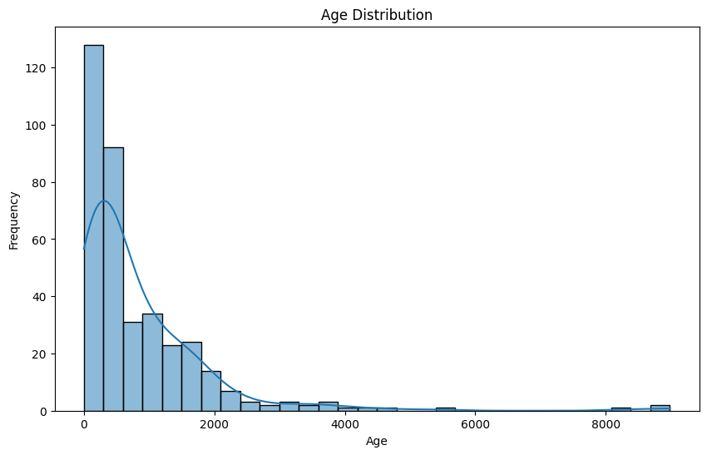

Table 1.1 Frequency table for age categories

Age Category (years) | Frequency
0-1 | 147
1-2 | 86
2-3 | 46
3-4 | 26
4-5 | 30
5-6 | 14
6-7 | 6
7-8 | 3
8-9 | 3
9-10 | 3
10-11 | 2
11-12 | 1
12-13 | 1
13-14 | 1
14-15 | 1
15-22 | 0
22-23 | 1
23-24 | 0
24-25 | 2

Figure 1.2 Comparative box-plots of Age vs Predicted Outcomes

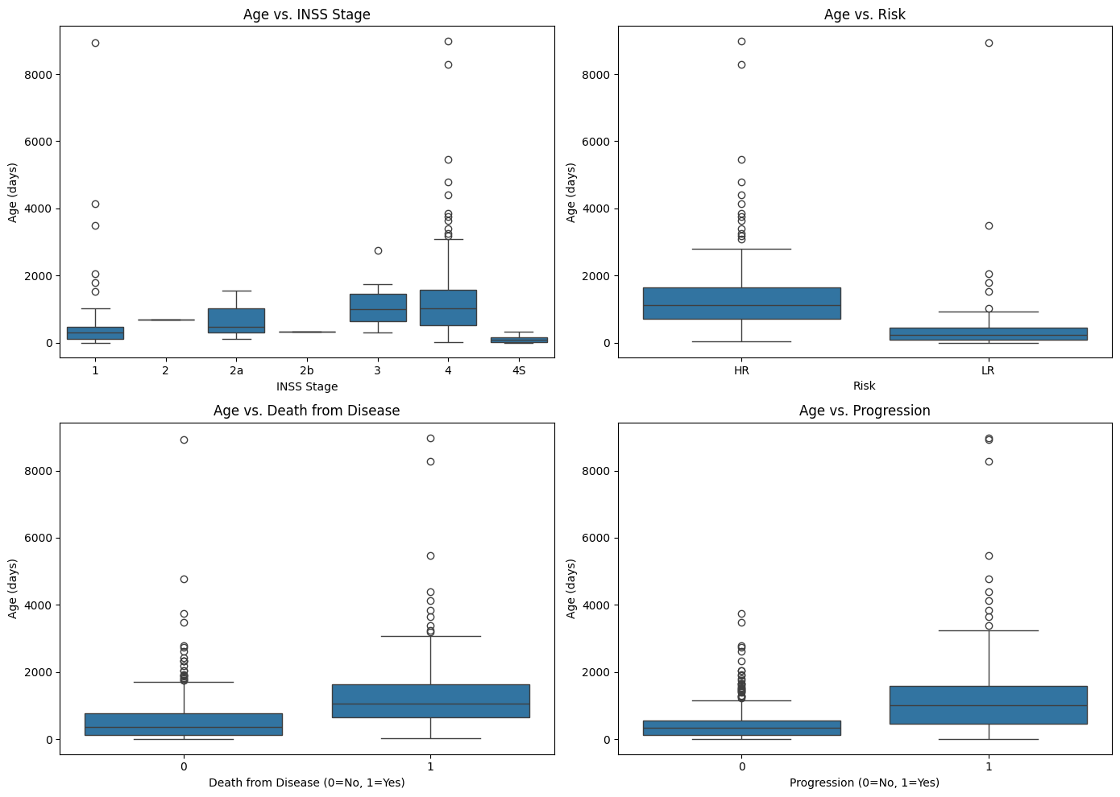
Figure 1.3 Distribution of Gender
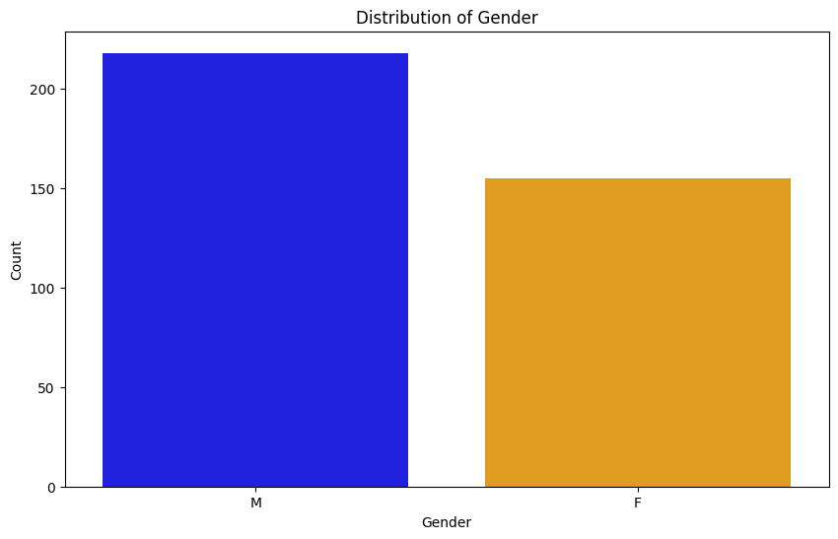

Figure 1.4 Comparative box-plots of Gender vs Predicted Outcomes

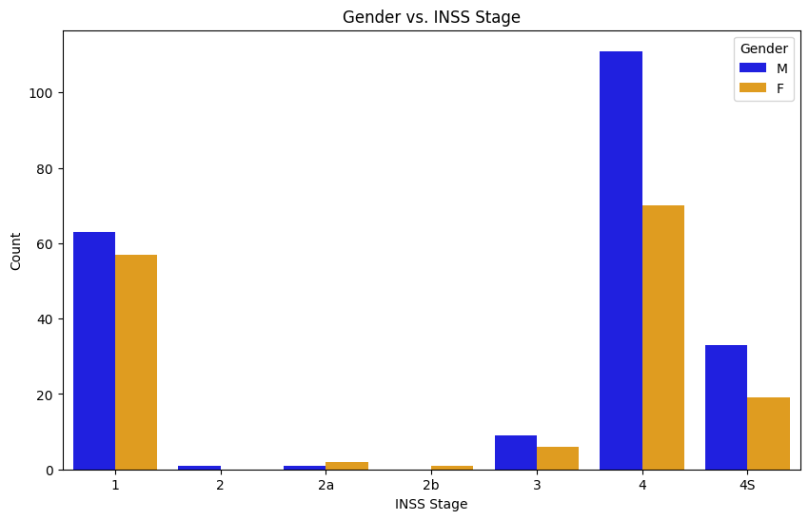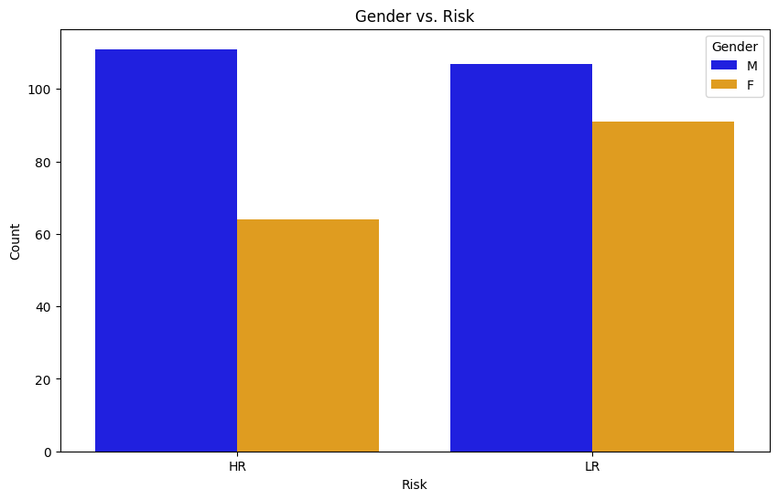

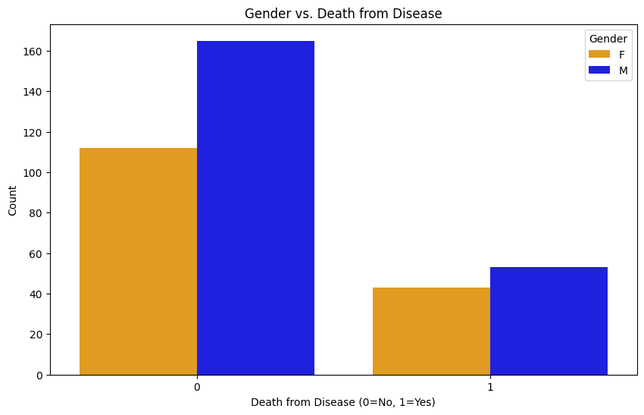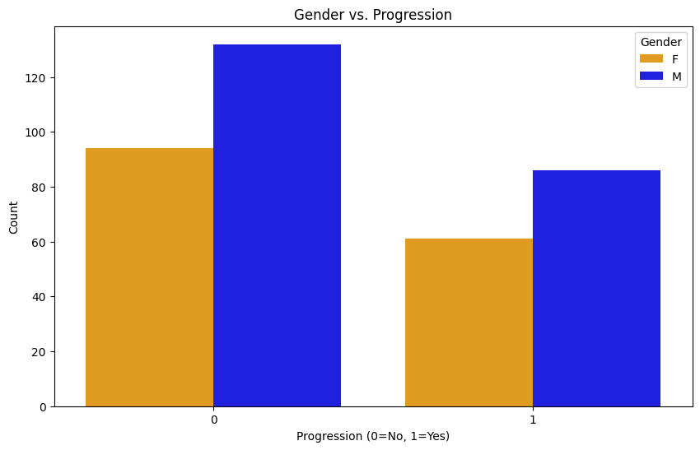

Table 1.2 Correlation and Chi-square analysis of Age and Gender separately vs clinical endpoints

Correlation for Age vs Clinical Endpoints
INSS Stage | 0.18
Risk | 0.48
Death from Disease | 0.33
Progression | 0.36
Chi-Square for Gender vs Clinical Endpoints
INSS Stage | chi2=5.81, p=0.4442
Risk | chi2=3.00, p=0.0835
Death from Disease | chi2=0.39, p=0.5309
Progression | chi2=0.00, p=1.0000

Unsupervised Learning: Clustering

Figure 1.5 PCA of Gender and Microarray Data

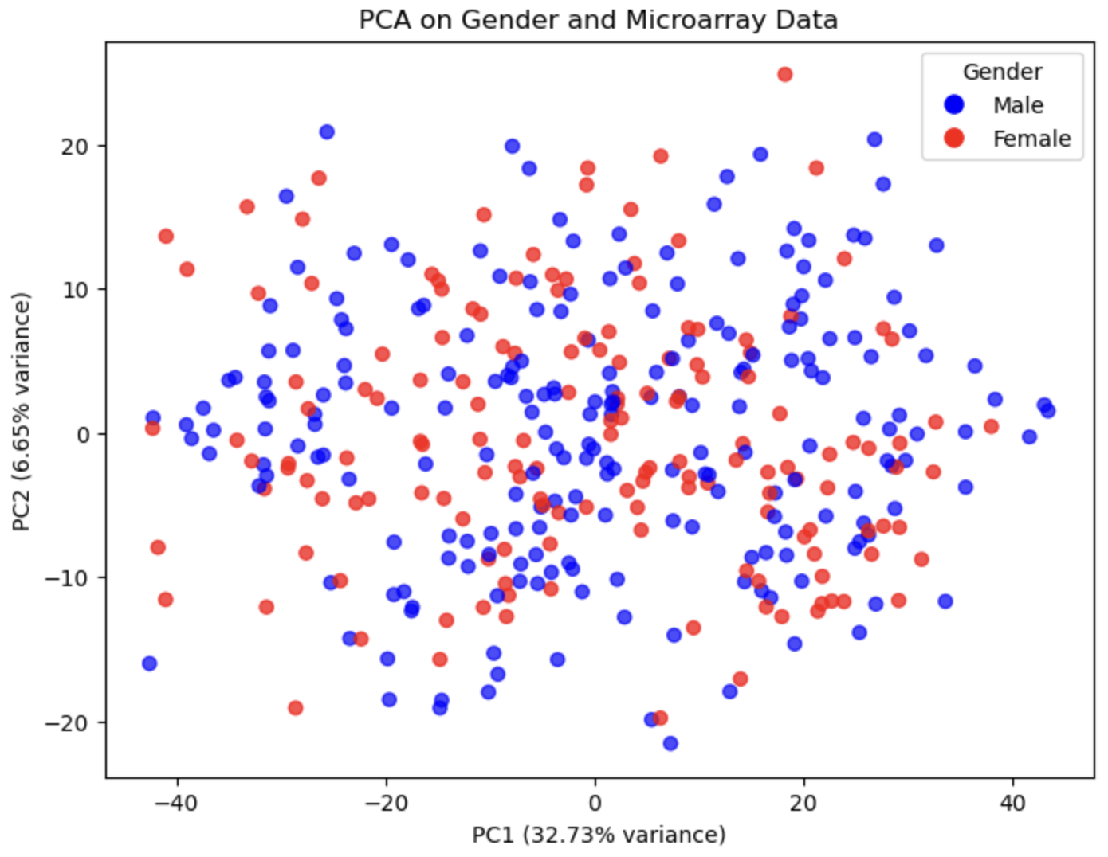
Figure 1.6 PCA Age and Microarray Data
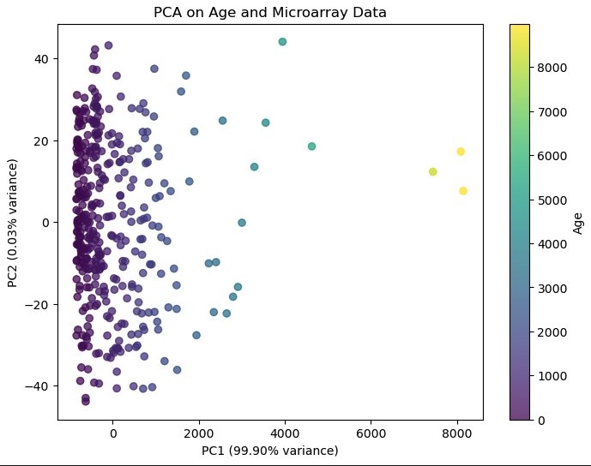

Figure 1.7 PCA Age, Gender and Microarray Data

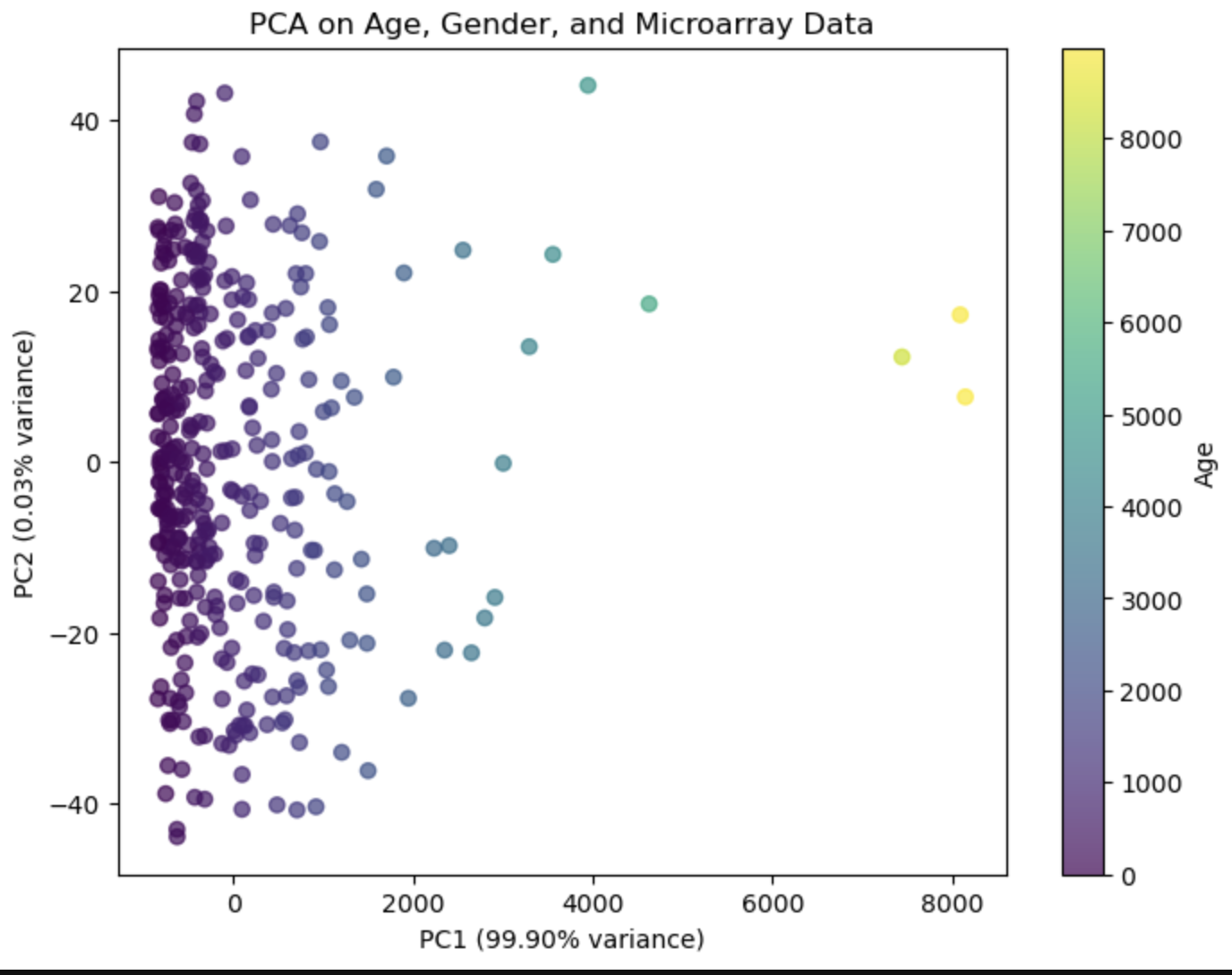

Figure 1.8 t-SNE Gender and Microarray Data

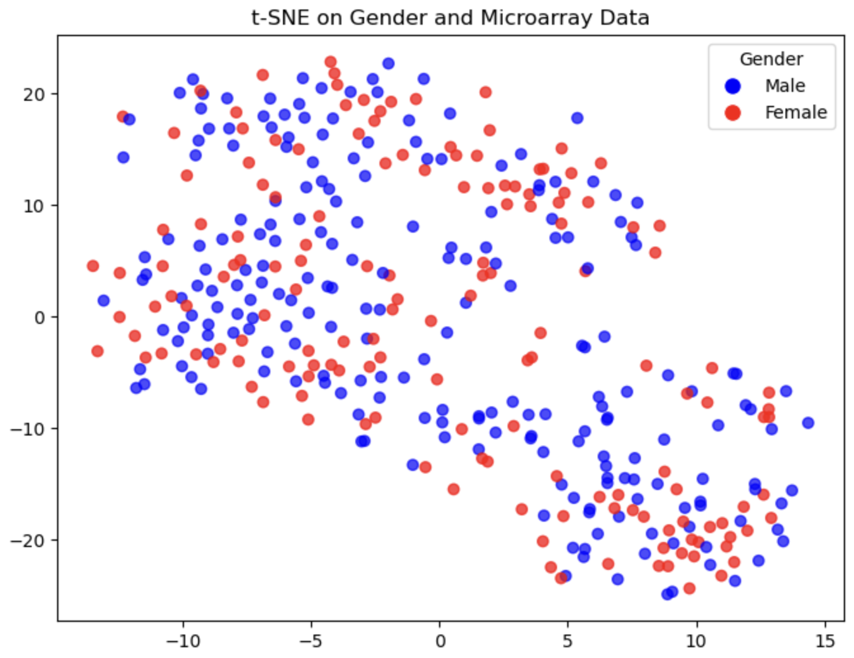

Figure 1.9 t-SNE Age and Microarray Data

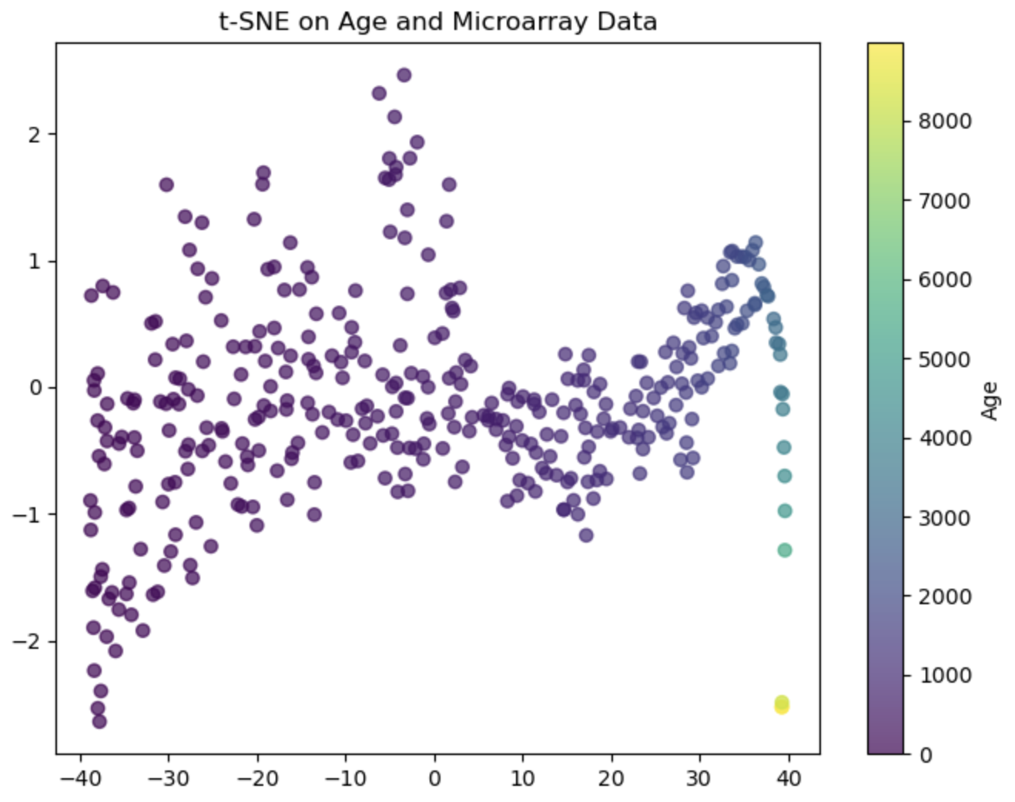

Figure 1.10
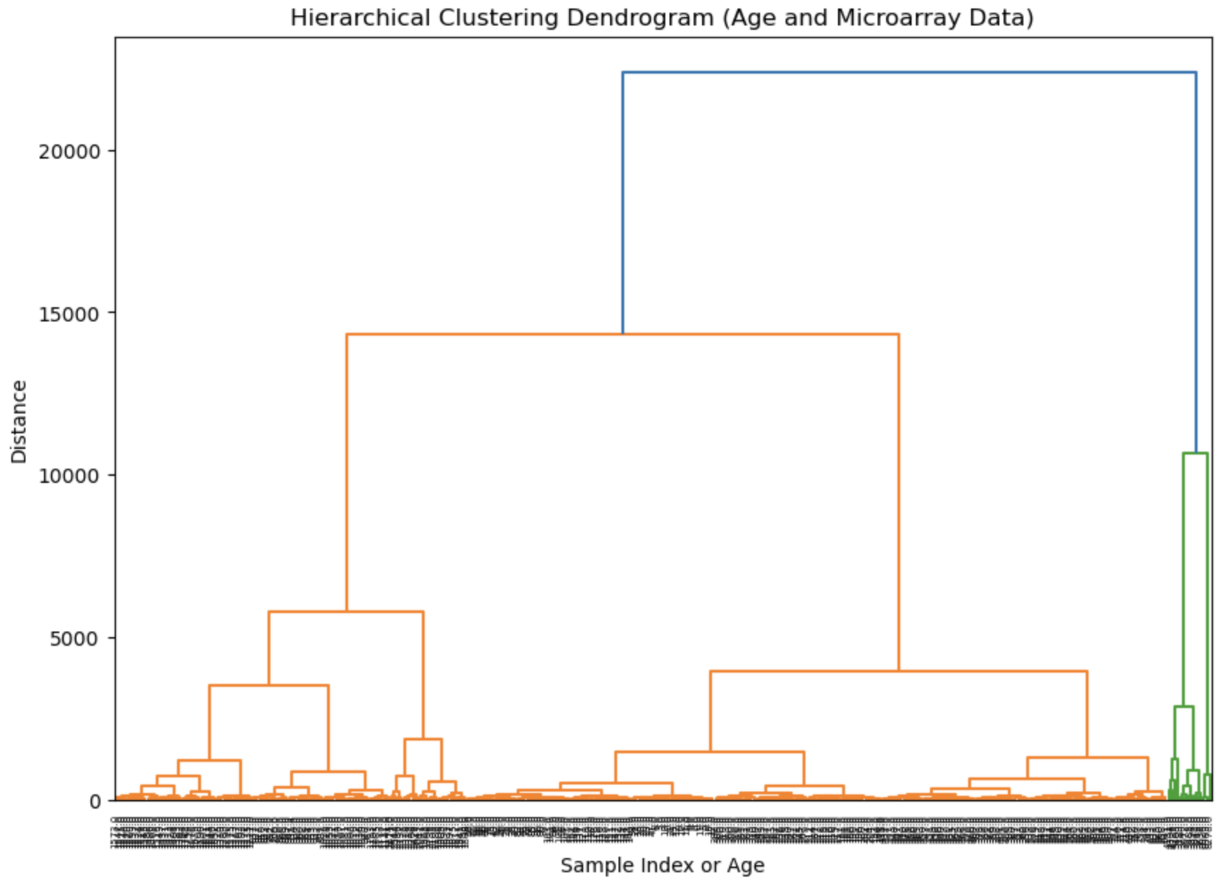

Figure 1.11

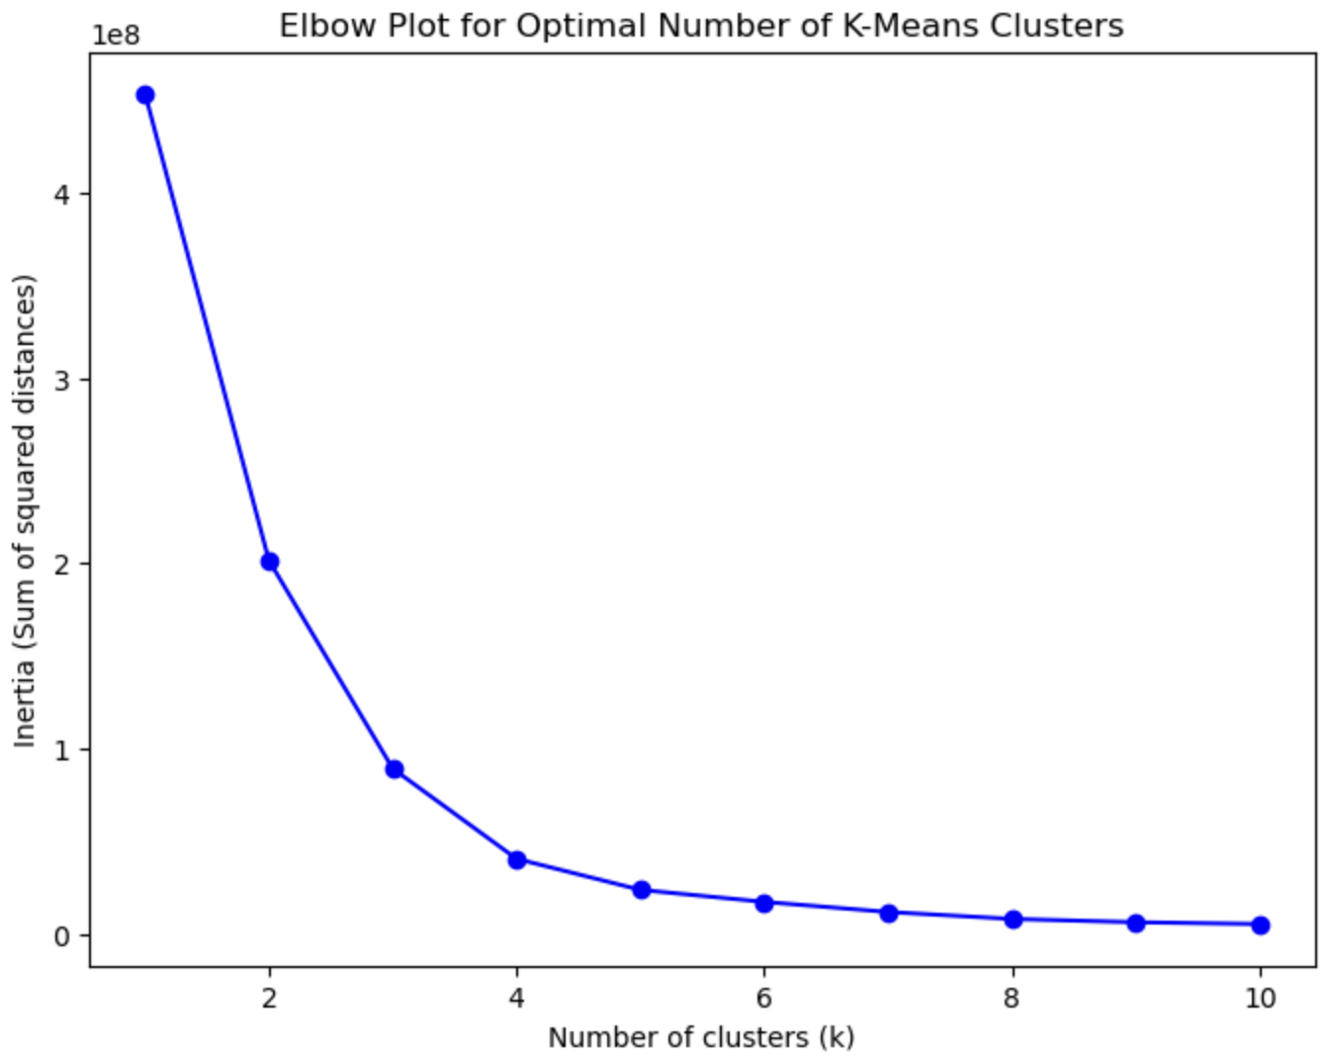

Figure 1.12

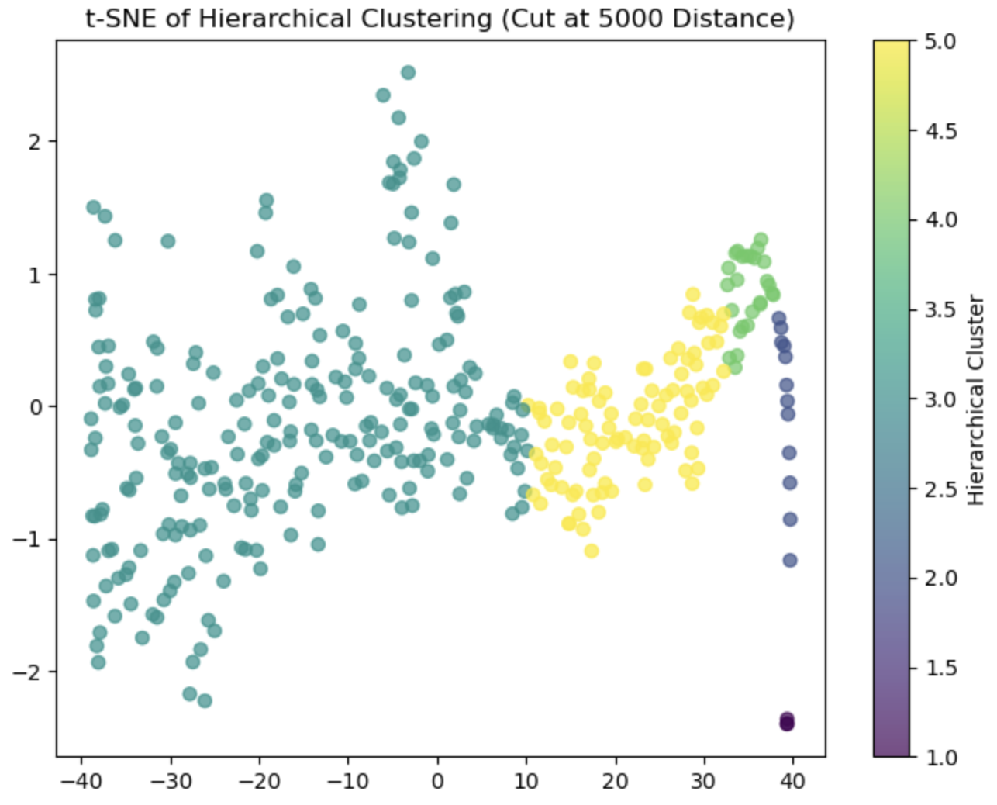
Supervised Learning Approach

Table 1.3 Summary of metrics for the three models after model optimization

Model | Target | Recall | Accuracy | F1-Score
1. Random Forest | High Risk | 0.96 | 0.94 | 0.94
 | Progression | 0.73 | 0.78 | 0.72
 | Death From Disease | 0.39 | 0.76 | 0.47
 | INSS Stage 1 | 0.82 | 0.74 | 0.84
 | INSS Stage 2a | 0 | - | 0
 | INSS Stage 2b | 0 | - | 0
 | INSS Stage 3 | 0 | - | 0
 | INSS Stage 4 | 0.98 | - | 0.8
 | INSS Stage 4s | 0.23 | - | 0.38
Model | Target | Recall | Accuracy | F1-Score
2. SVM | High Risk | 0.72 | 0.84 | 0.81
 | Progression | 0.82 | 0.81 | 0.77
 | Death From Disease | 0.1 | 0.72 | 0.63
 | INSS Stage 1 | 0.93 | 0.62 | 0.66
 | INSS Stage 2a | 0 | - | 0
 | INSS Stage 2b | 0 | - | 0
 | INSS Stage 3 | 0 | - | 0
 | INSS Stage 4 | 0.67 | - | 0.73
 | INSS Stage 4s | 0 | - | 0
Model | Target | Recall | Accuracy | F1-Score
3. XGBoost | High Risk | 0.96 | 0.92 | 0.93
 | Progression | 0.8 | 0.786 | 0.74
 | Death From Disease | 0.45 | 0.77 | 0.3
 | INSS Stage 1 | 0.93 | 0.83 | 0.85
 | INSS Stage 2a | 0 | - | 0
 | INSS Stage 2b | 0 | - | 0
 | INSS Stage 3 | 0.17 | - | 0.29
 | INSS Stage 4 | 0.91 | - | 0.88
 | INSS Stage 4s | 0.4 | - | 0.53

Figure 1.13 XGBoost INSS Stage 4s

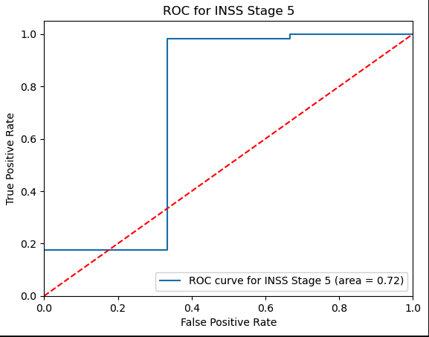

Figure 1.14 XGBoost INSS Stage 4

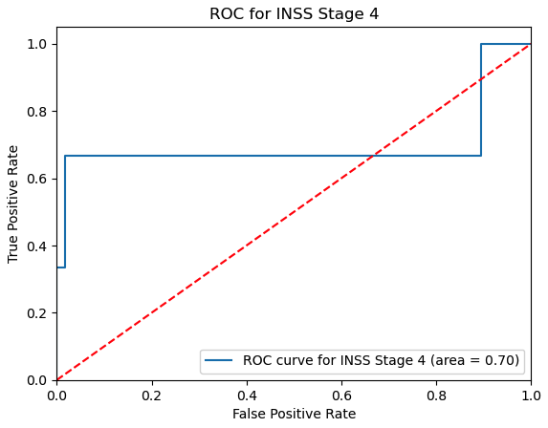

Figure 1.15 SVM INSS Stage 1

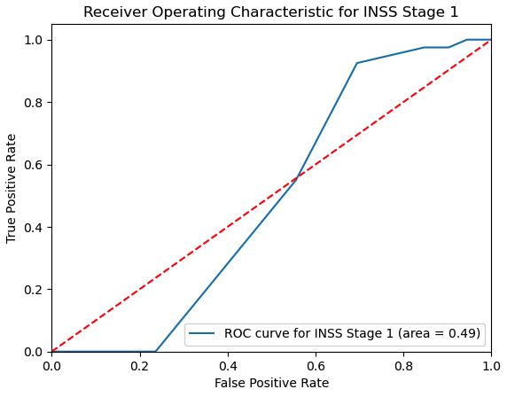
Figure 1.16 SVM INSS Stage 4

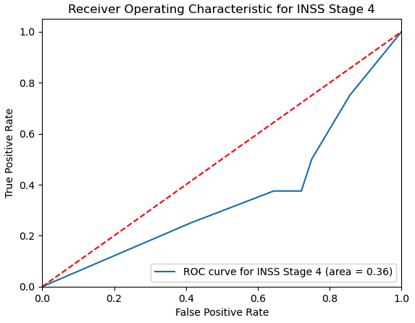

Model Evaluation
The Random Forest (RF) model achieved an accuracy of 0.94 and a recall of 0.96 for High Risk, highlighting its effectiveness in identifying at-risk patients. However, it struggled with Death from Disease (F1-score: 0.47) and various INSS Stages, indicating challenges due to class imbalance.
Support Vector Machine (SVM) reached an accuracy of 0.84 with a recall of 0.72 for High Risk and 0.82 for Progression. However, it struggled with Death from Disease (F1-score: 0.63) and INSS Stages, especially with low sample representation.
XGBoost excelled with an accuracy of 0.92 for High Risk but a recall of 0.45 for Death from Disease, demonstrating a mixed ability to manage predictions of these complex relationships outcomes. Despite some lower performance on less frequent classes, it remained the most reliable model overall.
Reflecting the results from Table 1.3, XGBoost appears to be the best performer among the models, demonstrating notable strengths in predicting clinical outcomes with its AUC values of 0.72 for INSS Stage 5 and 0.70 for Stage 4. While the average recall and F1-score metrics for XGBoost are competitive, they are not significantly superior to those of the other models. Therefore, further analysis is required to fully understand the model's effectiveness and to explore potential enhancements in predictive accuracy.

Discussion

XGBoost demonstrates some excellent performances in predicting clinical outcomes, particularly for High Risk and some of the INSS Stages .However, overall limitations imposed on the dataset such as extreme class imbalance (stage 2a,2b and 3) which led to the underperformance of all models. Despite attempts at addressing these imbalances via the model optimization, these particular values could be gained through advanced sampling techniques or by incorporating additional data sources, such as further clinical variables, to ensure robust modeling.

The findings also highlight the potential of hybrid approaches, such as combining XGBoost with models like Random Forest or Support Vector Machines to leverage their individual strengths. Stacking or boosting methods could enhance overall performance by reducing bias and variance, particularly for extreme class imbalance. The absence of non-linear categorization in the age variable limited the models' ability to capture the nuanced impacts of age on clinical outcomes. This simplification, while expedient, was a necessary compromise due to time constraints, preventing a more detailed exploration of how varying age groups influence predictive performance. Future analyses should consider reintroducing this complexity to better understand the age-related dynamics in the data.

Conclusion

This research builds on the findings of Zhang et al. (2015), who faced similar challenges in predicting INSS stages using RNA-seq and microarray models. This study not only reaffirms these difficulties but also highlights the potential of combining advanced machine learning techniques to improve predictive accuracy. By addressing the limitations identified in previous studies, I hope to contribute to the ongoing dialogue in bioinformatics about enhancing clinical endpoint predictions, thereby paving the way for more reliable diagnostic tools and personalized treatment strategies in oncology.

References

Anbananthen, Kalaiarasi Sonai Muthu et al. “A Comparative Performance Analysis of Hybrid and Classical Machine Learning Method in Predicting Diabetes.” Emerging Science Journal (2022): n. Pag.

Lertampaiporn, Supatcha et al. “Heterogeneous ensemble approach with discriminative features and modified-SMOTEbagging for pre-miRNA classification.” Nucleic Acids Research 41 (2012): e21 - e21.

Lertampaiporn, Supatcha et al. “Identification of non-coding RNAs with a new composite feature in the Hybrid Random Forest Ensemble algorithm.” Nucleic Acids Research 42 (2014): e93 - e93.

Tsai, Chih-Fong et al. “Under-sampling class imbalanced datasets by combining clustering analysis and instance selection.” Inf. Sci. 477 (2019): 47-54.

Yang, Li and Abdallah Shami. “On Hyperparameter Optimization of Machine Learning Algorithms: Theory and Practice.” ArXiv abs/2007.15745 (2020): n. pag.

Zhang, W., Yu, Y., Hertwig, F. et al. Comparison of RNA-seq and microarray-based models for clinical endpoint prediction. Genome Biol 16, 133 (2015). https://doi.org/10.1186/s13059-015-0694-

