Research and Development of a
"Party Style, Multiplayer Video Game"

April 2017

Group Prject
School of Informatics and Engineering,
Institute of Technology Blanchardstown,
Dublin, Ireland

Contents

1 Introduction 3
1.1 Situation Analysis 3
1.2 Design 3
1.3 Prototype 3
1.4 Evaluation of Prototype and Full working system 4
1.5 General Computer Science knowledge
2 System Analysis 5
2.1 5
2.2 6
2.3 7
3 System Design 9
3.1 9
3.2 9
3.3 9
4 Implementation of system 10
4.1 10
4.2 10
4.3 10
5 Testing and evaluation 11
5.1 11
5.2 11
5.3 12
6 Conclusions and Further Work 16
6.1 16

7 Personal reflections on project experiences 16
6.1 16

Abstract:
Keywords:
Computer, Game, Multiplayer, Video, Development.
Acknowledgments
1 Introduction
At the beginning of the year we were tasked with creating a team. The idea behind us coming together was to understand how a group of people would work together in the real world. Being in a team would involve interactons in dividing jobs and group communication.
As a team we were given multiple options for project subjects. Our team chose the development of a party style multiplayer video game. As we all have a heavy interest in computer games in general, it was the perfect choice for us.
Situation Analysis
As the party style multiplayer video game was our choice, this is what we researched. The first study was into different examples of what type of game a party style multiplayer video game is. This gave us a clear picture of what the end product was to be.
When we had a clear picture of what type of game we wanted, we put together some graphic design ideas of the menus levels and characters. We came up with general objectives per level and how the scoring systems would work per level and over all.
We had decided from the beggining to use Unity to help us develop the project since we all had a decent amount of experience with this environment. In Unity our code of choice is C#.
Design
Our idea is an easy to adapt to, multiplayer, party style game. Something anybody, from a low experience level to high in gaming would easily be able to pick up and play. The design is based around straight forward controlls and basic objectives. The chalenge is mainly focused on winning against each other, rather then winning the level. This sort of game should build an exstatic energy, perfect in a party environment. The look and feel of the game is a minimal simplistic feel. We didnt want anything with too high of a detail considering its nature. The assets for the game were all downloaded for free from a very helpfull website www.gameart2d.com.

Prototype
When we had a clear idea of our projects requirements we got to work on our prototype. One of the memebers designed and built the menu system, while the other two members and I, built a level each. Using the sprites we had downloaded, we were able to build, quite nice looking levels, with interesting charaters. We also put the animations together ourselfs for the characters from the sprite sheets. Implementing music and a basic points system, we had 3 levels and a menu system as our prototype.

Evaluation of Prototype and Full working system
The prototype was basic, and needed alot of polishing for what it was. There were also 3 more levels to be added. It was a simple display of how the mechanics of the game would work and how it would look and feel.
We gave the prototype to friends and family and got some great feedback, even considering it wasnt anywhere close to being finished. With the feedback we were able to imporve certain aspects of the game.

Our points system was unclear at the prototype stage, so we were to improve on a better system per level. A better UI was implemented with basic graphics that represented player statistics and lives.

Music was to be added to one of the levels for improved atmospheric feeling.

We had talked about and designed a tournement quickfire option, that was to be implemented when we had everything else done.

Have a menu system between games with score board with the results of the level, who won, whos go is it next etc.

We also wanted to implement xbox or playstation controllers if we had the time.

To complete the system we wanted full working animations on all characters.

General Computer Science knowledge
This subject rquired us to have knowledge in computer programming as well games design and experience in Unity. As we all have experience in Unity from previous projects from over the years of college it was perfect for us. As computer science student we are constanlty coding in different languages so the coding wasnt to much of a problem. This project required us to have this experince before we could start.

2 System Analysis and Design
As this project is a game i will explain in terms of "scenes". The first scene is the main menu where the games first loads too. There are 3 options, Quick Match, Tournament, and Exit. The quick match option will allow you and a friend to play a level of your choosing. The Tournament option will allow you to play all 6 levels with a final score and who won. During each of the levels there is a UI to display player statistic and timer depending on objectives.

Each leve has a different objectives and different dangers. Some are object that can damage or reduce the players health, others are a timer against the players.

Quick Match
Going form quick match, you will be brought into another menu where you pick the level you want to play. Once finished the level, you will be brought to another scene with your score, and who was the winner. From there you will be given the option to replay the level or return to main meun.

Tournament
In the tournament option, you will be brought to a menu to declare who is player one and player 2. The game will start off on the first level. When finished, you will be brought to another scene where it will show you your score and who won. You will then continue on to the next level and so on until you have completed all levels. When you have finished all of the levels you will be brought to another scene where it will tell you the score of each round and the winner of the tournament.

Exit
The exit option is exits the system to your desktop.

A diagram of the above described.
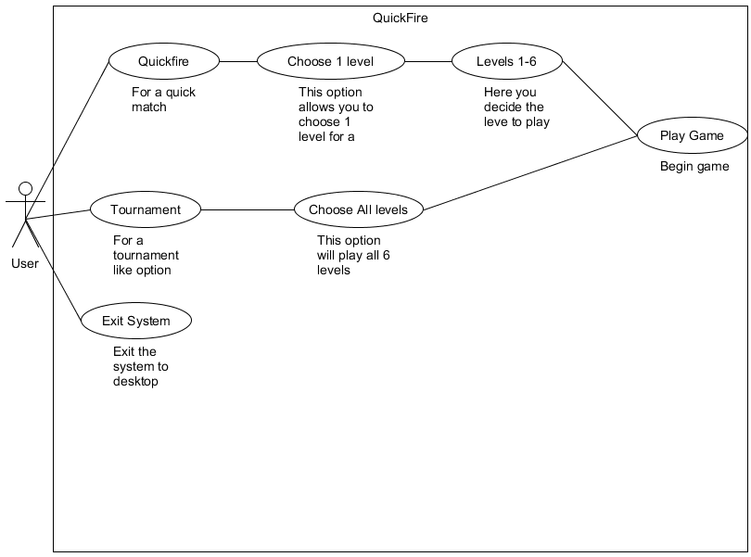
Illustration 1: Figure 1. A use case diagram of the application

User Interface Design
In one of the levels there is a very basic user interface. You can see in the top right and left corners there is Player 1 and Player 2. Each of the candy canes represents a life of the character. When a player loses all their lifes the other player wins. Each time the player is hit with the opponents snow ball the a candy cane is removed from the UI.

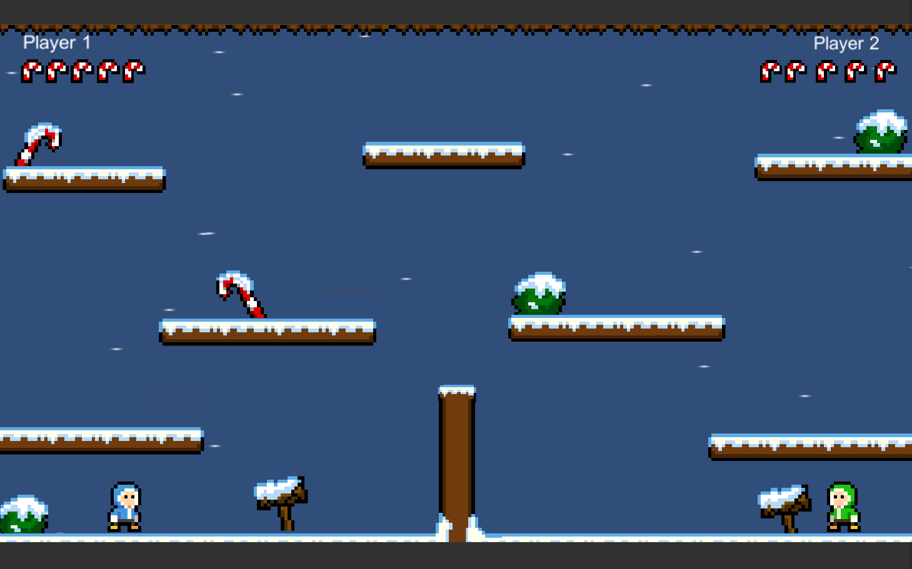
Illustration 2: Picture of Level and user interface
This is the class for managing this scene. It determines, if a player has no lifes it will load the next scene.
public class SnowBallManager {
if (P1Life <= 0){
player1.SetActive(false);
P1Wins.SetActive(true);
if (Input.GetKeyDown(KeyCode.Return)){
SceneManager.LoadScene(nextScene);
}
if (Input.GetKeyDown(KeyCode.Escape)){
SceneManager.LoadScene(mainMenu);
}}
if (P2Life <= 0){
if (Input.GetKeyDown(KeyCode.Return)){
SceneManager.LoadScene(nextScene);
}
if (Input.GetKeyDown(KeyCode.Escape)){
SceneManager.LoadScene(mainMenu);
}
}
public void HurtP1(){
P1Life -= 1;
for (int i = 0; i < P1Sticks.Length; i++){
if (P1Life > i){
P1Sticks[i].SetActive(true);
}else{
P1Sticks[i].SetActive(false);
}}
hurtSound.Play();
}
public void HurtP2(){
P2Life -= 1;
for (int i = 0; i < P2Sticks.Length; i++){
if (P2Life > i){
P2Sticks[i].SetActive(true);
}else{
P2Sticks[i].SetActive(false);
}}

2.5 Data Design
We have yet to implement our data storage.

3 Implementation of system
After doing research on the topic we took notes for specifications of the game. In one of the early meetings we drew out a list of features that were to be in the game. After getting our complete list together we drew up a rough draft on what type of code we need.

My two levels were to have a games manager to keep the overall organisation of the game in one script. Through this, the features would be added as nessecary. For example changing scenes would be managed through this script.

The player controlls and animations are controlled through a player1controll script. Each input button can be mapped to anywhere on the keyboard. Each time the button pressed the specific animation for that specific direction or movement is played.

We used alot of Unity's features to help go towards our original design ideas. One thing we didnt actuly plan in the design was the animations. Unity was a great help for that. We were able to take a sprite sheet, "slice" it into different pictures and build a moving animation from it.

4 Testing and evaluation
The has been no white box test yet, but we plan to do testing later on when we get other more important tasks done.

5 Conclusions and Further Work
Conclusions to be made after being fully tested .

There are an endless amount of other features i would have put in the game if i had more time. One of them would be to have it on the internet. To have a two player game like this that you could play with a friend across the globe would have been great. Considering the leight weight of it, it would have been easy to do. Having a website for high scores and chat rooms to talk to friends. Or uploading it as a facebook 2 player game.

More levels , more features, booster during the levels, extra lives. Having bigger levels with more then 2 players. 3D levels, the list endless.

Appendices
  - Appendix A: Project Planning
  - Appendix B: Project Diary (parts 1 and 2)
  - Appendix C: Code listings
  - Appendix D: (other technical or data appendices as required)

Reading lists (essential and recommended reading)
1. Brashmonkey Spriter. 2015. Game Art 2D. [ONLINE] Available at: http://www.gameart2d.com/. [Accessed 1 April 2017].

