

Ross Tierney  
FYP  
Supervisor – Dr. Paddy Healy

**Fingerprint Recognition**

# Introduction

Robust personal recognition systems are quickly becoming a more secure and efficient way of verifying an individuals identity. Although ID cards are inexpensive, they can be easily lost, stolen or damaged. Also the use of ID cards in companies allows employees to Biometrics is the science and technology of measuring and analyzing biological data so that human characteristics can be authenticated and identified. Such human body characteristics include fingerprints, eye retinas and iris, voice patterns, facial patterns and hand measurements. Fingerprint identification is one of the most well-known and publicized biometrics.

# Characteristics of fingerprints

* An individual characteristic.
* Remain unchanged throughout life time.
* Contain general ridge patterns that allow them to be classified systematically.

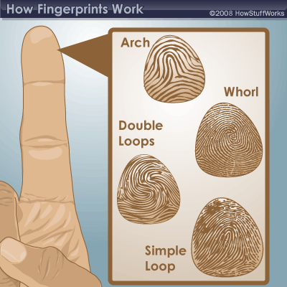

http://science.howstuffworks.com/fingerprinting1.htm



<http://static.myce.com/images_posts/2015/03/Digital-Fingerprint-Ashford-University.jpg>

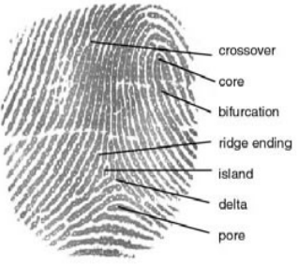

<http://www.biometrics.gov/Documents/FingerprintRec.pdf>

## Give It That Finishing Touch

Need to add a table of contents or a bibliography? No sweat.

### Add a Table of Contents

It couldn’t be easier to add a table of contents to your report. Just click in the document where you want the TOC to appear. Then, on the References tab, click Table of Contents and then click one of the Automatic options.

When you do, the TOC is inserted and text you formatted using Heading 1, Heading 2, and Heading 3 styles is automatically added to it.

### Add a Bibliography

On the References tab, in the Citations & Bibliography group, click Insert Citation for the option to add sources and then place citations in the document.

When you’ve added all the citations you need for your report, on the References tab, click Bibliography to insert a formatted bibliography in your choice of styles.

And you’re done. Nice work!