Assignment 4: Debugging Code
Katie Willi
2026-06-05

The Assignment:
Tip: View this in the visual editor in RStudio
You want to re-create the word document shared with this assignment titled Debugged_Document.docx. Here is the workflow to do so, however you will notice if you attempt to render this R Markdown document as is, it does NOT reproduce the Debugged_Document.docx file, and it won’t even render until you fix some of the mistakes/missing elements. Therefore, this workflow is not reproducible! Your task is to fix the below coding workflow so that it renders and exactly matches the output of Debugged_Document.docx (including whether or not certain code chunks and/or outputs are shown).
There are a total of 6 fixes you need to make to the workflow below. To complete this assignment you must identify the 6 errors and specify what they are.
List here the 6 errors you had to fix in this workflow:

The NOAA Atlantic Hurricane Dataset
This exploratory workflow uses the storms data from the {dplyr} package. This dataset is based on the NOAA Atlantic hurricane database (https://www.nhc.noaa.gov/data/#hurdat). The data includes storm tracks of storms from 1975-2022, as well as some characteristics (like wind and air pressure) during their progression. Storms from 1979 onward are measured every six hours during the lifetime of the storm. Storms in earlier years have some missing data. Descriptions of each variable in the dataset can be found with ?storms.
We read in the data and initially explore its structure:
## name year month day
## Length :20778 Min. :1975 Min. : 1.000 Min. : 1.00
## N.unique : 268 1st Qu.:1995 1st Qu.: 8.000 1st Qu.: 8.00
## N.blank : 0 Median :2005 Median : 9.000 Median :16.00
## Min.nchar: 3 Mean :2004 Mean : 8.708 Mean :15.71
## Max.nchar: 10 3rd Qu.:2016 3rd Qu.: 9.000 3rd Qu.:24.00
## Max. :2024 Max. :12.000 Max. :31.00
##
## hour lat long status
## Min. : 0.000 Min. : 7.00 Min. :-136.90 tropical storm :7252
## 1st Qu.: 5.000 1st Qu.:18.30 1st Qu.: -78.60 hurricane :5100
## Median :12.000 Median :26.40 Median : -61.90 tropical depression:3685
## Mean : 9.102 Mean :26.94 Mean : -61.32 extratropical :2318
## 3rd Qu.:18.000 3rd Qu.:33.80 3rd Qu.: -45.30 other low :1623
## Max. :23.000 Max. :70.70 Max. : 13.50 subtropical storm : 323
## (Other) : 477
## category wind pressure tropicalstorm_force_diameter
## Min. :1.000 Min. : 10.00 Min. : 882.0 Min. : 0.0
## 1st Qu.:1.000 1st Qu.: 30.00 1st Qu.: 986.0 1st Qu.: 0.0
## Median :1.000 Median : 45.00 Median :1000.0 Median : 120.0
## Mean :1.899 Mean : 50.07 Mean : 993.4 Mean : 148.1
## 3rd Qu.:3.000 3rd Qu.: 65.00 3rd Qu.:1007.0 3rd Qu.: 220.0
## Max. :5.000 Max. :165.00 Max. :1024.0 Max. :1440.0
## NAs :15678 NAs :9512
## hurricane_force_diameter
## Min. : 0.00
## 1st Qu.: 0.00
## Median : 0.00
## Mean : 14.82
## 3rd Qu.: 0.00
## Max. :300.00
## NAs :9512
Let’s first explore wind speed across all the different storm types with a histogram:
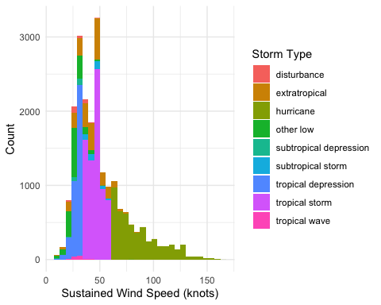
Now we want to visualize the relationship between pressure and wind speed across latitudes, where higher latitudes (blue) indicate locations further north:
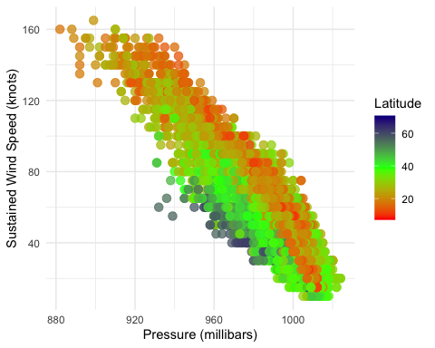
Finally, let’s visualize each hurricane’s maximum diameter through the years:
