The former tobacco factory on Via Riva di Reno in Bologna is a site of great historical and architectural interest, now enjoying a new lease of life linked to culture. Here's some key information, along with details about its history and current appearance:
History and Architecture
- Address: Via Riva di Reno, 72, Bologna.
- Origins: The Tobacco Factory was established at the beginning of the 19th century in the area that was the former convent of Santa Maria Nuova.
- Renovation of 1906: The main building on Via Riva di Reno, where the canal once flowed (now covered in the center of the street), retains the historic façade which was completely redesigned in 1906 by the architect Gaetano De Napoli.
- Art Nouveau: The facade is a notable example of Jugendstil (Art Nouveau), with a structure and decorations that reflect the taste of the time.
- Workforce: Historically, the factory employed mostly women, who were considered more skilled than men at rolling tobacco leaves to make cigars.
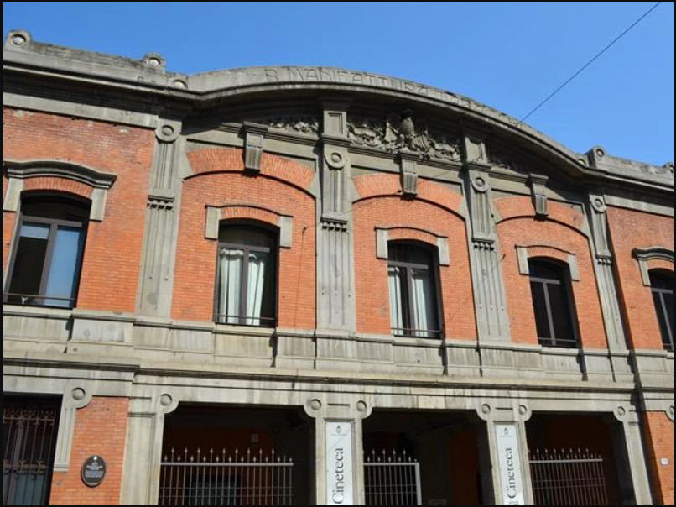
[SPLIT_BLOCK:manifattura_facciata.jpg];
Current Status and New Function
Today, the area of the former Manifattura is part of a major architectural and urban redevelopment project known as **Manifattura delle Arti**.
- Cineteca di Bologna: The historic building on Via Riva di Reno is the current home of the Cineteca di Bologna, an internationally renowned cultural center for the preservation and promotion of cinema.
- Gardens: Near the former tobacco factory are the Giardini ex Manifattura Tabacchi, a green area open to the public (generally from 7:00 am to 7:00 pm), often frequented by families and featuring a children's play area.
Links and Additional Content (Photos)
For photos, the best way is to consult online resources that document the historic building and the restoration projects:
- Former Royal Tobacco Factory - Bologna Online
- Tobacco Factory - History and Memory of Bologna
I especially recommend looking for images of the façade on Via Riva di Reno, which is the best-preserved and most characteristic part of the Art Nouveau architecture. If you're specifically interested in photos taken inside abandoned areas before their redevelopment (often with an industrial archaeology feel), you should look for exhibitions or projects like the one mentioned in the article "Spazi vicini. Ex Manifattura Tabacchi. Percorso fotografico verso il recupero" by Ivano Adversi.

