The votive shrine located at the corner of Via Tanari Vecchia and Via Avesella depicts the Blessed Virgin with Child. It is a sacred image of historical and architectural significance for the Porto district and Bologna's historical center, set into a facade that masterfully recalls the Romanesque style.
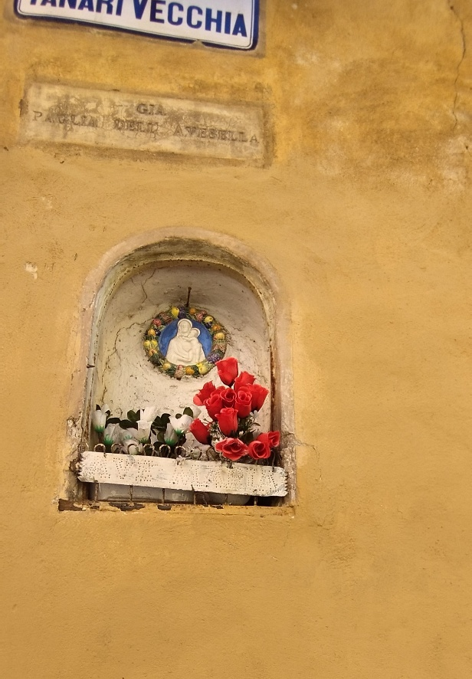
[SPLIT_BLOCK:edicola_madonna_con_bambino.jpg]

Artistic and Architectural Details
- The Artwork: A shrine dedicated to the cult of the Virgin Mary. While many Bolognese shrines feature the iconography of the Madonna di San Luca, this piece stands out for the remarkable craft of its architectural frame.
- Architecture and Historical Revival: The facade holding the shrine was designed by architect Edoardo Collamarini and built by Alfonso Rubbiani, key figures of historical restoration and Neo-Medieval revival in Bologna in the late 19th and early 20th centuries.
- Analysis of the Image and Visible Features:
  - The Subject: Inside the niche is a refined ceramic roundel (in the Della Robbia style or a faithful reproduction) depicting the Madonna and Child, framed by a colorful garland of flowers and fruit.
  - The Inscription: Above the arch of the niche, a partially legible ancient inscription reads: "COMPAGNIA DELL'AVESELLA". This confirms the historical link to the confraternity of the same name, which managed the nearby Hospital and Oratory of Santa Maria della Pioggia.
  - The Empty Niche on the Corner: On the left, directly on the corner of the wall, is a smaller, rustic stone niche, currently empty. In Bologna, building corners frequently featured multiple devotional spots, which often doubled as holding places for oil lamps prior to public street lighting.
  - Current Condition: The image highlights a striking contrast between historical devotion (red flowers placed by local residents) and the modern urban environment, marked by graffiti on the lower section of the wall.

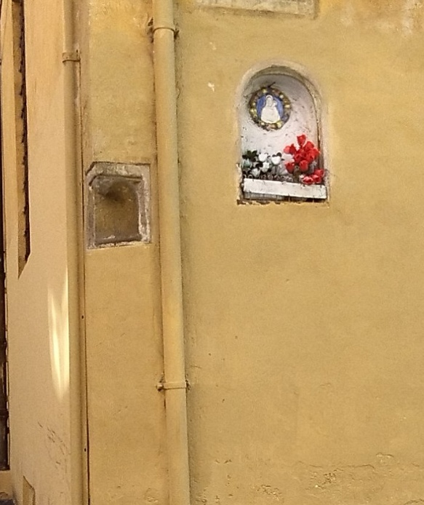
[SPLIT_BLOCK:angolo_edicola_nicchia_vuota.jpg]

Historical Insights, Anecdotes, and Curiosities
- The Compagnia dell'Avesella: This lay brotherhood was one of the most active in the area. The inscription above the shrine served as a formal ownership marker, reminding passersby of the spiritual protection and material aid (shelter for pilgrims and care for the poor) provided at the neighboring Hospital and Oratory of Santa Maria della Pioggia.
- The Hidden Canal and the Washerwomen: Today Via Avesella appears as a dry alley, but beneath the pavement flows the Avesa stream (Avesella canal). In the past, daily life here was defined by watermills, dyers, and washerwomen working along the open canal. The votive shrine offered spiritual comfort to workers in a damp area prone to frequent flooding.
- A Haven for Master Sculptors: Following the dissolution of religious orders by Napoleon in the late 18th century, the building's interior became prestigious sculpture studios. The area between Via Tanari and Via Avesella served for decades as the heart of 19th-century Bolognese sculpture, housing workshops of renowned masters such as Enrico Barberi and Tullo Golfarelli. Today, behind these doors lie restoration labs, exhibition spaces, and courtyards that retain the charm of old artist workshops.
- The "Mysterious" Niche: The smaller empty niche on the corner likely held a simpler terracotta figurine, known locally as a "Earthquake Madonna" or protector of travelers, which was lost or removed over time.
- Another Votive Shrine Nearby: Demonstrating the deep popular devotion of this street, another votive shrine depicting St. Anthony with Child is located nearby at Via Avesella 28.

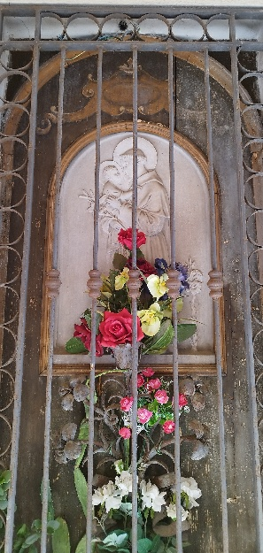
[SPLIT_BLOCK:edicola_san_antonio.jpg]

Visitor Tip
When standing before the Madonna and Child votive shrine at the corner of Via Tanari and Via Avesella, take a few steps into the small square and enter the Sanctuary of Santa Maria della Pioggia on your right: it houses valuable artworks and the miraculous image tied to the history of this street.

Tabella delle Fonti e Certificazione
Affermazione del testo | Fonte Certificata
The Blessed Virgin shrine at Tanari/Avesella corner features a facade designed by Edoardo Collamarini and built by Alfonso Rubbiani. | Storia e Memoria di Bologna / Bologna Online (Salaborsa Library)
The inscription "COMPAGNIA DELL'AVESELLA" certifies the link to the brotherhood running the nearby Hospital and Oratory of Santa Maria della Pioggia. | Historical Archive Archdiocese of Bologna / Origine di Bologna
Following Napoleonic dissolutions, the building housed the sculpture studios of 19th-century masters Enrico Barberi and Tullo Golfarelli. | Biographical Dictionary of Italians - Treccani / Storia e Memoria di Bologna
Via Avesella sits atop the underground Avesella canal; another votive shrine dedicated to St. Anthony with Child is located at No. 28. | Canali di Bologna / Toponymic Survey Municipality of Bologna

