Welcome to Via del Porto 11. Before you stands one of the most significant examples of sustainable architecture in the heart of Bologna. This building, designed by architect Aldo Vandini, represents a successful challenge: integrating a modern and technologically advanced structure into a stratified historical context.
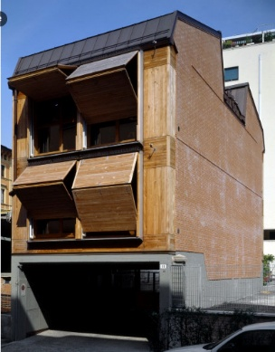
[SPLIT_BLOCK:stabile-legno-vandini-uno.jpg]
Constructed with a load-bearing wooden structure (X- Lam technology ), the building stands out for its high energy performance and use of natural materials. Aldo Vandini sought to create a "material dialogue": the warmth of wood inside and an exterior façade that, while contemporary, respects the rhythms and proportions of the surrounding Bolognese buildings.

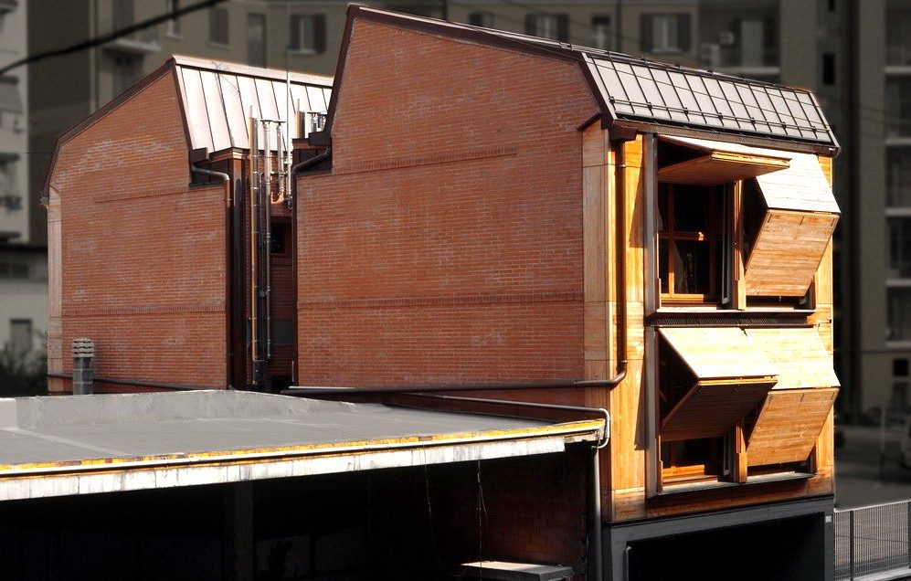
[SPLIT_BLOCK:stabile-legno-vandini-due.jpg ]
Despite its solid and perfectly integrated appearance, the choice of wood allowed for rapid construction and minimal environmental impact. It's a building that "breathes," capable of maintaining an ideal temperature in every season without wasting energy, demonstrating that even in the historic center, it's possible to build with the planet's future in mind.
X- Lam technology (also known as CLT , from the English Cross Laminated Timber ) represents one of the most significant innovations in the field of sustainable construction. It is a construction system based on cross-laminated solid wood panels.

How is an X- Lam panel made ?
An X- Lam panel is composed of several layers (usually 3, 5, or 7) of dried coniferous wood (often fir) boards, stacked so that the grain of each layer is rotated 90° with respect to the adjacent one. The layers are then glued together under strong pressure.
This "crossed" configuration gives the material exceptional properties:
- Dimensional stability: Variations in wood due to humidity are cancelled out by the orthogonal arrangement of the layers.
- Mechanical resistance: The panel can withstand very high loads, behaving like a rigid "plate", similar to reinforced concrete but much lighter.

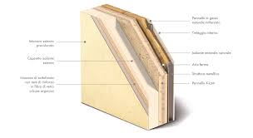
[SPLIT_BLOCK:tecnologia_x-lam.jpg ]

The main advantages
The use of X- Lam is revolutionising the way of building for several reasons:
- Sustainability: Wood sequesters CO₂ instead of emitting it during production. It's a renewable resource and requires much less energy to process than steel or concrete.
- Seismic Safety: Thanks to the natural elasticity of wood and the ability of mechanical joints to dissipate energy, X- Lam structures are among the safest in the event of an earthquake.
- Fire Resistance: Contrary to popular belief, solid wood burns slowly and predictably. The outer charred layer protects the panel's core, maintaining its load-bearing capacity longer than a steel beam.
- Construction Speed: The panels arrive at the construction site already cut to size (thanks to precision CNC machinery) with holes pre-drilled for doors and windows. This allows the structure of a house to be assembled in just a few days.

Areas of application
While in the past wood was limited to huts or small buildings, X- Lam today allows the construction of:
- Multi-story buildings: There are already wooden skyscrapers that exceed 20 stories.
- Schools and public buildings: Thanks to excellent thermal and acoustic performance.
- Additions: Being lightweight, it is perfect for adding floors to existing buildings without overloading the foundations.
In short, X- Lam is considered the "concrete of the future", combining the strength of massive structures with the flexibility and warmth of wood.

Who was Aldo Vandini?
Aldo Vandini was a prominent Italian architect and urban planner, whose activity was concentrated mainly in the second half of the twentieth century, leaving a significant mark especially on the urban fabric of Bologna .
His figure is closely linked to a vision of architecture understood as a civil service and a tool for social redevelopment, often working in contexts of public housing and urban planning.

Areas of Intervention and Style
Vandini interpreted the language of Modernism by filtering it through the practical needs of the postwar era and the urban growth of the 1960s and 1970s. His distinctive features include:
- Functional Rigour: An approach that prioritises the rationality of spaces and the solidity of materials.
- Participatory Urban Planning: Particular attention to integrating buildings into the pre-existing social context, avoiding the "cathedral in the desert" effect.
- Typological Experimentation: The search for new forms of collective living that guarantee dignity and services to residents.
Significant Works and Projects
Although his signature appears on numerous master plans and technical consultancy projects, some Bolognese projects define his career:
- The Barca District: He collaborated on one of Bologna's most ambitious urban planning projects, initially coordinated by Giuseppe Vaccaro. Vandini contributed to the definition of this self-sufficient "piece of the city."
- Public Housing: He was a key figure for the Istituto Autonomo Case Popolari (IACP), designing complexes that sought to overcome the "dormitory" concept through the inclusion of greenery and common spaces.
- Restoration and Conservation: In addition to new construction, Vandini was involved in the protection of architectural heritage, participating in the debate on the recovery of historic centers.

A Civil Legacy
Aldo Vandini is remembered not only for his individual buildings, but also for his commitment to professional institutions . He was long active in the Order of Architects, championing the quality of design as a citizen's right and transparency in construction processes.
His work represents that trend in Italian architecture capable of combining the aesthetics of concrete and brick with a profound building ethic.

Aneddoti e Curiosità
- Il Cantiere Silenzioso nel Cuore del Porto: Durante le fasi di realizzazione dell'edificio in via del Porto 11, i residenti della via vissero un'esperienza quasi surreale per il centro storico di Bologna: un cantiere straordinariamente veloce, pulito e "silenzioso". Grazie all'impiego dei pannelli prefabbricati X-Lam tagliati al millimetro tramite macchinari a controllo numerico (CNC), il montaggio della struttura portante è avvenuto a secco in pochissimi giorni, evitando i lunghi tempi di asciugatura e i rumori molesti tipici delle gettate in calcestruzzo.

- Il Paradosso del Fuoco e l'Abete delle Alpi: Una delle curiosità più sorprendenti legata alla tecnologia X-Lam riguarda la sua reazione agli incendi. Sebbene sia realizzato con tavole di abete, il pannello X-Lam massiccio offre una resistenza al fuoco superiore e più prevedibile rispetto travi in acciaio o pilastri in cemento. Durante un incendio, la superficie esterna del legno si carbonizza creando una barriera isolante naturale che protegge il cuore interno, permettendo alla struttura di mantenere la propria portata meccanica per ore.

- L'Armonia Materica con i Portici di Via del Porto: Il progetto inserito in via del Porto raccoglie l'eredità culturale del luogo: la via, storicamente legata all'acqua del Canale Navile e al trasporto del legname proveniente dagli Appennini, vede oggi un edificio moderno che riporta il legno al centro dell'architettura bolognese. All'interno si respira il calore del materiale naturale, mentre all'esterno l'edificio rispetta le altezze e i ritmi delle facciate circostanti.

- Aldo Vandini e il "Treno" del Quartiere Barca: L'architetto Aldo Vandini è stato una figura di spicco nella Bologna del dopoguerra. Oltre ad aver lavorato sul recupero dei centri storici e sulla sostenibilità, Vandini è ricordato per aver fatto parte del team di grandi progettisti (guidato da Giuseppe Vaccaro) che ideò il celebre "Treno" del Quartiere Barca, il lunghissimo edificio residenziale curvilineo divenuto un'icona dell'architettura sociale e dell'urbanistica partecipata a livello internazionale.

Tabella delle Fonti e Certificazione
Affermazione del testo | Fonte Certificata
The building at Via del Porto 11 in Bologna is an example of sustainable architecture designed by architect Aldo Vandini and built using X-Lam wooden technology. | Order of Architects of Bologna / Architectural Project Via del Porto 11
X-Lam (Cross Laminated Timber - CLT) technology consists of solid wood panels with cross-laminated layers (typically 3, 5, or 7 layers of softwood) glued under high pressure. | Sustainable Building Technical Manuals / Timber Engineering Guidelines (CLT)
X-Lam panels offer high dimensional stability, seismic resistance, environmental sustainability (CO₂ sequestration), rapid dry assembly, and fire resistance via surface charring. | CNR-IVALSA (Trees and Timber Institute) / X-Lam Technical Documentation
Architect and urban planner Aldo Vandini was a prominent figure in Bolognese Modernism and public housing (IACP), contributing to the Barca Quarter project alongside Giuseppe Vaccaro. | Order of Architects of Bologna / Historical Archive of Bolognese Urban Planning

