The Portone Sontuoso is much more than a simple entrance; it's the imposing "calling card" that marks the start of Bologna's most iconic climb. Located on Via Saragozza, it's the exact point where the portico separates from the city to begin its ascent toward Colle della Guardia.

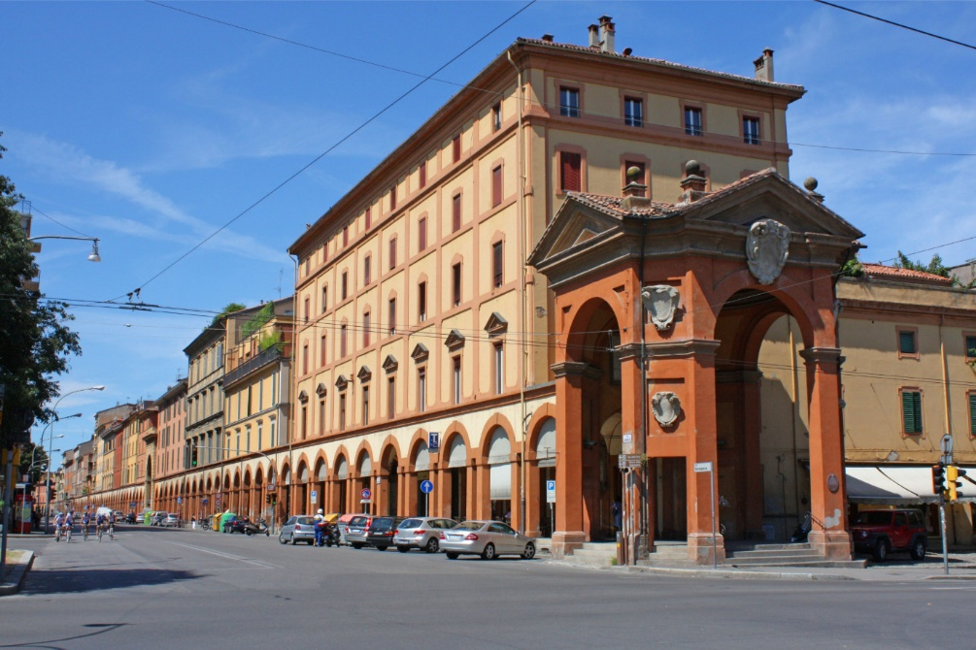
[SPLIT_BLOCK:Portone_Sontuoso.jpg]
Here are the key details about this architectural masterpiece:
1. Architecture and Symbolism
Built in 1674 , the arch was designed by architect Gian Giacomo Monti .
- Structure: It appears as a triumphal arch of the Corinthian order, monumental and decidedly taller and more ornate than the remaining 665 arches of the portico.
- Function: It marks the transition from the "profane" world of the city to the "sacred" world of the devotional journey. It marks the beginning of a nearly 4-kilometer-long path that symbolizes the body of the serpent (the devil) crushed at the feet of the Madonna (the Sanctuary).
2. Why is it called "Sumptuous"?
The name is not a modern exaggeration, but derives from its decorative richness compared to the sobriety of the rest of the route.
- It is adorned with the coat of arms of the Bonaccorsi family , who financed its construction.
- It features Latin inscriptions and relief decorations celebrating the protection of the Virgin over the city of Bologna.
3. A Historical Curiosity
Although today we see it perfectly integrated into the urban fabric, at the time of its construction, the Portone Sontuoso posed a real engineering and logistical challenge. It had to connect the flat stretch of road (built between 1674 and 1676) with the start of the steep climb leading to Meloncello.
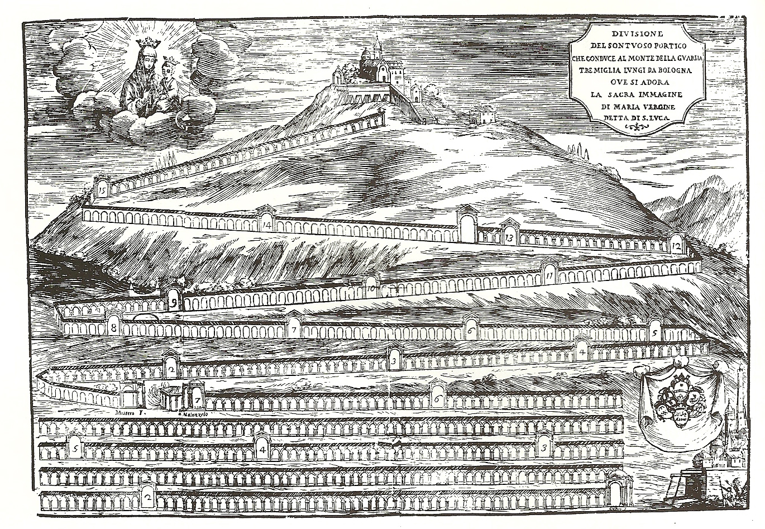 [SPLIT_BLOCK:Disegno_Bonaccorsi.jpg]
The plaque under the porch reads:
CLEMENTE X PONT OPT MAX
BONACCURSIUS
S R E CARDINALIS BONACCURSIUS
BONONIAE DE LATERE LEGATUS
SINGULARI
CIVIUM ERGA BEATAM VIRG. PIETATI
ELEGANTI HOC FORNICE PRAEIVIT
ANNO IVB MDCLXXV
LEGATIONIS II
RAYMUNDUS COM. CAS. S. PETRI IN SABINIS
ET ALY FRATRES DE BONACURSIS
CARD. BONACURSIS EX FRAT. NEPOTES
RESTAURARUNT
ANNO SAL. MDCCXVI

“Being Clement X, Pontiff Optimus Maximus, Bonaccorso Bonaccorsi, Cardinal of the Holy Roman Church, Legate of Bologna, preceded with this elegant bow the piety of the Bolognese towards the Blessed Virgin, in the jubilee year 1675, the second of his legation.
Count Raimondo of Castel S. Pietro in Sabina and the other Bonaccorsi brothers, nephews of Cardinal Bonaccorso on his brother's side, restored it in the year of salvation 1716.”

It corresponds to the major arch no. 1 (the number in this print is implied, but obvious) of the Division of the sumptuous portico.

Very Famous Portico 1707 – Arch 1. Financed by Cardinal Bonaccorsi, Legate of Bologna.

Tabella delle Fonti e Certificazione
Affermazione del testo | Fonte Certificata
The Portone Sontuoso was built in 1674 based on the design by architect Gian Giacomo Monti. | Dizionario Biografico degli Italiani - Treccani (Entry: Gian Giacomo Monti)
The arch is a Corinthian order monument marking the beginning of the San Luca portico and the start of the devotional path to the Colle della Guardia. | Le Chiese e i Portici di Bologna, Historical-Artistic Guide
The construction was funded by Cardinal Bonaccorso Bonaccorsi, Legate of Bologna, and bears the family coat of arms. | State Archives of Bologna, Apostolic Legation Fund
Latin inscription from 1675 commemorating the erection under Pope Clement X and the subsequent restoration by the Bonaccorsi nephews in 1716. | Inscriptions and Plaques of the City of Bologna, Historical Epigraphic Transcriptions
Corresponds to Arch No. 1 in the 1707 print and division of the "Portico Famosissimo". | Archiginnasio Municipal Library, Historical Prints and Drawings Collection

