The Madonna Fata is a terracotta statue preserved under the portico of Via Saragozza (at the height of the Arch of the Annunziata, near the intersection with Via Bellombra), along the historic route that leads up to the Sanctuary of the Madonna di San Luca.
Sculpted in 1749 by the Bolognese sculptor Andrea Ferreri , the statue depicts the Virgin with the Child in her arms. Its distinctive feature—hence the irreverent yet affectionate nickname given to it by the Bolognese—lies in its decidedly florid and matronly forms, typical of the Baroque style and prosperity of Emilia.
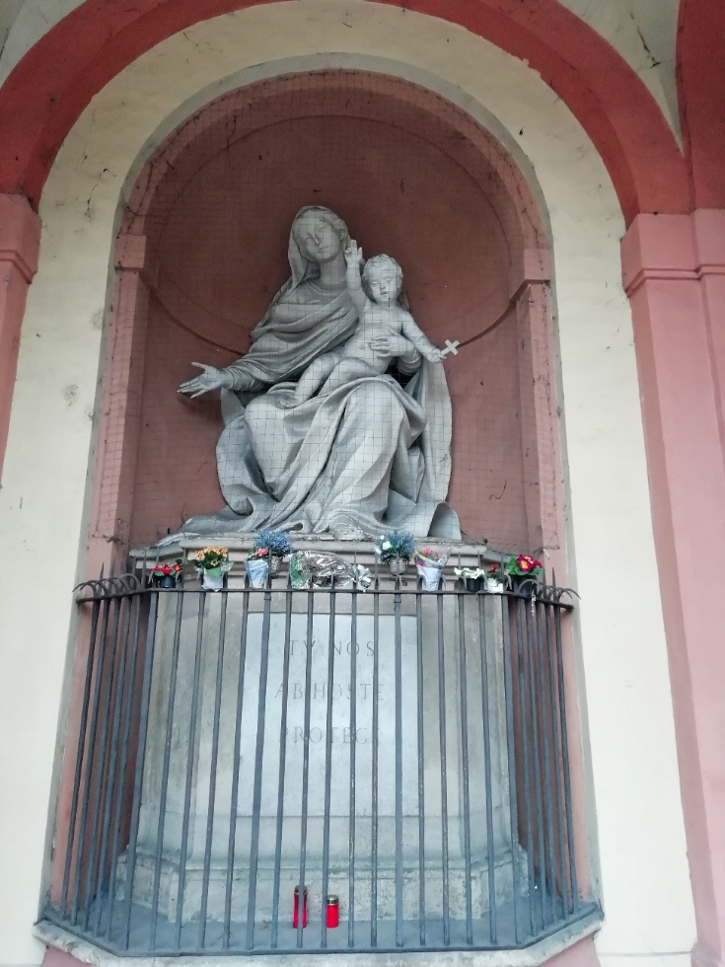
The Madonna Fata by Andrea Ferreri (1749). Source: Wikipedia
1. The "busty" nurse as a model
Among the most popular anecdotes surrounding the statue is the one about the model chosen by Andrea Ferreri. It is said that the sculptor didn't want to portray an ethereal or classical aesthetic ideal, but rather a woman of the people: specifically, he is said to have taken as his model a buxom wet nurse (or a commoner from the Saragossa area) known to everyone in the neighborhood for her imposing stature. The people of Bologna, seeing the finished statue, immediately recognized their fellow citizen, unceremoniously naming the work the Madonna. Grâsa .
2. The heart of the preparations for the descent of the Madonna of San Luca
The niche of the Madonna Grassa was a strategic point for the "birocciai" (coach drivers of the time) and pilgrims climbing the Colle della Guardia. During the famous week of the descent of the image of the Madonna di San Luca into the city, the niche became the meeting place to decorate the portico with drapes and candles. An ancient custom dictated that people would pause before the statue for a quick "propitiatory" prayer to endure the fatigue of the climb or to express gratitude for their return.
3. The "challenge" of motherhood and good food
In the Bolognese oral tradition, the opulent shape of the statue has often been linked to two symbols of the local culture:
- Prosperity and milk: this Junoesque figure was seen by future mothers or women who had just given birth as a protector of an abundance of milk for their newborns.
- Bolognese cuisine: in local folklore, it was often joked that even the Virgin, having spent so much time under Bologna's porticoes, couldn't resist the puff pastry, tortellini, and other traditional dishes.
4. The devout cartouche and the city's irony
Under the statue's niche, a marble plaque with a devotional Latin inscription is visible ( MATERI MISERICORDIAE or dedications from the Company that maintained it). It is said, however, that in the past, among university students and passers-by of the last century, there was no shortage of jocular folk songs and stories that mocked the statue's size, combining the solemnity of official prayers with typical Petronian irony .

Tabella delle Fonti e Certificazione
Affermazione del testo | Fonte Certificata
The terracotta statue depicting the Virgin and Child was sculpted in 1749 by the Bolognese sculptor Andrea Ferreri and is preserved under the Via Saragozza portico near the Annunziata arch. | Epigraphy and Historical Documentation of the Portico of San Luca
The artwork acquired the nickname "Madonna Grassa" due to its prosperous, matronly forms, traditionally modeled after a local wet nurse or woman from the Saragozza district. | Collections of Bolognese Popular Traditions and Folklore
The niche served as a strategic stop and prayer station for cart drivers (birocciai) and pilgrims ascending to the Sanctuary of the Madonna di San Luca. | Archive of the Company of the Blessed Virgin of San Luca
The statue is culturally associated with devotional prayers by new mothers seeking maternity protection and an abundance of milk. | Bolognese Devotional and Demo-ethno-anthropological Sources
The base of the niche features a Latin devotional inscription, historically accompanied by local goliardic and satirical traditions. | Epigraphic Monuments Catalog of the Portico of San Luca

