Welcome to the site about Bologna.
I'll accompany you with audio, and for more details, you can read the text and images on the page. I'll take you back in time based on the place you stop. If you find a QR code at the location, you can access a page directly. If you don't have a QR code, activate your smartphone's GPS. In the top right, you'll find a green rectangular button that will list nearby places of interest. Selecting an item from the list will open the corresponding page. In the top left, there are three horizontal lines that provide a complete list of the places documented on the site.
If you want to share the pages of this site with other people, have them frame the QR code with their smartphone,
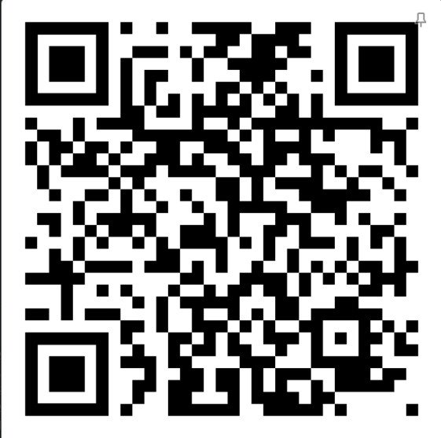
[SPLIT_BLOCK:qrcode_sito_quad.jpg];
Have a nice walk around Bologna

