There used to be an alley in Bologna called Pugliole di San Bernardino . This street disappeared following the urban planning interventions of the 1930s that led to the creation of Via Guglielmo Marconi (then Via Roma).
From the Napoleonic and Papal State land registry of 1871, we have a map showing the alleyway that connects the current number 25 of Via Polese with the current Piazza dei Martiri. The Reno tunnel, located at the level of Via Marconi 51, corresponds to the alleyway.
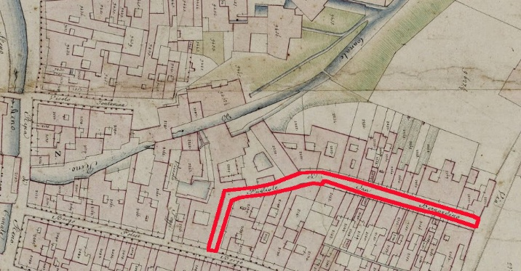
[SPLIT_BLOCK:mappavicolopugliole.jpg]
The " Pugliole di San Bernardino" took their name from the Monastery or Convent of San Bernardino which was located in the area of the current Piazza dei Martiri 1943-1945. The street branched off from Borgo Polese (the current Via Polese) and wound its way up to Via del Porto, partly following the current route of Via Marconi.
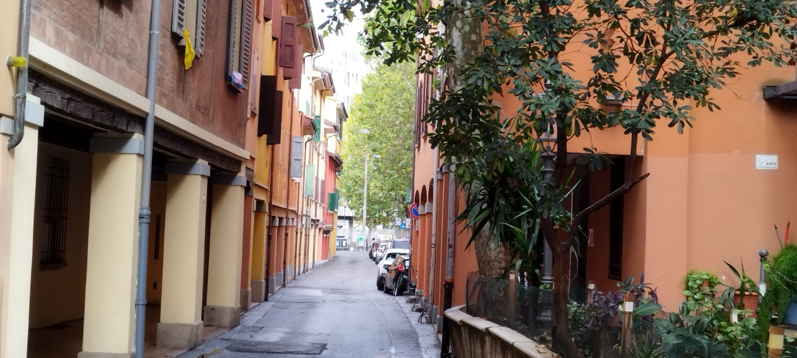
[SPLIT_BLOCK:viapolese.jpg]
The term "Pugliola" (or, in the plural, " Pugliole ") is an ancient term in Bolognese toponymy. It refers to an alley, a narrow street, or a small group of houses. It generally referred to a small road or a secondary residential area, often resulting from an ancient subdivision of the urban fabric.
Many streets and alleys in Bologna, such as " Pugliole di San Bernardino" or " Pugliole dello Spirito Santo," took their names from churches or monasteries that were located nearby, combining the name of the religious institution with the term " pugliola " to indicate the adjacent alley.

Tabella delle Fonti e Certificazione
Affermazione del testo | Fonte Certificata
An alley named Pugliole di San Bernardino existed in Bologna, which disappeared following urban redevelopment in the 1930s to create Via Marconi. | Historical Archive of the Municipality of Bologna
The Napoleonic and Papal States land registries (1871) map the alley connecting present-day Via Polese 25 to Piazza dei Martiri, intersecting the Reno gallery at Via Marconi 51. | Napoleonic Land Registry and Papal Land Registry (1871) - State Archive of Bologna
Pugliole di San Bernardino was named after the Monastery/Convent of San Bernardino located in the area of present-day Piazza dei Martiri 1943-1945. | Historical Topographic Dictionary of Bologna / Period Maps
The ancient Bolognese toponymic term "Pugliola/Pugliole" historically refers to an alley, a narrow street, or a small cluster of small-sized houses. | Historical Bolognese Toponymy Studies

