The Sanctuary of the Madonna della Pioggia and of San Bartolomeo di Reno (Via Riva di Reno, 124, corner of Via Galliera) in Bologna, houses the "Landscape with Bartolomeo" which is a work by the Bolognese painter Ludovico Mattioli .
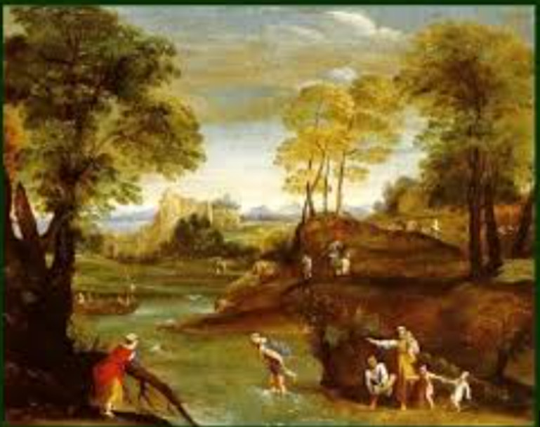
[SPLIT_BLOCK:Paesaggio_con_San_Bartolomeo.jpg];
🖼️ Ludovico Mattioli's "Landscape with Saint Bartholomew"
The work mentioned is located along the staircase leading to the upper rooms of the church and is not a painting by Annibale, as it is erroneously attributed to him, but by one of his successors from the Bolognese school.
- Artist: Ludovico Mattioli (1662-1747)
- Title (probable): Landscape with Saint Bartholomew
- Location: Staircase of the Sanctuary of the Madonna della Pioggia and San Bartolomeo di Reno, Bologna.
- Dating: 18th century.
Historical and Artistic Context:
- Landscape in the 18th Century: Although Annibale Carracci pioneered the "ideal landscape" in the 17th century, Ludovico Mattioli worked in a later era, the 18th century, when the landscape genre was fully developed and independent. Mattioli, a Bolognese artist active between the late 17th and early 18th centuries, was known not only for his canvases but also as an engraver and landscape painter .
- Style: His landscapes are typical of the late Baroque and Rococo style. Unlike Annibale's solemn and "heroic" nature, Mattioli's works present a more painterly , airy , and less structured style, with a predilection for atmosphere and light effects.
- The Church: The Sanctuary of the Madonna della Pioggia (or San Bartolomeo di Reno) has undergone numerous renovations over the centuries. The current church is mostly from the 18th century (rebuilt according to a design attributed to Alfonso Torreggiani), and works such as that by Mattioli fit into this 18th-century decorative context.
- Iconography: The inclusion of St. Bartholomew, the martyred apostle, serves as a reference to the ancient dedication of the church and the adjoining hospice.

Anecdotes and Curiosities
- The "Mystery" of the Attribution to Annibale Carracci: For a long time, local historians and 19th-century popular guides attributed this fresco directly to the great master Annibale Carracci, the founder of landscape painting. Only recently has art criticism definitively attributed the work to Ludovico Mattioli, a celebrated 18th-century Bolognese landscape painter who had extensively studied and embraced Carracci's teachings.
- A Fresco Along the Staircase and Not in the Chapel: One of the most interesting features of the work is its scenic placement: it is not above an altar or in a side chapel, but rather along the scenic eighteenth-century staircase (designed by architect Alfonso Torreggiani) that leads to the rooms of the ancient oratory and hospice. The painting visually accompanied the pilgrims and the brothers of Avesella as they ascended .
- Mattioli, the Engraver of "Playing Cards": In addition to painting large views and airy landscapes for the churches and palaces of Bologna, Ludovico Mattioli was renowned in the city as an extraordinarily skilled engraver. His popular fame was also linked to the engraving of tarot matrices, playing cards, and illustrative vignettes for the volumes printed by the Bolognese printers of the time.
- Saint Bartholomew and the Memory of the Ancient Hospital: The saint depicted in the landscape, Saint Bartholomew (recognizable by the iconography of his martyrdom), recalls the first and oldest dedication of the place of worship. Before the miracle of the rain of 1561 renamed the sanctuary, the church and the adjoining almshouse were known to all Bolognese as the Church of San Bartolomeo di Reno .

Tabella delle Fonti e Certificazione
Affermazione del testo | Fonte Certificata
The "Landscape with St. Bartholomew" is located along the staircase of the Sanctuary of Santa Maria della Pioggia and San Bartolomeo di Reno in Bologna. | Bologna Online / Salaborsa Library / Cultural Heritage Catalog
The artwork is by Bolognese painter and engraver Ludovico Mattioli (1662-1747) and not by Annibale Carracci, as erroneously attributed in the past. | Biographical Dictionary of Italians - Treccani / National Gallery of Bologna
The painting dates back to the 18th century, reflecting the late-Baroque and Rococo style of Mattioli's landscape painting with airy tones and light effects. | 18th-Century Bolognese Art Historiography / Ministry of Culture
The staircase and 18th-century structure of the Sanctuary stem from a project attributed to architect Alfonso Torreggiani. | Origine di Bologna (Municipality of Bologna) / Historical Archive Archdiocese of Bologna
The iconography of St. Bartholomew recalls the original 13th-century dedication of the church and adjoining charitable hospice (San Bartolomeo di Reno). | Historical-Artistic Guide to the Churches of Bologna / BeWeB CEI

