The address Via San Carlo, 19 in Bologna is associated with a building historically referred to as "Casa Carracci" (currently also known as "Casa Vacanze San Carlo" and used as tourist accommodation).
The building, protected by the Superintendence for Cultural Heritage, is identified by local tradition as one of the places where the painter Ludovico Carracci (Bologna, 1555 – Bologna, 1619) lived and worked, as well as one of the early workshops of the three Carracci cousins (Ludovico, Agostino, and Annibale), who founded the Accademia dei Desiderosi (later known as the Accademia degli Incamminati) in 1582.
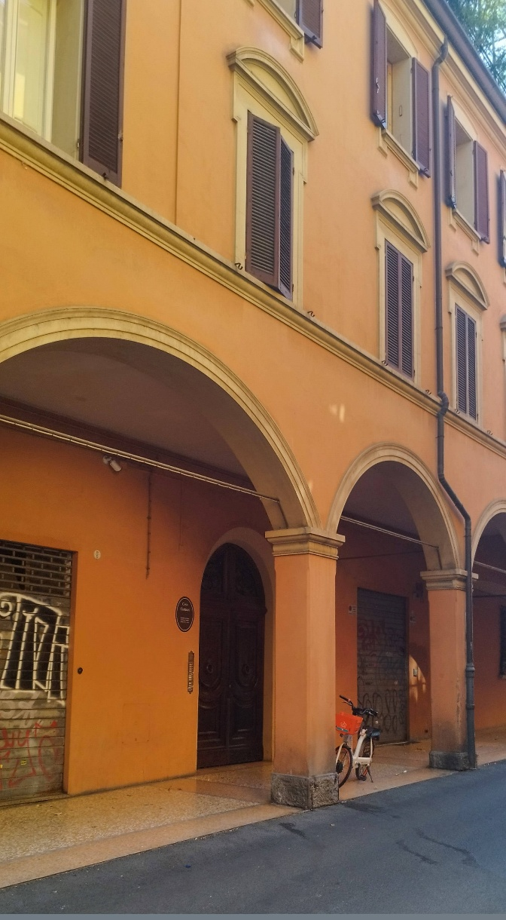
[SPLIT_BLOCK:casa_sanCarlo_19.jpg]

Historical and Architectural Clarifications
To ensure scientific and educational accuracy, two crucial aspects regarding the property at Via San Carlo, 19 should be highlighted:
- Chronological Precision: Some tourist guides incorrectly state that Ludovico's stay was restricted to the period between 1555 and 1609. Official biographical records document his birth in Bologna in 1555 and his death in 1619.
- Structural Evolution: The present building reflects architectural alterations resulting from 18th- and 19th-century renovations. Thus, the modern structure stands on the site of, or incorporates elements from, an original 16th-century core where the Carracci family—historically established in this area between nearby Via Riva di Reno and Piazzetta della Pioggia—owned workshops or residences.
The Historical Site in Via Rolandino
According to archival and architectural documentation in Bologna, the family's legacy and the official activities of the Accademia degli Incamminati are primarily associated with another building: "Casa Berò Gradi" (or Casa Berò, also known as Casa dei Carracci), located at Via Rolandino, 1, which underwent extensive restoration during the 19th century.
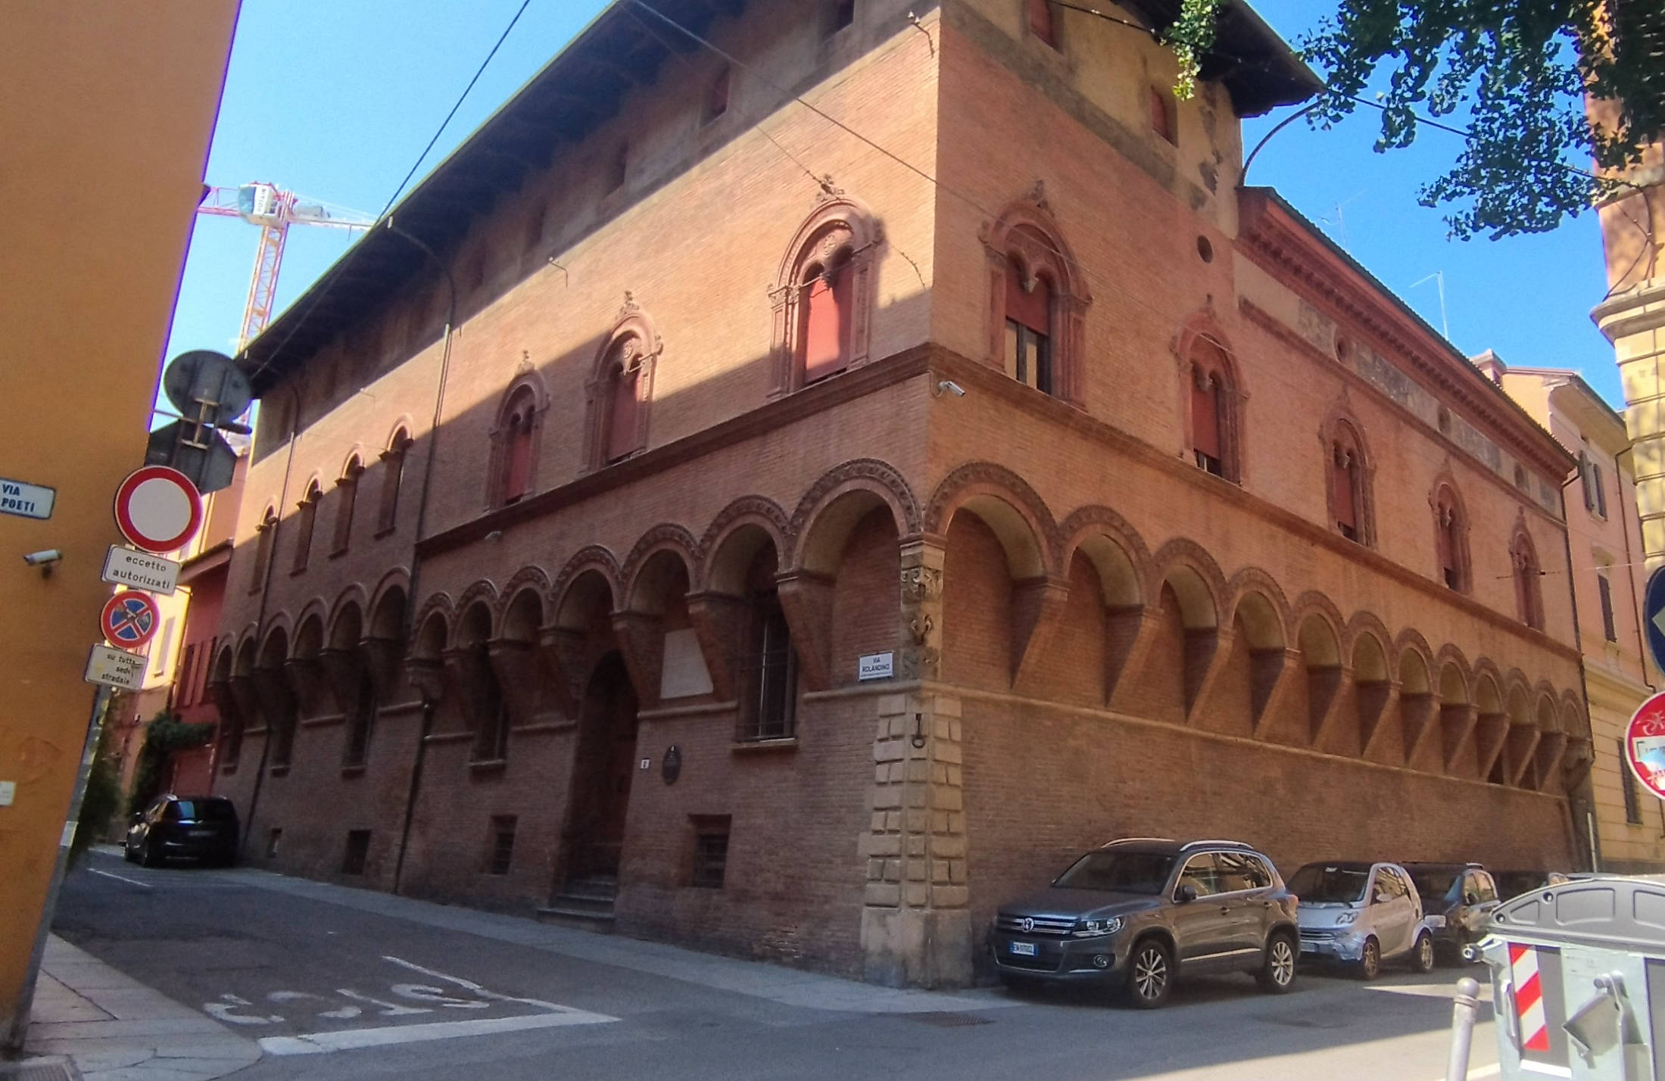
[SPLIT_BLOCK:casa_rolandino_1.jpg]

In summary, while Via San Carlo, 19 serves as an essential testament to the Carracci family's deep ties to the historic canal district, its presentation is enriched by accurate biographical information regarding Ludovico Carracci and broader artistic scholarship.

Tabella delle Fonti e Certificazione
Affermazione del testo | Fonte Certificata
Superintendence for Archaeology, Fine Arts and Landscape for the Metropolitan City of Bologna | Architectural protection and heritage status of Via San Carlo 19
Biographical Dictionary of Italians (Treccani) - Volume 20 | Verification of Ludovico Carracci's biographical dates (1555–1619)
Salaborsa Library - Chronicles of Bologna | History of the Accademia degli Incamminati and historical Carracci sites
Directorate General for Archives - State Archive of Bologna | Cadastral documentation and historical properties in Via Rolandino and Via San Carlo

